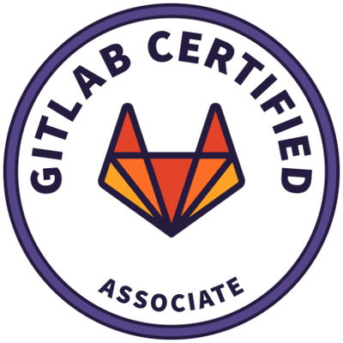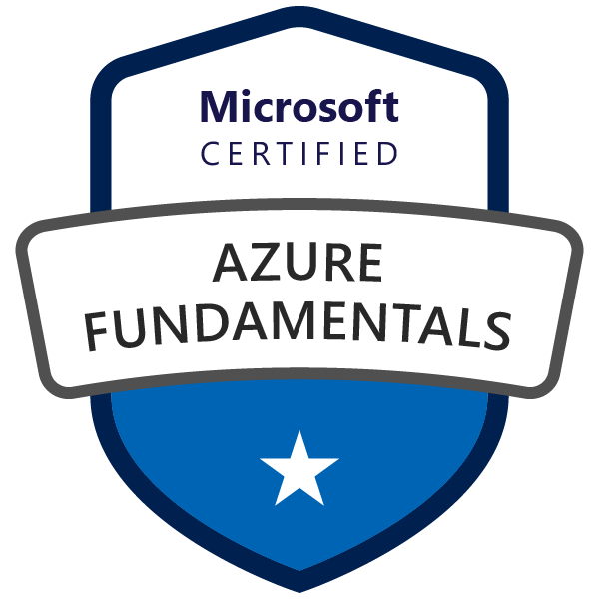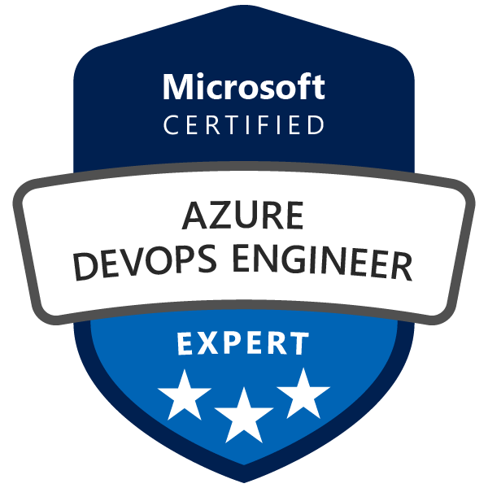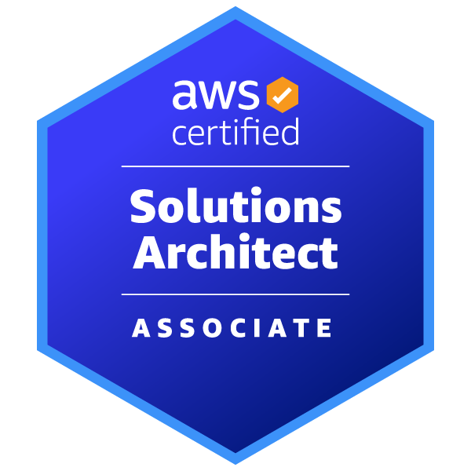
Rajendra P N
Lead Azure DevOps Engineer | AI | K8s
rajendran.scm@gmail.com | +1 (469) 926-4201 | Plano, Texas
LinkedIn: www.linkedin.com/in/rajendranelakurthi
Portfolio: https://rajendranelakurthi.github.io

Profile Summary
- Having 10+ years of proven expertise in Cloud, DevOps practices, SRE(Site Reliability Engineer), Kubernetes cluster management, Infrastructure automation and Software configuration and Release Management with strong experience Bash/Shell and Python.
- Major focus on Configuration, SCM, Build/Release Management, Infrastructure as a code (IaC) and as AWS & Azure DevOps operations Production and cross platform environments.
- Technically competent in creating and implementing DevOps best practices and architecting CI/CD pipelines in cloud AWS & AZURE and Kubernetes.
- Strong experience in developing infrastructure with Infrastructure as a code tool Terraform, Cloudformation, Ansible and strong experience in designing and deploying micro service application in Kubernetes EKS and on premise clusters using HELM charts.
- Expert in implementation of Azure Cloud services includes ARM templates, Azure virtual Networks, Virtual Machines, Cloud Services, Resource Groups, Express Route, Traffic Manager, VPN, Load Balancing, Application Gateways, Auto - Scaling.
- Experience in developing catalog items in ServiceNow and integrating ServiceNow with the DevOps toolchain to reduce manual interaction and integrate users into DevOps tools with one click.

Technical Skills
Operating Systems : Linux, RHEL, Ubuntu, HPUX, Windows Server 2012
Build tools : ANT, Maven, MSBuild, Make, Graddle
CI/CD : Jenkins, Electric Cloud, Gitlab, GitHub Actions, ArgoCD
IaC : Azure ARM templates , Terraform, Cloudformation, Ansible
Virtualization : VMWare Esxi, Virtual box, Vagrant, KVM, Hyper-V
Container Orchestration : Docker Swarm, ECS, Kubernetes
K8s Managed Service : OpenShift, AKS, EKS, Rancher
Application Server : IIS, Apache Tomcat, JBoss, WebLogic
Web Servers : Apache, nginx
Source Code management : Subversion, GitLab, GitHub, Bitbucket, Gerrit, TFS
Bug/Project Tracking Tools : Radar, Bugzilla, ServiceNow, Jira
Review/Security Tools : Fortify, SonarQube, Blackduck, RPM checker, Pylint
Cloud : AWS, Azure & Linode
Monitoring : Nagios, Zabbix, Grafana, Prometheus, AppDynamics
Logging : Splunk, ELK, Fluentd, Influxdb
Scripting Languages : Shell, batch, Python, PowerShell
Data Base : MySQL, MSSQL, PostgreSQL, MongoDB, Liquibase, Mongeeze
Programming Skills : Python .Net(C#), Core JAVA
IDE : VS 2012, VSCode
Other tools : datree.io, Helm, Consul, Istio, Hashicorp Vault, ACR, ECR

Professional Experience
- Working as Lead Azure DevOps Engineer at AT&T Services Inc, Plano, TX from Aug 23 – Till date
- Worked as Senior DevOps Engineer at GlobalLogic from Mar 2023 to Aug 2023.
- Worked as Senior DevOps Engineer-II at Akamai Technologies, from Dec 2021 to March 2023.
- Worked as DevOps Engineer at Turvo India Pvt Ltd, Hyderabad during Apr 2020 to Dec 2021.
- Worked as Sr. Specialist at HCL Technologies, Bangalore during Feb 2019 to April 2020.
- Worked as Software Engineer-systems at Mphasis Ltd, Bangalore during Aug 2016 to Dec 2018.

Projects

Lead Azure DevOps Engineer
AT&T Services Inc., Plano, TX June 2023 – Till date
Project : CDO (Chief Data Office)
Skills used : Azure, TFS, ADO, PowerShell, Terraform, confluence, Kubernetes (AKS), Git, Milvus, Azure Databricks, Azure API Management (APIM), Application Gateway, Helm, Argo CD
Roles & Responsibilities:
- Led the modernization of development workflows by migrating legacy systems from TFS and Jenkins to Azure DevOps, significantly enhancing collaboration, traceability, and deployment automation.
- Designed and operated AKS platform infrastructure with Terraform for Milvus and GPU workloads, troubleshooting deployments, networking, resource capacity, and access controls to support reliable enterprise services.
- Worked closely with developers, security engineers, and operations teams to shape cloud-native architectures that balanced resilience, cost-efficiency, and performance.
- Developed secure, repeatable CI/CD pipelines using Azure DevOps, incorporating controlled deployments, approval flows, and security scans to align with enterprise requirements.
- Incorporated safeguards in pipeline design and resource provisioning to ensure alignment with organizational policies for geographic compliance, security boundaries, and access governance.
- Engineered repeatable Azure Databricks workspace provisioning with Terraform across isolated subscriptions, standardizing network integration, RBAC, and environment configuration for data platform teams.
- Produced solution diagrams, environment specifications, and infrastructure runbooks to support architecture clarity and stakeholder alignment.
- Managed deployment infrastructure using custom agent pools and distributed deployment groups, optimizing job execution across controlled compute environments.
- Established secure communication pathways using Private Endpoints and Private Link, protecting sensitive services while maintaining application flexibility.
- Improved efficiency and system performance by continuously evaluating usage patterns and tuning deployments through Azure-native monitoring and cost optimization tools.
- Participated in regular architecture syncs and technical discussions to review evolving platform needs, contributing to the refinement of infrastructure patterns and tool selection.
- Standardized microservice delivery using Helm, Kubernetes manifests, and GitOps patterns, integrating automated deployment checks and environment configuration into CI/CD workflows.
- Designed, provisioned, and supported Azure API Management (APIM) gateway infrastructure with Terraform and CI/CD, maintaining API routing, backend connectivity, and environment-specific configuration.
- Administered APIM policies for authentication, rate limiting, and request handling; investigated gateway errors and backend failures using platform diagnostics and application logs.
- Integrated Azure Application Gateway with APIM, configuring TLS, backend health probes, and routing rules to provide secure, resilient API access.

Sr DevOps Engineer
GlobalLogic Mar 2023 - Aug 2023
Project : Here
Skills used : Azure, GitLab, Terraform, Jira, Kubernetes
Roles & Responsibilities:
- Deploying and configuring Selfhosted and VMSS agents/Agent pools(Windows, Linux).
- Creating views and upstream sources depending upon project development team requirements.
- Working with Docker containerization tool. Provisioning Docker containers, managing containers using different commands.
- Good Understanding of Kubernetes cluster and components. Deploying application to Kubernetes and administrating Kubernetes pods, deployments, services and so on.
- Migrated Jenkins pipelines to Gitlab along with new runners setup.
- Implemented SCM best practices and given trainings to developers on gitlab.

Sr DevOps Engineer II
Akamai Technologies Dec 2021 - March 2023
Project : Zero Trust
Skills used : Azure, Linode, Python, Terraform, confluence, Jira, Kubernetes, GitHub Actions, GitLab
Roles & Responsibilities:
- Deploying and configuring Selfhosted agents/Agent pools(Windows, Linux).
- Deploying and configuring Deployment groups to use in Release pipeline.
- Created dashboards in VSTS for CI/CD pipelines, Work items and bugs.
- Deployed Kubernetes pods or Microservices with ArgoCD.
- Building Infrastructure in Azure by writing ARM and Yaml pipeline Scripts.
- Experience in setting up and maintaining CI/CD pipelines using Jenkins, Git, Azure Container Registry & Kubernetes.
- Implemented GitHub Actions for deployments on to Kubernetes cluster.
- Building application and containerizing using Docker file and deploying app to AKS cluster by writing yaml scripts.
- Integrating Azure DevOps-VSTS with Slack/Team, Jenkins, Github and SonarCloud ..etc depending upon user requests.
- Building and deploying applications by adopting DevOps practices such as Continuous development, Continuous Integration (CI) and Continuous Deployment (CD)in runtime with various tools like Git, Maven, VSTS, Jenkins, Ansible, Docker, Kubernetes and managing cloud services with Azure.
- Writing automation scripts using Power shell scripts and making them available in central repo to use them in different environments.
- Troubleshooting Build and Release pipelines if any deployment error occurs.
- Publishing artifacts to Azure artifacts and NuGet Artifactory and making them available to development teams.
- Creating views and upstream sources depending upon project development team requirements.
- Working with Docker containerization tool. Provisioning Docker containers, managing containers using different commands.
- Good Understanding of Kubernetes cluster and components. Deploying application to Kubernetes and administrating Kubernetes pods, deployments, services and so on.
- Unique experience with Kubernetes architecture and design, troubleshooting issues with platform components (PCF), and developing global/multi-regional deployment models and patterns for large scale developments/deployments Kubernetes.
- Implementing the DR for Critical application servers using Azure Site recovery and performing the failover.
- Configuring Backup in Azure and performing Backups of VM and IAAS SQL VM’s on regular basis.
- Setting up alerts using Azure Monitor and Application insights.
- Hand-on experiences Webapp service, Azure SQL DB, Functions, Key vaults, Azure storage services.
- Configuration of Azure virtual Network, subnets, DHCP, DNS, Network Security Groups, VPN, Express route, Load Balances, Front Door, Application Gateway, and Traffic Manager.

Sr DevOps Engineer /Sr SRE (Site reliability Engineer)
Turvo India Pvt ltd April 2020 to Dec 2021
Project : Turvo TMS
Skills used : Azure, AWS, python, confluence, Jira, Cloudbees, Jenkins, GitHub Actions, SonarQube, Jfrog, IIS
Roles & Responsibilities:
- Writing Azure Build and Release pipelines for application and infrastructure deployment.
- Created ARD(Architecture resource diagrams) for getting clearance from the compliance and export control teams
- Written custom policies and applying built in/custom policies according to IT security team requirements.
- Setting up MFA, Conditional access control and creating user/groups and granting them access in Azur AD.
- Interact with peers to isolate product defects. Having retrospective meetings with development teams, sprint managers.
- Keeping abreast of industry trends and best practices and utilizing them to improve operational efficiency.
- Adopted best practices in CI/CD using GitHub Actions to streamline development and deployment processes.
- Designed and developed a robust solution that deploys a payment application using Terraform and Kubernetes, ensuring seamless provisioning of infrastructure and efficient container management
- Automated the deployment of new projects to Enterprise DevOps platform using API’s
- Developed custom API’s for tools Jenkins, Jira and JFROG using python FastAPI framework
- Maintaining and administrating Cloudbees Jenkins, Jfrog and Xray enterprise products
- Developed Prometheus custom exporters for getting custom metrics from applications using python
- Developed robust Ansible roles and playbooks to deploy HA monitoring stack using Grafana, Prometheus and Node Exporter
- Developed Jenkins shared pipelines for automating the image creation and upload to the private Artifactory(JFROG) with versioning
- Developed HELM charts to deploy the dockerized applications in Kubernetes.

Senior DevOps Engineer
HCL Technologies, Bangalore Feb 2019 to April 2020
Project : EnCoMa+, eLite
Client : Mercedes-Benz Research & Development India
Skills : Kubernetes, AWS, Ansible, GitHub, Shell scripting, Jenkins, maven, Tomcat, JBoss OEL, ServiceNow, nexus, HELM charts
Roles & Responsibilities:
- Represented DevOps team and gave presentation on implementation of CI&CD and infrastructure automation for identified projects (Model Finder)
- Presenting and reviewing DevOps platform enhancements and review roadmaps for following quarter in Germany as Lead
- Designed monitoring architecture for collecting multiple metrics using ELK stack
- Deployed Kubernetes manifests in on premise clusters using HELM
- Worked as an acting scrum master and taking care of creating stories and epics to deliver in sprint and took care of scrum ceremonies
- Created Kubernetes cluster with objects like Pods, Deployments, Services and ConfigMaps and created reproducible builds of the Kubernetes applications, managed Kubernetes manifest files and Helm packages and implemented Kubernetes to deploy scale, load balance, scale and manage Docker containers with multiple name spaced versions.
- Handling various project application on azure such as understand and troubleshooting various issues on Azure resources like App Insights, Azure SQL, Webapps, Application Gateway, Auto scale resources based on utilization, managed and Manage SSL certificates on domain name, CDN and AD authentication etc
- continuous delivery pipelines in Azure DevOps (VSTS) and Experience with designing APIs and working with REST-based microservices and deploying the infrastructure and application in various environment like Demo, Test, PENTEST, Training, CTDEV, Sandbox, UAT, and PROD Environments of the MDR products.
- Expertise in Microsoft Azure Cloud Services (PaaS&IaaS), Application Insights, Document DB, Azure Monitoring, Key Vault, Visual Studio Online (VSO) and SQL Azure.
- We used ARM templates and PowerShell script mechanism to deploy Azure resources.
- Implement migration strategies for traditional systems on Azure (Lift and shift/Azure Migrate, other third-party tools).
- Worked on Azure AD connect to sync on-premises AD user data, groups and organizations to Azure AD and troubleshoot Azure services sync with on-premise AD and resync using the Azure tools also Configure security in Azure AD using privilege access management, Identity protection, Multi-factor authentication (MFA) for two-factor authentication.
- Experience in migrating on premise workloads to the cloud such as migrated on premises Windows Server 2012 R2 on Azure cloud with the help of OMS (Azure Site Recovery Vault), Created VM to the migrated image with Test Failovers services and made necessary configuration changes according to the request.
- Configuring and Controlling the Scale Up and Scale Out of the App Service Plans and Pricing tier (scale DTUs) while migrating the Databases and Applications from on-premises to Azure Cloud Platform.
- Maintain and manage application users and organization through ruby console, created rake task to delete or create users and managed various role access policy for the application users.
- Updating SSL certificate on timely manner and validating application logs finding the bugs and fixing them routine activities like debugging the application issue with various tools such as log entries, libretto and roll bar checking and investigating the application performance with various monitoring performance tools like app insights new relic APM and resolving them on timely manner, also setup various alerts to track the application performance changes.
- Automated the task to enforce/disable the property on all the Azure Virtual Machines (Linux and Windows) by assigning to single storage account through Power shell Scripting and configuring through Run deck
- Worked on assigning the RBAC roles at group level and user level as per the LTA created for various Azure PaaS services as per the Organization security standards and Setting up Connection Strings and connecting PSQL Server AZURE Databases from locally Installed PSQL Server Management Studio (SSMS) for Developers.

DevOps Engineer
Mphasis Ltd, Bangalore Aug 2016 to Dec 2018
Project Name : RMC, OIU, PMU, SDX
Client : HPE
Skills used : Azure, CHEF, Ansible, Gitlab, Shell scripting, Python, maven, Tomcat, JBoss, Shield, Splunk, Nexus
Roles & Responsibilities:
- Created Deployment Pipeline using Ansible to support from Dev to till Production.
- Create and update Terraform scripts regularly and deploy changes through ADO CI/CD pipelines.
- Create build and release pipelines using YAML scripts and trigger builds automatically for each push.
- Perform poc's in Azure and provide requirement based solutions.
- Create and run Azure CLI scripts for updating specific configurations of Azure services.
- Create Agent pools and Install ADO agents to run the pipeline jobs.
- Propose and implement Branching strategy for Azure Git repos.
- Created and documented build and deployment flows for different components (Core-infra, API, DB, UI) of the project.
- Create CI/CD pipelines for multiple components of the project.
- Run Terraform scripts through pipelines, build the changes once and deployed to multiple environments using environment selection.
- Create and manage Variable groups in ADO which separate and control the deployments between the environments.
- Configured the Jenkins master server along with SSH and JNLP slaves to offload the work to slaves.

Education
B.Tech(2009-2013) in Information Technology from Prakasam Engineering College, affiliated from Jawaharlal Nehru Technological University, Kakinada.

