**PIZZA SALES ANALYSIS**

**Tools Used: SQL Server**

**Skills Used: MySQL  
  
KPI’s REQUIREMENT**  
  
**1. Total Revenue:**  
  
**Query:**   
select round(sum(total_price),2)

as Total_Revenue

from pizza_sales  
  
**Output:**  
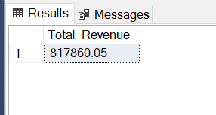  
  
**2. Average Order Value:**  
  
**Query:**   
select sum(total_price)/count(distinct(order_id))

as Avg_Order_Val

from pizza_sales  
  
**Output:**  
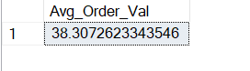

**3. Total Pizza Sold:   
  
Query:**  
select sum(quantity) as Total_Pizza_sold

from pizza_sales

**Output:**

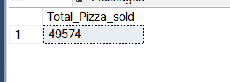

**4. Total Orders:**

**Query:**

select count (distinct(order_id))

as Total_Orders

from pizza_sales

**Output:**

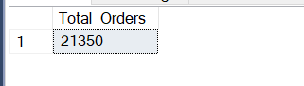

**5. Average Pizzas Per Order:**

**Query:**

select sum(quantity)/ count (distinct(order_id))

as Avg_pizza_per_order

from pizza_sales

**Output:**

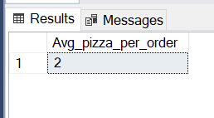

**CHARTS REQUIREMENT**

**1. Daily Trend for Total Orders:**

**Query:**  
select datename(DW,order_date) as Order_Day,

count(distinct(order_id)) as Total_Orders

from pizza_sales

group by datename(DW,order_date)

**Output:**

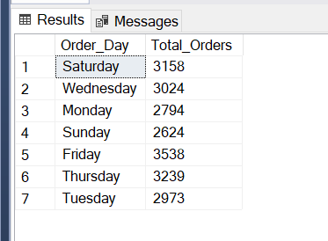

**2. Hourly Trend for Total Orders:**

**Query:**

select DATEPART(hour, order_time) as Order_Hours, count(distinct(order_id)) as Total_Orders

from pizza_sales

group by DATEPART(hour, order_time)

order by DATEPART(hour, order_time)

**Output:**

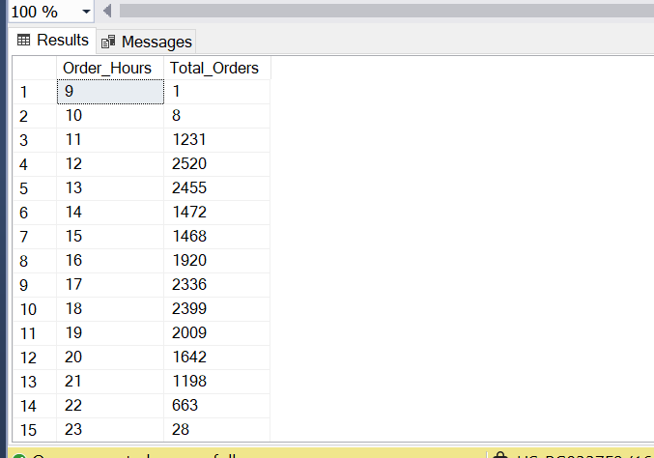

**3. Percentage of Sales by Pizza Category:**

**Query:**

select pizza_category, cast((sum(total_price)/ (select sum(total_price) from pizza_sales)) * 100 as decimal(10,2)) as PCD

from pizza_sales

group by pizza_category

**Output:**

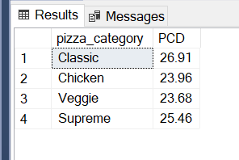

**4. Percentage of Sales by Pizza Size:**

**Query:**

select pizza_size, cast((sum(total_price)/ (select sum(total_price) from pizza_sales)) * 100 as decimal(10,2)) as PCT

from pizza_sales

group by pizza_size

**Output:**

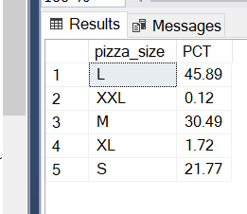

**5. Total Pizzas Sold by Pizza Category:**

**Query:**

Select pizza_category, sum(quantity) as Total_Pizza_Sold

from pizza_sales

group by pizza_category

**Output:**

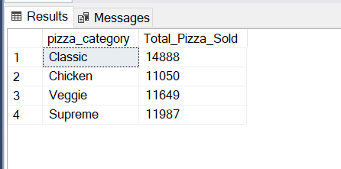

**6. Top 5 Best Sellers by Total Pizzas Sold:**

**Query:**

select top 5 pizza_name, sum(quantity) as Total_Pizza_sold

from pizza_sales

group by pizza_name

order by Total_Pizza_sold desc

**Output:**

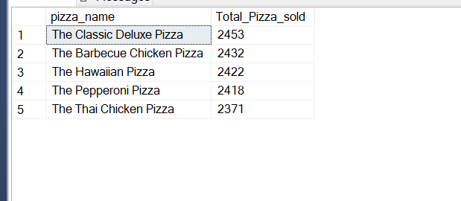

**7. Bottom 5 Worst Sellers by Total Pizzas Sold:**

**Query:**

select top 5 pizza_name, sum(quantity) as Total_Pizza_sold

from pizza_sales

group by pizza_name

order by Total_Pizza_sold asc

**Output:**

