1. Getting All records using UI

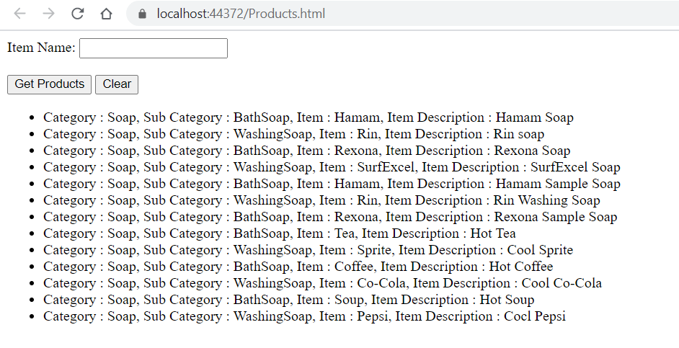

1. Getting Specific Item

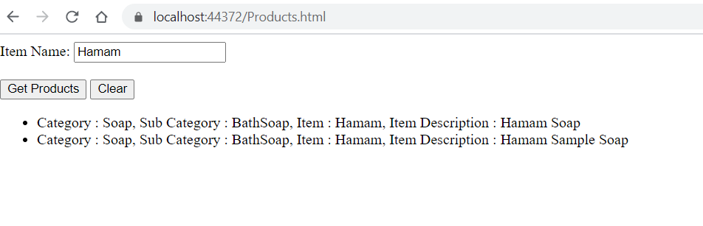

1. Item Min and Max length validation

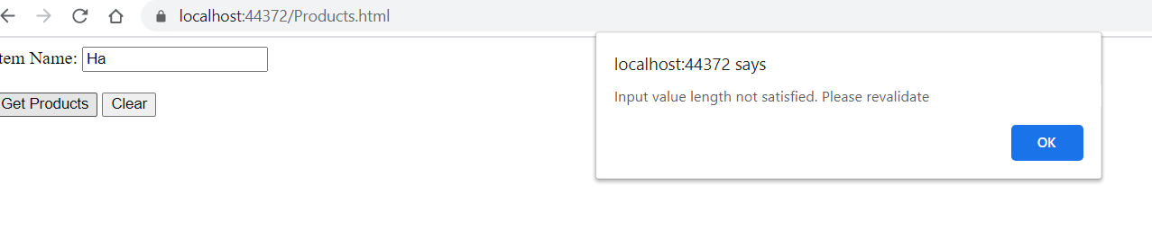

1. No record matching

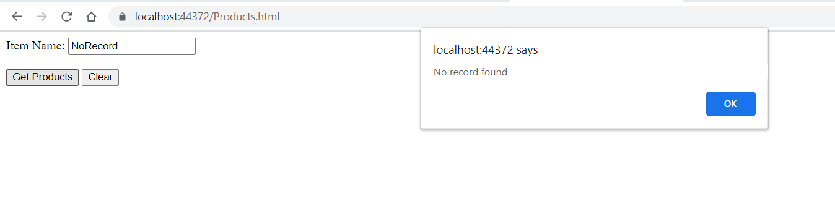

5. Using URI request for all item details (Web API get all items)

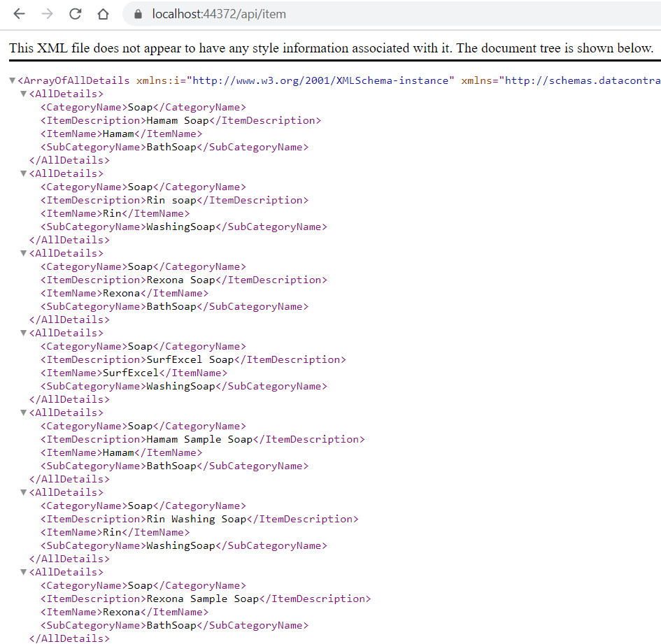

6. Using URI request for specific item (Web API get specific items)

