
Date: 13.08.2026
Review- 0
Domain: AI-Based Blind Spot Detection for All Vehicle Types
1. Blind Spot Detection Applications
Blind spots remain one of the leading causes of lane-change and turning accidents across all categories of vehicles, from passenger cars to heavy trucks and buses. AI-based Blind Spot Detection Systems combine Computer Vision, Deep Learning, and Sensor Fusion to continuously monitor the regions around a vehicle that are not visible through standard mirrors, alerting drivers before a hazardous maneuver is made.
Some major applications include:
- Camera-Based Object Detection: Detects vehicles, motorcycles, cyclists, and pedestrians entering the blind spot zones using real-time video feeds.
- Radar and Ultrasonic Sensing: Measures the distance and relative speed of nearby objects to detect approaching vehicles even in low visibility.
- Multi-Sensor Fusion: Combines camera, radar, and ultrasonic data to improve detection accuracy and reduce false alerts.
- Visual and Audio Warning Systems: Notifies the driver through dashboard indicators, mirror-mounted LEDs, or audible alerts when a hazard is detected.
- Lane Change Assist Integration: Works alongside lane detection systems to prevent unsafe lane changes when a vehicle occupies the blind spot.
- Heavy Vehicle Adaptation: Extends blind spot coverage to trucks and buses, where blind zones are significantly larger than in passenger cars.
- Rear Cross-Traffic Alert: Detects approaching vehicles or pedestrians while reversing out of parking spaces or driveways.
- Simulation-Based Testing: Enables safe evaluation of blind spot detection algorithms in virtual environments before real-world deployment.
2. Limitations in the Domain
Although blind spot detection technologies have advanced significantly, several challenges remain:
- Most commercial systems rely on radar or ultrasonic sensors alone, which are costly and difficult to retrofit onto heavy vehicles.
- Camera-based detection accuracy decreases under adverse weather conditions such as rain, fog, or low-light environments.
- False positive alerts remain common in dense traffic, reducing driver trust in the system.
- Existing systems often provide binary alerts rather than distinguishing between varying levels of collision risk.
- Real-time processing on embedded vehicle hardware demands significant computational efficiency.
- Blind spot zones vary considerably across vehicle types, making a one-size-fits-all solution difficult to design.
- Limited affordability restricts blind spot detection mostly to premium passenger vehicles, leaving buses and trucks underserved.
3. Future Scope
The future of AI-powered blind spot detection is expected to include:
- Low-cost, camera-only solutions that eliminate the need for expensive radar hardware.
- Adaptive risk-tiered alert systems that scale warnings based on proximity and closing speed.
- Integration with Vehicle-to-Everything (V2X) communication for cooperative hazard awareness.
- Edge AI deployment for real-time, on-device inference without cloud dependency.
- Retrofit-friendly designs suitable for heavy vehicles such as trucks and buses.
- Multi-object tracking to reduce false alerts in dense traffic scenarios.
- Standardized blind spot detection accessible across all vehicle classes, not just premium cars.
II. Proposed Project Title
AI-Powered Blind Spot Detection System for All Vehicle Types: A Camera-Based Deep Learning Approach for Real-Time Hazard Alerts
Description
The proposed project aims to develop a real-time Blind Spot Detection System that is adaptable across all vehicle types, including cars, trucks, buses, and two-wheelers. Using camera-based Computer Vision and Deep Learning, the system continuously monitors the blind spot zones on both sides of a vehicle, identifying vehicles, motorcycles, cyclists, and pedestrians that a driver may not otherwise see through standard mirrors.
Unlike traditional radar-only or ultrasonic-based blind spot systems, which are often restricted to passenger cars due to sensor placement and cost constraints, the proposed camera-based approach offers a low-cost, retrofittable solution suitable for heavy vehicles where blind spots are considerably larger. The system will classify detected objects by proximity and risk level, generating tiered visual and audio warnings ranging from cautionary alerts to critical collision-risk notifications.
III. Objectives to Achieve the Project
Objective 1
Develop a robust Computer Vision pipeline capable of detecting vehicles, motorcycles, cyclists, and pedestrians within the blind spot zones in real time using deep learning models.
Objective 2
Design and implement configurable left and right blind spot zones adaptable to different vehicle dimensions, including cars, trucks, and buses.
Objective 3
Build a tiered risk assessment module that classifies detected hazards by proximity and generates appropriate visual and audio warnings.
Objective 4
Evaluate system performance and false-alert rate across varied lighting and traffic density conditions to ensure reliable real-world deployment.
WorkFlow :
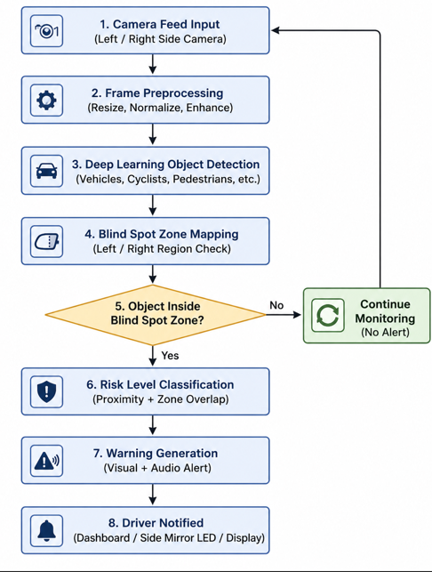

Team Members (shouldn't exceed 3):

Name Roll Number
- Rajendra 2420030609
- Nandan 2420030532
- Aryan 2420030137

