ADDRESS RESOLUTION PROTOCOL (ARP)
Detailed Lab Report
ARP Resolution and ICMP Communication Analysis using VirtualBox Host-Only Networking and Wireshark

Personal Revision / Practice Report
Prepared by: Rajendra Prasad D
Environment: Windows 11 · Windows XP · Kali Linux · Oracle VirtualBox · Wireshark
Date: July 2026

Table of Contents
(This table updates automatically. If it appears empty, right-click it and choose “Update Field”, or select the whole document with Ctrl+A and press F9.)
1. Introduction 1
2. ARP Concept — Theoretical Background 1
2.1 What Is ARP and Why It Is Needed 1
2.2 ARP in the TCP/IP Model 1
2.3 ARP Packet Format 1
2.4 Types of ARP Messages 1
2.5 Step-by-Step ARP Resolution Process 1
2.6 The ARP Cache 1
2.7 Security Considerations: ARP Spoofing 1
3. Project Objectives 1
4. Lab Environment and Network Topology 1
5. Host Machine Configuration — Windows 11 1
6. Windows XP VM Configuration 1
7. Kali Linux VM Configuration 1
8. Connectivity Test — Ping and ARP Cache Verification 1
9. Wireshark Packet Capture and Analysis 1
10. Results and Observations 1
11. Common Issues and Troubleshooting Reference 1
12. Learning Outcomes 1
13. Conclusion 1
14. References 1

1. Introduction
This report documents a personal, hands-on revision exercise on the Address Resolution Protocol (ARP), carried out inside an isolated virtual lab built with Oracle VirtualBox. The exercise combines protocol theory with a practical capture-and-analyse workflow: a Windows 11 host machine is configured on a VirtualBox Host-Only network alongside two virtual machines, a Windows XP guest and a Kali Linux guest, and Wireshark is used to capture and inspect the ARP and ICMP traffic generated when the host pings the Windows XP guest for the first time.
The report is organised to move from theory to practice and back to reflection. Section 2 reviews the theoretical background of ARP, including its packet format, message types, and security relevance. Section 3 restates the objectives of the exercise. Sections 4 through 9 walk through the lab environment, the network configuration of each machine, the connectivity test, and the resulting Wireshark capture, with screenshots taken directly from the exercise. Sections 10 through 13 consolidate the observations, note practical troubleshooting points, summarise the learning outcomes, and close with a conclusion and references.
The intended audience for this document is the author's own future self revising the topic, so explanations are kept deliberately thorough rather than assumed as prior knowledge, in the interest of the document also being useful as a standalone study reference on ARP.

2. ARP Concept — Theoretical Background

2.1 What Is ARP and Why It Is Needed
Every device on an Ethernet network is identified at two different layers simultaneously: a 48-bit hardware address (MAC address) burned into the network interface, and a logical IP address assigned by configuration or DHCP. Ethernet frames are delivered using MAC addresses, but applications and the IP layer only know the destination's IP address. The Address Resolution Protocol, defined in RFC 826, exists to bridge this gap: given a known IP address on the local network, ARP discovers the corresponding MAC address so that an Ethernet frame can actually be addressed and delivered.

2.2 ARP in the TCP/IP Model
ARP is often described as sitting between Layer 2 (Data Link) and Layer 3 (Network) of the OSI model. It is encapsulated directly inside an Ethernet frame (EtherType 0x0806) rather than inside an IP packet, which means it has no IP header of its own and, by design, cannot be routed beyond the local broadcast domain — a property that also defines its security boundary.

2.3 ARP Packet Format
An ARP message is a fixed-format packet carried inside an Ethernet frame. The main fields are summarised below.
Field | Size | Description
Hardware Type | 2 bytes | Type of hardware address; 1 for Ethernet
Protocol Type | 2 bytes | Type of protocol address being resolved; 0x0800 for IPv4
Hardware Address Length | 1 byte | Length of a MAC address in bytes; 6 for Ethernet
Protocol Address Length | 1 byte | Length of an IP address in bytes; 4 for IPv4
Operation | 2 bytes | 1 = ARP Request, 2 = ARP Reply
Sender Hardware Address | 6 bytes | MAC address of the sender
Sender Protocol Address | 4 bytes | IP address of the sender
Target Hardware Address | 6 bytes | MAC address of the target (all zero in a request)
Target Protocol Address | 4 bytes | IP address of the target being resolved

2.4 Types of ARP Messages
- ARP Request — broadcast to the entire local segment (destination MAC FF:FF:FF:FF:FF:FF), asking who owns a given IP address.
- ARP Reply — sent as a unicast frame directly back to the requester, containing the owner's MAC address.
- Gratuitous ARP — a host announces its own IP-to-MAC mapping unprompted, typically after boot or an IP change, so that neighbours update their caches proactively.
- Proxy ARP — a router answers ARP requests on behalf of another host, commonly used to bridge two segments transparently.
- RARP (historical) — Reverse ARP resolved a MAC address to an IP address for diskless workstations; it has been superseded by DHCP and is mentioned here only for completeness.

2.5 Step-by-Step ARP Resolution Process
1. A host needs to send an IP packet to a destination on the same subnet, but does not yet know the destination's MAC address.
2. The host checks its local ARP cache for an existing IP-to-MAC mapping.
3. If no entry exists, the host constructs an ARP Request and broadcasts it to the entire local segment.
4. Every host on the segment receives the broadcast; only the host whose IP matches the request processes and replies.
5. The owning host sends a unicast ARP Reply containing its MAC address directly back to the requester.
6. The requester stores the new mapping in its ARP cache and can now address Ethernet frames to that host directly.
7. Any higher-layer traffic queued behind the resolution, such as an ICMP Echo Request, is now sent using the resolved MAC address.

2.6 The ARP Cache
Resolving an address on every single packet would be wasteful, so operating systems maintain an ARP cache: a short-lived table of IP-to-MAC mappings. Entries learned automatically from replies are marked dynamic and expire after a timeout, typically in the range of 2 to 20 minutes depending on the operating system, after which they must be re-resolved. Entries can also be added manually as static, in which case they do not expire and are not overwritten by later ARP traffic. On Windows, the cache is inspected with arp -a and on Linux with ip neigh or the older arp -n.

2.7 Security Considerations: ARP Spoofing
ARP was designed for a trusted local network and includes no authentication: any host can claim to own any IP address, and most stacks will accept an unsolicited reply and update their cache accordingly. This is the basis of ARP spoofing (also called ARP cache poisoning), where an attacker sends forged ARP replies to associate its own MAC address with another host's IP address, redirecting traffic through the attacker for interception or a man-in-the-middle position. Common mitigations include static ARP entries for critical hosts, switch-level Dynamic ARP Inspection (DAI) that validates ARP packets against a trusted DHCP snooping table, and passive monitoring tools such as arpwatch that alert on unexpected IP-to-MAC changes. This connects directly to the practical exercise below: the same arp -a output and Wireshark ARP filter used here to confirm normal behaviour are the tools an analyst uses to spot spoofing in the field.

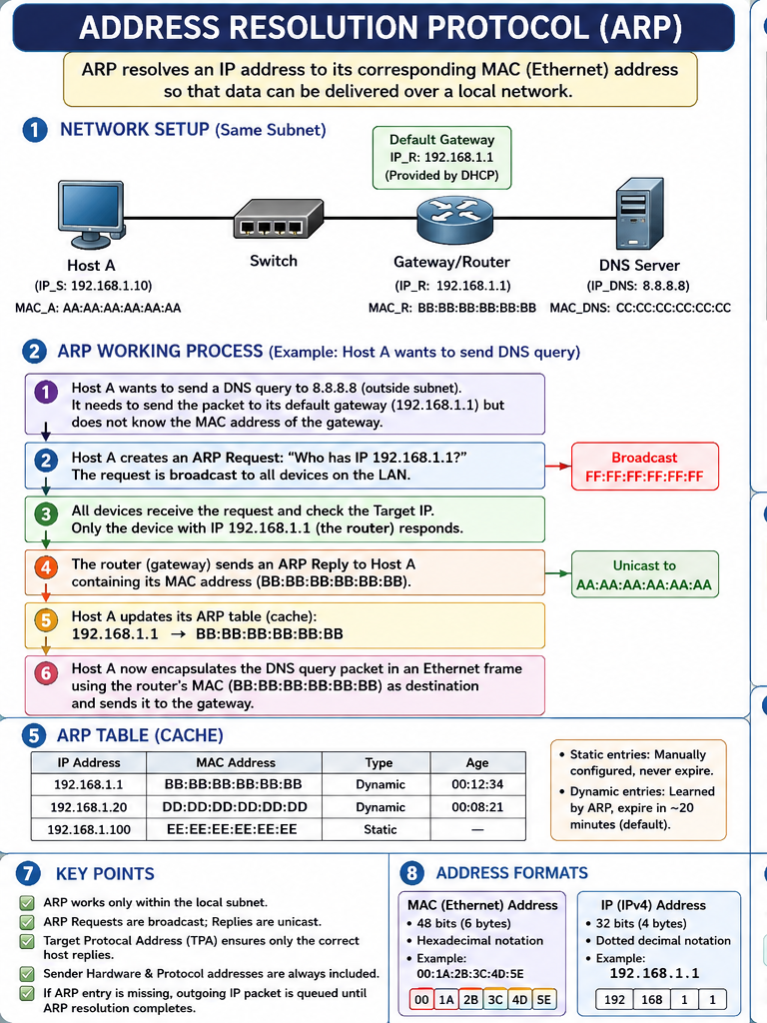
Figure 1. ARP overview infographic (part 1 of 2).

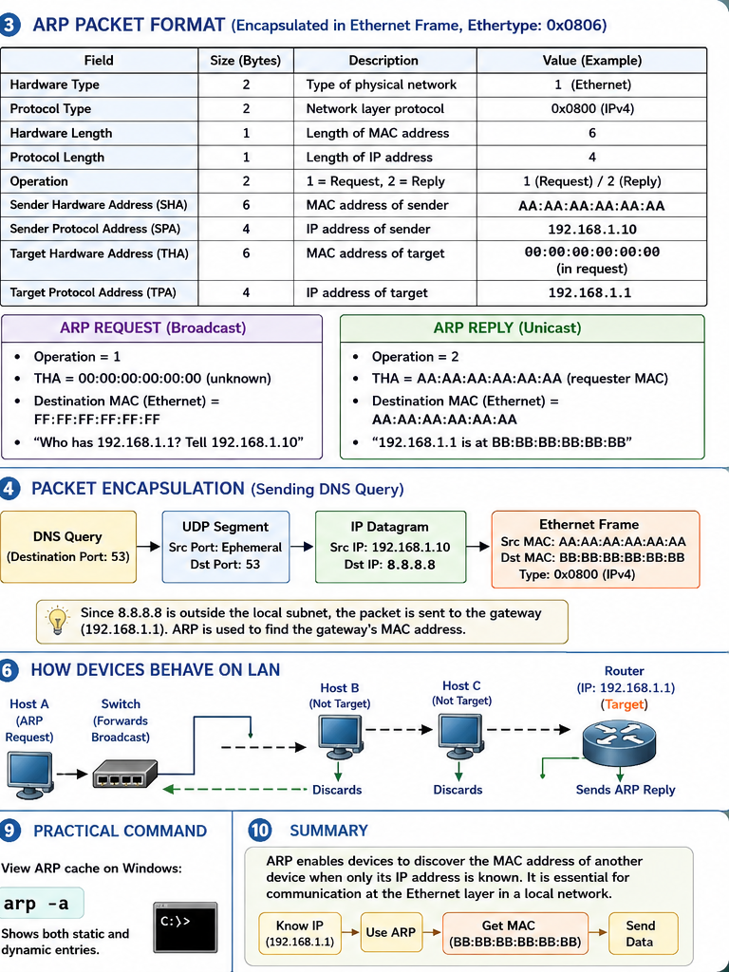
Figure 2. ARP overview infographic (part 2 of 2).

3. Project Objectives
The exercise was designed around five concrete objectives, each targeting a specific piece of the ARP-to-ICMP workflow:
- Understand how ARP works — review the protocol theory covered in Section 2 before observing it in a live capture.
- Capture an ARP Request and Reply — confirm the broadcast/unicast pattern directly in Wireshark rather than only in theory.
- Observe ICMP after ARP — verify that Echo Request/Reply traffic only begins once the destination MAC address has been resolved.
- Understand Host-Only networking — use VirtualBox's isolated Host-Only adapter to build a safe, repeatable lab segment.
- Analyse captured packets — read the relevant Ethernet, ARP, and ICMP header fields directly from the capture.

4. Lab Environment and Network Topology
The lab consists of one physical host and two virtual machines, all attached to the same VirtualBox Host-Only network so that the exercise is fully self-contained and generates no traffic on the wider network.
Device | Role | Operating System | IP Address | Adapter
Host | Initiates ping; runs Wireshark capture | Windows 11 | 192.168.56.1 | VirtualBox Host-Only
VM 1 | Responds to ARP and ICMP | Windows XP | 192.168.56.107 | VirtualBox Host-Only
VM 2 | Present on the same subnet | Kali Linux | 192.168.56.106 | VirtualBox Host-Only
A VirtualBox Host-Only adapter creates a private virtual switch shared only by the host and any guest attached to it; there is no route to the physical LAN or the internet. This makes it an ideal choice for a protocol-analysis lab: traffic is limited to exactly the machines under test, the segment is fully repeatable, and there is no risk of the exercise generating unwanted broadcast traffic on a real network. Figure 3 summarises the resulting topology.
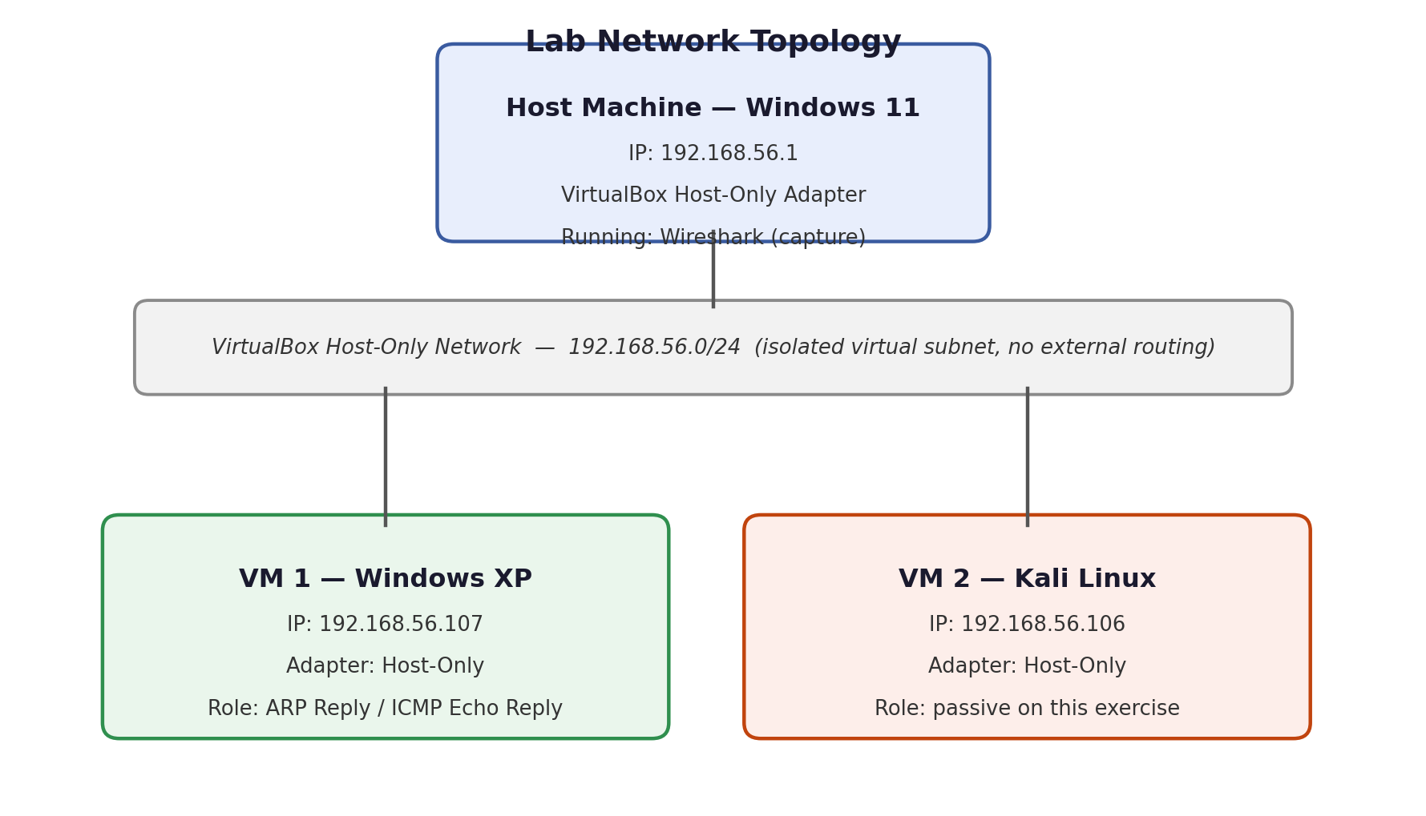
Figure 3. Lab network topology — host and two guests on a single VirtualBox Host-Only segment.

5. Host Machine Configuration — Windows 11
The host machine runs Windows 11 and connects to the lab segment through the VirtualBox Host-Only Ethernet Adapter, which Windows treats like any other network interface. Figure 4 shows this adapter configured with the address 192.168.56.1. This is also the interface Wireshark was pointed at for the capture in Section 9, since the ARP and ICMP traffic exchanged with the guests only appears on this adapter, not on the host's regular internet-facing connection.
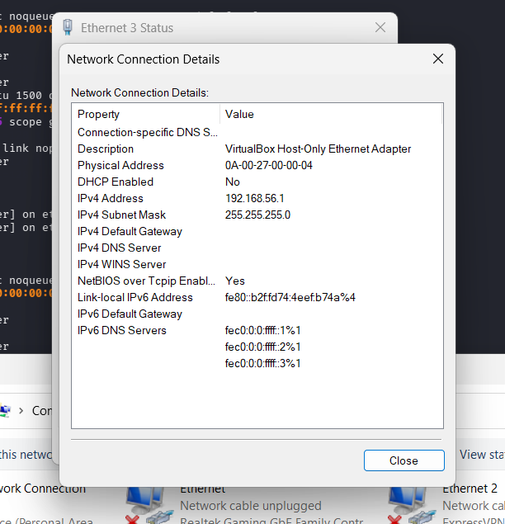
Figure 4. Windows 11 host — VirtualBox Host-Only adapter configuration (192.168.56.1).
Keeping the host's Host-Only address fixed and memorable made it straightforward to distinguish host-originated traffic (192.168.56.1) from guest traffic in the packet list later on.

6. Windows XP VM Configuration
The Windows XP guest was attached to the same Host-Only network and assigned the address 192.168.56.107, shown in Figure 5. Windows XP was chosen deliberately as one endpoint because it represents a minimal, low-noise TCP/IP stack with no modern firewall heuristics that might otherwise complicate an introductory ARP/ICMP capture.
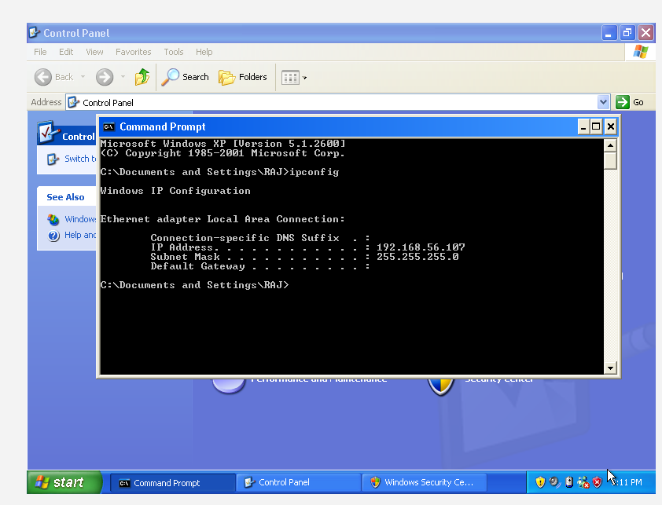
Figure 5. Windows XP guest — network configuration (192.168.56.107).
Because this segment is isolated, there is no default gateway configured; the guest only ever needs to talk to other machines on the same 192.168.56.0/24 segment, all of which are directly reachable at Layer 2.

7. Kali Linux VM Configuration
A second guest running Kali Linux was attached to the same Host-Only network and assigned 192.168.56.106, as shown in Figure 6. Kali was not an active participant in the ping/ARP exchange analysed in this report, but its presence on the segment is relevant: it reflects a realistic small lab where multiple hosts share a broadcast domain, and it is available for follow-up exercises such as observing how a third host also receives — but ignores — the ARP broadcast.
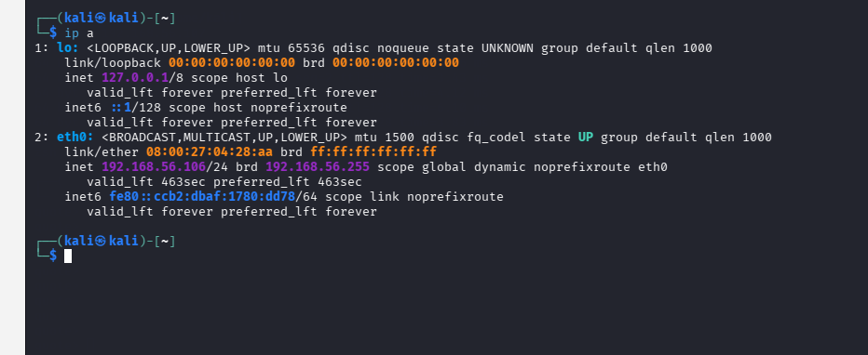
Figure 6. Kali Linux guest — network configuration (192.168.56.106).

8. Connectivity Test — Ping and ARP Cache Verification
With all three machines configured, the host pinged the Windows XP guest at 192.168.56.107. Figure 7 shows both the successful ping output and the subsequent arp -a command, which confirms that Windows learned and cached the MAC address returned in the ARP reply.
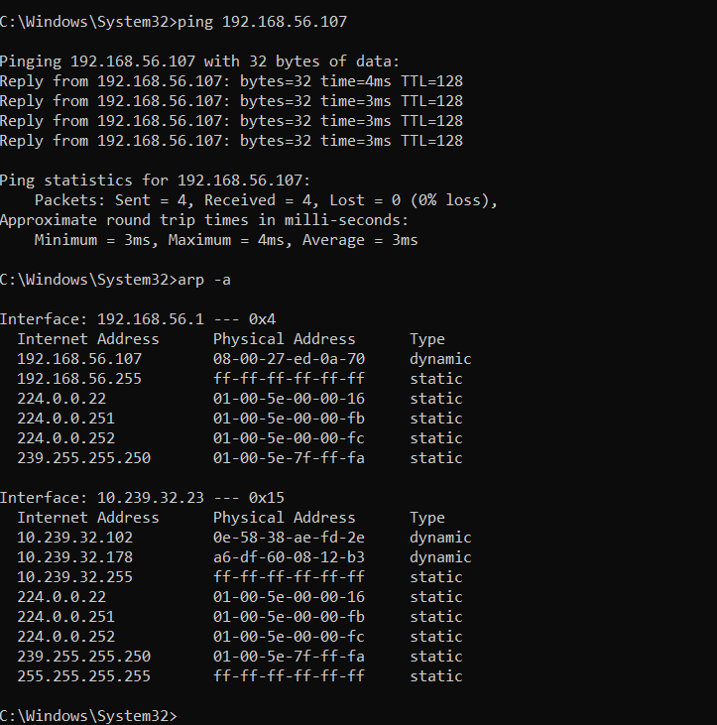
Figure 7. Ping test to Windows XP and the resulting dynamic ARP cache entry.
The cache entry follows the same three-column format on every Windows host:
Internet Address | Physical Address | Type
192.168.56.107 | (learned MAC address, as shown in Figure 7) | dynamic
A type of dynamic confirms the entry was learned automatically from an ARP reply and will expire after the operating system's cache timeout; a manually added entry would instead show as static and persist indefinitely.

9. Wireshark Packet Capture and Analysis
Wireshark was set to capture on the VirtualBox Host-Only adapter identified in Section 5, since that is the only interface on which host-to-guest traffic is visible. Figure 8 shows the resulting capture, filtered to the relevant frames around the ping.
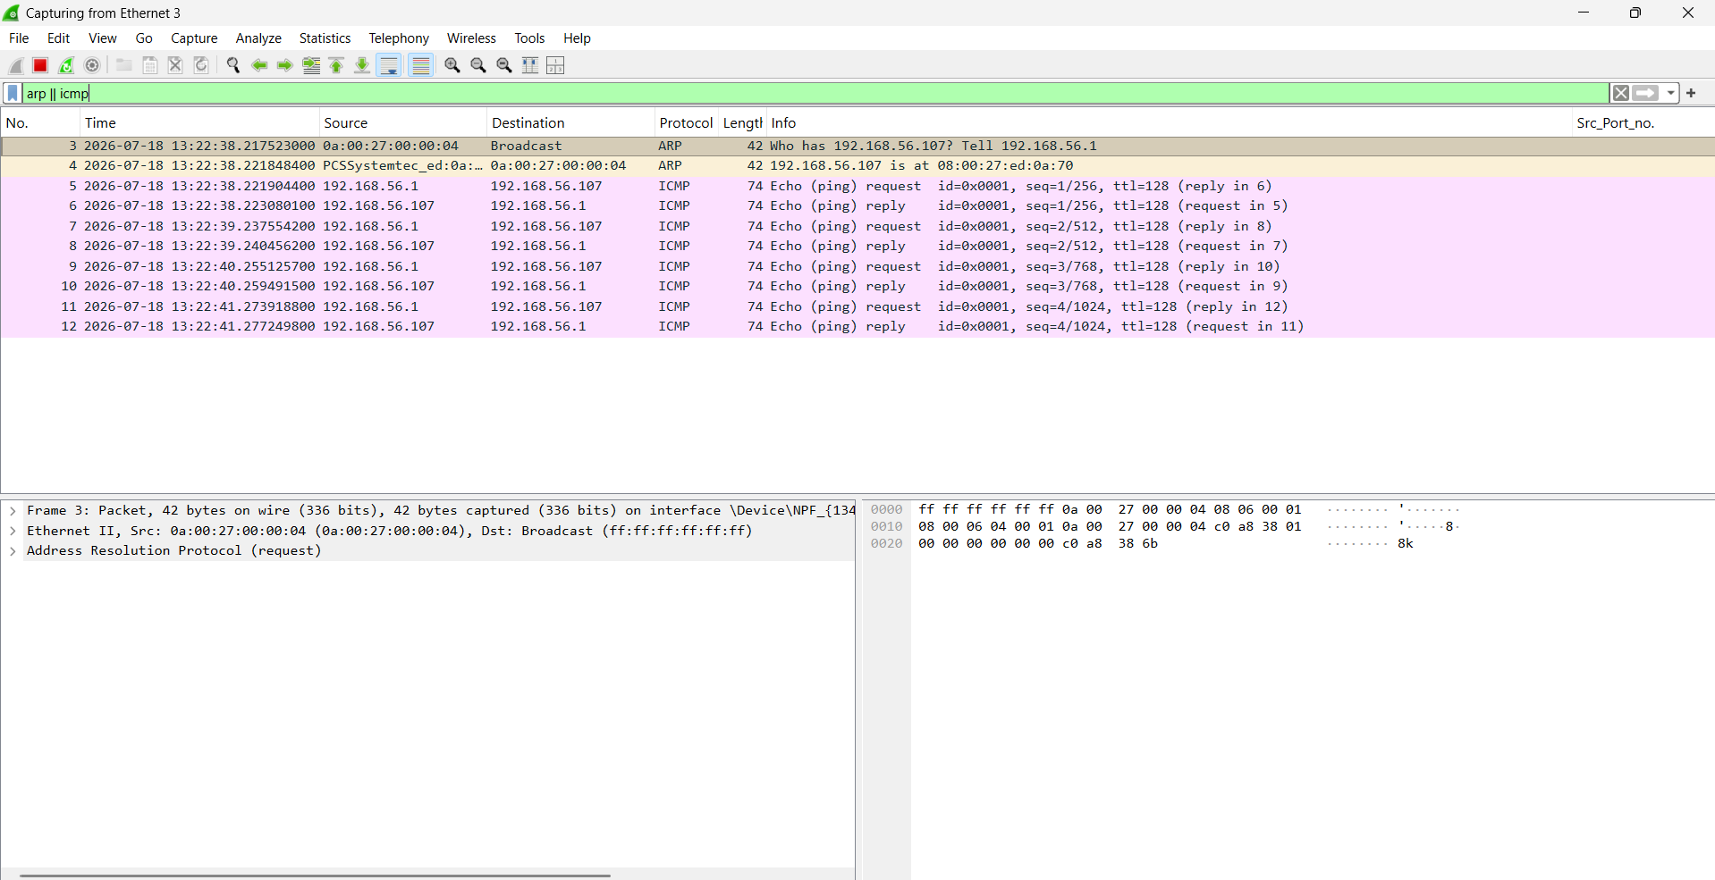
Figure 8. Wireshark capture of the ARP exchange followed by ICMP Echo traffic.
The capture shows a clean, textbook resolve-then-communicate sequence:
No. | Source | Destination | Protocol | Info
3 | 192.168.56.1 | Broadcast | ARP | Who has 192.168.56.107? Tell 192.168.56.1
4 | 192.168.56.107 | 192.168.56.1 | ARP | 192.168.56.107 is at (learned MAC address)
5–12 | 192.168.56.1 / .107 | 192.168.56.107 / .1 | ICMP | Echo Request / Echo Reply pairs (four exchanges)
Packet 3, the ARP Request, is sent to the Ethernet broadcast address FF:FF:FF:FF:FF:FF because the sender has no way of knowing in advance which physical port the target sits behind; every host on the segment must at least receive the frame, even though only the owner of 192.168.56.107 will respond. The Operation field inside this frame is set to 1 (request), and the Target Hardware Address field is all zeros because that is precisely the value being asked for.
Packet 4, the ARP Reply, looks structurally similar but with two important differences: the Ethernet destination is now the requester's actual unicast MAC address rather than the broadcast address, and the Operation field is set to 2 (reply). This is the frame that Windows uses to populate the arp -a entry seen in Figure 7.
Only after packet 4 do the ICMP Echo Request/Reply pairs (packets 5 through 12, four round trips for a default ping) appear. This ordering is not a coincidence: without a resolved MAC address, the host has no valid Ethernet destination to place in the frame carrying the ICMP packet, so the IP stack holds the ICMP traffic until ARP resolution completes. This is the single clearest illustration in the capture of why ARP exists at all — it is a hard prerequisite for any Layer 3 communication on Ethernet.

10. Results and Observations
- ARP Request is broadcast — confirmed by the destination address FF:FF:FF:FF:FF:FF on packet 3, consistent with theory, since the requester cannot yet know which port to target.
- ARP Reply is unicast — packet 4 is addressed directly to the requester's MAC address, avoiding unnecessary broadcast traffic for the response.
- ICMP starts only after ARP resolves the destination MAC — no Echo Request appears before packet 4 in the capture, matching the dependency described in Section 9.
- The Windows host captured Host↔XP traffic on the Host-Only adapter only — confirming that this adapter, and not the host's primary internet connection, is the correct capture point for guest traffic.
- The ARP cache avoids repeated broadcasts — once the 192.168.56.107 mapping was cached, none of the subsequent seven ICMP exchanges required a further ARP lookup, which is exactly the efficiency the cache is designed to provide.
- The whole exchange completed at LAN speed — the gap between the ARP request and its reply, and between each ICMP request and reply, was small enough to be visually adjacent in the packet list, illustrating typical local-segment latency with no routing hops involved.
- The broadcast domain was correctly scoped to the lab — because the segment is a VirtualBox Host-Only network, the ARP broadcast in packet 3 reached only the host and its two guests, not any physical network device.

11. Common Issues and Troubleshooting Reference
The following checklist summarises points worth checking first if this exercise is repeated and the expected ARP/ICMP sequence does not appear, kept here for future reference rather than as a record of specific incidents.
- Adapter not attached to Host-Only — each VM's network adapter must explicitly be set to Host-Only and to the same virtual adapter instance as the host; a VM left on NAT will not be visible to the others.
- Guest firewall blocking ICMP — Windows XP's built-in firewall, if enabled, can silently drop Echo Requests; File and Printer Sharing / ICMP exceptions need to be allowed for ping to succeed.
- Wrong capture interface in Wireshark — capturing on the host's main internet adapter instead of the Host-Only adapter will show no guest traffic at all, since the two networks are physically separate.
- Stale ARP cache entries — if a VM is recreated or its MAC address changes, an old dynamic cache entry on the host can point at the previous MAC address until it times out; clearing it with arp -d forces a fresh resolution.
- Unexpected IP assignment — if VirtualBox's Host-Only DHCP server is enabled, a guest may receive an address outside the range expected in this report; checking the DHCP server settings for the Host-Only network resolves this.

12. Learning Outcomes
- Protocol fluency — a working, packet-level understanding of the ARP request/reply exchange and its packet format, beyond the textbook description alone.
- Lab-building skill — practical experience configuring an isolated, repeatable VirtualBox Host-Only segment for protocol experiments without touching a production network.
- Packet analysis technique — comfort reading Ethernet, ARP, and ICMP fields directly in Wireshark and correlating a capture against the corresponding arp -a output.
- Layer interdependency — a concrete example of how Layer 2 address resolution gates Layer 3 communication, rather than the two layers operating independently.
- Security relevance — a grounding in why ARP's lack of authentication makes it a target for spoofing, and which artefacts (unexpected replies, changing IP-to-MAC mappings) a SOC analyst would look for when investigating suspected ARP-based attacks.

13. Conclusion
This exercise demonstrated the complete ARP workflow, from an initial broadcast request through to a unicast reply and the subsequent, dependent ICMP communication. It also confirmed, in practice, how VirtualBox Host-Only networking provides an isolated and repeatable environment for this kind of packet-level learning: the entire ARP broadcast domain was contained to the host and its two guests, and Wireshark on the Host-Only adapter captured the full exchange cleanly.
Beyond confirming the theory in Section 2, the capture also reinforced why ARP matters operationally: because it carries no authentication, the same broadcast/reply pattern observed here is exactly what an attacker abuses in ARP spoofing, and exactly what a defender or SOC analyst monitors for anomalies in. As a natural extension of this revision exercise, a follow-up lab could reproduce a controlled ARP spoofing scenario within this same isolated segment — observing what a poisoned cache entry looks like in arp -a and in a Wireshark capture — to build the corresponding detection skill on top of the resolution mechanics documented here.

14. References
- D. Plummer, RFC 826 — An Ethernet Address Resolution Protocol, Internet Engineering Task Force.
- Wireshark Foundation, Wireshark User's Guide, wireshark.org/docs.
- Oracle, VirtualBox User Manual — Network Settings and Host-Only Networking, virtualbox.org.
- J. F. Kurose and K. W. Ross, Computer Networking: A Top-Down Approach, Pearson (Link Layer and ARP chapter).

