DNS Traffic Analysis Lab Report

Experiment Title
DNS Traffic Analysis: Analyze DNS packets to identify domain lookups and resolve IP addresses.

Aim
To capture and analyze DNS packets using Wireshark to identify domain name lookups and resolve IP addresses.

Objective
• Capture DNS traffic.
• Identify DNS queries and responses.
• Analyze A, AAAA and HTTPS record lookups.
• Resolve domain names to IP addresses.

Requirements
- Windows 11
- Wireshark
- Internet connection
- Web browser

Network Information
Client IP: 10.255.108.23
DNS Server: 10.255.108.187
Protocol: DNS
Transport: DNS over TCP
Port: 53

Theory
DNS translates human-readable domain names into IP addresses. A records map domains to IPv4 addresses, AAAA records map to IPv6 addresses, and modern browsers may also request HTTPS resource records.

Procedure
- Start Wireshark and capture traffic on the active network interface.
- Flush the DNS cache (optional).
- Open www.google.com in a web browser.
- Stop the capture.
- Apply the display filter: dns.
- Analyze DNS query and response packets.

Captured Screenshots
Figure 1: DNS Query Packet
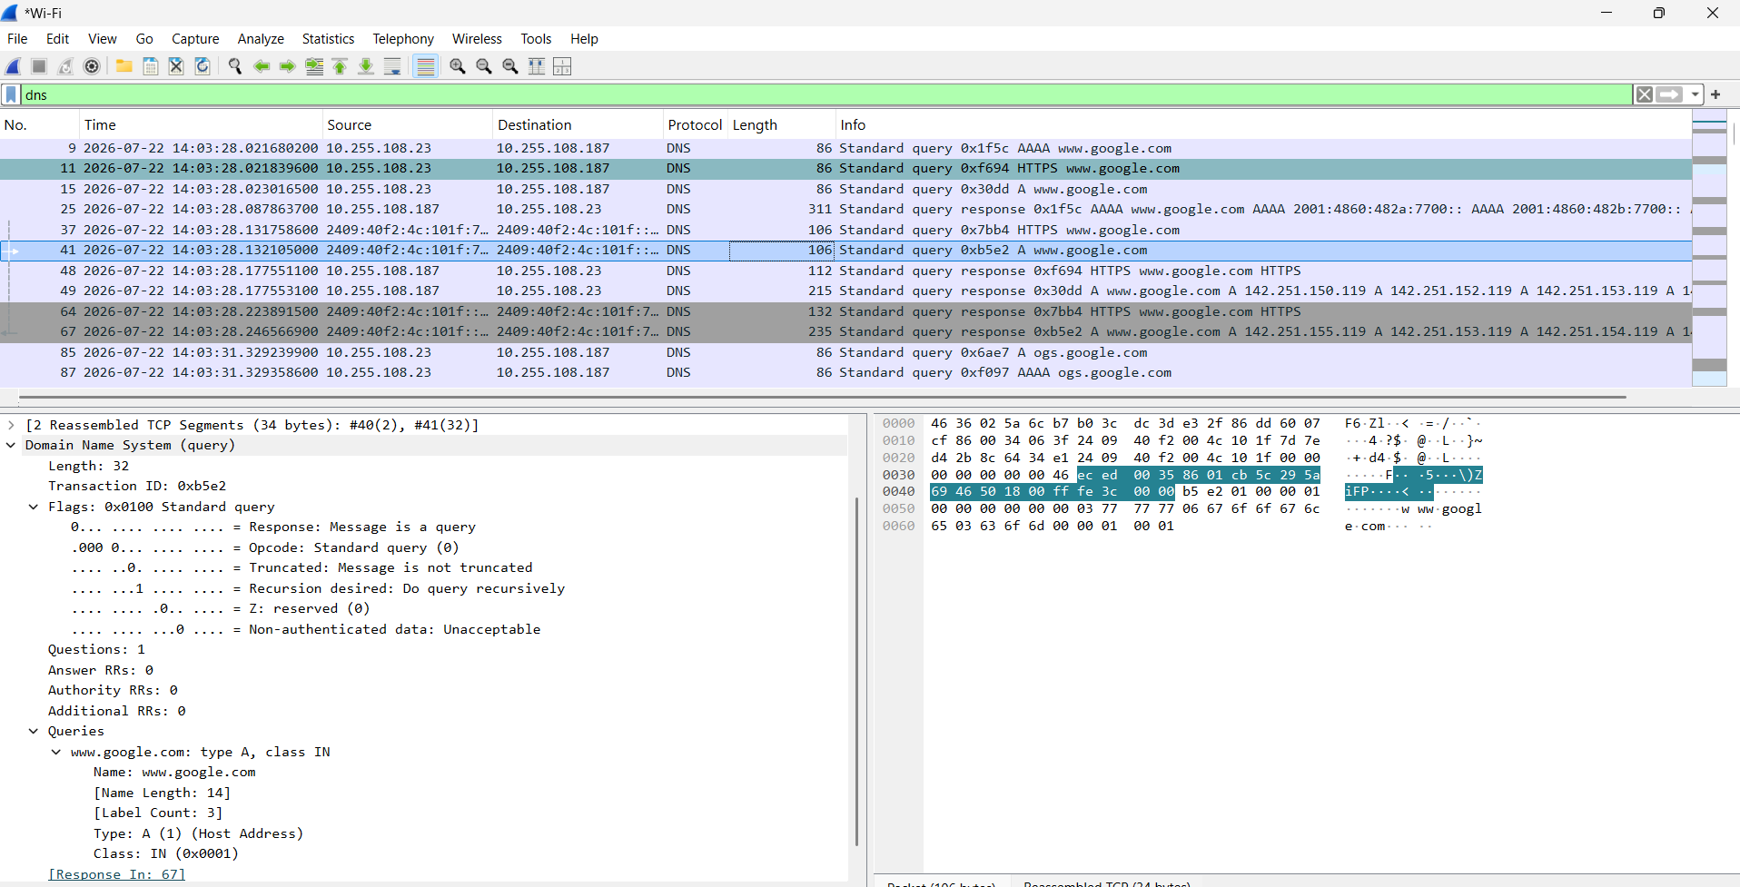
Figure 2: DNS Response Packet
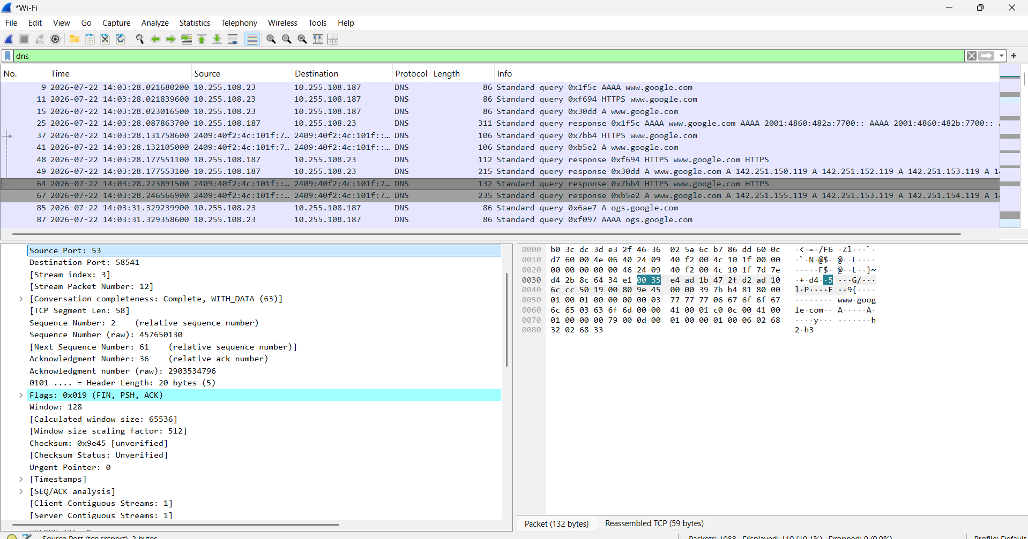

Analysis
Observed DNS queries for www.google.com including A (IPv4), AAAA (IPv6), and HTTPS resource records. The DNS server responded successfully with multiple IPv4 addresses (142.251.x.x) and IPv6 addresses (2001:4860:...). Additional queries for ogs.google.com were also observed, which are generated by Google services.
Observation | Value
Client IP | 10.255.108.23
DNS Server | 10.255.108.187
Queried Domain | www.google.com
Record Types | A, AAAA, HTTPS
Resolved IPv4 | 142.251.150.119, 142.251.152.119, 142.251.153.119, 142.251.154.119, 142.251.155.119
Additional Domain | ogs.google.com

Result
The DNS traffic was successfully captured and analyzed. The capture demonstrated successful DNS queries and responses for www.google.com, showing how DNS resolves domain names into IPv4 and IPv6 addresses before a browser connects to a website.

Conclusion
The lab demonstrated the working of DNS and the role of DNS queries and responses in resolving domain names. Wireshark effectively displayed the DNS packets, allowing analysis of domain lookups, resource record types, and returned IP addresses.

