FTP TRAFFIC ANALYSIS USING WIRESHARK
Digital Forensics / SOC Packet-Level Lab Report
Lab Title | FTP Traffic Analysis Using Wireshark
Category | Network Protocol / Digital Forensics — SOC Packet Analysis
Capture File | Ftp.pcapng (212 packets, SHA-256: fd7f170b…86fbd)
Analysis Tool | Wireshark / Dumpcap 4.6.7 (tshark 4.2.2 used for verification)
Capture Date | 22 July 2026 (11:39:40 – 11:41:14 IST, UTC+5:30)
Student Name | _______________________________
Roll No. / Batch | _______________________________

1. Aim
To capture and analyze File Transfer Protocol (FTP) traffic using Wireshark, observe the complete FTP communication process between a Windows FTP client and a vsFTPd server, identify the FTP commands and response codes exchanged, and evaluate the security posture of the protocol.

2. Objective
- Capture live FTP control- and data-channel packets using Wireshark.
- Analyze the FTP authentication handshake (USER / PASS).
- Observe FTP commands, server response codes, and the Active-Mode data connection.
- Identify a file transfer attempt and interpret the resulting error.
- Demonstrate — with packet-level evidence — why FTP is unsuitable for transmitting sensitive data.

3. Requirements
Hardware | Software
Windows 11 host PC | Wireshark (packet capture & analysis)
Oracle VirtualBox (Host-Only Network adapter) | Windows Command Prompt — native ftp client
Metasploitable 2 virtual machine | vsFTPd 2.3.4 (intentionally vulnerable FTP daemon)

4. Network & Capture Information
Client IP Address | 192.168.56.1
Client MAC Address | 0a:00:27:00:00:04
FTP Server IP Address | 192.168.56.105
FTP Server MAC Address | 08:00:27:fa:4f:c5
FTP Server Software | vsFTPd 2.3.4
Server OS (inferred, IP TTL = 64) | Linux — consistent with Metasploitable 2
Control Connection | TCP 192.168.56.1:54860 ↔ 192.168.56.105:21
Data Connection (Active Mode, LIST) | TCP 192.168.56.105:20 ↔ 192.168.56.1:65322
Data Port Offered for RETR (unused — transfer failed) | 192.168.56.1:65349
Authentication Credentials | msfadmin / msfadmin
FTP Session Duration | ≈ 94.25 seconds (frame 28 → frame 141)

5. Theory
FTP is an application-layer protocol (RFC 959) used to transfer files between a client and server over TCP/IP. It separates control and data into two independent TCP connections: a persistent control connection on TCP port 21 used for authentication and commands, and a per-transfer data connection used to move directory listings or file contents.
Two connection modes exist. In Active Mode, the client sends a PORT command telling the server which client-side port to connect back to; the server then initiates the data connection from its own port 20. In Passive Mode (PASV), the server opens a listening port and the client connects out to it, which generally traverses client-side firewalls and NAT more reliably — the reason vsFTPd's own responses in this capture repeatedly suggest "Consider using PASV."
Because FTP was designed before modern security considerations, it transmits usernames, passwords, commands, and filenames as unencrypted plain text. Any party with visibility into the network path — including a passive observer running Wireshark — can reconstruct the full session, credentials included. SFTP and FTPS are the modern, encrypted replacements.

6. Procedure
- Started the Metasploitable 2 virtual machine and confirmed vsFTPd was running.
- Opened Wireshark on the Windows 11 host and started a capture on the VirtualBox Host-Only Network adapter.
- Opened Windows Command Prompt and launched the native FTP client (ftp).
- Connected to the server with: open 192.168.56.105
- Authenticated using username msfadmin and password msfadmin.
- Issued dir (LIST) to request a directory listing.
- Issued pwd (XPWD) to confirm the current working directory.
- Issued get test.txt (RETR) to attempt a file download.
- Issued put lab.txt, which failed client-side because the local file did not exist (not sent over the wire).
- Issued bye (QUIT) to close the session.
- Stopped the Wireshark capture and applied the display filter: ftp
- Cross-verified every command and response against the raw capture using tshark.

7. Evidence A — FTP Client Session
The screenshot below shows the raw Command Prompt session exactly as typed on the Windows host, including the server's plain-text responses to every command.
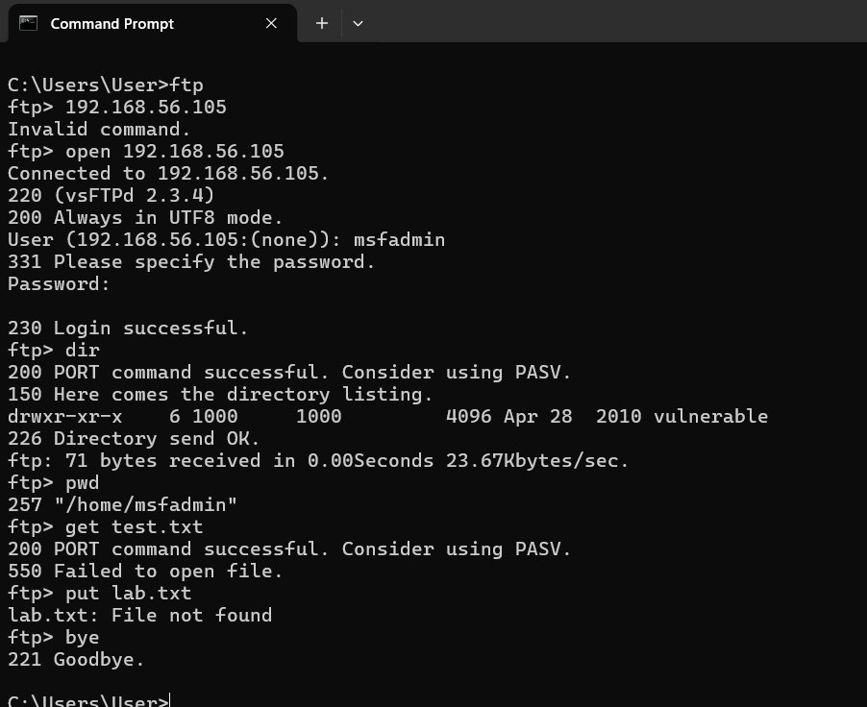
Figure 1. Windows FTP client session against 192.168.56.105 (vsFTPd 2.3.4).

8. Evidence B — Wireshark Capture Overview
Applying the ftp display filter in Wireshark isolates the 20 control-channel packets that make up the session. Frame numbers, timestamps, and response codes below correspond directly to the packet-level analysis in Section 10.
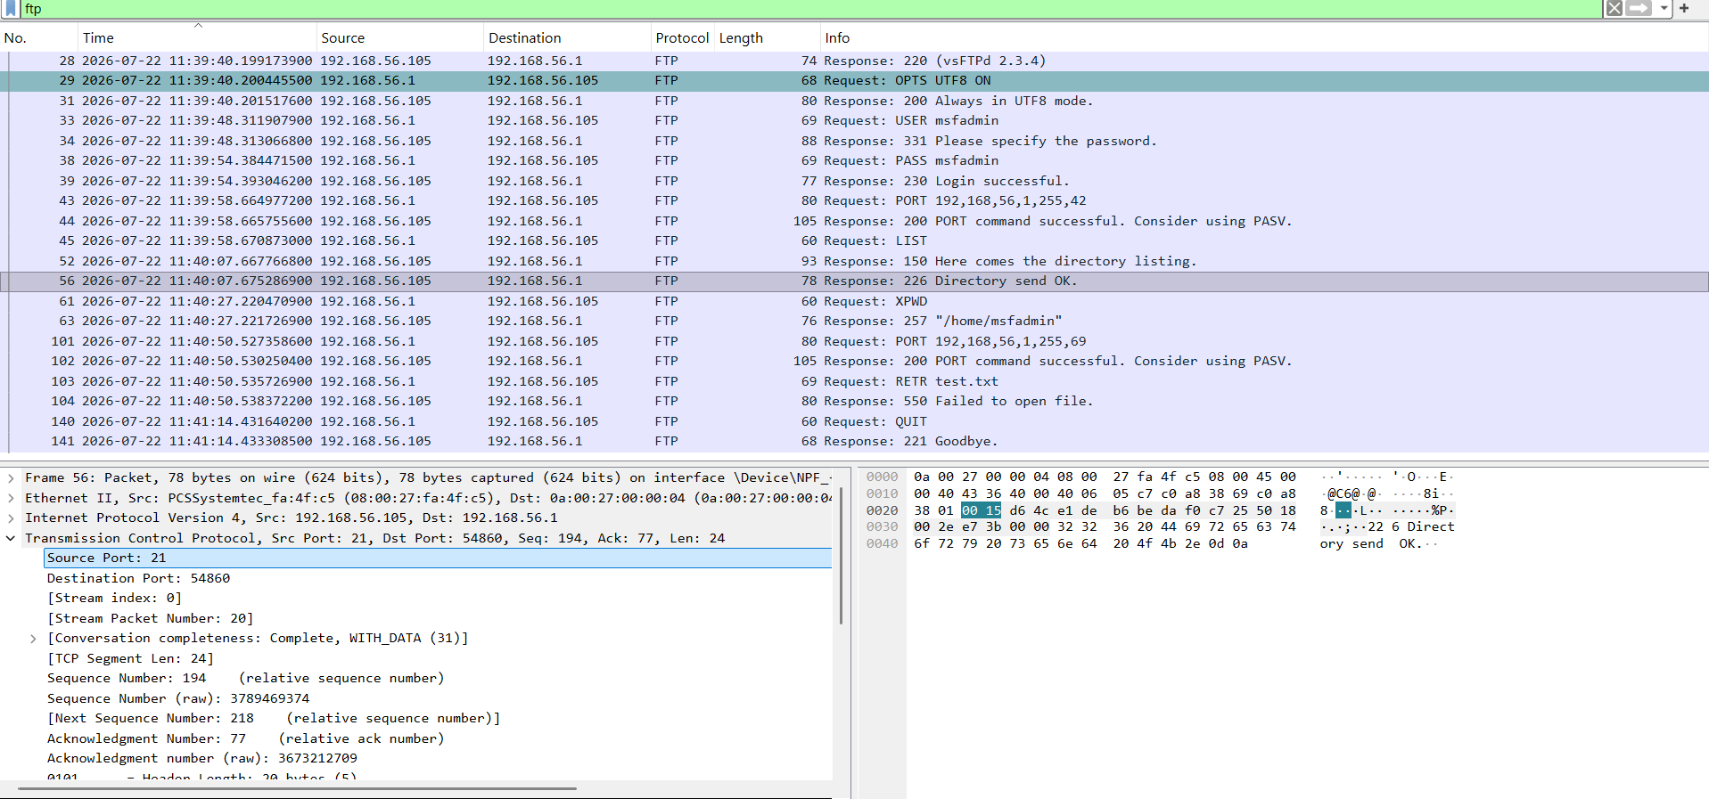
Figure 2. Wireshark packet list filtered by ftp, with the detail pane for frame 56 (226 Directory send OK) expanded.

9. Captured FTP Commands & Server Responses
Frame # | Time (IST) | Command / Response | Meaning
28 | 11:39:40.199 | 220 (vsFTPd 2.3.4) | Server banner / service ready
29→31 | 11:39:40.200 | OPTS UTF8 ON → 200 | UTF-8 filename encoding negotiated
33→34 | 11:39:48.312 | USER msfadmin → 331 | Username submitted, password requested
38→39 | 11:39:54.384 | PASS msfadmin → 230 | Password submitted, login successful
43→44 | 11:39:58.665 | PORT 192,168,56,1,255,42 → 200 | Client opens Active-Mode data port 65322
45 | 11:39:58.671 | LIST | Directory listing requested
52 / 56 | 11:40:07.668 / .675 | 150 … → 226 Directory send OK | Listing delivered over the data channel
61→63 | 11:40:27.220 | XPWD → 257 "/home/msfadmin" | Current working directory queried
101→102 | 11:40:50.527 | PORT 192,168,56,1,255,69 → 200 | Client opens data port 65349 for RETR
103→104 | 11:40:50.536 | RETR test.txt → 550 | File download requested; file unavailable
140→141 | 11:41:14.432 | QUIT → 221 Goodbye | Session terminated normally

10. Detailed Packet-by-Packet Analysis

10.1 Server Greeting & Feature Negotiation (Frames 28–31)
220 (vsFTPd 2.3.4)
OPTS UTF8 ON
200 Always in UTF8 mode.
The server identifies itself immediately upon connection as vsFTPd 2.3.4 — a version banner that, on Metasploitable 2, is intentionally left exposed for training. The client then negotiates UTF-8 filename encoding, which the server confirms.

10.2 User Authentication (Frames 33–39)
USER msfadmin
331 Please specify the password.
PASS msfadmin
230 Login successful.
Both the username and password cross the wire as unencrypted ASCII text inside frames 33 and 38 respectively. Following the TCP stream in Wireshark reproduces the literal strings "USER msfadmin" and "PASS msfadmin" — meaning any packet capture taken on this network segment discloses valid credentials without any decryption effort.

10.3 Active-Mode Data Connection Setup (Frames 43–44)
PORT 192,168,56,1,255,42
200 PORT command successful. Consider using PASV.
The client instructs the server to connect back to 192.168.56.1 on TCP port 65322 (encoded as 255×256 + 42). The server's advisory to "Consider using PASV" is a standing hint that Active Mode is more failure-prone across firewalls/NAT — borne out in Section 11.

10.4 Directory Listing (Frames 45, 52, 56)
LIST
150 Here comes the directory listing.
226 Directory send OK.
The LIST command itself is a single control-channel packet; the actual listing travels over the separate data connection opened in Section 10.3. Roughly 9 seconds elapse between the LIST request (frame 45) and the 150 response (frame 52) — the data-connection retry behaviour analyzed in Section 11 explains this delay.

10.5 Working Directory Query (Frames 61–63)
XPWD
257 "/home/msfadmin"
Confirms the session's current working directory as /home/msfadmin, matching the msfadmin account's home directory on the target.

10.6 File Retrieval Attempt — RETR test.txt (Frames 101–104)
PORT 192,168,56,1,255,69
200 PORT command successful. Consider using PASV.
RETR test.txt
550 Failed to open file.
A fresh data port (65349) is opened for the download, but the server immediately returns 550 Failed to open file — test.txt does not exist in /home/msfadmin (only the vulnerable subdirectory was present, per Section 11). Because the transfer never started, no data connection was opened for this exchange.

10.7 Session Termination (Frames 140–141)
QUIT
221 Goodbye.
The client closes the session cleanly; the server acknowledges and the control connection is torn down.

11. FTP Data Connection Analysis — Directory Listing Transfer
Wireshark separates the LIST transfer into its own TCP conversation, 192.168.56.105:20 ↔ 192.168.56.1:65322, distinct from the control channel. Examining it directly explains both the transferred content and the delay noted in Section 10.4:
Frame # | Time (IST) | Src → Dst | Flags | Len | Note
46 | 11:40:01.672 | 105:20 → 1:65322 | SYN | 0 | Server 1st SYN attempt (data conn.)
48 | 11:40:04.665 | 105:20 → 1:65322 | SYN | 0 | Retransmission (~3s timeout)
49 | 11:40:07.664 | 105:20 → 1:65322 | SYN | 0 | Retransmission (~6s timeout)
50 | 11:40:07.665 | 1:65322 → 105:20 | SYN, ACK | 0 | Client accepts (Windows Firewall passed it)
51 | 11:40:07.666 | 105:20 → 1:65322 | ACK | 0 | Handshake complete
53 | 11:40:07.671 | 105:20 → 1:65322 | PSH, ACK | 68 | Directory listing payload delivered
54 | 11:40:07.673 | 105:20 → 1:65322 | FIN, ACK | 0 | Server closes data connection
55/58/59 | 11:40:07.673–.681 | — | ACK / FIN, ACK / ACK | 0 | Graceful teardown

The 68-byte payload in frame 53 is the raw directory listing, recovered by following the TCP stream:
drwxr-xr-x 6 1000 1000 4096 Apr 28 2010 vulnerable
The two retransmitted SYNs (frames 46, 48) before the client finally completes the handshake (frame 50) are a textbook illustration of why Active-Mode FTP struggles behind client-side firewalls: the server must open an unsolicited inbound connection to the client, which is exactly the traffic pattern host firewalls are designed to delay or block. This is the practical justification behind vsFTPd's repeated "Consider using PASV" advisory.

12. FTP Response Codes Observed
Code | Meaning | Observed In
220 | Service ready for new user | Server banner
200 | Command OK | OPTS UTF8 ON, PORT
331 | Username OK, password needed | After USER
230 | User logged in | After PASS
150 | File status OK, opening data connection | Before LIST transfer
226 | Closing data connection — transfer complete | After LIST transfer
257 | Pathname created / current directory | After XPWD
550 | Requested action not taken — file unavailable | After RETR test.txt
221 | Service closing control connection | After QUIT

13. Security Analysis
- Both the username and password were transmitted and captured in plain, human-readable text — trivially recoverable from the .pcapng file.
- Any device with visibility into the network path (a compromised switch port, ARP spoofing position, or a span/mirror port) can passively harvest FTP credentials without needing to break any encryption.
- FTP provides no confidentiality or integrity guarantees for commands, filenames, or file contents.
- Active Mode was used throughout (evidenced by the PORT commands), which additionally requires permissive inbound firewall rules on the client — a further attack-surface consideration for SOC monitoring.
- The exposed vsFTPd 2.3.4 banner is itself an information-disclosure risk: this specific version has a well-known historical backdoor vulnerability (CVE-2011-2523), which is precisely why Metasploitable 2 ships it for training.
- From a SOC/IDS perspective, plaintext USER/PASS command pairs on port 21 are a reliable, high-confidence detection signature for credential-harvesting or unauthorized-access alerts.
- Recommended mitigations: replace FTP with SFTP or FTPS, disable anonymous/legacy FTP services where not required, and alert on any port-21 traffic carrying USER/PASS command pairs outside approved maintenance windows.

14. Observations
- The FTP control connection was established successfully between 192.168.56.1 and 192.168.56.105 on TCP port 21.
- Authentication with msfadmin / msfadmin succeeded (230 Login successful), with both credentials visible in clear text.
- The directory listing was retrieved successfully via a separate Active-Mode data connection on TCP port 20, after two SYN retransmissions.
- The current working directory was confirmed as /home/msfadmin.
- The RETR test.txt request failed with 550 because the file did not exist on the server.
- The session was terminated cleanly with QUIT / 221 Goodbye.
- Every command, response, username, and password observed in this lab was recoverable in plain text directly from the packet capture.

15. Result
FTP traffic between a Windows client and a vsFTPd 2.3.4 server was successfully captured and analyzed using Wireshark. The 20-packet control-channel exchange and the associated Active-Mode data connection were reconstructed frame-by-frame, confirming successful authentication, a successful directory listing, a failed file-retrieval attempt (file unavailable), and a clean session termination. The analysis confirmed FTP's core security weakness in practice: usernames, passwords, and commands were all recoverable from the capture in unencrypted plain text, reinforcing the case for SFTP or FTPS in any production environment.

16. Viva Questions
Q1. What is FTP?
FTP (File Transfer Protocol) is an application-layer protocol used to transfer files between a client and server over TCP/IP.
Q2. Which ports does FTP use, and why two?
TCP 21 for the control channel (commands/responses) and a separate TCP connection — port 20 in Active Mode — for the actual file/data transfer.
Q3. What is the difference between Active and Passive FTP?
In Active Mode the client tells the server which port to connect back to (PORT command, as seen in this capture); the server then initiates the data connection. In Passive Mode (PASV) the server opens a port and the client connects to it — friendlier to client-side firewalls/NAT, which is why vsFTPd suggested "Consider using PASV" in every 200 response.
Q4. Why is FTP considered insecure?
It transmits usernames, passwords, commands, and file contents in plain text with no encryption, so anyone capturing the traffic (as done here with Wireshark) can read credentials directly.
Q5. What does response code 230 indicate?
Successful user authentication (login successful).
Q6. What does response code 550 indicate?
The requested action was not taken because the file was unavailable — in this capture, RETR test.txt failed because the file did not exist on the server.
Q7. Why did the LIST command take about 9 seconds to complete?
The server's first two attempts to open the Active-Mode data connection (frames 46 and 48) went unanswered and had to be retransmitted before the client accepted the connection in frame 50 — a classic Active-FTP/firewall delay.
Q8. What evidence in the capture reveals the server's operating system?
The IP TTL value of 64 on server-originated packets is the default for Linux, consistent with Metasploitable 2.
Q9. Which secure alternatives should replace FTP in production?
SFTP (SSH File Transfer Protocol) or FTPS (FTP over SSL/TLS), both of which encrypt credentials and data in transit.
Q10. Which FTP server software and version was targeted?
vsFTPd 2.3.4, running on the Metasploitable 2 virtual machine — a version deliberately kept vulnerable for training purposes.

