HTTP Traffic Analysis Lab Report

Experiment Title
HTTP Traffic Analysis: Capture HTTP Traffic and Extract URLs Visited

Aim
To capture HTTP packets using Wireshark, analyze HTTP requests and responses, and extract visited URLs.

Objectives
- Capture HTTP traffic.
- Analyze GET and POST requests.
- Extract visited URLs.
- Observe HTTP headers and status codes.
- Understand HTTP security risks.

Requirements
Windows 11
Wireshark
Mozilla Firefox
Internet connection

Theory
HTTP is an application-layer protocol that operates over TCP port 80. Unlike HTTPS, HTTP traffic is not encrypted, allowing URLs, headers, cookies, and form data to be viewed in Wireshark.

Procedure
- Start Wireshark capture.
- Generate HTTP traffic.
- Apply display filter: http.
- Inspect GET and POST packets.
- Analyze request and response fields.

Captured Screenshots
Figure 1: HTTP GET Request
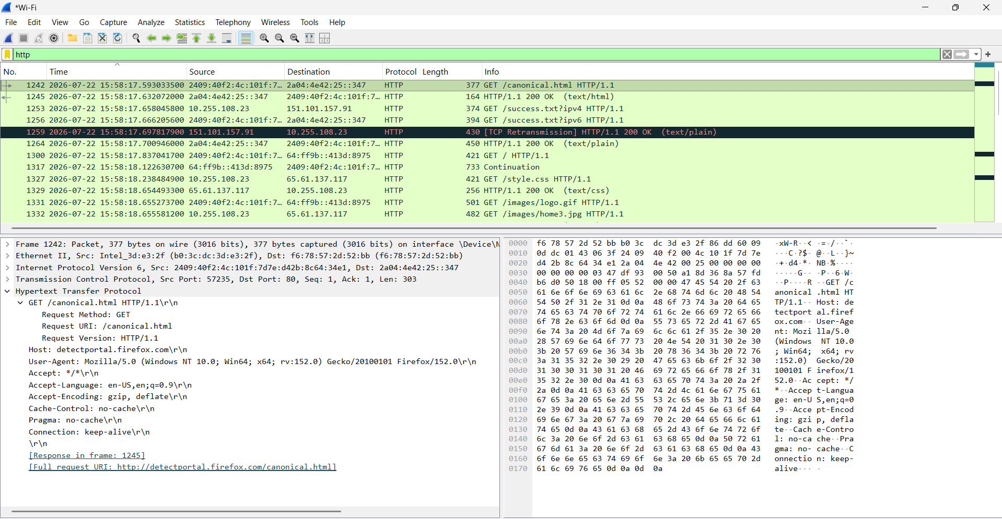
Figure 2: HTTP POST Request
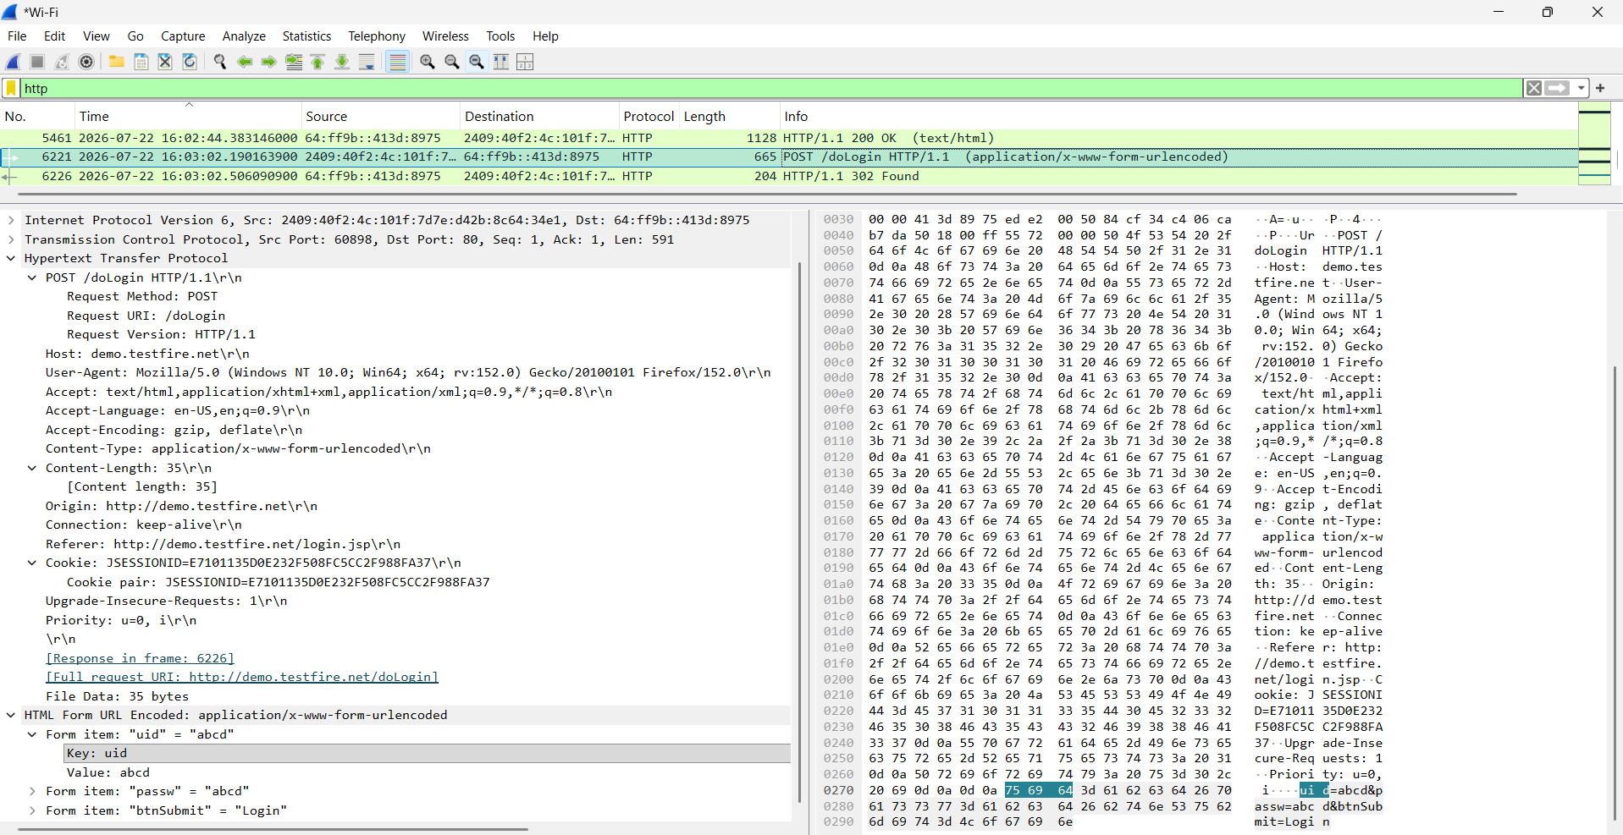

Packet Analysis

HTTP GET Request
Request Method: GET
Request URI: /canonical.html
Host: detectportal.firefox.com
Full URL: http://detectportal.firefox.com/canonical.html
Response: HTTP/1.1 200 OK

HTTP POST Request
Request Method: POST
Request URI: /doLogin
Host: demo.testfire.net
Full URL: http://demo.testfire.net/doLogin
Content-Type: application/x-www-form-urlencoded
Observed Form Data: uid=abcd, passwd=abcd, btnSubmit=Login
Response: HTTP/1.1 302 Found

URLs Extracted
URL | Purpose
http://detectportal.firefox.com/canonical.html | Firefox connectivity check
http://demo.testfire.net/doLogin | Login request
http://demo.testfire.net/login.jsp | Login page
/style.css | Stylesheet
/images/logo.gif | Website image
/images/home3.jpg | Website image

Security Analysis
HTTP traffic is transmitted in plain text. Wireshark revealed URLs, headers, cookies, and submitted form data, demonstrating why HTTPS should be used for secure communication.

Result
The HTTP traffic was successfully captured and analyzed. GET and POST requests, visited URLs, HTTP response codes, and transmitted form data were successfully identified.

