USE CASE DIAGRAM RFID

Tampilan

Login :



Dashboard :

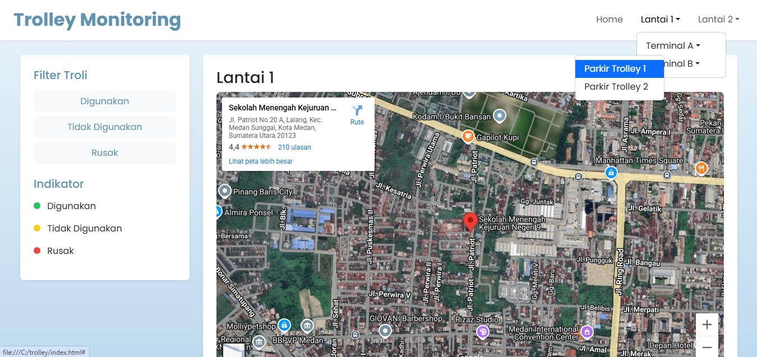

Tabel :

