|  |  |
| --- | --- |
| Version: | FSM_HLA_v0.3 |
| Owner: | Lizzy Feven |
| Approved by | Smart DCC CTO |
| Classification: | DCC Controlled |
| Next Review | TBD |

Future Service Management High-Level Architecture Document

December 2020

Document Control Heading

Revision History (Document Control Subtitle)

|  |  |  |  |  |
| --- | --- | --- | --- | --- |
| Revision Date | Summary of Changes | Changes Marked | Version Number | |
| 04/03/2024 | Initial Draft |  | 0.1 | |
| 13/03/2024 | Updates to sections 2.3, 2.4, amended document guidance text to grey italics | Yes | | 0.2 |
| 09/05/2024 |  |  | | 0.3 |
|  |  |  |  | |
|  |  |  |  | |

Reviewers

|  |  |  |  |
| --- | --- | --- | --- |
| Name | Title / Responsibility | Release Date | Version Number |
|  |  |  |  |
|  |  |  |  |

Approvals

|  |  |  |  |  |
| --- | --- | --- | --- | --- |
| Name | Signature | Title / Responsibility | Release Date | Version Number |
|  |  | Smart DCC CTO |  |  |
|  |  | Smart DCC Head of CFDA |  |  |

References & Traceability

|  |  |  |  |
| --- | --- | --- | --- |
| Artefact ID | Title / Responsibility | Release Date | Version Number |
|  |  |  |  |
|  |  |  |  |

Contents

1 Introduction 4

1.1 Scope 4

1.2 Objectives 4

1.3 Exceptions 4

2 Document Requirements 5

2.1 Document lifecycle 5

2.2 Documentation Standards 5

2.3 Architectural decisions 5

2.4 Requirements Scope 5

2.5 System Elements 5

2.6 Interfaces 6

2.7 Data Model 6

2.8 Volumetric 6

2.9 Business Processes 6

2.10 Measures of Performance 7

2.11 Security 7

2.12 Validation 7

2.13 Business Continuity Disaster Recovery 7

3 Document Review and Communication 8

4 Compliance 9

# Introduction

This document defines the High-Level Architecture Documentation for the Future Service Management (FSM) programme.  The FSM programme involves the replacement of DCC’s on-premises ‘BMC Remedy’ DSMS (DCC Service Management System) solution, which is hosted in the CGI data centre (private cloud). The primary objective of the programme is to disaggregate the DCC Service Management System from the Data Service Provider (DSP) and align the solution to DCC’s ‘Cloud first’ strategy outlined in the [Cloud Adoption Framework](https://smartdcc.sharepoint.com/sites/CTO/_layouts/15/Doc.aspx?sourcedoc=%7B71B5A401-1B42-41A8-91FD-76058BF586A7%7D&file=DCC%20CAF%20Internal%20Review%20v1.3.docx&action=default&mobileredirect=true&DefaultItemOpen=1).

A reverse logistics solution for the 3G, LRR and 4G Comms Hubs is also within the scope of this programme. This functionality will be a replacement of the Remedy Return Record module for 3G and LRR Comms Hubs. In addition to this, a strategic OMS solution for 4G comms hub forecasting, ordering & returns will also be provisioned.

The key drivers are:

1. Disaggregation of the Data Service Provider (DSP)
2. Replacement for the current BMC Remedy DSMS solution
3. Reverse logistics solution for 3G & LRR Comms Hubs
4. Forward & Reverse logistics solution for 4G Comms Hubs
5. Competitive procurement of the FSM (‘to-be’ DSMS) solution

## Scope

This programme will replace the following components:

|  |  |
| --- | --- |
| **DSMS As-Is Component** | **Description** |
| Self-service portals SSI & SSMI | Currently these are separate bespoke portals developed by CGI on the ‘Page Furnace’ platform. DCC Service Users interact with DSMS only via the SSI portal, whereas SSMI is used to perform admin activities by DCC and CGI. |
| BMC Remedy Platform (including integration component – Orchestrator) | Includes Remedy Return Record module. |
| ‘SAP Business Objects’ is the reporting component of DSMS, this is part of the ‘BMC Analytics' product (add-on). | This will not be replaced, as the ‘DS&A Data Platform’ project will be delivering ‘Static Reporting’ requirements of FSMS. Native FSM platform ‘Analytics’ components will be used for Realtime reporting. |
| Remedy Reporting Database | This will not be replaced, as ‘DS&A Data Platform’ project will be delivering DCC’s ‘FSMS Reporting Database’ requirements. Native FSM platform ‘Analytics’ components will be used for Realtime reporting. |
| API Gateway | **New**: Deployed as per CTO integration roadmap. |
| DSP Access Layer | **New**: Required for DSP-FSMS integration. |
| CSP Access Layer | **New**: Required at CSP North and CSP South for direct integration with the CSPs. |
| IDP Hub | **New**: A Solution that allows integrating both DCC IDP and DCC Service User IDPs and providing options to users to either authenticate to FSMS using their existing corporate identity or DCC's IDP. If the solution also has the capability to be used as an identity provider, so that we can use to support the requirement of giving users the option to have a DCC IDP's identity. |

## Objectives

The objectives of this document are:

1. Define a High-level Architecture for the Future Service Management programme
2. Alignment of design documentation with the CFDA

## Exceptions

Exceptions to this document must be obtained in writing from the Chief Technology Officer (CTO).

# Document Requirements

This section details the requirements for High-Level Architecture (HLA) Documentation:

## Document lifecycle

The document shall be completed during Architecture Definition and complete when submitted and approved by DCC CFDA.

## Documentation Standards

The following standards apply to the HLA artefacts

|  |  |
| --- | --- |
| Artefact | Standard |
| Documents | Microsoft Word Office 365 (.docx) |
| Diagrams | ArchiMate version 4 **OR** BizzDesign ArchiMate ‘Application Structure View’ |
| Entity-Relationship Diagrams | BizzDesign ER Model |
| Requirements | Microsoft Excel Office 365 (.xlsx) **OR** BizzDesign ArchiMate Model ‘Stakeholder View’ |

## Requirements Scope

*Guidance: The generally accepted method is to include additional columns on the requirements list to allow for filtering.*

*Documentation shall include (directly or by hyperlink) details of all the requirements that are within the scope of the HLA.*

*Compliance status of each requirement will be clearly indicated (Full, Partial or None) in CFDA Phase 3 (Design / Build / Test)*

1. *Partial and Non-Compliance shall contain addition information regarding the deviation*

The full Requirements Traceability Matrix for the FSM programme is available here: [08 - RTM (Technical Requirements, Integration Requirements)](https://smartdcc.sharepoint.com/:f:/r/sites/DesignAuthority565/Shared%20Documents/000-CFDA%20Governance/030%20CFDA%20Baselines/6.Standalone/Future%20Service%20Management%20(FSM)/Phase%202/00%20-%20Phase%202%20RFP/08%20-%20RTM%20(Technical%20Requirements,%20Integration%20Requirements)?csf=1&web=1&e=GkBIuY)

## System Elements

*Documentation shall detail (as an ArchiMate ‘Application Structure View’) each system element, interfaces between system elements, and interfaces with external systems.*

*Each system element shall detail the following:*

1. *Physical implementation (including geographic locations)*
2. *Application software (Major version)*
3. *Configuration/customisation details*
4. *Status of each system element shall have the object element status set to (new, current, changing, or deprecated)*

The FSM program will disaggregate DSMS from the DSP solution and replace BMC Remedy with a new service management solution. The most likely candidate for the new service management solution is ServiceNow, however this can only be confirmed after the relevant governance parties have confirmed and competitive procurement has been initiated.

Figure 1 below depicts the to-be architecture of the proposed solution. It depicts the highest level of abstraction and is the DCC CTO view at the time of Phase 2 CFDA (28/05/2024). More detail will be added to this section as the programme progresses through the following phases.

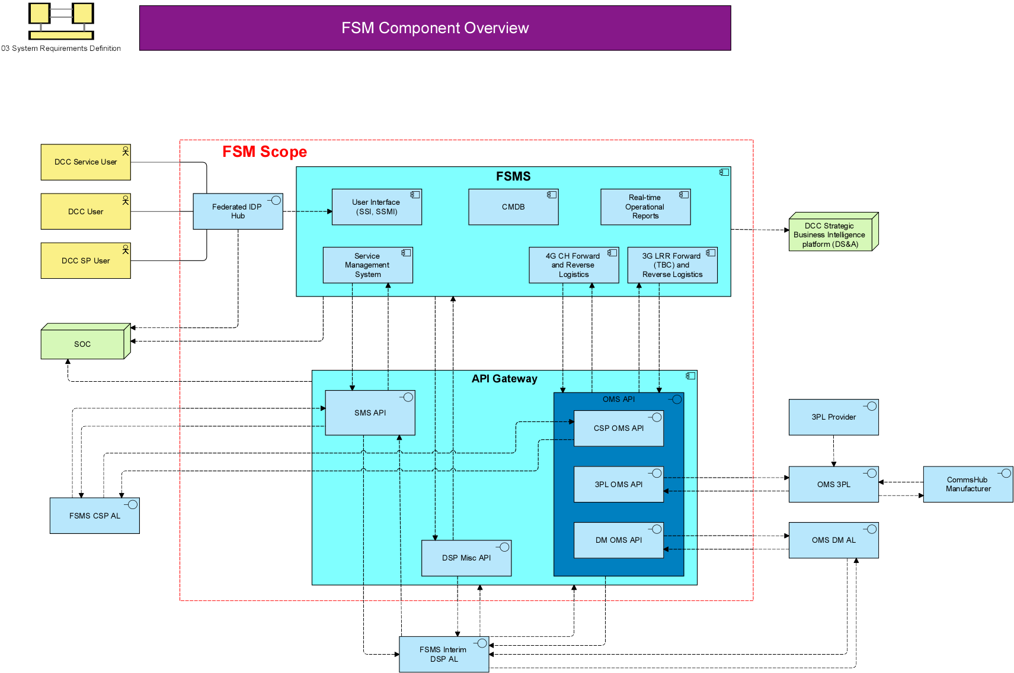

Figure 1: Proposed High Level Architecture

## Interfaces

*Documentation shall include (directly or by hyperlink) interface design specifications for each system interface specified within Section 2.5. Each interface design specification document shall be documented as specified in DCC’s ‘Interface Control Documentation’ standard or an alternative approved by DCC CFDA.*

## Data Model

The Data Model for the Future Service Management System is described in the following document: [FSMS Programme Data Strategy DRAFT - v0.1.docx](https://smartdcc.sharepoint.com/:w:/r/sites/FutureServiceManagementProgramme/Shared%20Documents/Functional%20SME%20Work%20Areas/CTO%20(Architecture)/Stage%202%20-%20RFP/FSMS%20Programme%20Data%20Strategy%20DRAFT%20-%20v0.1.docx?d=w82cd696be90244a2bd37f952ab4e991f&csf=1&web=1&e=xLWcqE)

<<Include extract from ER Model in Bizz Design>>

*Documentation shall include a BizzDesign ER Model or an alternative approved by DCC CFDA. The data model shall contain:*

1. *If a Data Protection Impact Assessment (DPIA) is required, Data flow diagrams of major data flows with enough detail to enable a DPIA to be undertaken*
2. *Identification of non-standard data entities*
3. *Data mapping between internal and external data entities[1]*
4. *DCC Security Classification of each data entity*

## Data Governance

Data Governance for the Future Service Management System is also described in the following document: <<CFDA Link required>>

Documentation shall include information on the following:

1. Data Retention Periods and the high-level approach to deletion

The Future Service Management Service Provider shall be able to retrieve Service Audit Trail data, which has been held for a period of more than 3 months and less than 28 months, within 24 hours.

Data should be managed in accordance with the DCC Data Retention Policy and Data Retention Schedule.

SEC Section H 8.16 and 8.17 will be adhered to. Security Architecture Framework obligations will also be adhered to.

1. Data Archiving Document and high level-level approach

The Future Service Management Service Provider shall make Archived Data available to the DCC in accordance with the DCC's Archival Policy

1. How data quality is measured and maintained – this will be defined by operations / data architect / business analyst before ‘CFDA Gate 2 – contract’ expected in May 2024.

## Volumetric

Over a 12 month period (2023), the following volumes have been reported:

* There are currently circa 270 entities with ~10,000 individual users who access the current BMC Remedy application
* The system has handled 165,625 returns, across 8 different return categories
* There have been 18,393 service requests, creating 21,762 work orders, across 45 different categories
* Across the 6 change request types, there have been 3,549 requests, with 1,331 of these been for information only, and 40 of these been emergency changes.
* Over a two-year period, there have been a total of 51 problems, TBC by Shane Clarke
* The response times, SLA’s and resolutions are dictated by the SEC (Smart Energy Code) [More Information Here](https://smartenergycodecompany.co.uk/document-download-centre/download-info/sec-appendix-ag-incident-management-policy/)

### Incident Volumes

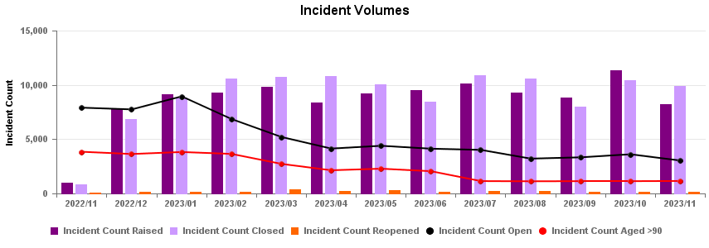

### Comms Hub Returns

### Service Requests

### Change Requests

### Problems

## Business Processes

*Documentation shall detail (as an ArchiMate ‘Application Structure View’) each business process, and interactions with internal and external systems.*

*Each Business Process shall detail the following:*

1. *High level business process (ArchiMate Business Process object)*
2. *Business owner of the process (Business Role object)*
3. *High-Level Business Process defined in Business Process Modelling Language (BPMN)*
4. *Bizzdesign Cross-functional link between the ArchiMate Business Process Object and the BPMN business process*
5. *Bizzdesign Cross-functional link between the ArchiMate Business Role Objects and the BPMN Resources*
6. *Status of each business process shall have the object element status set to (new, current, changing, or deprecated)*

## Measures of Performance

*Guidance: These will normally be specified within contract schedule 2.2 ‘Appendix 1. If this is a new project, then this section will contain the measures of effectiveness that will become part of schedule 2.2 appendix 1*

Documentation shall detail the measures of performance that have been defined for the system and how these measures of performance meet the Measures of effectiveness defined in the Conceptual Design. The performance measure documentation is a deliverable for the FSM ‘Phase 2 – Contract’ CFDA Gate, expected at the end of May 2024.

## Security

Security design is detailed in the Security Architecture Document (SAD). No additional documentation required.

Proposed Security Components:

* SEC Compliant User Authentication.
  + DCC IDP Auth.
  + 3rd Party IDP Auth.
* Authenticated User Token is exchanged with DCC SAML Token.
  + User groups and access rights are checked against allowed User Groups and Privileges for a given organisation.
  + Single Sign On is used to authenticate Service Users to the FSM by the IDP Hub.
  + All applications (API gateway, DSP, CSP etc) validates DCC Token and checks against the User Groups & Privileges before granting access to the requested resources.
* Communications between API Gateway and External Systems are secured using DCCKI certificates.
* SOC receives real-time Sys Logs from each application (API gateway, DSP, CSP etc) and correlates for any security breaches.

## Validation

*Guidance: Validation will normally be specified within contract schedule 6.2. If this is a new project, then this section will contain information to complete schedule 6.2*

Documentation shall provide information on how this system element will be validated:

1. Validation Method
2. Validation Lifecycle (including environments)
3. Temporary systems/services required to enable validation
4. Provision of test data
5. Provision of test devices and environments

## Business Continuity Disaster Recovery

*Guidance: BCDR will normally be specified within contract schedule 8.6. RTO/RTO values must be specified within the system requirements*

Documentation shall detail how each system element is integrated into the DCC Business Continuity Disaster Recovery plan as specified in DCC Schedule 8.6. The BCDR documentation is a deliverable for the FSM ‘Phase 2 – Contract’ CFDA Gate, expected at the end of May 2024.

# Document Review and Communication

This document will be reviewed by the document owner on an annual basis. An intermediate review may be conducted at any time should it be deemed necessary by events either internal or external to the Smart DCC.

Publication of a new version of this document will be controlled and communicated by the Smart DCC CTO.

1. This is at the entity level not at the attribute level