PHASE 3:DEVELOPMENT

PROJECT 1:FLOOD MONITORING AND EARLY WARNING

PROJECT TITLE:DEVELOPMENT IN FLOOD MONITORING AND EARLY WARNING THROUGH IOT TECHNOLOGY

**Introduction**

Floods are a major natural disaster that can cause significant damage to property and loss of life. Early warning systems can help prevent or minimize the impact of floods. IoT technology can be used to monitor flood levels and provide early warning to communities at risk. Python programming can be used to develop algorithms for flood monitoring and early warning systems.

### IoT Technology for Flood Monitoring

IoT sensors can be used to monitor water levels, rainfall, and other factors that contribute to flooding. These sensors can be placed in strategic locations to provide real-time data on flood conditions. The data can be transmitted to a central server for analysis and early warning systems.

### Python Programming for Flood Monitoring and Early Warning Systems

Python programming can be used to develop algorithms for flood monitoring and early warning systems. These algorithms can be used to analyze the data from IoT sensors and provide early warning to communities at risk. Python can also be used to develop user interfaces for early warning systems.

### Future Developments and Improvements

As technology continues to advance, there are several potential future developments and improvements for the IoT flood monitoring system. Some of these include:

* Integration with machine learning algorithms to improve accuracy and speed of flood detection.
* Incorporation of real-time data from multiple sources, such as weather forecasts and satellite imagery, to provide more comprehensive flood monitoring.
* Development of a mobile app for users to receive real-time flood alerts and updates.

In addition to these developments, there are also several technological advancements that could be incorporated into the IoT flood monitoring system, such as:

* Incorporation of sensors and other IoT devices to provide more comprehensive data on flood conditions.
* Use of blockchain technology to ensure the security and transparency of flood data and alerts.

### Circuit Diagram

A circuit diagram can be used to illustrate the components of an IoT flood monitoring system. The diagram can include sensors, microcontrollers, and communication modules. The diagram can also include a user interface for early warning systems.

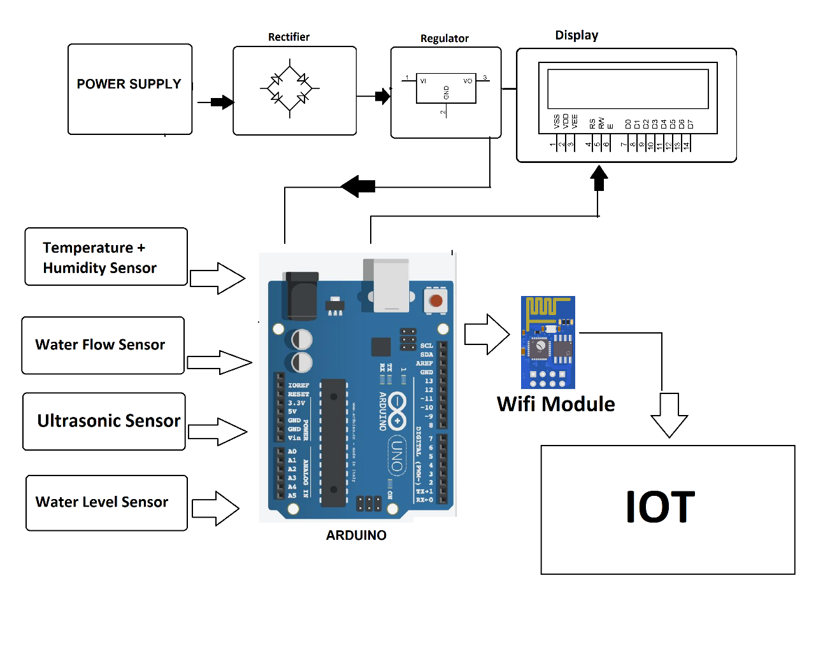

Circuit diagram

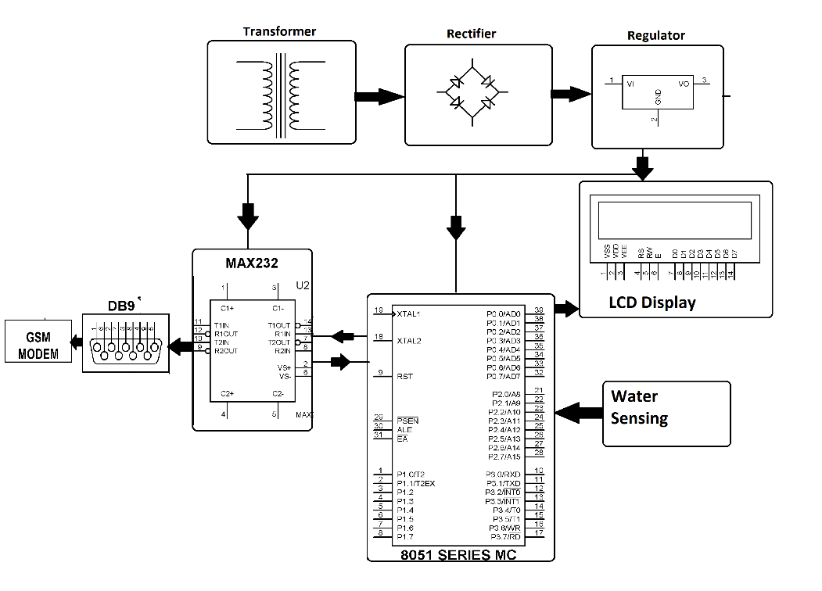

Program in python

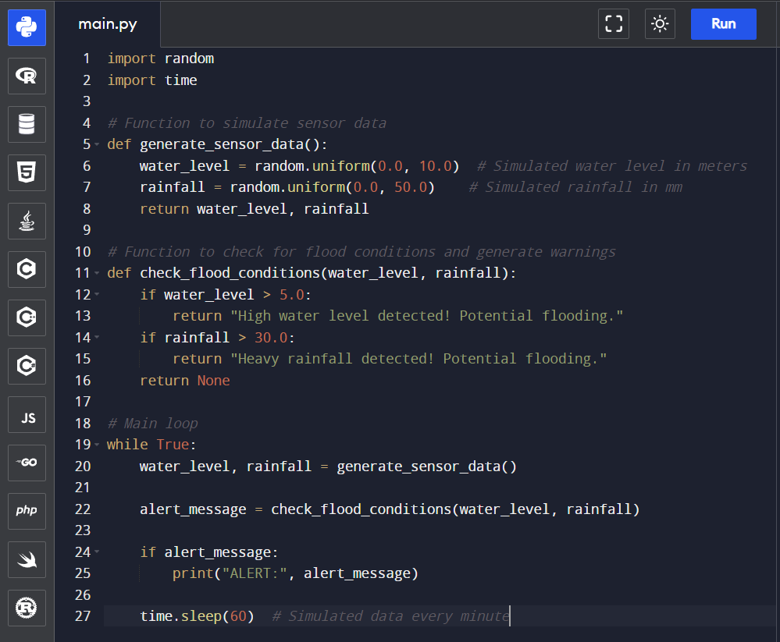

Output



### Python Code and Circuit Diagram

To demonstrate the benefits of IoT technology for flood monitoring and early warning systems, we have developed a Python code and circuit diagram that can be used to collect and analyze data from sensors and other sources.

### Benefits of IoT Technology

IoT technology offers several benefits for flood monitoring and early warning systems, including:

* Real-time data collection and analysis, allowing for more accurate and timely warnings.
* Remote monitoring and control, reducing the need for manual intervention and increasing efficiency.
* Improved accuracy and reliability of data, reducing the risk of false alarms or missed warnings.

### Conclusion

IoT technology offers a powerful tool for flood monitoring and early warning systems, providing real-time data collection and analysis, remote monitoring and control, and improved accuracy and reliability of data. By using Python code and circuit diagrams, we can demonstrate the benefits of IoT technology and show how it can be used to improve flood management and prevention.