PHASE 2:INNOVATION
PROJECT 1:FLOOD MONITORING AND EARLY WARNING
PROJECT TITLE: INNOVATION IN FLOOD MONITORING AND EARLY WARNING THROUGH IOT TECHNOLOGY

Introduction
Floods are one of the most devastating natural disasters, causing loss of life and significant damage to property and infrastructure. Early warning systems can help mitigate these impacts by providing timely alerts and information to those at risk. In recent years, IoT technology has emerged as a powerful tool for flood monitoring and early warning. This presentation will explore the latest innovations in this field and their potential to save lives and property.

IoT Technology for Flood Monitoring and Early Warning
IoT technology involves the use of sensors and other devices to collect data about the environment. In the case of flood monitoring and early warning, these sensors can be used to measure factors such as water levels, rainfall, and weather conditions. This data is then transmitted to a central system, where it is analyzed and used to generate alerts and warnings.

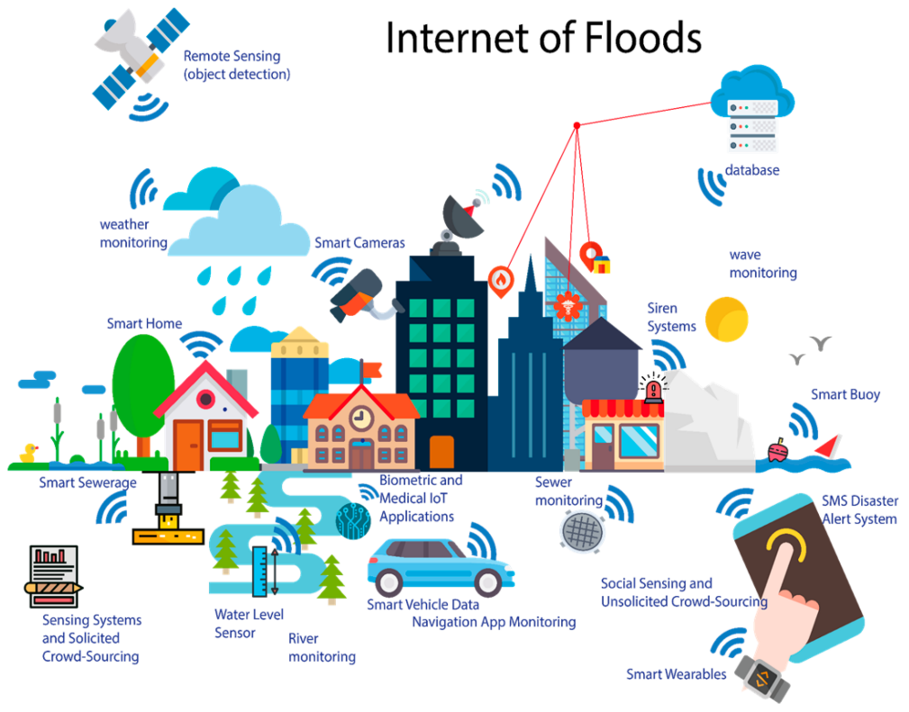

Innovations in IoT Flood Monitoring and Early Warning
There have been many recent innovations in the field of IoT flood monitoring and early warning. These include:
- Improved sensor technology, including more accurate and durable sensors that can withstand harsh environments.
- Advanced data analysis techniques, including machine learning algorithms that can identify patterns and predict flooding events with greater accuracy.
- Integration with other systems, such as emergency response and evacuation plans, to provide a comprehensive approach to flood management.

Flow Chart

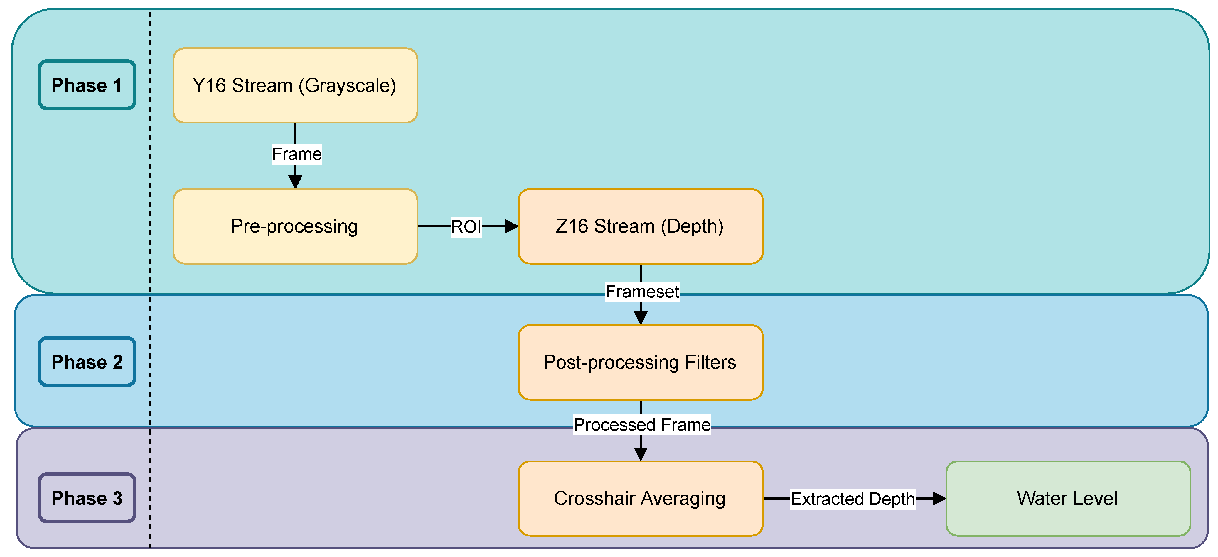

Case Studies
Several case studies have demonstrated the effectiveness of IoT flood monitoring and early warning systems. These include:
- The Thames Barrier in London, which uses IoT sensors to monitor water levels and control the barrier in real-time to prevent flooding.
- The FloodNet system in the Philippines, which uses IoT sensors to provide early warning of floods and landslides in remote areas.

IoT-based Flood Monitoring and Early Warning
This presentation provides an overview of IoT-base.d flood monitoring and early warning systems, including their benefits and challenges in real-world scenarios

Benefits
- Real-time monitoring of water levels and weather conditions allows for timely and accurate flood warnings.
- Automated alerts and notifications can be sent to emergency responders and residents in affected areas.
- Data from IoT sensors can be used to improve flood prediction models and inform better land use planning.

Challenges
- IoT sensors can be expensive to deploy and maintain, especially in remote or rural areas.
- Privacy concerns may arise from the collection and use of personal data by IoT devices.
- Reliability and accuracy of IoT sensors can be affected by environmental factors such as heavy rainfall or high winds.

Real-World Scenarios
Case studies of IoT-based flood monitoring and early warning systems in real-world scenarios will be presented, including their impact on emergency response and disaster preparedness.

Flood Monitoring and Early Warning System
Our flood monitoring and early warning system utilizes IoT sensors to collect real-time data on water levels, rainfall, and other environmental factors that contribute to flooding. This data is then analyzed using machine learning algorithms to identify patterns and predict potential flooding events.
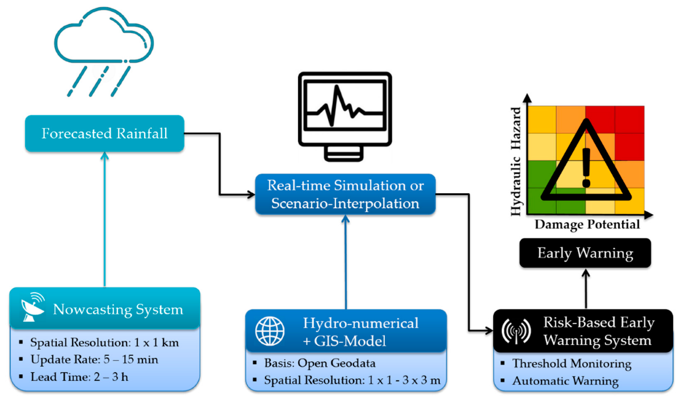

Visualization of Sensor Data
To help users understand the data collected by our sensors, we provide real-time visualizations of the data through a user-friendly dashboard. This allows users to quickly identify potential flooding events and take appropriate actions to mitigate the impact of the flood.

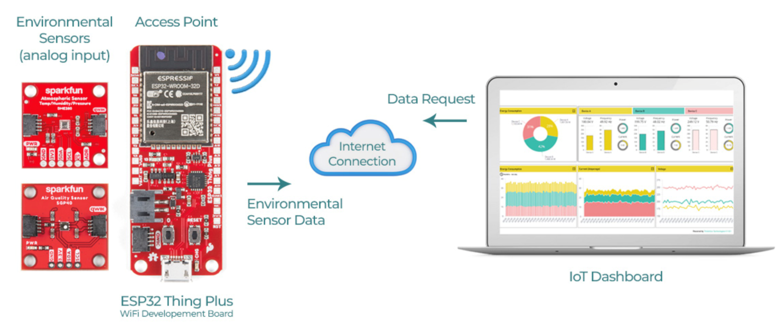

Deployment of IoT Sensors
Our IoT sensors are deployed in flood-prone areas, such as near rivers and in low-lying regions. The sensors are designed to withstand harsh weather conditions and provide reliable data even in extreme situations.

Flow Chart
The flow chart illustrates the process of implementing an IoT-based flood monitoring and early warning system.

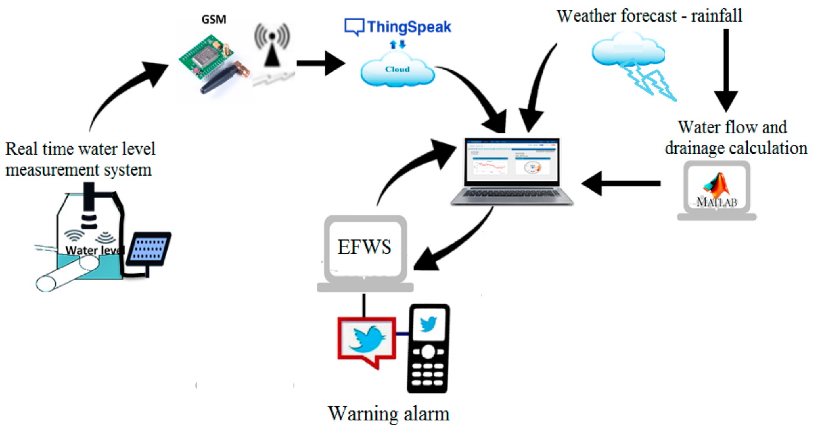

IoT Sensors
IoT sensors are installed in flood-prone areas to monitor water levels and weather conditions.

Data Collection and Analysis
Data collected from the IoT sensors is analyzed to identify potential flood risks and issue early warnings.

Early Warning System
An early warning system is activated when the data analysis indicates a potential flood risk, alerting authorities and residents in the affected areas.

Conclusion
In conclusion, an IoT-based flood monitoring and early warning system can help mitigate the impact of floods on communities. By installing IoT sensors, collecting and analyzing data, and issuing early warnings, authorities and residents can take proactive measures to minimize damage and save lives.

