PROJECT:FLOOD MONITORING AND EARLY WARNING
PHASE 5:PROJECT DOCUMENTATION & SUBMISSION

PROJECT DEFINITION:

The project’s primary goal is to establish an Internet of Things (IoT) infrastructure for monitoring environmental conditions, specifically temperature and humidity, in public parks. This endeavor seeks to deliver real-time environmental data to park visitors through a public platform, allowing them to make informed decisions regarding their outdoor activities. The project encompasses the following key components.

1.Project Objectives:
  - Real-time Environmental Monitoring: Implement a system that continuously monitors temperature and humidity in public parks.
  - Aiding Park Visitors: Furnish park visitors with access to real-time environmental data to facilitate planning and enhance their outdoor experience.
  - Promoting Outdoor Experiences: Encourage and enable park visitors to engage in outdoor activities by providing data-driven insights.
  - Enhancing Visitor Satisfaction: Improve visitor satisfaction by ensuring they are well-prepared for changing weather conditions.

2. IoT Device Design:
  - Sensor Selection: Identify appropriate temperature and humidity sensors that are reliable, accurate, and cost-effective.
  - Development Strategy: Develop a strategy for the optimal placement and distribution of IoT sensors within public parks to achieve comprehensive coverage while efficiently utilizing resources.
  - Power Source: Determine the power source for IoT devices, considering options such as battery power, solar panels, or a combination thereof.
  - Connectivity: Select suitable connectivity options (e.g., Wi-Fi, cellular, LPWAN) to ensure robust and reliable data transmission.

3. Environmental Monitoring Platform:
  - Web-Based Interface: Design a user-friendly web-based platform accessible via various devices (mobile phones, computers) for park visitors.
  - Real-time Data Display: Develop a dashboard that presents real-time temperature and humidity data in a comprehensible and visually appealing format.
  - Historical Data Access: Enable access to historical environmental data, allowing visitors to review past conditions.
  - Weather Forecasts: Integrate weather forecast data to enhance the platform's predictive capabilities and assist visitors in planning activities.

4. Integration Approach:
  - Data Transmission: Determine the data transmission protocol and frequency from IoT devices to the environmental monitoring platform.
  - Data Security: Implement robust data security measures to safeguard data integrity and user privacy.
  - Scalability: Consider the system's scalability to accommodate additional parks or sensors in the future.
  - Development Technology: Utilize Python for platform development and IoT technology for seamless sensor integration.

DESIGN THINKING APPROACH:
To effectively address the project's objectives and requirements, we will adopt a Design Thinking approach, comprising the following phases:
- Empathize: Gain a deep understanding of the needs and challenges faced by park visitors and park management. Conduct surveys, interviews, and on-site observations to empathize with their expectations and pain points.
- Define: Clearly articulate the project's objectives, requirements, and success criteria, informed by the insights gathered in the empathy phase. Create user personas to represent different categories of park visitors.
- Ideate: Brainstorm innovative ideas for sensor deployment, platform design, and integration strategies. Encourage collaborative cross-functional ideation sessions to generate creative solutions.
- Prototype: Develop prototypes of the IoT sensor system and the environmental monitoring platform. Conduct user testing to gather feedback and iterate on the prototypes.
- Test: Conduct usability tests with users and gather feedback from stakeholders. Use this feedback to refine the prototypes, ensuring they align with the defined project objectives.
- Implement: Develop the final IoT sensor system and environmental monitoring platform based on the refined prototypes. Ensure the solution aligns with the project's defined objectives and requirements.
- Deliver: Deploy IoT sensors in public parks according to the deployment plan. Launch the environmental monitoring platform for public access, and provide training for park administrators.
- Evaluate: Continuously monitor the performance of IoT devices and gather user feedback. Measure the impact of the project on visitor satisfaction and park utilization.
- Iterate: Make ongoing improvements and updates based on user feedback and data analysis. Consider the possibility of expanding the project to additional parks or enhancing the platform with additional features.
- Sustain: Develop a maintenance plan to ensure the long-term functionality of IoT devices and the platform. Stay updated with advancements in IoT and web technologies to ensure the project remains relevant.

By embracing this Design Thinking approach, we aim to create a robust and user-centric IoT environmental monitoring system that not only enhances the park experience for visitors but also contributes to their safety, satisfaction, and appreciation of outdoor activities.

IoT Technology for Flood Monitoring and Early Warning
IoT technology involves the use of sensors and other devices to collect data about the environment. In the case of flood monitoring and early warning, these sensors can be used to measure factors such as water levels, rainfall, and weather conditions. This data is then transmitted to a central system, where it is analyzed and used to generate alerts and warnings.

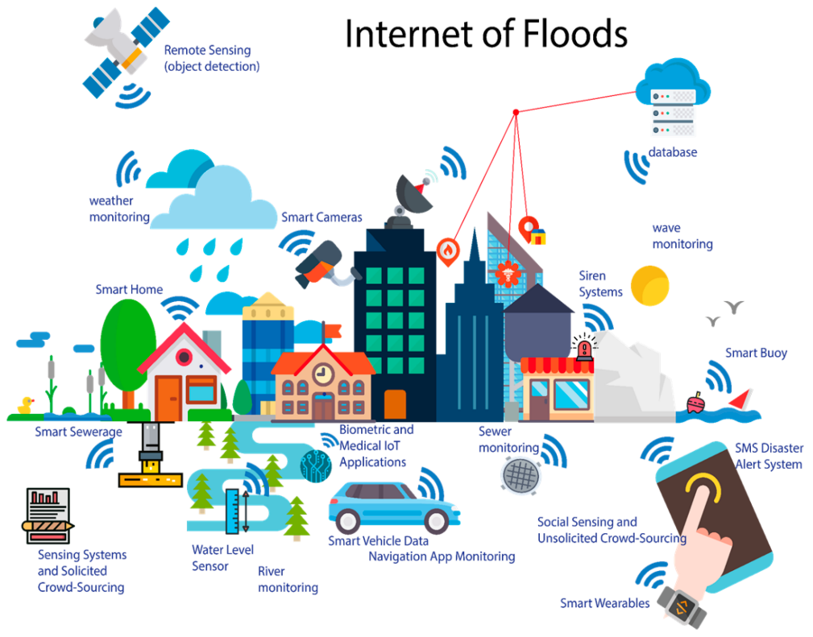

Innovations in IoT Flood Monitoring and Early Warning
There have been many recent innovations in the field of IoT flood monitoring and early warning. These include:
- Improved sensor technology, including more accurate and durable sensors that can withstand harsh environments.
- Advanced data analysis techniques, including machine learning algorithms that can identify patterns and predict flooding events with greater accuracy.
- Integration with other systems, such as emergency response and evacuation plans, to provide a comprehensive approach to flood management.

Flow Chart

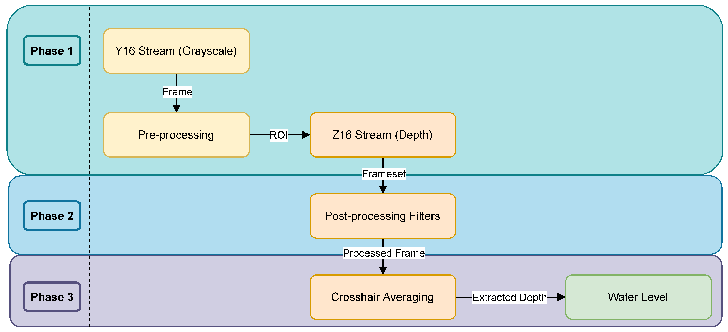

Case Studies
Several case studies have demonstrated the effectiveness of IoT flood monitoring and early warning systems. These include:
- The Thames Barrier in London, which uses IoT sensors to monitor water levels and control the barrier in real-time to prevent flooding.
- The FloodNet system in the Philippines, which uses IoT sensors to provide early warning of floods and landslides in remote areas.

IoT-based Flood Monitoring and Early Warning
This presentation provides an overview of IoT-base.d flood monitoring and early warning systems, including their benefits and challenges in real-world scenarios

Benefits
- Real-time monitoring of water levels and weather conditions allows for timely and accurate flood warnings.
- Automated alerts and notifications can be sent to emergency responders and residents in affected areas.
- Data from IoT sensors can be used to improve flood prediction models and inform better land use planning.

Challenges

- IoT sensors can be expensive to deploy and maintain, especially in remote or rural areas.
- Privacy concerns may arise from the collection and use of personal data by IoT devices.
- Reliability and accuracy of IoT sensors can be affected by environmental factors such as heavy rainfall or high winds.

Real-World Scenarios
Case studies of IoT-based flood monitoring and early warning systems in real-world scenarios will be presented, including their impact on emergency response and disaster preparedness.

Flood Monitoring and Early Warning System
Our flood monitoring and early warning system utilizes IoT sensors to collect real-time data on water levels, rainfall, and other environmental factors that contribute to flooding. This data is then analyzed using machine learning algorithms to identify patterns and predict potential flooding events.
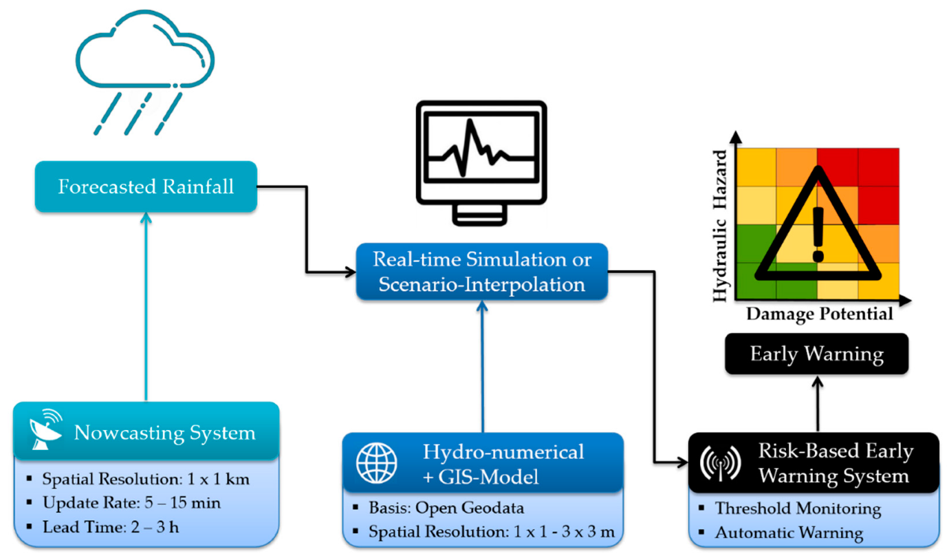

Visualization of Sensor Data
To help users understand the data collected by our sensors, we provide real-time visualizations of the data through a user-friendly dashboard. This allows users to quickly identify potential flooding events and take appropriate actions to mitigate the impact of the flood.

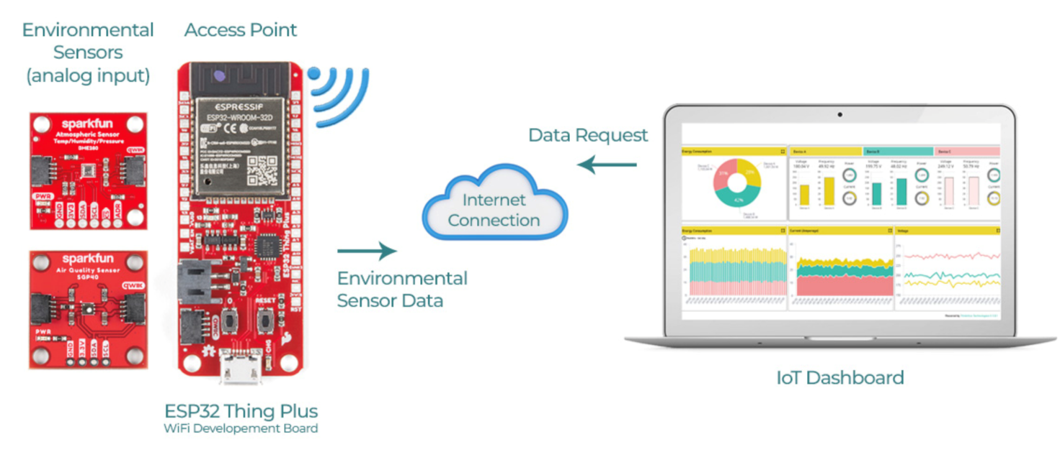

Deployment of IoT Sensors
Our IoT sensors are deployed in flood-prone areas, such as near rivers and in low-lying regions. The sensors are designed to withstand harsh weather conditions and provide reliable data even in extreme situations.

Flow Chart
The flow chart illustrates the process of implementing an IoT-based flood monitoring and early warning system.

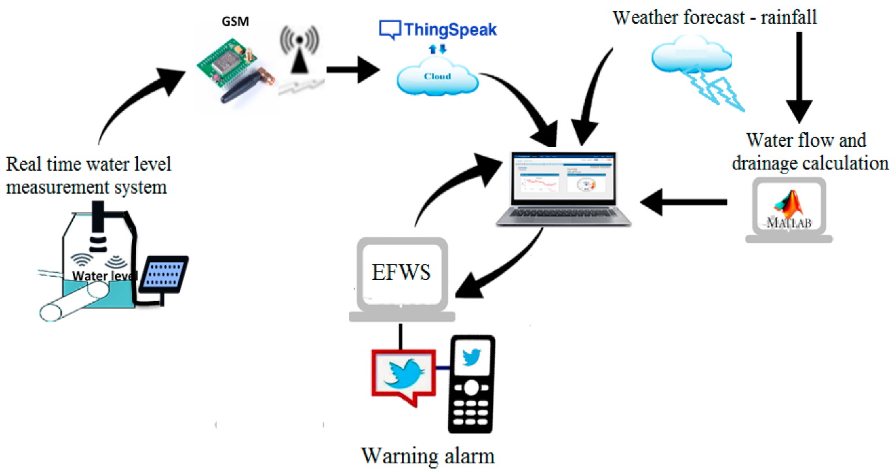

IoT Sensors
IoT sensors are installed in flood-prone areas to monitor water levels and weather conditions.

Data Collection and Analysis
Data collected from the IoT sensors is analyzed to identify potential flood risks and issue early warnings.

Early Warning System
An early warning system is activated when the data analysis indicates a potential flood risk, alerting authorities and residents in the affected areas.

IoT Technology for Flood Monitoring
IoT sensors can be used to monitor water levels, rainfall, and other factors that contribute to flooding. These sensors can be placed in strategic locations to provide real-time data on flood conditions. The data can be transmitted to a central server for analysis and early warning systems.

Python Programming for Flood Monitoring and Early Warning Systems
Python programming can be used to develop algorithms for flood monitoring and early warning systems. These algorithms can be used to analyze the data from IoT sensors and provide early warning to communities at risk. Python can also be used to develop user interfaces for early warning systems.

Future Developments and Improvements
As technology continues to advance, there are several potential future developments and improvements for the IoT flood monitoring system. Some of these include:
- Integration with machine learning algorithms to improve accuracy and speed of flood detection.
- Incorporation of real-time data from multiple sources, such as weather forecasts and satellite imagery, to provide more comprehensive flood monitoring.
- Development of a mobile app for users to receive real-time flood alerts and updates.
In addition to these developments, there are also several technological advancements that could be incorporated into the IoT flood monitoring system, such as:
- Incorporation of sensors and other IoT devices to provide more comprehensive data on flood conditions.
- Use of blockchain technology to ensure the security and transparency of flood data and alerts.

Circuit Diagram
A circuit diagram can be used to illustrate the components of an IoT flood monitoring system. The diagram can include sensors, microcontrollers, and communication modules. The diagram can also include a user interface for early warning systems.
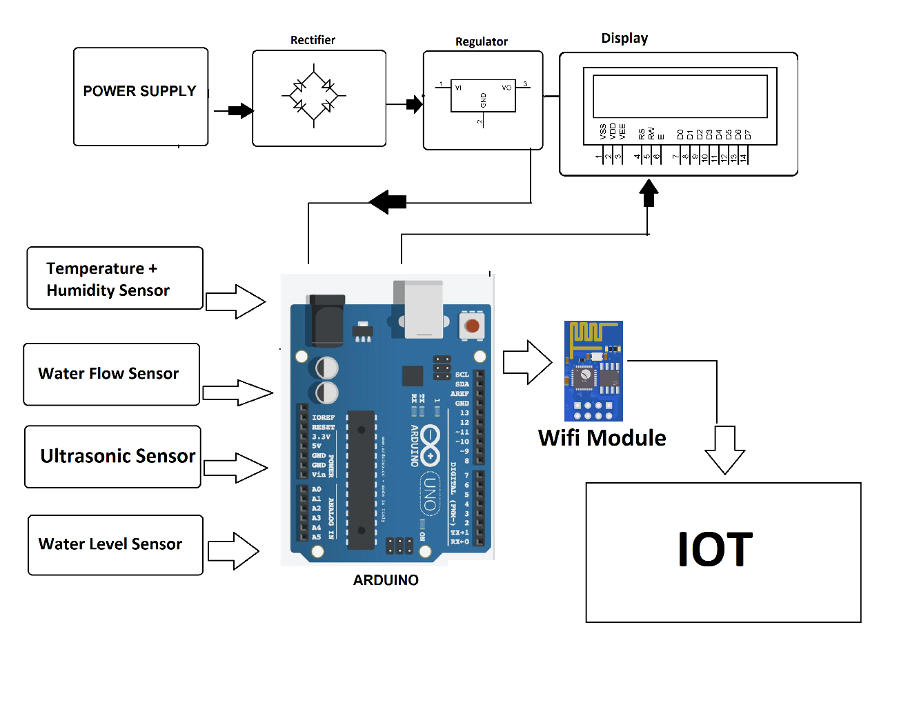
Circuit diagram
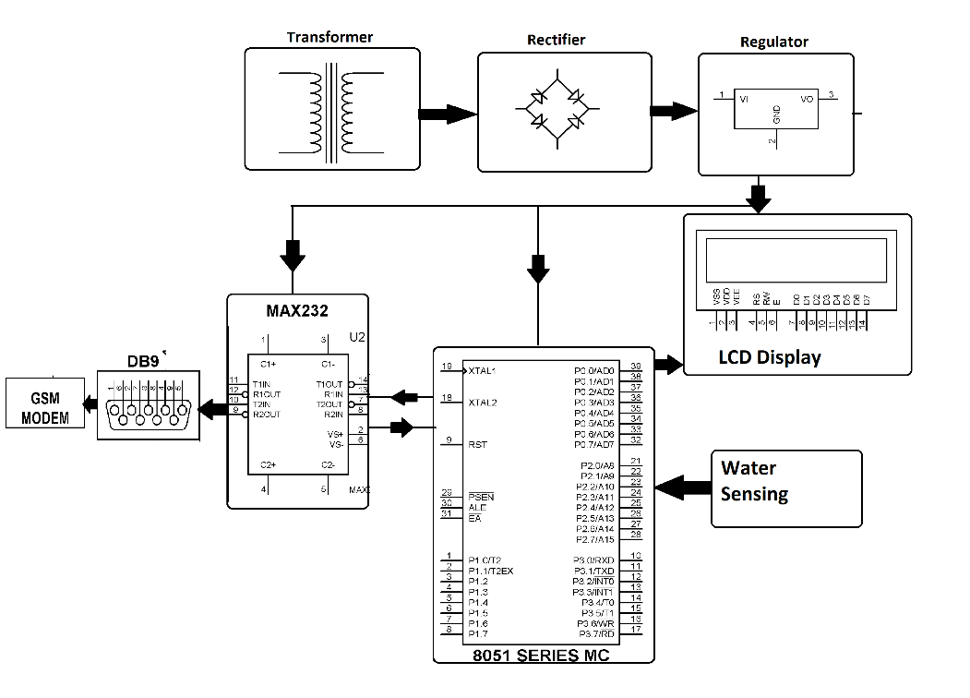

Program in python

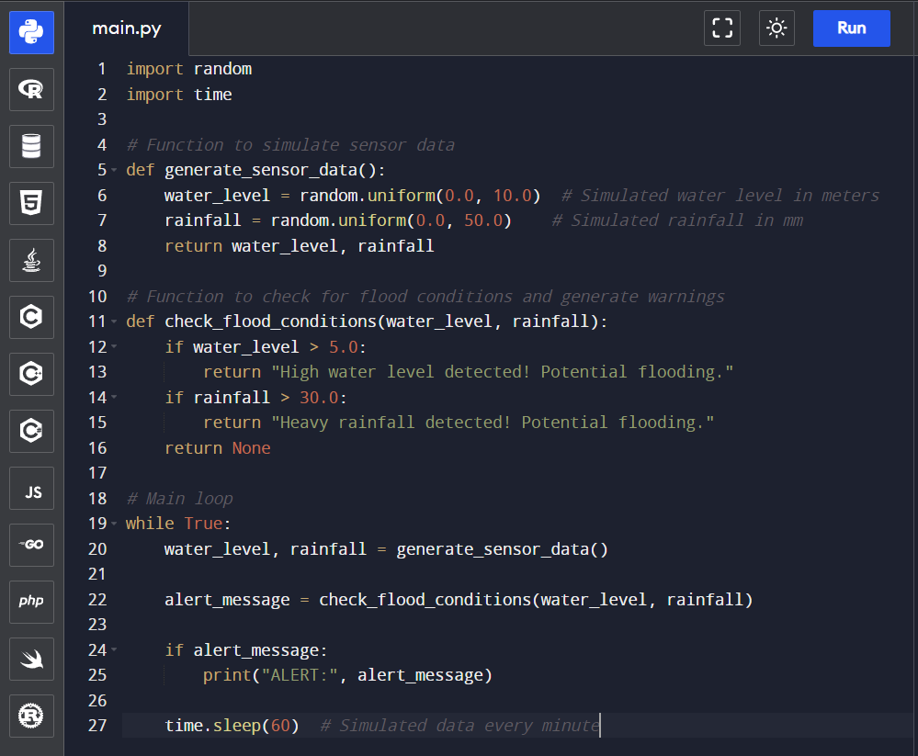

Output

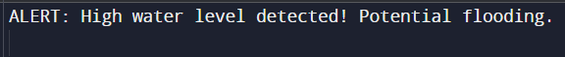

Python Code and Circuit Diagram
To demonstrate the benefits of IoT technology for flood monitoring and early warning systems, we have developed a Python code and circuit diagram that can be used to collect and analyze data from sensors and other sources.

Benefits of IoT Technology
IoT technology offers several benefits for flood monitoring and early warning systems, including:
- Real-time data collection and analysis, allowing for more accurate and timely warnings.
- Remote monitoring and control, reducing the need for manual intervention and increasing efficiency.
- Improved accuracy and reliability of data, reducing the risk of false alarms or missed warnings.
Hardware Setup (IoT)
- Water Level Sensors: Install water level sensors in flood-prone areas. These sensors should be capable of measuring water levels and transmitting data.

- Microcontrollers or IoT Devices: Use microcontrollers or IoT devices to collect data from sensors and transmit it to a central server. Devices like Arduino, Raspberry Pi, or specialized IoT modules can be used for this purpose.

- Connectivity: Set up connectivity options for data transmission, such as Wi-Fi, GSM, LoRa, or NB-IoT, depending on the location and available infrastructure.

Software and Server-Side:
- Data Transmission Protocol: Define a protocol for data transmission from IoT devices to the server. MQTT (Message Queuing Telemetry Transport) is a common protocol used in IoT applications.

- Server Infrastructure: Set up a server to receive, process, and store the incoming data. Cloud services or a dedicated server can be used for this.

- Database: Create a database to store the real-time water level data. Consider using databases like MySQL, MongoDB, or time-series databases for efficient data storage.

Web Development
- Backend Development: Develop the backend of the web platform. This involves creating APIs to receive and process the real-time data coming from the sensors and storing it in the database.

- Frontend Development: Design the user interface. Develop a web-based dashboard or portal that displays the real-time water level data, flood warnings, charts, maps, and any other relevant information. JavaScript frameworks like React, Vue.js, or Angular can be used for frontend development.

- Real-Time Updates: Implement real-time data updates using technologies like WebSockets or Server-Sent Events (SSE) to push updates to the user interface as soon as new data is available.

- Flood Warning System: Implement algorithms or rules that analyze the incoming data to predict potential flood events and trigger warnings. Integrate a notification system for users to receive alerts about potential flooding.

- Geographical Mapping: Integrate maps to visualize the areas at risk or already affected by flooding.

HTML structures
<!DOCTYPE html>
<html lang="en">
<head>
<meta charset="UTF-8">
<title>Real-Time Water Level & Flood Warnings</title>
<link rel="stylesheet" href="styles.css">
</head>
<body>
<div class="container">
<h1>Real-Time Water Level & Flood Warnings</h1>
<div class="data-display">
<h2>Water Level</h2>
<div id="waterLevel">Loading...</div>
</div>
<div class="warning">
<h2>Flood Warnings</h2>
<div id="floodWarning">No Warnings</div>
</div>
</div>
<script src="script.js"></script>
</body>
</html>

(Css) for style your page

body {
font-family: Arial, sans-serif;
margin: 0;
padding: 0;
display: flex;
justify-content: center;
align-items: center;
height: 100vh;
background-color: #f4f4f4;
}

.container {
text-align: center;
}

.data-display, .warning {
margin: 20px 0;
padding: 20px;
background-color: #fff;
box-shadow: 0 0 10px rgba(0, 0, 0, 0.1);
}

h1 {
color: #333;
}

h2 {
margin-bottom: 10px;
}

Javascript for real-time data

// Simulated real-time data
function updateData() {
// Simulate water level data
const waterLevel = Math.floor(Math.random() * 100); // Random number between 0 and 100
document.getElementById('waterLevel').innerText = `Current Water Level: ${waterLevel} cm`;

// Simulate flood warnings
const isFloodWarning = waterLevel > 80; // Example threshold for flooding
document.getElementById('floodWarning').innerText = isFloodWarning ? 'Flood Warning: High Water Levels Detected' : 'No Warnings';
}

// Update data every 5 seconds (5000 milliseconds)
setInterval(updateData, 5000);

// Initial data load
updateData();

server slide
Report:1
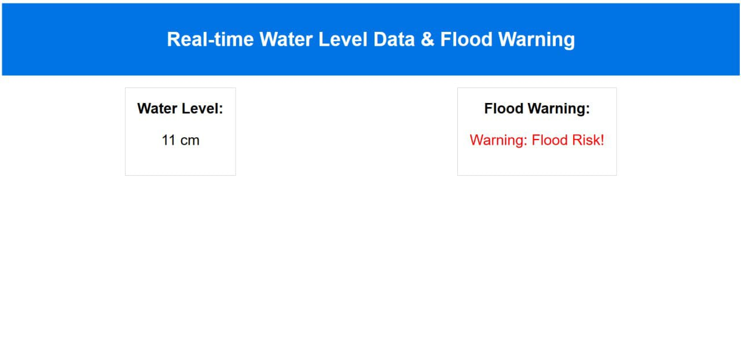
Report:2
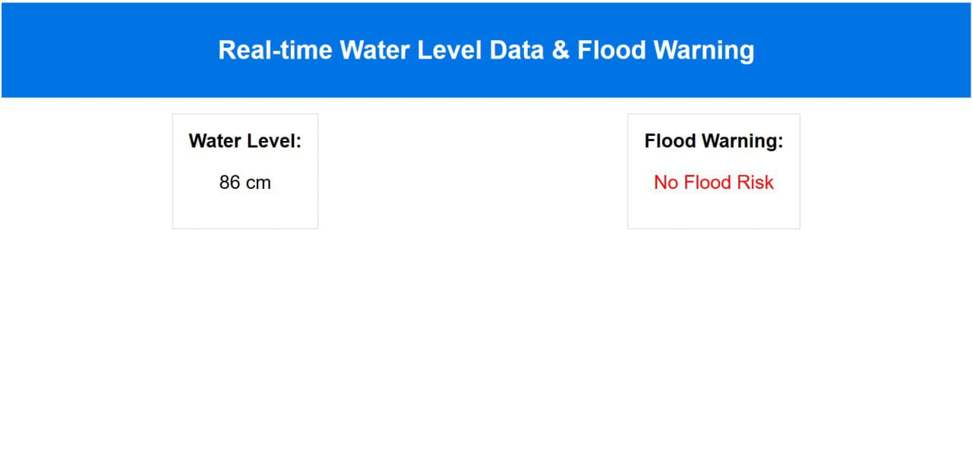

Security and Maintenance
Ensure robust security measures to protect data transmission and storage.
Regularly maintain and update the platform, including sensor maintenance, software updates, and improvements based on user feedback and new data.
Creating such a platform requires expertise in IoT, backend and frontend development, database management, and possibly geospatial data visualization. Collaboration with experts in hydrology or related fields is also beneficial for accurate data interpretation. Additionally, attention to security, user experience, and data accuracy is crucial in such systems.

Real-Time Updates
- Details on how real-time updates are achieved.
- Technologies used for instant data transmission.

Flood Warning System
- Explanation of flood prediction algorithms.
- Notification system for alerts.

Maintenance and Updates
- Regular maintenance of the platform.
- Importance of sensor calibration and software updates.

Conclusion
- Summary of the platform’s significance and capabilities.
- Future improvements and possibilities.

