A F F I D A V I T
I, SOMASUNDARAM KUMARASAMY, hereby state the following:
- I now work as IT PROFESSIONAL - LEVEL 2 of R1RCM Inc. I supervised Mr. Rajesh Babu Thoghuluva Rajagopal Chandrasekaran at Wipro Technologies Ltd in Richmond, VA - USA. I can be reached at +1 952 200 0308.
- I confirm that Mr. Rajesh Babu Thoghuluva Rajagopal Chandrasekaran held the position of Senior Software Engineer of Wipro Technologies Ltd from 09/13/2010 to 06/30/2013 and held the position of Technical Lead of Wipro Technologies Ltd from 07/01/2013 to 02/27/2015.
- Wipro Technologies Ltd was engaged in consulting, technology and outsourcing solutions.
- As Technical Lead of Wipro Technologies Ltd, Mr. Rajesh Babu Thoghuluva Rajagopal Chandrasekaran was responsible for
- Requirement analysis with the business analyst and translating them into functional and technical documents.
- Development of web solutions using HTML5, Javascript, CSS3 and creating reusable components.
- Estimation of development effort and involved in the design of web solution using HTML5, Javascript, CSS3 and jQuery.
- Creating technical documentation to better explain the flow of data to non-technical stakeholders.
- Performing peer code reviews to adhere to best practices and standards.
- Involved in doing Integration testing and resolving System testing defects.
- Application development using Modern Web Open source framework and library such as Angular.js, Bootstrap, SASS, GruntJS, Node.js, Require.js and jQuery especially AJAX driven web applications.
- Subject Matter Expert (SME) to both business and offshore team in Front End development.
- Responsible for deliverables of the assigned module via unit testing and resolving issues/bugs in the web solution.
- Mr. Rajesh Babu Thoghuluva Rajagopal Chandrasekaran gained experience in programming languages like HTML5, Java Script, CSS3, JSP and Java, and in tools like NodeJS, Eclipse IDE, Fiddler, SVN, GIT, Microsoft Office, Apache Tomcat and Windows.

I, SOMASUNDARAM KUMARASAMY, am a competent adult. I declare under penalty of perjury that the foregoing is true and correct.

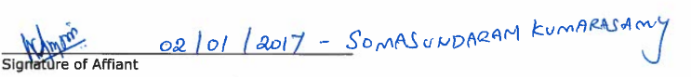

Subscribed and Sworn to me, a Notary Public,
this 1st day of February 2017.

