LITERATURE REVIEW

Farmer Crop and Income Planning Using Reinforcement Learning Under Climate and Market Uncertainty

Full Name : Rajesh Dabbugottu
Student ID : A00073166

Table of Contents
- Introduction
- Agricultural Planning and Farm Management
2.1 Traditional Agricultural Planning
2.2 Linear Programming Approaches in Agriculture
2.3 Dynamic Programming Approaches in Agriculture
2.4 Mixed Integer Programming Approaches in Agriculture
2.5 Critical Evaluation of Traditional Planning Methods
2.6 Climate Risk and Agricultural Uncertainty
- Weather-Related Risks in Agriculture
3.1 Climate Change and Long-Term Agricultural Planning
3.2 Economic and Market Uncertainty
3.3 Implications for Agricultural Decision-Making
- Machine Learning in Agriculture
4.1 Crop Yield Prediction
4.2 Disease and Pest Detection
4.3 Soil and Nutrient Management
4.4 Irrigation Scheduling and Water Management
4.5 Precision Agriculture and Smart Farming
4.6 Limitations of Machine Learning in Agricultural Decision-Making
- Reinforcement Learning
5.1 Introduction to Reinforcement Learning
5.2 Fundamental Components of Reinforcement Learning
5.3 Markov Decision Process
5.4 Reinforcement Learning Algorithms
5.4.1 Q-Learning
5.4.2 Deep Q Networks (DQN)
5.4.3 Advantage Actor-Critic (A2C)
5.4.4 Proximal Policy Optimisation (PPO)
5.5 Suitability of Reinforcement Learning for Agriculture Planning
- Reinforcement Learning Applications in Agriculture
6.1 Introduction
6.2 Greenhouse Climate Control
6.3 Fertiliser and Nutrient Management
6.4 Resource Allocation and Farm Management
6.5 Crop Planning and Land Allocation
6.6 Critical Review of Current RL Application Studies
- Data Sources for Agricultural Decision Support
7.1 Introduction
7.2 Crop Production Dataset
7.3 Agricultural Market Price Dataset
7.4 Combination of Datasets
7.5 Limitations of the Dataset and Simulation Variables
7.6 Reasons for Dataset Selection
- Research Gap and Research Motivation
8.1 Limitations of Traditional Optimisation Methods
8.2 Limitations of Machine Learning Approaches
8.3 Research Gaps in Reinforcement Learning Applications
8.4 Proposed Reinforcement Learning Framework Motivation
- Chapter Summary
- References

1.Introduction
In this chapter, relevant literature related to agricultural planning, climate uncertainty, machine learning, and reinforcement learning is reviewed. The complexity of agricultural decision-making has increased significantly due to price volatility, climate variability, and the growing demand for sustainable agricultural practices [6] – [10]. Traditionally, optimisation techniques have been widely used to support agricultural planning and resource allocation decisions; however, these approaches often lack adaptability when environmental and economic conditions change unexpectedly [1] – [5].
The emergence of Artificial Intelligence (AI), and more recently Reinforcement Learning (RL), has introduced new opportunities for developing intelligent decision-support systems capable of learning optimal actions through interactions with dynamic and uncertain environments [16]–[20]. Existing studies have demonstrated the potential of AI-based approaches to improve agricultural productivity, resource management, and operational efficiency [11]–[15]. Consequently, a critical review of current research on agricultural planning and intelligent decision-support systems is necessary to identify existing limitations and research gaps.
This review begins with an examination of traditional agricultural planning approaches and subsequently discusses climate and market uncertainties affecting agricultural systems. The chapter then explores machine learning and reinforcement learning techniques and their applications in agricultural decision-making [11]–[20]. Finally, the identified research gaps are presented, providing the motivation for the proposed reinforcement learning framework for long-term crop and income planning under uncertainty.

2.Agricultural Planning and Farm Management

  - Traditional Agricultural Planning
Agricultural planning refers to the decision-making process involved in crop selection, land allocation, resource utilisation, and investment management with the objective of maximising farm productivity and profitability [1], [2]. Effective planning is essential for ensuring food security, economic sustainability, and efficient resource utilisation within agricultural systems [1]. A successful planning strategy must balance multiple objectives, including profit maximisation, cost reduction, soil conservation, and environmental sustainability [1], [2].
Historically, agricultural decisions have been based primarily on farmers’ experience, local knowledge, and observations from previous growing seasons [1]. Farmers often make decisions using historical weather patterns, market conditions, and consultations with agricultural experts [1]. Although this approach has been effective under relatively stable conditions, its reliability decreases when agricultural systems are exposed to climate variability, fluctuating commodity prices, and changing production costs [6]–[10].
One of the major challenges in agricultural planning is the allocation of limited resources [2]. Farmers typically face constraints related to land availability, labour, water resources,machinery, and financial capital [2], [5]. Decisions regarding crop selection and land allocation influence both short-term profitability and long-term sustainability [1], [2]. Poor planning decisions can therefore result in reduced productivity, financial losses, and inefficient use of available resources [1].

2.2 Linear Programming Approaches in Agriculture
Linear Programming (LP) is among the earliest optimisation techniques applied to agricultural planning problems [2], [3]. The primary objective of LP is to maximise or minimise a predefined objective function while satisfying a set of constraints [2], [3]. In agricultural applications, these constraints commonly include land availability, labour requirements, water resources, production costs, and market demand [2].
Numerous studies have applied LP models to agricultural planning and farm management problems [2], [3]. LP has been widely used to determine optimal crop combinations that maximise farm revenue while satisfying resource limitations [2]. Furthermore, LP techniques have been employed in irrigation planning, fertiliser allocation, and agricultural supply chain optimisation [5]. The ability of LP to incorporate multiple constraints into a single optimisation framework has made it an important tool for agricultural decision support [2].

Dynamic Programming Approaches in Agriculture
Dynamic Programming (DP) was developed to address optimisation problems involving sequential decision-making over time [4]. Unlike LP, which generally focuses on a single planning period, DP considers the long-term consequences of current decisions and evaluates future rewards associated with alternative actions [4]. This characteristic makes DP particularly relevant for agricultural planning problems where decisions have long-term implications.
DP has been applied to crop rotation planning, irrigation scheduling, livestock management, and long-term farm planning [4]. The method divides a complex optimisation problem into smaller sub-problems and determines optimal decisions at each stage while considering future outcomes [4]. Consequently, decision-makers can evaluate long-term benefits rather than focusing exclusively on immediate gains.
Despite its advantages, DP suffers from computational limitations known as the “curse of dimensionality” [4]. Agricultural systems often involve numerous state variables, including crop types, weather conditions, input costs, and resource availability [4]. As the number of variables increases, computational complexity grows substantially, making DP difficult to apply to large-scale agricultural planning problems [4]..
  - Mixed Integer Programming Approaches in Agriculture
Unlike previous optimisation methods, which were limited in the use of either continuous or discrete decision variables, Mixed Integer Programming can handle both continuous and discrete variables. Thus, this optimisation approach can be used to make binary decisions related to agriculture, like planting a particular crop, buying equipment, or installing irrigation facilities.
A number of researchers have applied MIP to various agricultural optimisation problems, including those related to crop rotation schemes, allocation of land for various uses, planning for the acquisition of machinery, and logistics. In many cases, MIP was used when agricultural decision-making involved logical conditions that could not be modelled by using LP. For instance, a farmer might be required to either plant a crop on an entire field or not use the field for any cultivation purposes. It is possible to model such situations using discrete variables.
  - Critical Evaluation of Traditional Planning Methods
Optimisation approaches have been instrumental in promoting agricultural planning and agricultural resource management practices. Some of these include linear programming, dynamic programming, and mixed integer programming. These optimisation methods have shown great promise in assisting agricultural resource managers with crop allocation and irrigation decisions, as well as helping individual farms make profit-maximising decisions.
This has led to greater interest in applying concepts such as Artificial Intelligence and machine learning techniques. For instance, Reinforcement Learning is one of the concepts that show promise in helping to make agricultural decisions due to its ability to enable agents to learn from the environment. Contrary to conventional optimisation techniques that focus on maximising short-run gains at the expense of long-run considerations, reinforcement learning is capable of making trade-offs between short-term gains and long-term objectives. It is in this regard that the following discussion focuses on climate uncertainties and risks.
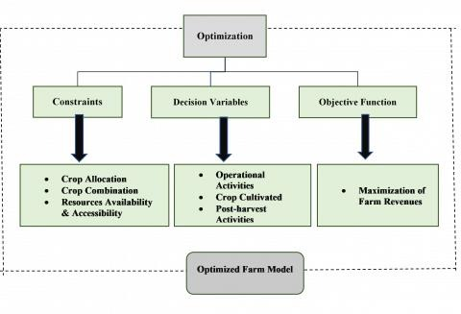
Figure 1: Traditional optimisation methods used in agricultural planning and their limitations in uncertain agricultural environments.

  - Climate Risk and Agricultural Uncertainty
One of the economic sectors that are most affected by the environment is agriculture. The growth and productivity of crops require several environmental variables such as rainfall, temperature, humidity, sunshine, and weather patterns. Agricultural processes are carried out in natural environments, which are very unpredictable and uncontrollable compared to some industrial manufacturing activities. As a result, climate variability is among the biggest obstacles to successful agricultural operations.
Climate variability has become a more prevalent problem for agriculture in the past few decades. Several publications by the Inter-governmental Panel on Climate Change (IPCC) state that the world has experienced global warming, alterations in the rain pattern, and increased occurrences of natural calamities.

3. Weather-Related Risks in Agriculture
Weather conditions significantly influence crop growth and agricultural productivity [6]–[10]. Rainfall patterns directly affect soil moisture availability and crop development [7], [8]. Insufficient rainfall may lead to drought conditions that reduce crop yields and increase the risk of crop failure, whereas excessive rainfall can contribute to flooding, soil erosion, and disease outbreaks [6]–[10].
Temperature variability also plays a critical role in agricultural production [7], [8]. Each crop species has specific temperature requirements for optimal growth and development [7]. Excessively high temperatures can cause heat stress, while extremely low temperatures may damage plant tissues and reduce productivity [8]. Frost events are particularly harmful to fruit crops because they can interfere with flowering and fruit development [8].
Research has consistently shown that weather variability contributes substantially to fluctuations in agricultural production [7], [8]. The effects of weather conditions vary according to crop type, geographic location, and planting period [7]. Therefore, farmers must consider both expected production outcomes and weather-related risks when selecting crops and planning agricultural activities [6]–[10].
3.1 Climate Change and Long-Term Agricultural Planning
Climate change has introduced additional complexity into agricultural planning processes [6], [8], [10]. Historical weather records are becoming less reliable predictors of future conditions due to changing rainfall patterns, temperature increases, and seasonal shifts [6]. These changes create significant uncertainty regarding future agricultural productivity and profitability [8].
Long-term agricultural investments are particularly affected by climate uncertainty [10]. Decisions such as establishing orchards, investing in irrigation infrastructure, or adopting new crop varieties often involve planning horizons extending over many years [10]. However, future climate uncertainty makes it difficult for farmers to accurately estimate long-term economic returns [6], [10].
3.2 Economic and Market Uncertainty
In addition to environmental risks, agricultural producers face considerable economic uncertainty [2], [6]. Commodity prices fluctuate due to changes in supply and demand, transportation costs, trade regulations, inflation, and broader economic conditions [2]. Consequently, high agricultural production does not necessarily guarantee economic success if market prices decline significantly.
Production costs also contribute to uncertainty in agricultural planning [2], [5]. Expenses related to fertilisers, pesticides, fuel, labour, and equipment maintenance frequently change over time [5]. These fluctuations influence farm profitability and can affect decisions regarding crop selection and resource allocation [2].

3.3 Implications for Agricultural Decision-Making
The increasing complexity of agricultural systems has created a growing need for decision-support systems capable of operating effectively under uncertainty [6]–[10]. Traditional optimisation approaches generally assume that future information is either known or can be accurately predicted [1]–[5]. However, real-world agricultural systems are characterised by numerous stochastic events and unpredictable changes [6]–[10].
As a result, there is increasing interest in intelligent decision-support approaches capable of adapting to changing environmental and economic conditions [11]–[20]. These developments have motivated the application of machine learning and reinforcement learning techniques to agricultural decision-making problems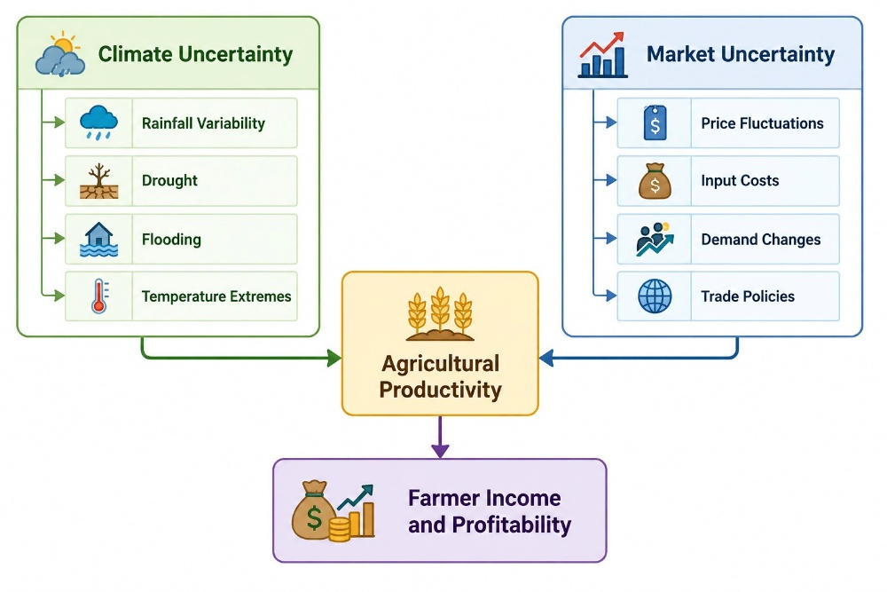

Figure 2: Major sources of uncertainty affecting agricultural planning and farm profitability.

- Machine Learning in Agriculture

Machine Learning (ML) has emerged as one of the most significant technological advancements in modern agriculture, enabling data-driven decision-making and improving the efficiency of farming operations [11], [12]. The increasing availability of agricultural data from sensors, weather stations, satellites, drones, and farm management systems has created opportunities for the application of advanced analytical techniques in agriculture [11]. Unlike traditional statistical methods, machine learning algorithms can identify complex relationships within large datasets and generate accurate predictions without requiring explicitly defined mathematical relationships among variables [12].
Agriculture faces numerous challenges, including climate variability, resource scarcity, pest infestations, disease outbreaks, and market uncertainty [6]–[15]. Consequently, machine learning techniques have gained considerable attention because of their ability to improve forecasting accuracy, optimise resource utilisation, and enhance farm productivity [11], [12]. Over the past decade, researchers have successfully applied machine learning algorithms to crop yield prediction, irrigation management, disease detection, soil analysis, and precision agriculture applications [11]–[15].
4.1 Crop Yield Prediction
Crop yield prediction is one of the most extensively studied applications of machine learning in agriculture [11], [14]. Accurate yield forecasting enables farmers and policymakers to make informed decisions regarding resource allocation, risk management, and agricultural planning [14]. Numerous studies have developed predictive models using climatic, environmental, and management variables to estimate agricultural productivity [11], [14].
Several machine learning algorithms have demonstrated effectiveness in crop yield prediction, including Random Forest (RF), Support Vector Machines (SVM), Artificial Neural Networks (ANN), and Extreme Gradient Boosting (XGBoost) [11], [14]. These algorithms utilise historical data such as rainfall, temperature, soil characteristics, fertiliser application rates, and crop management practices to predict future agricultural output [14].
Research findings indicate that machine learning models often outperform traditional statistical approaches in crop yield forecasting because of their ability to capture nonlinear relationships and complex interactions among variables [11], [14]. Consequently, machine learning has become an important tool for supporting agricultural planning and reducing production-related risks [14].
4.2 Disease and Pest Detection
Plant diseases and pest infestations represent major threats to global agricultural production and food security [12], [13]. Early detection of disease symptoms is essential for minimising crop losses and reducing economic damage [13]. Machine learning techniques, particularly deep learning approaches, have significantly improved the accuracy and speed of disease diagnosis using image-based analysis [13].

Convolutional Neural Networks (CNNs) have been widely employed for the identification and classification of plant diseases using photographs of leaves, stems, and fruits [13]. These models have achieved performance levels comparable to human experts in several agricultural disease detection tasks [13]. Furthermore, image-based classifiers have demonstrated the capability to identify disease symptoms during early stages of infection, thereby supporting timely intervention and treatment [12], [13].
The application of machine learning in disease detection contributes to more efficient pesticide utilisation, lower production costs, and reduced environmental impacts associated with excessive chemical use [12]. Therefore, disease detection systems represent one of the most successful implementations of machine learning in modern agriculture [13].

4.3 Soil and Nutrient Management
Soil quality is a critical factor influencing agricultural productivity and long-term sustainability [11], [12]. Accurate assessment of soil fertility and nutrient availability is necessary for effective crop management and efficient fertiliser application [12]. Various machine learning approaches have been proposed to predict soil properties and support nutrient management decisions [11].
Researchers have applied machine learning techniques such as Random Forest, Artificial Neural Networks, and k-Nearest Neighbours (KNN) to evaluate soil fertility and estimate nutrient availability [11], [12]. These models support precision agriculture by providing recommendations that optimise fertiliser application and improve nutrient utilisation efficiency [12].
Effective soil management not only contributes to increased agricultural productivity but also supports sustainable farming practices by preserving soil health and reducing environmental degradation [29], [30]. Consequently, machine learning-based soil management systems have become increasingly important in sustainable agriculture initiatives [12]..
4.4 Irrigation Scheduling and Water Management
Water management has become increasingly important due to growing concerns regarding water scarcity and climate change [6], [10]. Efficient irrigation scheduling is essential for maintaining crop productivity while minimising water consumption [12].
Machine learning algorithms have been developed to estimate crop water requirements using variables such as rainfall, soil moisture content, humidity, temperature, and evapotranspiration rates [11], [12]. These predictive models assist farmers in determining both the timing and quantity of irrigation required for optimal crop growth [12].

Studies have demonstrated that machine learning-based irrigation systems can significantly improve water-use efficiency and reduce resource wastage [11], [12]. As a result, intelligent irrigation scheduling systems have become an important component of sustainable agricultural water management practices [10], [12].
4.5 Precision Agriculture and Smart Farming
The integration of machine learning with Internet of Things (IoT) technologies, remote sensing systems, and agricultural sensors has contributed significantly to the development of precision agriculture [12], [15]. Precision agriculture aims to optimise farm management through the collection and analysis of detailed information regarding crop conditions, soil characteristics, weather patterns, and resource requirements [15].
Machine learning algorithms process large volumes of agricultural data collected from multiple sources and generate actionable insights for farmers [11], [12]. Applications include crop monitoring, weed detection, nutrient management, yield mapping, and machinery automation [15]. These technologies enable farmers to apply resources more efficiently and improve overall agricultural productivity [12].
The adoption of precision agriculture technologies has increased substantially due to their potential to reduce production costs, improve yields, and enhance environmental sustainability [15]. Therefore, machine learning continues to play a central role in the digital transformation of agriculture [11], [15]
4.6 Limitations of Machine Learning in Agricultural Decision-Making
Despite the significant achievements of machine learning in agricultural prediction and classification tasks, several limitations remain [11], [12]. Most machine learning models focus primarily on forecasting outcomes rather than recommending actions [12]. For example, a crop yield prediction model may accurately estimate future productivity but does not necessarily indicate which crop should be planted or how resources should be allocated to maximise long-term profitability [12].
Furthermore, machine learning algorithms generally operate as predictive systems rather than adaptive decision-making frameworks [11]. They are often unable to optimise sequential decisions under uncertainty because they do not explicitly consider future consequences of current actions [16].
These limitations have encouraged researchers to explore reinforcement learning approaches capable of addressing dynamic decision-making problems within uncertain agricultural environments [16]–[20].

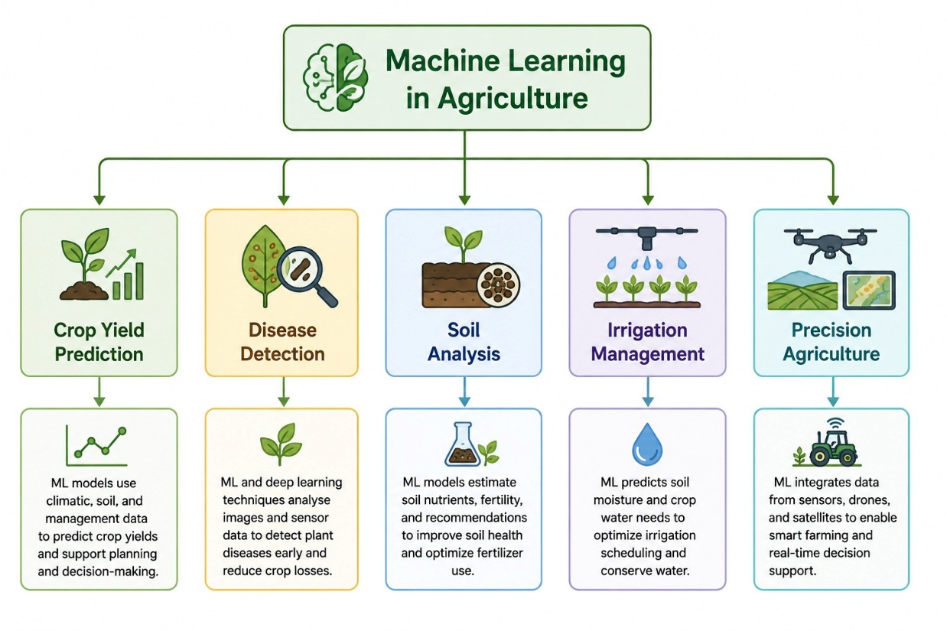
Figure 3: Major applications of Machine Learning in modern agricultural systems.

5. Reinforcement Learning
5.1 Introduction to Reinforcement Learning
Reinforcement Learning (RL) is a branch of artificial intelligence and machine learning that focuses on learning optimal decision-making strategies through interaction with an environment [16]. Unlike supervised learning, which relies on labelled datasets, reinforcement learning enables an agent to learn from experience by receiving rewards or penalties based on its actions [16]. The primary objective of RL is to maximise cumulative rewards over time [16].
Reinforcement learning has gained considerable attention because of its ability to solve complex sequential decision-making problems [16]. Successful applications have been reported in robotics, autonomous vehicles, gaming, finance, healthcare, and resource management [16], [18]. The ability of RL algorithms to adapt to dynamic and uncertain environments makes them particularly suitable for agricultural planning applications [16].
5.2 Fundamental Components of Reinforcement Learning
A reinforcement learning system consists of several interconnected components that collectively support the learning process [16].

### Agent
The agent is the decision-making entity that interacts with the environment and selects actions to maximise cumulative rewards [16]. Within the context of this research, the agent represents either a farmer or an intelligent agricultural planning system responsible for making crop allocation and resource management decisions.

### Environment
The environment represents the external system with which the agent interacts [16]. In agricultural planning, the environment includes farmland, crop conditions, weather variables, market prices, production costs, and farmer savings. The environment responds to the actions selected by the agent and generates corresponding outcomes.

### State
The state describes the current condition of the environment at a particular point in time [16]. In agricultural planning, the state may include variables such as available land area, weather conditions, crop yields, commodity prices, production costs, soil conditions, and available financial resources.

### Action
Actions represent decisions available to the agent [16]. Examples in agricultural planning include crop selection, land allocation, fertiliser application, irrigation scheduling, and investment decisions.

### Reward
The reward function provides feedback regarding the quality of an action [16]. Positive rewards encourage beneficial actions, while negative rewards discourage undesirable decisions. In agricultural planning, rewards may be based on farm income, crop productivity, sustainability indicators, or resource efficiency.

5.3 Markov Decision Process
Most reinforcement learning problems are modelled using a Markov Decision Process (MDP) framework [16]. An MDP provides a mathematical representation of sequential decision-making under uncertainty and consists of states, actions, transition probabilities, and rewards [16].

The Markov property assumes that the future state depends only on the current state and selected action, rather than the complete sequence of previous states [16]. Agricultural planning can be naturally represented as an MDP because decisions are made sequentially over time and influence future agricultural and economic outcomes [16].
Consequently, MDPs provide an appropriate theoretical foundation for modelling long-term agricultural planning problems involving uncertainty and delayed rewards [16].
5.4 Reinforcement Learning Algorithms
Several reinforcement learning algorithms have been developed to address different categories of decision-making problems [16]–[20].
Q-Learning
Q-Learning is one of the earliest and most influential reinforcement learning algorithms [17]. The algorithm estimates the expected cumulative reward associated with each state-action pair and gradually learns an optimal policy through repeated interactions with the environment [17].
Advantages of Q-Learning include simplicity of implementation and model-free learning capabilities [17]. However, Q-Learning suffers from scalability limitations when applied to problems involving large state spaces [17].
Strengths:
Easy implementation
Model-free learning
Weaknesses:
Does not scale well for large state spaces

Deep Q Networks (DQN)
Deep Q Networks (DQN) combine reinforcement learning with deep neural networks to address high-dimensional decision-making problems [18]. By using neural networks to approximate value functions, DQN can effectively operate in environments with large and complex state spaces [18].
DQN has demonstrated impressive performance across a range of challenging applications and is capable of learning complex behavioural patterns [18]. However, the algorithm is primarily designed for discrete action spaces, which may limit its applicability in certain agricultural planning scenarios [18]
Strengths:
Works well with high-dimensional problems
Can learn complex patterns
Weaknesses:
Designed mostly for discrete action spaces
Advantage Actor-Critic (A2C)
Advantage Actor-Critic (A2C) is a reinforcement learning algorithm that combines value-based learning with policy gradient methods [20]. The architecture consists of two components: an actor responsible for selecting actions and a critic responsible for evaluating those actions [20].
A2C offers advantages including faster convergence and improved learning stability compared with some traditional reinforcement learning methods [20]. Nevertheless, the algorithm often requires careful parameter tuning to achieve optimal performance [20].
Actor – chooses actions;
Critic – evaluates chosen actions.
Strengths:
Fast convergence
Stability of learning
Weaknesses:
Dependence on parameter tuning

Proximal Policy Optimisation (PPO)
Proximal Policy Optimisation (PPO) is among the most widely used modern reinforcement learning algorithms [19]. PPO improves training stability by restricting excessively large policy updates during the learning process [19].
The algorithm demonstrates strong performance across a wide range of complex decision-making tasks and supports both continuous and discrete action spaces [19]. Additionally, PPO exhibits efficient utilisation of training samples and has become popular in many real-world reinforcement learning applications [19].

Strengths:
Training process stability
Efficiency for complex tasks
Effective usage of training samples
Works with both continuous and discrete actions
PPO's strength and reliability have contributed greatly to making it popular for decision support in real world applications.

5.5 Suitability of Reinforcement Learning for Agriculture planning
Agricultural planning possesses several characteristics that make reinforcement learning particularly suitable for decision support applications [16]–[20].
First, agricultural decisions are inherently sequential because actions taken during one season influence future production outcomes, soil conditions, and financial resources [16]. Second, agricultural systems operate under substantial uncertainty resulting from weather variability, market fluctuations, and changing production costs [6]–[10]. Third, agricultural decision-making requires balancing short-term profitability with long-term sustainability objectives [29], [30].
Reinforcement learning addresses these challenges by enabling agents to learn adaptive decision-making strategies through interactions with uncertain environments [16]. Unlike conventional optimisation methods, RL continuously updates decision policies based on observed outcomes and accumulated experience [16], [19].
Therefore, reinforcement learning provides a promising framework for developing intelligent agricultural planning systems capable of optimising crop allocation, income generation, resource utilisation, and sustainability over extended planning horizons [16]–[20].
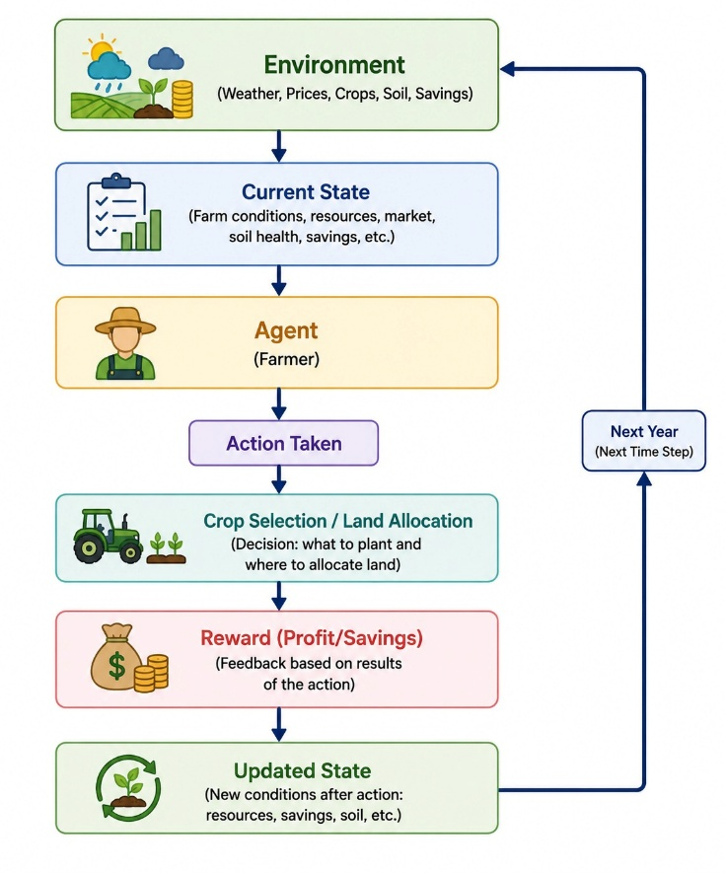
Figure 4: Conceptual Reinforcement Learning framework for long-term agricultural planning.

6.Reinforcement Learning Applications in Agriculture
6.1 Introduction
Recent research has increasingly explored the application of reinforcement learning techniques to agricultural decision-making problems [21]–[28]. Agricultural systems are characterised by sequential decisions, environmental uncertainty, resource constraints, and long-term objectives, making them well suited to reinforcement learning methodologies [21], [24]. Unlike traditional optimisation methods that rely on predefined assumptions, reinforcement learning agents learn adaptive strategies through interactions with the environment [16], [21].
6.2 Greenhouse Climate Control
Greenhouse management requires continuous control of environmental variables such as temperature, humidity, lighting, and carbon dioxide concentration [21], [24]. Reinforcement learning approaches have been successfully applied to automate decisions related to heating, cooling, ventilation, and irrigation [21].
By continuously interacting with greenhouse environments, RL agents learn optimal control strategies that maximise plant growth while minimising resource consumption [21], [24]. Studies have demonstrated that RL-based greenhouse control systems can improve operational efficiency and reduce energy costs [24].
6.3 Fertiliser and Nutrient Management
Efficient fertiliser management is essential for achieving high crop productivity while minimising environmental impacts [26]. Excessive fertiliser use can increase production costs and contribute to environmental degradation, whereas insufficient fertiliser application can reduce crop yields [26].
Researchers have applied reinforcement learning techniques to nutrient management and fertiliser recommendation problems [26]. RL agents learn optimal fertiliser policies by analysing soil conditions, crop growth indicators, nutrient levels, and environmental variables [26]. The objective is to maximise productivity while reducing costs and environmental impacts [26].
6.4 Resource Allocation and Farm Management
Several studies have investigated the use of reinforcement learning for farm management and resource allocation decisions [21], [22], [23]. These applications involve crop selection, labour allocation, machinery utilisation, and production planning under uncertainty [23].
Simulation-based RL models have demonstrated the ability to optimise farm profitability while respecting resource constraints [21]–[23]. Furthermore, reinforcement learning can adapt to changing environmental and economic conditions more effectively than many traditional optimisation approaches [16], [23].

6.5 Crop Planning and Land Allocation
Crop planning and land allocation represent fundamental agricultural decision-making problems [21], [25]. Farmers must determine which crops to cultivate and how much land should be allocated to each crop while considering profitability, sustainability, and resource constraints [25].
Recent studies have modelled crop planning as a sequential optimisation problem in which RL agents select crop allocation strategies based on environmental and economic conditions [21], [25]. Results indicate that reinforcement learning can effectively support long-term agricultural planning under uncertainty [25].
6.6 Critical Review of Current RL Application Studies
The existing literature demonstrates considerable potential for reinforcement learning in agricultural decision support systems [21]–[28]. Successful applications have been reported in irrigation scheduling, greenhouse climate control, nutrient management, and resource allocation [21], [24], [26], [27].
However, several limitations remain. Most existing studies focus on isolated operational-level decisions rather than comprehensive farm-level planning problems [21]–[28]. Many irrigation management studies, for example, do not incorporate market conditions, financial constraints, crop selection decisions, or long-term sustainability considerations [27].
Furthermore, relatively few studies integrate environmental uncertainty, economic uncertainty, and farmer financial sustainability within a single reinforcement learning framework [21]–[28]. These limitations highlight important opportunities for future research and motivate the development of comprehensive reinforcement learning models capable of supporting long-term agricultural planning under uncertainty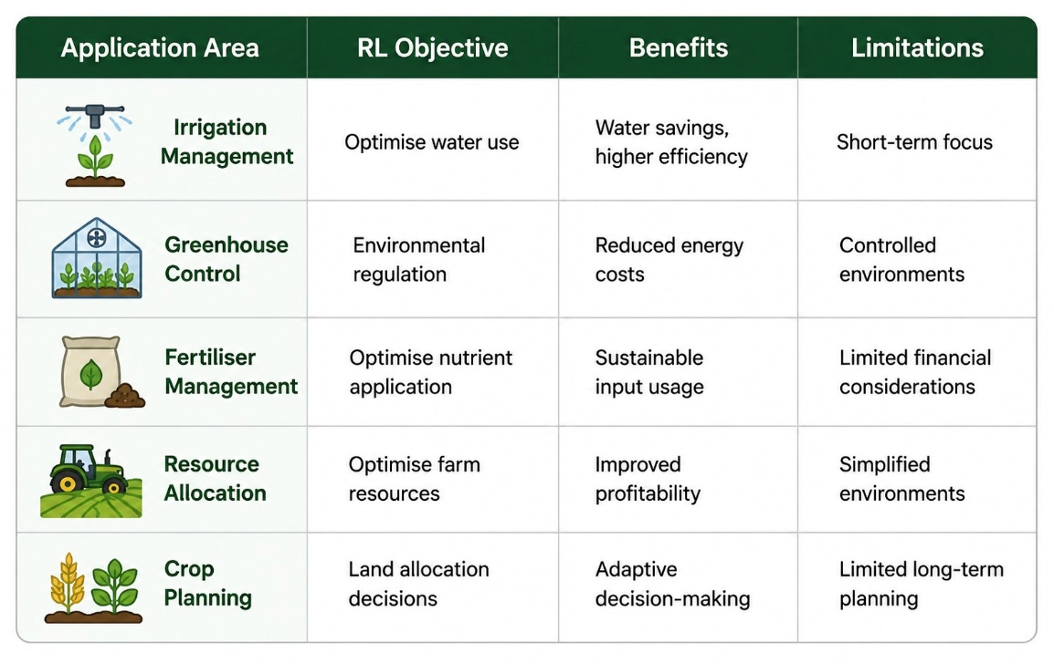
Table 1 : Summary of Reinforcement Learning Applications in Agriculture

7. Data Sources for Agricultural Decision Support
7.1 Introduction
Data serves as the foundation of modern agricultural decision-support systems and plays a critical role in the successful implementation of optimisation and artificial intelligence techniques [11], [12]. The effectiveness of machine learning and reinforcement learning models depends heavily on the availability, quality, and relevance of input data used to represent agricultural environments [11]. Agricultural decision-making involves not only production-related considerations but also economic and environmental factors. Consequently, datasets containing information related to crop production, climate conditions, and market behaviour are essential for developing realistic agricultural planning frameworks [11], [12].
The objective of this research is to develop a reinforcement learning framework capable of supporting long-term crop and income planning under conditions of environmental and economic uncertainty. To achieve this objective, two complementary datasets have been selected. The first dataset provides information regarding crop production and agricultural productivity, while the second dataset contains agricultural market price information reflecting economic conditions and market fluctuations. Together, these datasets provide the foundation for modelling the interactions between agricultural productivity and farm profitability under uncertainty.
7.2 Crop Production Dataset
Crop productivity is a key determinant of farm profitability and agricultural sustainability [1], [2]. Consequently, information related to crop production is essential for supporting agricultural planning decisions and evaluating the performance of alternative crop allocation strategies.
The selected crop production dataset contains information regarding crop types, cultivated area, production levels, yield performance, and climatic variables affecting agricultural productivity. Important variables within the dataset include:

* *Crop* – Name of the cultivated crop.
* *Crop Year* – Year of cultivation.
* *Area* – Land area allocated to crop cultivation.
* *Production* – Total agricultural production.
* *Annual Rainfall* – Rainfall received during the cultivation period.
* *Yield* – Production output per unit area.

These variables provide valuable insights into crop performance under different environmental conditions [7], [8]. In particular, rainfall and yield data are highly relevant for modelling climatic uncertainty within the reinforcement learning environment. The dataset enables the analysis of productivity patterns and supports the estimation of crop performance under varying environmental scenarios [6]–[10].
Furthermore, historical production records can assist in simulating realistic agricultural environments where weather conditions influence production outcomes and farm profitability [7], [8]. Therefore, the crop production dataset constitutes a fundamental component of the proposed reinforcement learning framework.
7.3 Agricultural Market Price Data Set
Although agricultural productivity is important, farm profitability is ultimately determined by both production output and market conditions [2]. Agricultural commodity prices are highly volatile and are influenced by supply-demand relationships, transportation costs, government policies, inflation, and broader economic factors [2], [6]. Consequently, market uncertainty represents a major challenge in agricultural planning and farm management.
To capture economic uncertainty, this research incorporates an agricultural market price dataset containing information collected from agricultural markets. Key variables within the dataset include:
* *State* – Location of the agricultural market.
* *District/Region* – Administrative region.
* *Market* – Agricultural trading market (mandi).
* *Commodity* – Agricultural commodity traded.
* *Variety* – Commodity variety.
* *Arrival Date* – Date of market activity.
* *Minimum Price* – Lowest observed market price.
* *Maximum Price* – Highest observed market price.
* *Modal Price* – Most frequently observed market price.
Among these variables, modal price is considered the primary indicator of market value because it reflects the most representative transaction price within a given market period. Minimum and maximum prices provide additional information regarding price volatility and market fluctuations.
The dataset facilitates the analysis of economic uncertainty and enables estimation of potential farm revenue based on prevailing market conditions. Consequently, the market price dataset plays a critical role in modelling financial outcomes and supporting income optimisation within the proposed reinforcement learning framework.

7.4 Combination of Datasets
The selected datasets provide complementary perspectives on agricultural decision-making. While the crop production dataset focuses on agricultural productivity and environmental conditions, the market price dataset captures economic performance and market uncertainty.
Rather than merging the datasets into a single unified database, each dataset serves a distinct function within the reinforcement learning framework. The crop production dataset is primarily used to estimate:

* Crop yields.
* Production quantities.
* Environmental impacts.
* Effects of rainfall variability.
Similarly, the market price dataset is used to estimate:
* Commodity prices.
* Farm revenue.
* Economic uncertainty.
* Market fluctuations.
The integration of both datasets enables the estimation of agricultural income using the following relationship:
*Revenue = Production × Price*
This relationship allows the reinforcement learning agent to evaluate both productivity and profitability when making agricultural planning decisions. Consequently, the framework can learn policies that maximise long-term income while accounting for uncertainty in both production and market conditions.
7.5 Limitations of the Dataset and Simulation Variables
Although the selected datasets provide valuable information regarding agricultural productivity and market performance, they do not contain all variables required for comprehensive long-term agricultural planning.
Several important variables are either unavailable or only partially represented in publicly accessible agricultural datasets. Examples include:

* Farmer savings.
* Household living expenses.
* Production costs.
* Soil quality indicators.
* Crop rotation history.
* Drought occurrence probabilities.
* Frost events.
* Maturity stages of perennial crops.
These variables play an important role in real-world agricultural decision-making and significantly influence long-term farm sustainability [29], [30]. However, obtaining reliable and comprehensive data for these variables remains challenging.
To address these limitations, additional simulation variables will be incorporated into the reinforcement learning environment using assumptions derived from existing agricultural literature and domain knowledge [1], [29], [30]. This approach allows the simulation environment to better represent realistic agricultural conditions while maintaining manageable levels of model complexity.
7.6 Reasons for Dataset Selection
The selected datasets were chosen because they collectively represent the two primary sources of uncertainty affecting agricultural planning: environmental uncertainty and economic uncertainty.
The crop production dataset captures environmental variability through climatic and productivity-related variables, while the market price dataset represents fluctuations in agricultural commodity markets. Together, these datasets provide sufficient information to construct a realistic agricultural simulation environment without introducing excessive data complexity
Furthermore, the inclusion of both datasets enables the proposed reinforcement learning framework to evaluate decisions from both productivity and profitability perspectives. This dual perspective is essential because successful agricultural planning
requires balancing agronomic performance with economic outcomes.
Therefore, the selected datasets provide an appropriate foundation for developing and evaluating a reinforcement learning framework for long-term crop and income planning under uncertainty.

8. Research Gap and Research Motivation
8.1 Limitations of Traditional Optimisation Methods
Agricultural planning has historically relied on optimisation techniques such as Linear Programming (LP), Dynamic Programming (DP), and Mixed Integer Programming (MIP) [2]–[5]. These methods have been successfully applied to crop allocation, irrigation management, resource planning, and production optimisation problems [2], [5].
Despite their effectiveness, traditional optimisation approaches exhibit several limitations when applied to real-world agricultural systems. Most optimisation models assume deterministic conditions and require predefined parameters describing future environmental and economic conditions [2], [4]. However, agricultural systems are inherently uncertain and are influenced by unpredictable weather events, fluctuating commodity prices, and changing production costs [6]–[10].
Furthermore, many optimisation approaches struggle to adapt dynamically when environmental conditions change significantly during the planning process. As a result, solutions generated under static assumptions may become suboptimal when confronted with real-world uncertainty [4], [5].
8.2 Limitations of Machine Learning Approaches
Machine learning techniques have significantly improved predictive capabilities within agriculture [11]–[15]. Applications such as crop yield prediction, disease detection, soil analysis, irrigation scheduling, and precision agriculture have demonstrated considerable success [11], [12].
Nevertheless, traditional machine learning algorithms are primarily designed for prediction rather than decision-making [12]. Most machine learning models focus on forecasting future outcomes without explicitly recommending actions that maximise long-term benefits.
For example, a crop yield prediction model may accurately estimate future productivity but cannot determine which crop allocation strategy should be adopted to maximise future profitability. Consequently, machine learning models alone are often insufficient for addressing complex sequential decision-making problems involving uncertainty and delayed rewards [16].
8.3 Research Gaps in Reinforcement Learning Applications
Recent studies have demonstrated the potential of reinforcement learning for solving agricultural decision-making problems [21]–[28]. Existing applications include irrigation scheduling, greenhouse climate control, fertiliser management, and crop production optimisation [21], [24], [26], [27].
Although promising results have been reported, several research gaps remain.

First, many reinforcement learning studies focus on isolated operational-level decisions rather than comprehensive farm-level planning problems [21]–[28]. Existing research often examines a single agricultural process while neglecting interactions among multiple farm management decisions.
Second, relatively few studies simultaneously consider environmental uncertainty and economic uncertainty within a unified reinforcement learning framework. Most existing approaches focus primarily on production-related outcomes while giving limited attention to market fluctuations and financial sustainability [21], [25].
Third, long-term financial planning considerations such as farmer savings, household expenditures, and multi-season profitability remain largely unexplored within current reinforcement learning applications [21]–[28].
Finally, sustainability-related factors including crop rotation, soil conservation, and long-term resource management are frequently omitted from reinforcement learning models despite their importance for sustainable agricultural development [29], [30].

8.4 Proposed Reinforcement Learning Framework Motivation

The identified research gaps highlight the need for a comprehensive decision-support framework capable of addressing environmental uncertainty, economic uncertainty, financial sustainability, and long-term agricultural planning simultaneously.
This dissertation proposes a reinforcement learning framework designed to support long-term crop and income planning for farmers operating under uncertain environmental and economic conditions. The framework aims to optimise crop selection, land allocation, and resource utilisation while considering weather variability, market fluctuations, production costs, and financial constraints.
Unlike many existing approaches, the proposed framework integrates both productivity and market-price information to evaluate agricultural decisions from agronomic and economic perspectives. Furthermore, the framework incorporates long-term planning considerations that extend beyond short-term operational optimisation.
By addressing these limitations, the proposed reinforcement learning approach seeks to contribute to the development of intelligent agricultural decision-support systems capable of improving farm profitability, resilience, and sustainability under uncertainty.

9. Chapter Summary

This chapter has presented a comprehensive review of literature related to agricultural planning, climate uncertainty, machine learning, and reinforcement learning. The discussion began with an examination of traditional optimisation techniques, including Linear Programming, Dynamic Programming, and Mixed Integer Programming, which have historically been used to support agricultural planning and resource allocation decisions [2]–[5].
The review subsequently examined the influence of environmental and economic uncertainty on agricultural systems. Climate-related risks such as droughts, floods, temperature fluctuations, and rainfall variability significantly affect agricultural productivity and profitability [6]–[10]. Similarly, commodity price volatility and changing production costs introduce additional challenges for farm management and long-term planning.
The chapter also explored the role of machine learning in modern agriculture. Existing research has demonstrated the effectiveness of machine learning algorithms in crop yield prediction, disease detection, soil analysis, irrigation scheduling, and precision agriculture applications [11]–[15]. Despite these achievements, machine learning approaches remain limited in their ability to support adaptive sequential decision-making.
Reinforcement learning was then introduced as a promising approach for addressing complex decision-making problems under uncertainty [16]–[20]. Fundamental reinforcement learning concepts, including agents, environments, rewards, actions, and Markov Decision Processes, were discussed alongside widely used algorithms such as Q-Learning, Deep Q Networks, Advantage Actor-Critic, and Proximal Policy Optimisation [16]–[20].
The review of reinforcement learning applications in agriculture revealed encouraging results in areas such as greenhouse management, irrigation scheduling, fertiliser optimisation, and resource allocation [21]–[28]. However, several important limitations were identified, including insufficient consideration of long-term planning objectives, financial sustainability, market uncertainty, and sustainability-related agricultural practices.
Based on these observations, a significant research gap was identified concerning the development of integrated reinforcement learning frameworks capable of simultaneously addressing environmental uncertainty, economic uncertainty, long-term financial planning, and sustainable agricultural management. Consequently, this dissertation proposes a reinforcement learning-based decision-support framework designed to optimise crop allocation and income planning while promoting resilience and sustainability within agricultural systems.

10.References

[1] J. L. Dillon, Farm Management for Asia: A Systems Approach. Rome, Italy: Food and Agriculture Organization (FAO), 1997.
[2] P. B. R. Hazell and R. D. Norton, Mathematical Programming for Economic Analysis in Agriculture. London, U.K.: Macmillan Publishing Company, 1986.
[3] E. O. Heady and W. Candler, Linear Programming Methods. Ames, IA, USA: Iowa State University Press, 1958.
[4] A. N. Rae, “An empirical application and evaluation of dynamic programming in farm management,” Journal of Agricultural Economics, vol. 22, no. 3, pp. 331–348, 1971.
[5] B. A. McCarl and T. H. Spreen, Applied Mathematical Programming Using Algebraic Systems. College Station, TX, USA: Texas A&M University Press, 2017.
[6] Intergovernmental Panel on Climate Change (IPCC), Climate Change 2023: Synthesis Report. Geneva, Switzerland: IPCC, 2023.
[7] D. B. Lobell, W. Schlenker, and J. Costa-Roberts, “Climate trends and global crop production since 1980,” Science, vol. 333, no. 6042, pp. 616–620, 2011.
[8] T. Wheeler and J. von Braun, “Climate change impacts on global food security,” Science, vol. 341, no. 6145, pp. 508–513, 2013.
[9] C. Rosenzweig et al., “Assessing agricultural risks of climate change in the 21st century,” Nature Climate Change, vol. 4, no. 5, pp. 385–391, 2014.
[10] S. M. Howden et al., “Adapting agriculture to climate change,” Proceedings of the National Academy of Sciences, vol. 104, no. 50, pp. 19691–19696, 2007.
[11] K. G. Liakos, P. Busato, D. Moshou, S. Pearson, and D. Bochtis, “Machine learning in agriculture: A review,” Sensors, vol. 18, no. 8, Art. no. 2674, 2018.
[12] L. Benos, A. C. Tagarakis, G. Dolias, R. Berruto, D. Kateris, and D. Bochtis, “Machine learning in agriculture: A comprehensive updated review,” Sensors, vol. 21, no. 11, Art. no. 3758, 2021.
[13] A. Kamilaris and F. X. Prenafeta-Boldú, “Deep learning in agriculture: A survey,” Computers and Electronics in Agriculture, vol. 147, pp. 70–90, 2018.
[14] M. Shahhosseini, G. Hu, and I. Huber, “Machine learning and crop yield prediction,” Scientific Reports, vol. 11, Art. no. 3170, 2021.
[15] S. P. Sudha and J. B. S. Loret, “A review on machine learning-based precision agriculture techniques for crop farming monitoring with IoT,” Discover Agriculture, vol. 3, 2025.
[16] R. S. Sutton and A. G. Barto, Reinforcement Learning: An Introduction, 2nd ed. Cambridge, MA, USA: MIT Press, 2018.
[17] C. J. C. H. Watkins and P. Dayan, “Q-learning,” Machine Learning, vol. 8, nos. 3–4, pp. 279–292, 1992.
[18] V. Mnih et al., “Human-level control through deep reinforcement learning,” Nature, vol. 518, no. 7540, pp. 529–533, 2015.
[19] J. Schulman, F. Wolski, P. Dhariwal, A. Radford, and O. Klimov, “Proximal Policy Optimization Algorithms,” arXiv preprint arXiv:1707.06347, 2017.
[20] V. R. Konda and J. N. Tsitsiklis, “Actor-Critic algorithms,” in Advances in Neural Information Processing Systems (NIPS), 2000.
[21] R. Gautron, X. Wang, and P. Berruet, “Reinforcement learning for crop management,” 2022.
[22] R. Tao, B. Konomi, et al., “Optimizing crop management with reinforcement learning,” in Proceedings of the International Joint Conference on Artificial Intelligence (IJCAI), 2023.
[23] M. Madondo, M. Azmat, K. Dipietro, R. Horesh, M. Jacobs, A. Bawa, R. Srinivasan, and F. O’Donncha, “A SWAT-based reinforcement learning framework for crop management,” 2023.
[24] G. Goldenits, K. Mallinger, S. Raubitzek, and T. Neubauer, “Current applications and future directions of reinforcement learning-based digital twins in agriculture,” 2024.
[25] J. Balderas, D. Chen, Y. Huang, L. Wang, and R. Li, “A comparative study of deep reinforcement learning for crop production management,” 2024.
[26] Z. Wang et al., “Reinforcement learning-based agricultural fertilization framework under uncertainty,” Smart Cities, vol. 7, no. 8, Art. no. 252, 2025.
[27] Y. Sun et al., “Reinforcement learning for irrigation management in agriculture,” 2017.
[28] F. Garcia, “Reinforcement learning for wheat management optimisation,” 1999.
[29] J. Pretty, “Agricultural sustainability: Concepts, principles and evidence,” Philosophical Transactions of the Royal Society B, vol. 363, no. 1491, pp. 447–465, 2008.
[30] D. Tilman, C. Balzer, J. Hill, and B. Befort, “Global food demand and sustainable intensification of agriculture,” Proceedings of the National Academy of Sciences, vol. 108, no. 50, pp. 20260–20264, 2011.

