LITERATURE REVIEW

Farmer Crop and Income Planning Using Reinforcement Learning Under Climate and Market Uncertainty

Full Name : Rajesh Dabbugottu
Student ID : A00073166

Table of Contents
- Introduction
- Agricultural Planning and Farm Management
2.1 Traditional Agricultural Planning
2.2 Linear Programming Approaches in Agriculture
2.3 Dynamic Programming Approaches in Agriculture
2.4 Mixed Integer Programming Approaches in Agriculture
2.5 Critical Evaluation of Traditional Planning Methods
2.6 Climate Risk and Agricultural Uncertainty
- Weather-Related Risks in Agriculture
3.1 Climate Change and Long-Term Agricultural Planning
3.2 Economic and Market Uncertainty
3.3 Implications for Agricultural Decision-Making
- Machine Learning in Agriculture
4.1 Crop Yield Prediction
4.2 Disease and Pest Detection
4.3 Soil and Nutrient Management
4.4 Irrigation Scheduling and Water Management
4.5 Precision Agriculture and Smart Farming
4.6 Limitations of Machine Learning in Agricultural Decision-Making
- Reinforcement Learning
5.1 Introduction to Reinforcement Learning
5.2 Fundamental Components of Reinforcement Learning
5.3 Markov Decision Process
5.4 Reinforcement Learning Algorithms
5.4.1 Q-Learning
5.4.2 Deep Q Networks (DQN)
5.4.3 Advantage Actor-Critic (A2C)
5.4.4 Proximal Policy Optimisation (PPO)
5.5 Suitability of Reinforcement Learning for Agriculture Planning
- Reinforcement Learning Applications in Agriculture
6.1 Introduction
6.2 Greenhouse Climate Control
6.3 Fertiliser and Nutrient Management
6.4 Resource Allocation and Farm Management
6.5 Crop Planning and Land Allocation
6.6 Critical Review of Current RL Application Studies
- Data Sources for Agricultural Decision Support
7.1 Introduction
7.2 Crop Production Dataset
7.3 Agricultural Market Price Dataset
7.4 Combination of Datasets
7.5 Limitations of the Dataset and Simulation Variables
7.6 Reasons for Dataset Selection
- Research Gap and Research Motivation
8.1 Limitations of Traditional Optimisation Methods
8.2 Limitations of Machine Learning Approaches
8.3 Research Gaps in Reinforcement Learning Applications
8.4 Proposed Reinforcement Learning Framework Motivation
- Chapter Summary
- References

1.Introduction
In this chapter, relevant literature is reviewed concerning agricultural planning, climate uncertainties, machine learning and reinforcement learning. The complexity of decision-making in agriculture is increasing due to price volatility, climate uncertainties and the demand for sustainable agricultural practices. Traditionally, the use of optimisation methods has been common in agricultural planning to assist farmers' decisions; however, such methods lack adaptability to uncertainties in the environment.
The emergence of Artificial Intelligence and more recently Reinforcement Learning has brought new possibilities for creating smart decision-making solutions based on learning optimal decisions through interactions with dynamic and uncertain environments. In this chapter, a critical analysis of existing research studies on agricultural planning and artificial intelligence solutions for agriculture will be conducted in order to explore the research problem and research gaps.
The review starts with traditional approaches in agriculture planning and follows up with an overview of climate and market uncertainties in agriculture. Next, machine learning and Reinforcement Learning are described, focusing on their applications in agricultural decision-making. Lastly, the chapter presents the research gap, which motivates this thesis work and provides the basis for the development of a reinforcement learning solution for agricultural planning.

2.Agricultural Planning and Farm Management

  - Traditional Agricultural Planning
Agricultural planning can be defined as the decision-making involved in the choice of crops, land allocation, use of agricultural resources, and investments to optimise the farm's productivity and profitability. The success of agricultural activities depends largely on good planning, as it guarantees food security and sustainability. A successful planning strategy involves meeting various requirements including income optimisation, cost reduction, soil conservation, and environmental hazards minimisation.
In the past, agricultural activities have been guided by the experiences of farmers, local traditions, and observations made in previous years. The farmer would make decisions based on the conditions experienced in previous agricultural years, weather, market situations, and consultations with agriculturalists. While this approach has proven quite successful, its effectiveness decreases significantly when faced with variable climatic conditions, prices, and production costs.
An important issue faced in agriculture is that of allocating scarce resources. Farmers usually face constraints in terms of available land, labour, water, machinery, and capital budget. Decisions on crops to grow and the amount of land allocated determine not only profitability but sustainability as well. Ineffective planning can lead to poor agricultural outcomes and even loss of resources.

2.2 Linear Programming Approaches in Agriculture
The method of linear programming (LP) is one of the oldest methods applied in agriculture optimisation. The main goal of linear programming is to obtain an optimum value of a specified criterion by satisfying the necessary criteria (constraints). In case of agriculture, the common types of constraints include land area, labour force, amount of water, budget costs, and demand. Therefore, LP makes decision-making processes more rational since the optimisation process takes into account certain predetermined variables.
There are many different applications of linear programming models for various agricultural planning processes. Linear programming models are used to calculate the best combination of crops in order to achieve the maximum revenue with respect to land and other production conditions. Additionally, linear programming was used for irrigation and fertilisation management and for agricultural supply chains optimisation.

  - Dynamic Programming Approaches in Agriculture
The method of Dynamic Programming (DP) was formulated as a response to the challenges posed by optimisation problems that involved sequential decision-making at various times. In contrast to linear programming, whose objective is usually limited to one planning period, dynamic programming takes account of the impact of present decisions on future situations and results. This makes dynamic programming relevant in agriculture where various farm planning problems have lasting impacts.
Dynamic programming has been employed in the agricultural sector in optimising crop rotations, water usage, livestock operations, and long-term planning. It entails subdividing a complicated problem into sub-problems, and making the optimal decision for each sub-problem after considering future rewards. This technique allows decision makers to weigh the future impacts of various approaches rather than relying on short-term benefits alone.
Dynamic Programming, however, has its own drawbacks. As the number of state variables increases, it leads to a computational difficulty associated with it, known as the "curse of dimensionality." The agricultural system contains a number of variables ranging from the type of crops planted to weather conditions, cost of seeds, and other factors. Thus, as the size of the problem increases, the use of DP can become problematic. It is for this reason that other methods of decision-making have been explored.
  - Mixed Integer Programming Approaches in Agriculture
Unlike previous optimisation methods, which were limited in the use of either continuous or discrete decision variables, Mixed Integer Programming can handle both continuous and discrete variables. Thus, this optimisation approach can be used to make binary decisions related to agriculture, like planting a particular crop, buying equipment, or installing irrigation facilities.
A number of researchers have applied MIP to various agricultural optimisation problems, including those related to crop rotation schemes, allocation of land for various uses, planning for the acquisition of machinery, and logistics. In many cases, MIP was used when agricultural decision-making involved logical conditions that could not be modelled by using LP. For instance, a farmer might be required to either plant a crop on an entire field or not use the field for any cultivation purposes. It is possible to model such situations using discrete variables.

  - Critical Evaluation of Traditional Planning Methods
Optimisation approaches have been instrumental in promoting agricultural planning and agricultural resource management practices. Some of these include linear programming, dynamic programming, and mixed integer programming. These optimisation methods have shown great promise in assisting agricultural resource managers with crop allocation and irrigation decisions, as well as helping individual farms make profit-maximising decisions.
This has led to greater interest in applying concepts such as Artificial Intelligence and machine learning techniques. For instance, Reinforcement Learning is one of the concepts that show promise in helping to make agricultural decisions due to its ability to enable agents to learn from the environment. Contrary to conventional optimisation techniques that focus on maximising short-run gains at the expense of long-run considerations, reinforcement learning is capable of making trade-offs between short-term gains and long-term objectives. It is in this regard that the following discussion focuses on climate uncertainties and risks.
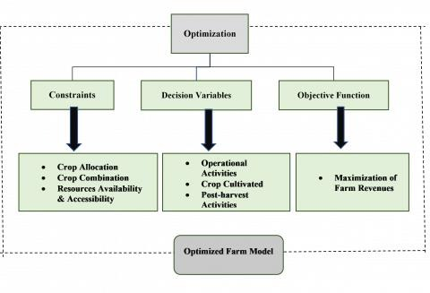
Figure 1: Traditional optimisation methods used in agricultural planning and their limitations in uncertain agricultural environments.

  - Climate Risk and Agricultural Uncertainty
One of the economic sectors that are most affected by the environment is agriculture. The growth and productivity of crops require several environmental variables such as rainfall, temperature, humidity, sunshine, and weather patterns. Agricultural processes are carried out in natural environments, which are very unpredictable and uncontrollable compared to some industrial manufacturing activities. As a result, climate variability is among the biggest obstacles to successful agricultural operations.
Climate variability has become a more prevalent problem for agriculture in the past few decades. Several publications by the Inter-governmental Panel on Climate Change (IPCC) state that the world has experienced global warming, alterations in the rain pattern, and increased occurrences of natural calamities.

3 Weather-Related Risks in Agriculture
Weather impacts crop growth and agricultural productivity through various ways. The amount of rainfall received will determine soil moisture levels as well as the growth of the crops. Inadequate rainfall may result in drought situations, which will lower crop yield and even lead to crop failure. Too much rainfall, on the other hand, might cause soil erosion, flooding, and disease attacks.

Temperature variations also play an important role in agricultural practices. Each type of crop has a preferred range of temperatures at which it grows and develops. Very high temperatures may stress the crop while very low temperatures may harm the crops. Frost situations may be harmful to trees since the low temperatures may affect flowering and fruiting processes.
Scientists have confirmed that weather risk contributes significantly to the variation of agricultural production. It has been observed that weather impacts may differ from one crop to another depending on geographical locations as well as the time of planting. This implies that the farmer must consider expected production and weather risks in determining suitable crops for planting.
3.1 Climate Change and Long-Term Agricultural Planning
A shift towards global warming has also led to more complexity in the process of agricultural planning. Historical records of weather no longer prove sufficient when trying to estimate the future. Changing patterns of rainfall and temperature variations, as well as seasons, add to the difficulty of estimating future agricultural efficiency.
Making long-term investments requires careful consideration and is especially complicated for farmers in the case of climate change. For example, choosing whether to plant a certain type of fruit trees or to invest in irrigation infrastructure usually requires a longer perspective. However, future uncertainties make it hard for farmers to predict the profitability of their decisions.
  - Economic and Market Uncertainty
In addition to the environmental uncertainties faced by farmers, there are economic uncertainties as well. Commodity prices in agriculture are subject to frequent fluctuations due to variations in supply and demand, trade policies, cost of transportation, inflation, and other factors. Hence, even a very bountiful agricultural output cannot necessarily lead to economic success when prices happen to fall.
Production-related costs can also add to uncertainty in farm management, as costs associated with fertiliser use, pesticide application, fuel prices, wages, and maintenance of equipment might change over time. This impacts profitability and influences crop choice.

3.3 Implications for Agricultural Decision-Making
Growing complexity of agricultural systems means that there is a need to apply decision support systems that work well within the context of uncertainty. The conventional optimization approach usually assumes that all information about the future is available or can be forecasted. On the contrary, actual agricultural systems involve numerous stochastic events and changes that cannot be fully foreseen in advance.
This issue will be considered further in the next chapter devoted to Machine Learning in agriculture.
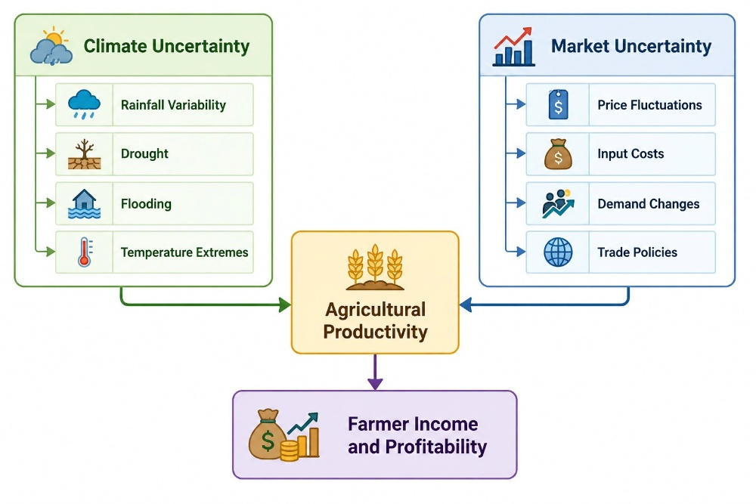

Figure 2: Major sources of uncertainty affecting agricultural planning and farm profitability.

- Machine Learning in Agriculture

Machine Learning is another technology that has become increasingly vital in agriculture because it offers farmers an opportunity to make more informed decisions based on analytics. With the ever-growing amount of information available about agriculture through sensors, weather centers, satellites, drones, and on-farm operations data, Machine Learning has offered a way of using advanced analytics to solve agriculture's challenges. While statistical techniques require explicitly programmed knowledge about relationships between variables, Machine Learning algorithms help identify complex patterns in large data sets and make predictions.
The agricultural industry faces many challenges related to climate change, resource limitations, diseases, and markets. The application of Machine Learning algorithms has gained much attention since it promises more effective forecasts, more efficient management, and higher efficiency in agricultural operations. For the last decade, researchers have extensively used Machine Learning algorithms in crop production, irrigation, plant disease prediction, and soil analysis among other things.
4.1 Crop Yield Prediction
Prediction of crop yield is among the most researched areas for Machine Learning applications in agriculture. Precise forecasting allows for effective planning, resource allocation, and risk reduction. Various studies have used environmental, climate, and management variables to predict crop yields by developing various Machine Learning predictive models.
Some of the Machine Learning algorithms which can be employed in yield prediction include Random Forest (RF), Support Vector Machines (SVM), Artificial Neural Network (ANN), and Extreme Gradient Boosting (XGBoost). All these Machine Learning algorithms consider historical information such as rainfall, temperatures, soil characteristics, fertilizer utilization, and crop management in predicting future agricultural output.
Research findings indicate that Machine Learning algorithms usually give more accurate predictions as compared to statistical models in predicting crop yields. This advantage is attributed to their ability to consider non-linear relations and multiple interactions.
4.2 Disease and Pest Detection
Plant diseases and pest attacks constitute serious risks to agriculture around the globe. The timely detection of these risks is necessary in order to minimise losses and economic impacts. Machine learning technologies, especially those involving deep learning techniques, have greatly enhanced the process of disease detection using computer vision.
The Convolutional Neural Networks technology has been extensively used in order to detect different types of plant diseases using photos of plants' leaves. These algorithms are highly accurate in their predictions and compete with human specialists in their ability to detect disease symptoms. Image-based classifiers have also been developed to detect crop diseases during their initial development stage.
Disease detection using Machine Learning technologies leads to more effective pesticide use, lower costs, and better environmental safety.

4.3 Soil and Nutrient Management
The quality of the soil plays an important role in determining agricultural output. Various machine learning methods have been proposed for the prediction of soil parameters, the evaluation of soil fertility and nutrient availability, and to assist with fertilizer management.
Scientists have employed machine learning methods including Random Forest, Artificial Neural Networks, and k-Nearest Neighbors (KNN) for predicting soil fertility and nutrient availability. Such machine learning methods help in implementing precise farming by offering soil management strategies that improve the utilization of fertilizer.
Effective management of soil helps not only to increase the agricultural output but also in ensuring sustainable agricultural practices through maintenance of soil quality.
4.4 Irrigation Scheduling and Water Management
Water management has become very crucial because of issues of water scarcity and climate change. Irrigation systems for farming operations have adopted machine learning models which can predict water needs by estimating soil moisture.
Scientists have managed to create systems which can predict through the use of variables like rain levels, humidity levels, and evapotranspiration rates. With these predictions, farmers can determine the right time to irrigate their farms and the right amount of water to apply.
It has become evident that the use of machine learning techniques in the development of irrigation methods can improve agriculture by ensuring the conservation of water resources.
4.5 Precision Agriculture and Smart Farming
The amalgamation of Machine Learning with IoT technology, remote sensing, and agricultural sensors is responsible for the emergence of precision agriculture. The objective of precision agriculture is the optimization of farm management operations through the provision of precise information on crop growth, soil status, weather conditions, and resource needs.
Machine Learning uses large amounts of agricultural data gathered from various sources and gives farmers valuable information in return. Machine Learning is used in such applications as crop monitoring, weeds detection, nutrients management, yields mapping, and machinery automation. These technologies allow the efficient utilization of agricultural resources.
4.6 Limitations of Machine Learning in Agricultural Decision-Making
Although Machine Learning has achieved success in predictive and classification problems in agriculture, there exist certain shortcomings of this technique while solving strategic decision-making problems. Most Machine Learning algorithms concentrate on outcome prediction but not action recommendation. The agricultural productivity prediction model will provide a forecast of the future productivity but not specify which crop needs to be planted and which resources need to be allocated.
The next part analyses the theoretical aspects of Reinforcement Learning as well as the feasibility of using Reinforcement Learning to solve complicated issues arising in agriculture under uncertainty.

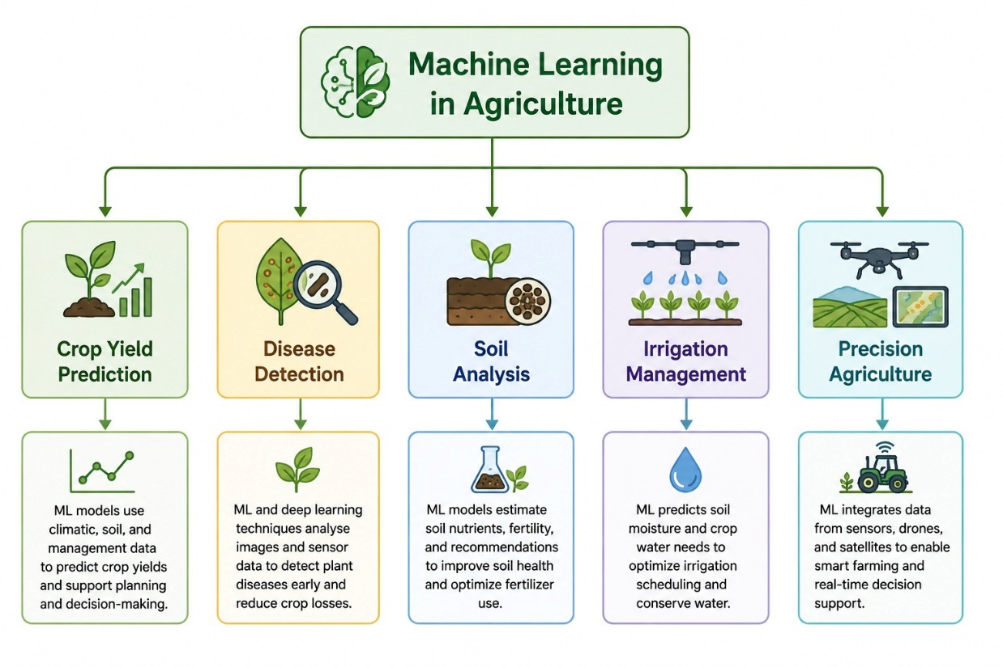
Figure 3: Major applications of Machine Learning in modern agricultural systems.

5. Reinforcement Learning
5.1 Introduction to Reinforcement Learning
Reinforcement Learning (RL) can be defined as a field of artificial intelligence and machine learning which concerns the process of learning how to act optimally in a certain environment. While in case of traditional supervised learning methods, learning occurs through the use of labelled data, Reinforcement Learning allows an agent to learn through experience gained as a result of being rewarded or penalised. The goal of RL is to achieve the greatest sum of rewards in the long run.
Reinforcement Learning has received increasing recognition because of its capability of solving sequential decision problems that require a great deal of expertise. RL has proven successful in a variety of applications such as robotics, autonomous driving, gaming, finance, healthcare, and resources management. The capability of adapting to dynamic changes in the environment makes Reinforcement Learning highly relevant for agricultural planning.

5.2 Fundamental Components of Reinforcement Learning
There are different elements that comprise an RL system and act together throughout the whole process of learning.
Agent
The agent is an entity inside the environment capable of making decisions. With respect to our work, the RL agent is represented by a farmer or the agricultural planning system. The agent acts based on observation of the current state of the environment in an effort to maximize long-term gains.
Environment
The environment is an external system interacting with the agent. In our case, the environment is represented by agricultural land, crops, weather conditions, market prices, production expenses, and savings of the farmer. The environment reacts to the actions of the agent and presents the outcomes to the latter.
State
The state is the condition of the environment in a certain moment in time. In the context of agricultural planning, state may be represented as follows:

5.3 Markov Decision Process
Almost all reinforcement learning tasks are represented using a Markov Decision Process (MDP). An MDP is a framework used to model sequential decision processes under uncertainty.
The Markov assumption states that the next state depends only on the current state and actions taken in the latter, and not the full sequence of events leading up to it.
Planning of agriculture can be easily described as a form of an MDP since all the plans related to agriculture will be made one after another based on certain conditions. In such a way, the MDP method serves as an adequate basis for modeling long-term agricultural issues.

5.4 Reinforcement Learning Algorithms
Several Reinforcement Learning algorithms have been proposed to solve various kinds of decision-making problems.
Q-Learning
Q-learning is an early RL algorithm. It calculates the expected reward per each state-action pair and learns a policy.

Strengths:
Easy implementation
Model-free learning

Weaknesses:
Does not scale well for large state spaces
Deep Q Networks (DQN)

DQN uses the combination of reinforcement and deep neural networks methods. It can work efficiently in more complicated environments compared to the standard Q-Learning.

Strengths:
Works well with high-dimensional problems
Can learn complex patterns

Weaknesses:
Designed mostly for discrete action spaces
Advantage Actor-Critic (A2C)

A2C is an algorithm which combines value-based and policy gradient methods. The algorithm includes two parts:

Actor – chooses actions;
Critic – evaluates chosen actions.

Strengths:
Fast convergence
Stability of learning

Weaknesses:
Dependence on parameter tuning
Proximal Policy Optimisation (PPO)

Proximal Policy Optimisation (PPO) is one of the most popular recent RL algorithms. PPO achieves higher training stability through reducing very big policy updates in each iteration.

Strengths:
Training process stability
Efficiency for complex tasks
Effective usage of training samples
Works with both continuous and discrete actions
PPO's strength and reliability have contributed greatly to making it popular for decision support in real world applications.

5.5 Suitability of Reinforcement Learning for Agriculture planning

Agriculture planning displays certain features which render reinforcement learning highly suitable.
Firstly, the decisions in agriculture planning happen sequentially year after year. This is because current year's decisions regarding the planting of crops affect soil and economic situation in future.
Secondly, there is a lot of uncertainty in agriculture planning. This is because one cannot predict rainfall, droughts, prices, and cost of producing.
Lastly, there is usually short term and long term considerations. Profit maximisation in the short run does not guarantee a sustainable solution in the long run.
RL offers solutions to these problems by having agents that interact with the uncertain environment to learn adaptively. Unlike the optimisation methods where the parameters remain static, RL constantly adjusts the parameters in response to observed outcomes.
For the aforementioned reasons, Reinforcement Learning offers a suitable basis for creating intelligence-driven agricultural planning systems that can optimize crop allocation and income, as well as ensure sustainability.

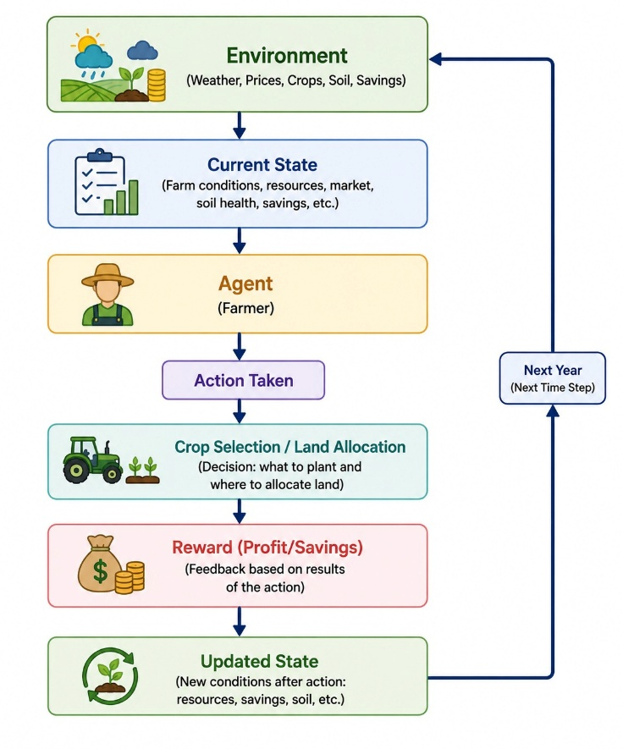
Figure 4: Conceptual Reinforcement Learning framework for long-term agricultural planning.

6.Reinforcement Learning Applications in Agriculture
6.1 Introduction
Increasing focus has been laid on using Reinforcement Learning methods for improving decision-making in uncertain and dynamic scenarios, making RL a growing area of interest in agricultural science research. Agricultural operations are characterized by sequential decision-making, environmental uncertainty, constraints on resources, and goal-oriented planning – all factors which make agriculture a suitable field of applications for reinforcement learning techniques. As opposed to optimisation algorithms, which require a series of predefined assumptions, reinforcement learning agents adapt their behaviour based on environmental feedback.

6.2 Greenhouse Climate Control
For greenhouse farming, monitoring and controlling factors such as temperature, humidity, lighting, and CO2 concentration is critical for ensuring optimal plant growth and productivity.
RL approaches have been implemented in greenhouse control systems to automatically make decisions related to adjusting heating, ventilation, cooling, and watering. By interacting with the environment over time, an RL agent learns how to optimally control greenhouse factors based on environmental conditions and plants' needs.
Studies show that implementing greenhouse control systems based on RL can help to optimise resource usage and save money. Adaptive learning capabilities of RL contribute to better functioning of management systems in dynamic environments.
6.3 Fertiliser and Nutrient Management
Fertiliser application greatly affects the productivity of crops. While excessive fertiliser usage can be costly and damaging for the environment, insufficient amounts can limit productivity. Finding an optimal fertiliser policy can be seen as an agriculturally relevant optimisation task.
Some works have applied Reinforcement Learning techniques to nutrient management and recommendation problems. Agents can learn fertiliser policies through observations of soil states, crop growth indices, nutrient amounts, and environmental parameters, where they aim to maximise crop yields at minimal fertiliser cost and negative impact on the environment.
6.4 Resource Allocation and Farm Management
Only a few works focus on applying Reinforcement Learning for more general farm management and resource allocation tasks. In those studies, reinforcement learning is used to optimize choices about crop selection, resource allocation, manpower management, and production planning.
Such reinforcement learning models make decisions within a simulated farming environment in order to maximize economic gain under resource constraints. It has been shown that Reinforcement Learning can cope well with uncertainty and changing conditions of an environment. Moreover, Reinforcement Learning allows optimizing decisions made over several periods of time.
6.5 Crop Planning and Land Allocation
The selection of crop and determination of the amount of land used for each is one of the most important issues of farm management since farmers have to consider their profits and other environmental and resources issues when making decisions.
Some researchers have studied RL approaches for solving crop planning tasks. In these cases, agricultural activity is treated as a sequential optimisation task where an RL agent chooses strategies of crop allocation depending on economic and environmental conditions.
6.6 Critical Review of Current RL Application Studies

From the available literature, it is clear that RL has great prospects for decision support in agriculture. This technology has been employed in areas like irrigation scheduling, greenhouse management, fertilizer management, and resource allocation decisions.
However, there are certain limitations in these studies. In the first place, current studies tend to apply RL to isolated agricultural operations. Many studies on irrigation scheduling fail to consider factors such as market conditions, financial considerations, and crop selection process.
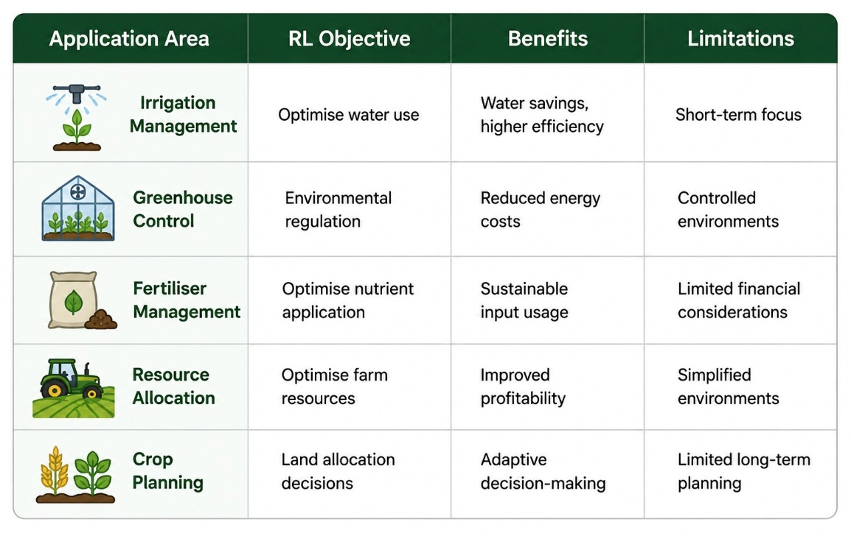
Table 1 : Summary of Reinforcement Learning Applications in Agriculture

7. Data Sources for Agricultural Decision Support
7.1 Introduction
Data forms the basis of agricultural decision-making systems that operate in modern agriculture. The success of optimization and AI-based algorithms relies on the availability and quality of the input data that helps create models of agricultural landscapes. Decision-making processes related to agriculture should take into account not only production aspects but also economic conditions. Therefore, the datasets that include information aboutproduction, climate, and market behavior should be considered.
The goal of the research is the creation of the Reinforcement Learning approach, which is able to perform long-term crop and income planning when there is uncertainty regarding the economic and environmental situation. The following datasets were chosen in order to fulfill the goals mentioned above. One of them includes information about production and agricultural productivity. The other one is related to market price fluctuations.
7.2 Crop Production Dataset
Crop productivity forms an important aspect of farm planning since crop choices have a direct impact on crop productivity and profitability in agriculture. The crop production dataset includes information on crop type, crop productivity, allocated land area for crop cultivation, and climatic conditions that affect agricultural productivity.

The dataset has variables like:
Variable-Description
Crop- Name of cultivated crop
Crop year- Year of cultivation
Area- Allocated area for crop cultivation
Production- Crop production
Annual rainfall- Annual rainfall at time of cultivation
Yield- Yield per unit area

This variable gives valuable insight into crop performance under certain climatic conditions. Variables like rainfall and yield are very useful in simulating climatic uncertainties in the Reinforcement Learning Environment.

7.3 Agricultural Market Price Data Set

Besides agricultural productivity, farm profitabilities are also affected by the state of the market. Agricultural commodity prices are prone to fluctuation due to many reasons ranging from supply and demand dynamics, transportation costs, change in policies to macroeconomic factors. Thus, the element of market uncertainty becomes a key issue affecting agricultural decisions.
Economic variability is considered in the current research, as one of the data sets involves an agricultural market price data set, which consists of data collected from agricultural markets.

Data variables include:

Variable- Description
State- State where the market is located
District Region -administratively
Market Agricultural- market (mandi)
Commodity- Name of agricultural commodity
Variety- Variety of the product
Arrival Date- Date of the market activity
Min Price- The lowest market price
Max Price- The highest market price
Modal Price- Most popular market price

Among the above-mentioned variables, modal price is considered as the key indicator reflecting the market value, thus being used to project possible farm income. Minimum and maximum prices are included to facilitate the analysis of market fluctuations.
This dataset allows for the analysis of economic uncertainty as well as the calculation of revenue created through the process of crop production.

7.4 Combination of Datasets
The two datasets provide different perspectives on how decisions regarding agriculture can be made. While the former contains information about agricultural productivity, the latter gives information about economic performance.
While the datasets come from different sources and have different data elements, it does not mean that they should necessarily be combined into one unified dataset. Rather, the datasets play different roles within the Reinforcement Learning framework.
The crop production dataset can be utilized to estimate:
Yield of crops
Quantity produced
Environmental impact
Impact of rainfalls

The market price dataset can be used to estimate:
Prices of commodities
Revenue creation
Economic uncertainty

Thus, the combination of both datasets allows estimating agricultural income through the following equation:
Revenue = Production * Price

7.5 Limitations of the Dataset and Simulation Variables
Although the chosen datasets offer valuable information about the efficiency of agriculture and commodity pricing, some of the necessary variables for long-term agricultural planning are not easily found in such datasets.

For instance, the following:
Farmer savings
Living expenditures of the household
Costs of production
Soil quality
History of crops rotation
Risk of drought
Events of frost occurrence
Maturity stage of tree crops

These variables play a crucial role in effective agricultural planning but are rarely presented in publically available databases. Thus, they will be considered in the simulation setup based on assumptions obtained from the literature review on agriculture.

7.6 Reasons for Dataset Selection

Both the chosen datasets were selected due to the fact that they reflect two main types of uncertainties, namely environmental uncertainty and economic uncertainty, which play a significant role in agricultural planning.
[10:01 pm, 08/06/2026] Rajesh: These datasets together provide adequate information to design a realistic farming simulation environment without getting into excessive data complexity. The inclusion of two datasets makes it possible for the proposed Reinforcement Learning model to analyze productivity-oriented results as well as economically driven ones.

8. Research Gap and Research Motivation

The study of agricultural planning through optimization and decision support methods has been conducted using several methods including Linear Programming, Dynamic Programming, and Mixed Integer Programming. These have been used to solve agricultural production planning problems and allocate crops effectively. The use of such mathematical techniques helps find optimal solutions with regard to certain criteria within a set of restrictions imposed. However, this approach is often hindered by assumptions about determinism and stationary decision environment.
Based on the literature discussed in this chapter, climate uncertainties and market uncertainties remain among the most pressing problems facing agricultural production in contemporary times. Weather uncertainties, including droughts, floods, and changes in temperatures, directly affect agricultural production, while uncertainties in commodity prices and production costs reflect economic uncertainties. While optimization algorithms could include constraints, their application is usually not adaptive enough to address changes in the environment and economic situations.

The introduction of Machine Learning has greatly increased the predictive power of the agricultural industry. Applications of Machine Learning algorithms in predicting crop yields, detecting diseases, soil analysis, irrigation optimization, and other uses in precision agriculture have been demonstrated successfully in various researches. The results show that the application of Machine Learning can benefit agriculture by enhancing agricultural production efficiency. However, traditional Machine Learning algorithms are mostly designed for prediction purposes but not decision-making.
Finally, there is the increasing use of Reinforcement Learning approaches within agriculture. In existing literature, there are numerous applications of RL in irrigation scheduling, greenhouse climates, fertilizer application and optimization of resources. The ability of agents to learn adaptable strategies and act successfully under uncertainty conditions has been demonstrated. In comparison to traditional approaches to optimization, reinforcement learning algorithms allow for more flexibility and improvement based on interactions with an environment.

Despite these achievements, there are still several issues and questions to be explored. Firstly, most of the RL applications within agriculture are focused on operational level problems. Current research does not consider farm-level optimization problems that involve making decisions regarding more complex strategic actions.

Lastly, there is lack of consideration of some sustainability aspects such as crop rotations and soil protection. These issues help to maintain sustainability in agriculture over the long period.
Given the above-listed gaps, it can be said that there arises a need for development of a comprehensive decision-supporting framework which will take into account environmental uncertainty, economic uncertainty, long-term financial considerations, diversity in crops as well as sustainability considerations. This dissertation attempts to fill in this gap through a proposed Reinforcement Learning framework for long-term crop and income planning for farmers. The proposed framework aims at optimising crop choices and land usage for long-term planning horizons while keeping in mind the variability of weather conditions, markets, cost of production and farmer savings. The use of productivity as well as market price data aims to assist agricultural decision making under uncertainty.

9. Chapter Summary

The current chapter provided an overview of the existing literature on agricultural planning, climate uncertainty, Machine Learning and Reinforcement Learning. The discussion started with an analysis of the conventional approaches to agricultural planning, such as Linear Programming, Dynamic Programming and Mixed Integer Programming. These approaches have been instrumental in providing solutions to problems related to crop allocation as well as resources allocation.
The rest of the chapter was dedicated to the role of climate uncertainty and market uncertainty in the context of agricultural decision making. Environmental uncertainties such as droughts, floods, unpredictable amounts of rainfall, and temperature changes can significantly influence agricultural productivity. Likewise, price changes and production cost changes add to economic uncertainties.

Application of Machine Learning in agriculture has been considered. Current research has already shown that Machine Learning models can be successfully applied to predict crop yields, detect diseases, manage irrigation, analyze soil properties, and implement precision agriculture practices. Even though they are highly efficient, the algorithms mentioned are usually unable to solve sequential decision-making and optimization tasks.

Following this, the concept of Reinforcement Learning was introduced as a solution to adaptive decision-making under conditions of uncertainty. Basic notions in reinforcement learning such as agent, environment, state, action, reward, and Markov Decision Process (MDP) were considered, and popular reinforcement learning algorithms such as Q-Learning, Deep Q Networks, Advantage Actor-Critic (A2C), and Proximal Policy Optimisation (PPO) were briefly described.
The analysis of the current Reinforcement Learning applications to agriculture demonstrated that there are some positive findings in irrigation scheduling, greenhouses' management, fertilizer optimization, and resources' planning. Still, there are certain drawbacks identified within the existing literature on the topic. In particular, there is a lack of long-term planning models, climate uncertainty and market uncertainty are not taken into account properly, the sustainability of farmers' finances are not considered, and the management of both annual and perennial crops remains beyond the scope of the analysis.

10.References

Agricultural Planning and Optimisation
1. Dillon, J. L. (1997). Farm management for Asia: A systems approach. Food and Agriculture Organization.
2. Hazell, P. B. R., & Norton, R. D. (1986). Mathematical programming for economic analysis in agriculture. Macmillan.
3. Heady, E. O., & Candler, W. (1958). Linear programming methods. Iowa State University Press.
4. Rae, A. N. (1971). An empirical application and evaluation of dynamic programming in farm management. Journal of Agricultural Economics, 22(3), 331–348.
5. McCarl, B. A., & Spreen, T. H. (2017). Applied mathematical programming using algebraic systems. Texas A&M University.
Climate Risk and Agricultural Uncertainty

6. Intergovernmental Panel on Climate Change (IPCC). (2023). Climate Change 2023: Synthesis Report. IPCC.
7. Lobell, D. B., Schlenker, W., & Costa-Roberts, J. (2011). Climate trends and global crop production since 1980. Science, 333(6042), 616–620.
8. Wheeler, T., & von Braun, J. (2013). Climate change impacts on global food security. Science, 341(6145), 508–513.
9. Rosenzweig, C., et al. (2014). Assessing agricultural risks of climate change. Nature Climate Change, 4(5), 385–391.
10. Howden, S. M., et al. (2007). Adapting agriculture to climate change. Proceedings of the National Academy of Sciences, 104(50), 19691–19696.

Machine Learning in Agriculture
11. Liakos, K. G., Busato, P., Moshou, D., Pearson, S., & Bochtis, D. (2018). Machine learning in agriculture: A review. Sensors, 18(8), 2674.
12. Benos, L., Tagarakis, A. C., Dolias, G., Berruto, R., Kateris, D., & Bochtis, D. (2021). Machine learning in agriculture: A comprehensive updated review. Sensors, 21(11), 3758.
13. Kamilaris, A., & Prenafeta-Boldú, F. X. (2018). Deep learning in agriculture: A survey. Computers and Electronics in Agriculture, 147, 70–90.
14. Shahhosseini, M., Hu, G., & Huber, I. (2021). Machine learning and crop yield prediction. Scientific Reports, 11, 3170.
15. Sudha, S. P., & Loret, J. B. S. (2025). A review on machine learning-based precision agriculture techniques for crop farming monitoring with IoT. Discover Agriculture.

Reinforcement Learning Foundations
16. Sutton, R. S., & Barto, A. G. (2018). Reinforcement learning: An introduction (2nd ed.). MIT Press.
17. Watkins, C. J. C. H., & Dayan, P. (1992). Q-learning. Machine Learning, 8(3–4), 279–292.
18. Mnih, V., et al. (2015). Human-level control through deep reinforcement learning. Nature, 518(7540), 529–533.
19. Schulman, J., Wolski, F., Dhariwal, P., Radford, A., & Klimov, O. (2017). Proximal Policy Optimization Algorithms. arXiv preprint arXiv:1707.06347.
20. Konda, V. R., & Tsitsiklis, J. N. (2000). Actor-Critic algorithms. Advances in Neural Information Processing Systems.

Reinforcement Learning in Agriculture
21. Gautron, R., Wang, X., & Berruet, P. (2022). Reinforcement learning for crop management.
22. Tao, R., Konomi, B., & colleagues. (2023). Optimizing crop management with reinforcement learning. Proceedings of IJCAI 2023.
23. Madondo, M., Azmat, M., Dipietro, K., Horesh, R., Jacobs, M., Bawa, A., Srinivasan, R., & O’Donncha, F. (2023). A SWAT-based reinforcement learning framework for crop management.
24. Goldenits, G., Mallinger, K., Raubitzek, S., & Neubauer, T. (2024). Current applications and future directions of reinforcement learning-based digital twins in agriculture.
25. Balderas, J., Chen, D., Huang, Y., Wang, L., & Li, R. (2024). A comparative study of deep reinforcement learning for crop production management.
26. Wang, Z., et al. (2025). Reinforcement learning-based agricultural fertilization framework under uncertainty. Smart Cities, 7(8), 252.
27. Sun, Y., et al. (2017). Reinforcement learning for irrigation management in agriculture.
28. Garcia, F. (1999). Reinforcement learning for wheat management optimisation.

Sustainability and Agricultural Decision Support
29. Pretty, J. (2008). Agricultural sustainability: Concepts, principles and evidence. Philosophical Transactions of the Royal Society B, 363(1491), 447–465.
30. Tilman, D., Balzer, C., Hill, J., & Befort, B. (2011). Global food demand and sustainable intensification. Proceedings of the National Academy of Sciences, 108(50), 20260–20264.

