1. The reference base code used is <https://github.com/SamYuen101234/Masked_Face_Recognition>

1. Code layout structure

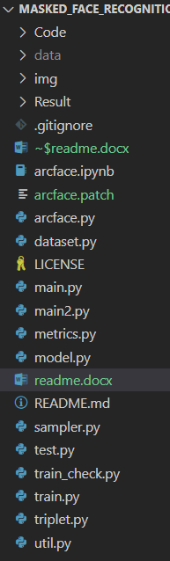

|  |  |
| --- | --- |
| Folder/file |  |
| ./Code | This has the location of train and test image |
| ./data | Location of train, test, eval csv’s |
| Main.py | Main file to execute triplet loss |
| Main2.py | Main file to execute ArcLoss |
| Arcface.py | Arc loss file |
| Triplet.py | Triplet loss file |

1. Steps to run the code.
2. Clone the forked repository

!git clone <https://github.com/rajesh-iitj/Masked_Face_Recognition.git>

1. Download the dataset.
2. cd /content/drive/MyDrive/AML/Masked_Face_Recognition
3. install the python package dependencies

!pip install facenet-pytorch

!pip install efficientnet_pytorch

!pip install timm

1. For arcface run the below command

!python main2.py

1. For triplet run the below command

!python main.py