RESUME
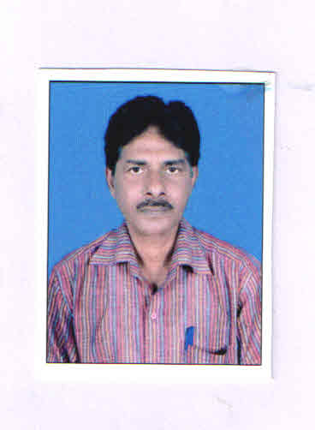

IMARAT HUSSAIN ANSARI
B.Tech.(Mech.)
N.I.T. Kurukshetra (HARYANA)
Contact No.-9835742775,7909033959
e-mail: imarat.hussain@gmail.com

Objective

To obtain a challenging position in an organization where I can make useful contribution to the organization and prove credentials as a better professional.

Post applied for – Vice President-Production

Job Location – Bihar

Name of the candidate : IMARAT HUSSAIN ANSARI
Date of birth : 14th October, 1964
Category (SC/ST/OBC/PH/GEN) : OBC
Sex : Male
Marital Status : Married
Father's Name : Late Tamijuddin Ansari
Nationality : Indian
Permanent Address : Imarat Hussain Ansari
Vill- Birgaon,
P.O.- Panjania,
Via- Jamtara
Distt.-Jamtara (Jharkhand)
Correspondence Address : C/o-Late Md. Yasin
Bariatu Near Madersa,
P.O.- Bariatu-834009
Ranchi (Jharkhand)
M- 9835742775, 7909033959

Professional Qualification

Passed B.Tech(Mech.) from National Institute of Technology Kurukshetra (HARYANA) in 1990 under Kurukshetra University.

Vocation Training

- After 3rd year of 5 yrs degree engineering course of Mechanical Engineering I had gone to 30 days training in Panchet Hydel Power Station under Damodar Valley Corporation.
- Again after 4th year I had gone to 30 days training in Mathon Hydel Power Station. This power station is also under Damodar Valley Corporation.

Knowledge of languages

I know Hindi, English and Bengali.

Key skill

Learn & grasp easily.
Easily adjustable in a team environment.
Look forward to handle responsibilities.

Hobbies

To go to a picnic spot along with friends and family members.

Industrial Experience

- I worked as Mechanical Engineer (Production, Manufacturing & Maintenance) from Aug.1990 to Oct 31st 2004,in Hind Protective Coatings Ltd, Sohna Gurgoan (Haryana)

Note:-I worked more than 14 years. as Mechanical Engineer in a manufacturing company(Production, Manufacturing & Maintenance) in the Mechanical Maintenance Shop where MS Pipes were made first as known as pattern or mandrel of different size ranging from 50mm dia. to 1200mm dia. as per requirement. Finally on the mandrel the FRP pipes were made. There are so many Machines for Maintenance purposes. There are a team of Technician, they were all controlled by me. Therefore I led Mechanical Maintenance Shop.

- I worked as a Part Time Lecturer in Govt. Poly Technic Adiyapur,Jamshedpur from Dec 10th 2004 to July 21st 2007.

Note:-I worked 2 years and 8 months as a Part Time Lecturer(Mechanical) in Govt.Poly Technic Jamsedpur,where I taught Manufacturing Process to the students there.

- Again I joined. as a Plant Manager in Hind Protective Coatings Ltd, Sohna Gurgoan(Haryana)in Sep 15th 2007 to 30/04/2016. Last 2 years I was there as a Plant Head. Note:-Again I joined the above Plant as a Plant Manager. I worked more than 7 years . Last 2 years I was there as a Plant Head.I looked Production, Manufacturing & Maintenance etc of the Plant.
- I am working in the same plant as above.

Production of The Plant

FRP(Fiber Reinforced Plastic) Pipes and Tanks of different diameter are manufactured through chemical resin on the glass fiber, after cooling the pipes become solid state.

Job Assignment

Pipes were manufactured on the mandrels of sheet metal. The pipes were manufactured of different diameter ranging from 50 mm dia to 1200 mm dia and 5m long. So initially mandrels were made in the Mechanical Maintenance shop where I am deployed. These work were done by my own supervision. In Mechanical Maintenance shop there was a team of fitter, welder, Machinist and other workers. They were all controlled by me. I was responsible for whole the work.
At last the hydraulic test was done to the prepared pipes. This showed the strength of the pipes that these how much pressure could withstand.
On requirement I used to go the site where these pipes were fitted along with the team of Mechanical Maintenance shop.
I also looked Production Manufacturing, Maintenance and administration etc. of the Plant.

Declaration

I do hereby declare that all the information, as mentioned above is true and correct to the best of my knowledge and belief.

Yours Faithfully
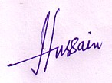
Place: Ranchi
Date: - 23.11.2020
(IMARAT HUSSAIN ANSARI)
Experience : 25 Years +

