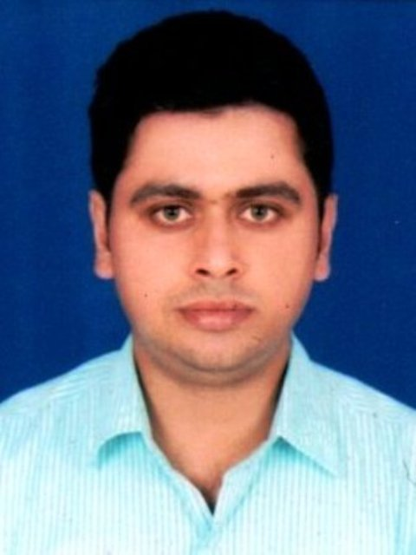 GAURAV BANERJEE
Address: A Extension Block, Nutan Pally, Benachity, Durgapur (W.B)
Email:gbanerjee88@gmail.com Contact: +91- 9834839352,8390869531

OBJECTIVE

- I want to build my career on instrumentation field where I can grow up my potential and knowledge in the presence of dedicated and committed people. I can do my work independently with my colleagues and other co-workers by motivating, providing guidance and directions to help them in such a safe working environment.
PROFILE

- Competent Professional with 9 years 6 months of Experience in Maintenance & Operation, Erection, Installation and Calibration, Reporting and Documentation in Power Plant.

- Profficient in C&I Drawing, Control Logics, Control Wiring, PLC Network Communication, Optical Fibre Communication, PLC and ABB DCS Inputs and Outputs ( DI , AI , DO , AO , RTD).

- An Effective Communicator with Analytical, Relationship Management and Problem Solving Skills.

TECHNICAL SKILLS

- Working knowledge on SCADA (Simplicity, WinCC, 800xA Service ABB System) and PLC of Proficy Machine Edition (GE), Unity Pro (Schnieder), SIMATIC MANAGER (Siemens), Rockwell and DCS (ABB).

- Calibration & Servicing of Belt-Weigher of conveyors, Position Monitoring System of Travelling Tripper of Bunkers, Pressure Switch, Pressure Gauge, Temperature Switch, Temperature Gauge, DP Switch and Transmitters.

- Monitoring and Maintenance of - Temperature/ Flow/ Level and Pressure Field Instruments, Control Valves, Actuators, ZSS, Pull-chord Switch, Belt-sway Switch, Thruster Brake Limit Switch, Proximity Sensor, Heavy Duty Limit Switch, Toggle Limit Switch, Local Push Buttons, Position Limit Switch, Torque Limit Switch, Metal Detector, Belt Rapture Unit, PA System Unit and Fire Detection System.

- Thermocouple, RTD, Control Valves, Damper and it's positioner, Pressure, Flow and Level Transmitters, Level Probe, Air Limit Switch, Power Cylinder, Quick Exhaust Valve, Blow Valve, SOV, Air Lock Relay,Air Filter Regulator, I/P Converter etc.

- Moreover has an efficient IT skill in SAP system as per industries demand.

WORK EXPERIENCE

- Since March 2018 Working as a Jr. Manager at Captive Power Plant of 85 MW STG under Jai Balaji Industries Limited, Banskopa (W.B).
Key Result Areas:
- Responsible for Preventive and Breakdown Maintenance of Field Instruments and Field Junction Box of 170 tph and 85 tph Boilers.
- Preventive and Breakdown Maintenance of 2*25 MW and 35 MW Steam Turbine Generator related Instruments

- Preventive and Breakdown Maintenance of 4*10 tph Sponge WHRB Field Instruments and JB

- Preventive and Breakdown Maintenance of 2*40 tph Coke Oven WHRB Field Instruments and JB

- Preventive and Breakdown Maintenance of Ash Handling System of 170 and 85 tph Boiler

- Preventive and Breakdown Maintenance of Coal Handling System Instruments

- Monitoring of DCS and PLC and maintain Checklist of All of these

- Installation and Mounting of all Vibration Probe, RTD's, Speed Sensors in Turbine Area

- Control Cable Scheduling, estimation of length and size, cable lying and termination with loop checking from field to the DCS cabinet

- Leading team of Engineers and Technicians and improving the skill sets of workmen

- Since July 2015 to March 2018 under McNally Bharat Engineering Co. Ltd. as a Senior Engineer (Instrumentation)of 5*660 MW with Adani Power Maharashtra Limited, Tiroda(Maharashtra).

Key Result Areas:
- Responsible for Preventive and Breakdown Maintenance of Instrumentation related Equipments.

- Responsible for Prepare Spare Details.

- Coordinating with the client (Adani Power Maharashtra Limited) for the complete maintenance of C&I related job of Coal Handling Plant systems like Belt Conveyors, Scoop Coupling, Stacker cum Reclaimer, Wagon Tippler, Appron Feeder, Dribble Conveyor, Paddle Feeder, Crushers, Travelling Tripper, Flap Gates, Air Compressor, UPS and maintain Checklist.

- Leading Team of Engineers and Technicians.

Highlights
- Implementation of 5S to provide a proper discipline and quality of work.

- Implementation of IMS (INTEGRATED MANAGEMENT SYSTEM) for improvement of work culture.

- PPE’S, JOB SAFETY ANALYSIS AND RISK ASSESSMENT

- IT Skill like SAP

- Since August 2011 to June 2015 under AKA LOGISTICS PVT. LTD.(FORMERLY CISC ESSAR ENGINEERING CONSORTIUM PVT. LTD.) as an Instrumentation Engineer of 2*500 MW with Damodar Valley Corporation, Andal(W.B).

Key Result Areas:
- Responsible for making C&I checklist report,Take Current and Temperature readings and submit to client (DVC) Executives for daily basis.

- Provide Direct Technical Support to Technicians by ensure proper Operation & Maintenance.

- Responsible for Execution of Preventive Maintenance, Breakdown Maintenance and Corrective Maintenance practices to maximize reliability of all C&I related equipments.

- Maintain Preventive Maintenance Checklist of Instruments.

- Checkout all Instrumentation matters through client.

- Management of Manpower, Job Planning and Execution of work in time.

- Responsible for Prepare Spare Details.
INDUSTRIAL TRAINING

- 4 Weeks Vocational Training at Steel Authority of India Limited, Durgapur (West Bengal). Taken overview of Steel Plant and Instrumentation Lab.
EDUCATIONAL QUALIFICATION
- Full Time B.Tech (Instrumentation & Control Engineering) in 2011 from Institute of Engineering & Technology in Bundelkhand University Campus (Jhansi, Uttar Pradesh) with 65.36%

COMPUTER SKILLS

- Operating System: Windows 7/XP
- Expertise in Office Tools-MS Word, Excel, PowerPoint
- Languages: C, C#.Net
- Database: My Sql
PERSONAL DETAILS

- Date of Birth: 17th May 1988
- Father’s Name: Shri Saradendu Banerjee
- Marital Status: Married
- Current Location: Durgapur (W. B)
ABOUT MYSELF

- I am hardworking, sincere & an extrovert who loves going around places, meeting people, chatting with friends & whatever work I have to do, I do it to the best of my abilities and knowledge. My strength is never loose hope and never gives up.
- The above information is true as per I know. I assure that if you give me a chance, I can prove my worth to you.

DATE: GAURAV BANERJEE

