AJAY KUMAR CHAUBEY
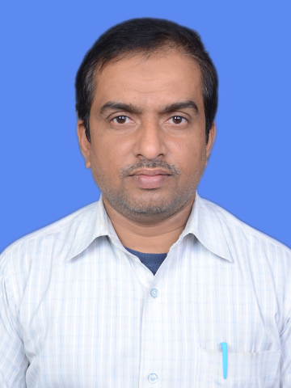
E Mail: ajay.chaubey1@gmail.com & akc_ch2005@rediffmail.com

Contact: +91-9631624755 & 9304919655

To Work & grow in professionally managed organization where I can all my skills creativity and hard work to prove any worth. I would like to work in challenging & competitive environment.

PROFILE AT A GLANCE

Total Work Experience: 15 years & 10 Months

Working as Assistant Project Manager in BAJAJ ELECTRICALS LTD at DDUGJY RE Project in Gaya (Bihar) from June 2017 to Dec 2020 .

Working as Sr. Executive in JYOTI STRUCTURES LTD at 400/220KV New Substations in
Kisangarh (Rajsthan) at RRVPNL Project from April 2017 to June 2017.

Working as Sr. Executive in JYOTI STRUCTURES LTD at 220/132KV &132/33kv New Substation 220kv Bay- Extn. Work of PGCIL in Bihar from Feb2016 to March 2017 .

Working as Sr. Executive in JYOTI STRUCTURES LTD at 220/33kv New Substation Gharbara Greater Noida NPCL Project from Sep 2014 to Jan2016.

Working as Executive (Testing & commissioning) in JYOTI STRUCTURES LTD at 220/132KV & 132/33kv New Substation & 132KV Bay Extn. Work of PGCIL in Bihar from Dec 2008 to August 2014.

Working as Electrical Engineer (Testing) in JYOTI STRUCTURES LTD at 400/220KV New
Sub-station in Coachine (Kerala) at PGCIL Project from Dec 2007 to Dec 2008.

Working as Electrical Engineer (Testing) in JYOTI STRUCTURES LTD at 33/11KV RE
Project in Koderma (Jharkhand) at DVC Project from Sep 2007 to Dec 2007.

Worked as Electrical Engineer in VIJAI ELECTRICALS LTD. Hyderabad at Siddharth Nagar (U.P.) RGGVY RE Projects from June2006 to Sep2007.

Worked as Electrical Engineer in AMRAPALI HOMES ,Multistories Building Projects at Indirapuram Ghaziabad (U.P.) from March2005 to June2006 .

WORK EXPERIENCE

Total Work Experience: 15 years & 10 Months

Key Responsibilities:

- Supervision and necessary instructions & guidelines for PSS all ELECTRICAL activities.
- Supervision of Testing & commisioning works of Sub-stations.
- Co-ordination with contractors/suppliers/vendors/Agencies at site for smooth and strict of construction of
Project with in time schedule.
- Supervision of the construction activities as per approved quality manual Inspection test plan With identified
Hold Points.
- Sub-mission of Daily Progress Report to Client and Head Office.
- Preparation of Bill for contractor & Client work.
- Checking & Approval of Drawings with Clients.
- Monitoring of New Substation & Extn.Substation Works
- Supervision of closer activities of site.

QUALIFICATIONS

Year | Degree/ Certificate | Institute, /City | Percentage (%)
2013 | MBA | IICT, Lucknow | 69
2003 | Diploma, Electrical Engineering | U.P.B.T.E. Lucknow | 75.01
1999 | B.Sc. | Gorakhpur University, Gorakhpur | 47.4
1996 | 12th | U.P. Board, Allahabad | 60

1994 | 10th | U.P. Board, Allahabad | 71.8

TECHNICAL TRAINING

0ne years experience in Electrical Maintenance & Repair Shop as a Diploma Apprenticeship completed from 2x500MW BTPS Anpara Thermal Power project, Anpara Sonebhadra (U.P.) from 04-02-2004 to 03-02-2005.

CORE SKILLS

- Transformers
- Current & Voltage Transformers
- Circuit Breaker
- Transmission System
- Distribution System
- Switchgear
- Control & Relay Panels
- SCADA System
- GIS Substations

IT EXPOSURE

Six Month Certificate in Web Application from NIIT.

PERSONAL DETAILS

Permanent Address : H.No.-20/90, Saket Nagar
Deoria (U.P.) Pin -274001
Father’s Name : Late Sri Ramadhar Chaubey
Nationality : Indian
Languages Known : English, Hindi
Marital Status : Married
Date Of Birth : 09/07/1980

(Ajay kumar chaubey)

Place: Deoria

