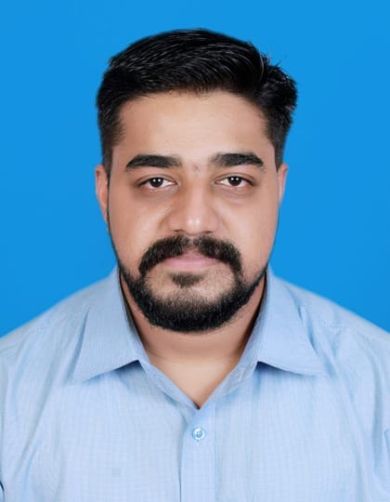

Arunkumar K
Mobile No : 09048182181
Resident No : 0481-2701784 Email : arunkavumkal@gmail.com

CAREER OBJECTIVES
With sound professional knowledge, expertise and creativeness, aspire to render quality service to the organization for it to attain its goal and be a successful finance and accounts professional working on latest tools and technologies.

PROFILE SUMMARY
Total 9 Years of hands on experience in the field of Accounts Finance and Auditing.
- Holds MBA Degree with specialized area in Finance and Marketing.
- More than 5 years Experience in SAP
- Experience of working as Accountant In Paragon Polymer Products Pvt Ltd
- Experience of working Internal Auditor at Muthoot Fincorp Ltd.
- Experience of working Accounts Executive in Somatheeram Ayurveda Beach Resort.
- Good work ethics with excellent communication and interpersonal skills.
- Ability to work well in both a team environment and individual environment for obtain the objectives of company.
- Also completed a 6 months Bank coaching program from July 2013 to Dec 2013

PROFESSIONAL EXPERIANCE
9 years’ experience in Accounts, Finance and Auditing

- 1, NAME OF THE EMPLOYER : PARAGON POLYMER PRODUCTS PVT LTD KOTTAYAM( MUMBAI)
Paragon Polymer Products Pvt Ltd Is India’s leading Footwear Manufacturers, its sales is approximated to 14, 00, 00,000 pairs each year.

- DESIGNATION : ACCOUNTANT
- DURATION : 21ST JULY 2014- Presently working

Summary of duties performing

- SAP
- Cash journal, Pay roll Of Workers
- Bank Reconciliation
- Invoice Creation
- Credit/Debit Note
- Purchase Entries Migo /Miro
- Trial Balance
- Vendor Payable, Receivables
- Logistics, Freight related, works
- GST-Tax entries
- Various F form-C Form works
- Order Taking/Placing
- Overall Stock& Asset Monitoring
- Various types of Bill settlements
- Cash management & Bank Entries

2. NAME OF THE EMPLOYER : mUTHOOT fINCORP lTD,
Muthoot Fincorp Ltd is a Non Banking Financial Company, which having more than 3500 branches in all over India and its controlling and supervision is done by Reserve Bank of India (RBI)

- DESIGNATION : INTERNAL AUDITOR
- DURATION : 1ST DEC 2011- MAY 2013

Summary of duties performing
- Verification of cash and stock with appropriate statements.
- Effective Cash Flow and Fund Flow analysis.
- Scrutinizing Day book, Journal, Ledger a/c’s and sorting out the discrepancies.
- Updating accounting, finance, management policies and procedures.
- Liaison with business related organizations such as Banks, RBI, Etc. for smooth functioning of company.
- Preparation of Bank Reconciliation Report.
- Verification of Money Transfer and Foreign Exchange Documentations.
- Verify all other statutory registers.
- Schedule management and staff meetings to present audit results and recommend pertinent solutions to any unaccountable transactions,
3. Name of the employer : Somatheeram Ayurvedic Beach Resort (P) Ltd -Trivandrum
- DESIGNATION :ACCOUNTS EXECUTIVE
- DURATION :SEPTEMBER 2010 to NOV 2011

Summary of duties performing
- Complete account reconciliations
- Perform billing, payment allocation, collection and activity reporting following established protocols, to tight deadlines
- Maintain up-to-date billing system and customer files
- Monitor customer account
- Investigate and resolve customer queries
- Prepare bank deposits
- Front office Management
- Guest Relation
- Check out Settlement

TECHNICAL QUALIFICATION
- SAP
- Tally 9.0 & ERP
- MS Office
- Hot soft
- Basic knowledge in Hardware and Software’s

EDUCATIONAL QUALIFICATION
EDUCATIONAL QUALIFICATION

Course/ Degree | University/ Board | Period | Percentage
MBA (Finance & Marketing) | Anna University | 2008-2010 | 77.3%
B.Com(Computer Application) | M.G. University Kerala | 2005-2008 | 61%
HSS(Commerce) | Board Of Higher Secondary Examination Kerala | 2003-2005 | 66%
SSLC | Board Of public Examination Kerala | 2003 | 54%

RESEARCHES AND PROJECTS
Main Project:-
Project Title: - Efficiency Analysis of portfolio creation by considering risk factor
Project Area: - Financial Management
Company : - Indiainfoline Ltd
Duration :- May to June 2010

Mini Project:-
Project Title:- Customer Satisfaction
Project Area: - Marketing
Company :-St. Antony’s Motors Ltd
Duration : - July to August 2009

SPECIFIC AREA SPECIALISED

- Finance and Accounting
- Marketing Management

SKILLS AND ACCOMPLISHMENTS

- Communication skill.
- Team Building and Leadership

LANGUAGES KNOWN

- Malayalam, English ,Hindi (Write, Read and Speak)
- Tamil , (Read& Speak)

PERSONAL PROFILE
PERSONAL PROFILE
Father’s name : V.K Gopalakrishnan Nair
Date of Birth : 12-03-1988
Age : 32
Sex : Male
Marital Status : Single
Religion : Hindu
Caste : Nair
Nationality : India
Permanent Address : Kavumkal (House)
Lakkattoor (Post)
Kottayam (Dist), Kerala
Pin:-686502 Passport No : K8013882
Place of Issue : COCHIN
Date of Issue : 08/03/2013
Date of Issue : 07/03/2023
Reference : Rajeevmon R
Manager, Paragon Polymer Products Pvt Ltd
(Mumbai) 0887908022

: Bindu R Kaimal
Ph No: 9446759773
Manager Audit – Muthoot
Fincorp Ltd

: Sunny
Ph No:-9446191894
Accounts Manager-
Somatheeram Ayurveda Beach Resort,
DECLARATION
I hereby declare that all the statement made above are true and correct to the best of my knowledge and belief.

Place: Mumbai ARUNKUMAR. K

Date:

