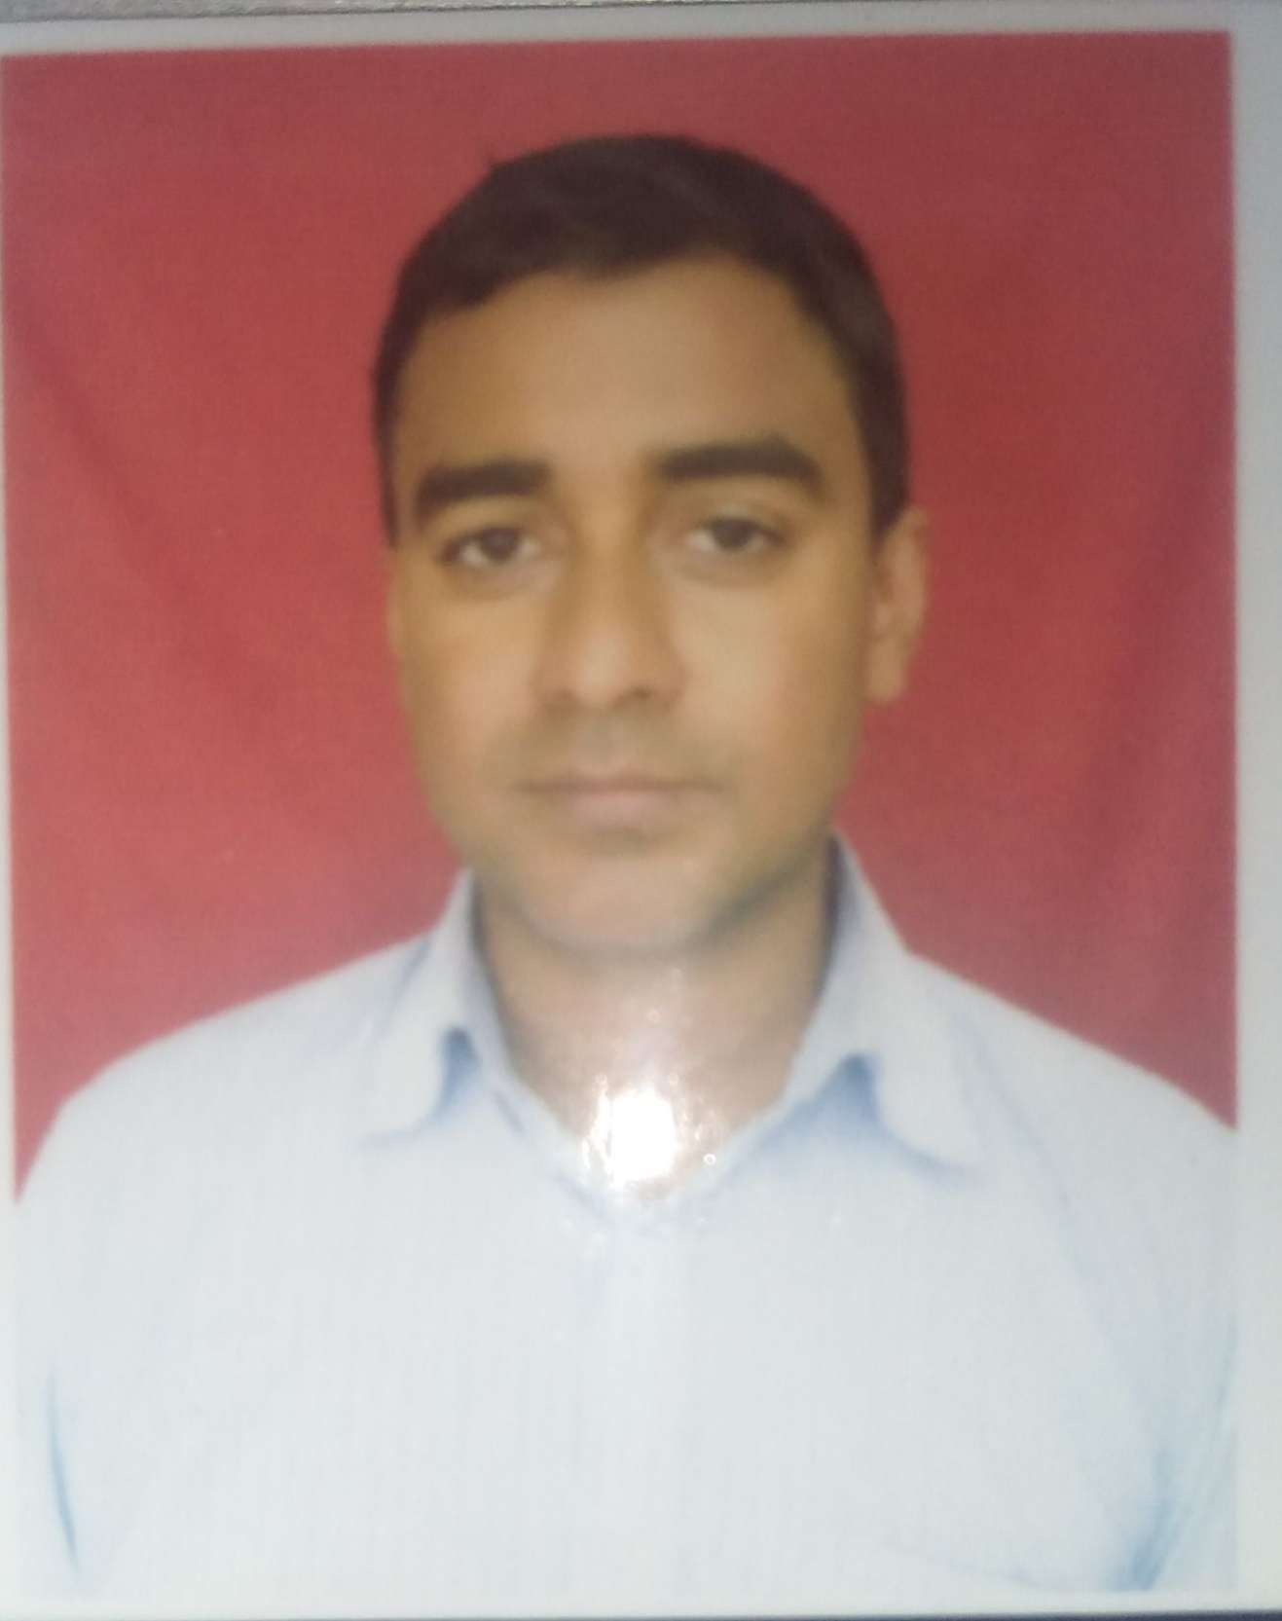
IMRAN HUSSAIN.
DIPLOMA ELECTRICAL ENGINEER
TINSUKIA
8638183637/9954245006
WORK HISTORY:

A) Oil Input Trading Company, Sivsagar
Electrical Technician
From january 2007 to june 2008
Site : GAS COMPRESSOR STATION, ONGC,GGS-IX, Lakwa ( Operation and maintenance)
Duties:
a) Overseeing the complete site.
b)Dealing with any technical issue when arise.
c)carrying out periodic and preventive maintenance.
d) Installation and repair faulty section.

B) SAURAV AUTO PVT LTD
i/c Electrical (O&M)
Site : TANK FARM CAPTIVE POWER PLANT, CTF TENGAKHAT (OIL INDIA LIMITED)
July 2008 to December 2019
ROLE
- Operation and Maintenance of Electrical Captive Power Plant.
- Monitoring parameters and keeping them under limit.
- Maintenacne activities of various stationary and rotary equipments.
- Co-ordinatinate between maintenance and operation team/ client.
- Checking and make report of observation of equipment like Circuit Breaker, HT & LT Panel,Genset etc.
- Execution of Break down jobs & trouble shooting.
- Spares management & Inventory control.
- Synchronizing of alternator.
- Responsible for operating and maintaining the plant equipment.
- Done the Maintenance of MCC control panel.
- All maintenance job ( Schedule and unscheduled)
C) GREEN POWER INTERNATIONAL PVT LTD
Site : OIL INDIA LTD (PUMP HOUSE)
Electrical Maintenance Supervisor
From January 2020 to present

EDUCATION
A) HSLC PASSED In 1999 from SEBA
B)HS Passed in 2002 from AHSEC
C) 3 Years Diploma in Electrical Engineering from Dibrugarh Polytechnic affiliated to SCTE in 2005
d) completed OIL MINES TRAINING at oil india limited in 2015.

PERSONAL DETAILS:
  - Name : IMRAN HUSSAIN
  - Fathers name : LATE ABDUL RASHID
  - Date of birth : SEP 4th 1982
  - Gender : Male
  - Marital status : Married
  - Nationality : Indian.
  - Languages known : Assamese, Hindi, English.

DECLARATION:
I here by Declare that the particulars furnished above are true to the best of my knowledge and belief.

Place: TINSUKIA

