CURRICULUM VITAE
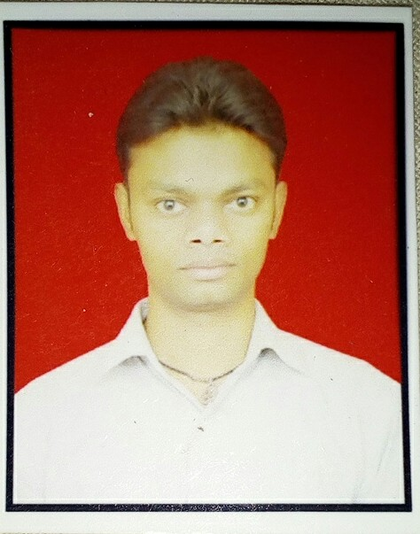

BAJARANGEE LAL
Mob. No.  8127148622, 8923631060
E-mail: bkmmrj@gmail.com

Objective:
To get technically challenged and professionally satisfied assignments maintenance contributes towards the growth of an organization & enhances my knowledge as well.

Strengths:
I am straight forward, analytical very practical in my life. Assets are my strong relations with people, which provide a technical base for me.

Work experience:- 3 .5 Years

Currently Working: (From 12th July 2018 to Till date )

- Hindalco Industries Ltd . Renukoot Sonebhadra UP. ( Aditya Birla Group).
- Covestro India Pvt LTD. Greater Noida. (OCS) Jr Engineer in Instrumentation Department.(April 2017 to June 2018).

- CLASSIC INSTRUMENTATION Pvt. Ltd NOIDA Delhi NCR as a Jr. Engineer (May 2016 to March 2017).

- ONE year Working at GAIL India. Ltd. Babrala U.P as a Technician ( Contract Base ). May 2015 to April.2016

Job Profile

- Trouble Shooting of All Process Variable Instrument
- Maintenance of temperature measuring instrument (RTD, Thermocouple, Temperature Transmitter, Temperature Gauge).
- Maintenance of Pressure measuring instrument (Pressure Transmitter, Pressure Gauge)
- Calibration of All Process Variable Instrument (Pressure Gauge,RTD,Thermocouple,Level,Positioner Valve,Weighing Scale, )
- PLC,SCADA,HMI,DRIVES
- Solenoid Valve, Control Valve,Actuator valve .
- Limit switch, Reed Switch,Proximity Senser,Photo Senser, Relay,Contactor ,Timer, Motors.
Apprenticeship& Training

- I have completed Apprenticeship Training (1 year) in Thermal Power Plant Obra U.P.
Work duration: 11st Feb 2014 To 10st Feb. 2015
- Summer vocational training in UPPCL For One Month
- Three Month Automation training from SOFCON INDIA Pvt. Ltd. Lucknow U.P

Technical Qualification
- Three Years Diploma in Instrumentation and control Engineering with 1st div. From Government Polytechnic, pilibhit (U.P.B.T.E.) in 2013

Academic Qualification:

- Passed 10th with 2nd div. From U.P. Board .in 2008
- Passed 12th with 2nd div. From U.P. Board .in 2010

Academic Projects:
- Uninterrupted Power Supply (UPS)
Technical Skill:

- One year diploma in Computer application (DCA)
- Course on computer concept ( CCC )

Industrial Skills:
- ISO
- 5,S
- Process variable Instrument Testing & calibration
- RTD , Thermocouple,PLC ,Senser
- Maintenance Troubleshooting

AIM:
Want to get more success in Instrumentation engineering sector.
PERSONAL DETAILS:

Fathers Name : Govind Prasad
Date of Birth : 26-07-1992
Sex : Male
Language known : Hindi, English
Nationality : INDIAN
Marital Status : Unmarried
Permanent Address : Vill. + Post  Khutha bajar
Dist.  maharajganj, State - U.P.
Pin no.-273303
Deceleration:-
I hereby declare that all the above given information by me are true to the best of my knowledge and belief.
I like to assure you that if you will be given a chance to work in your esteemed organization, you will positively feel satisfied with my attitude and working.

Date:

Place: ( Bajarangee lal )

