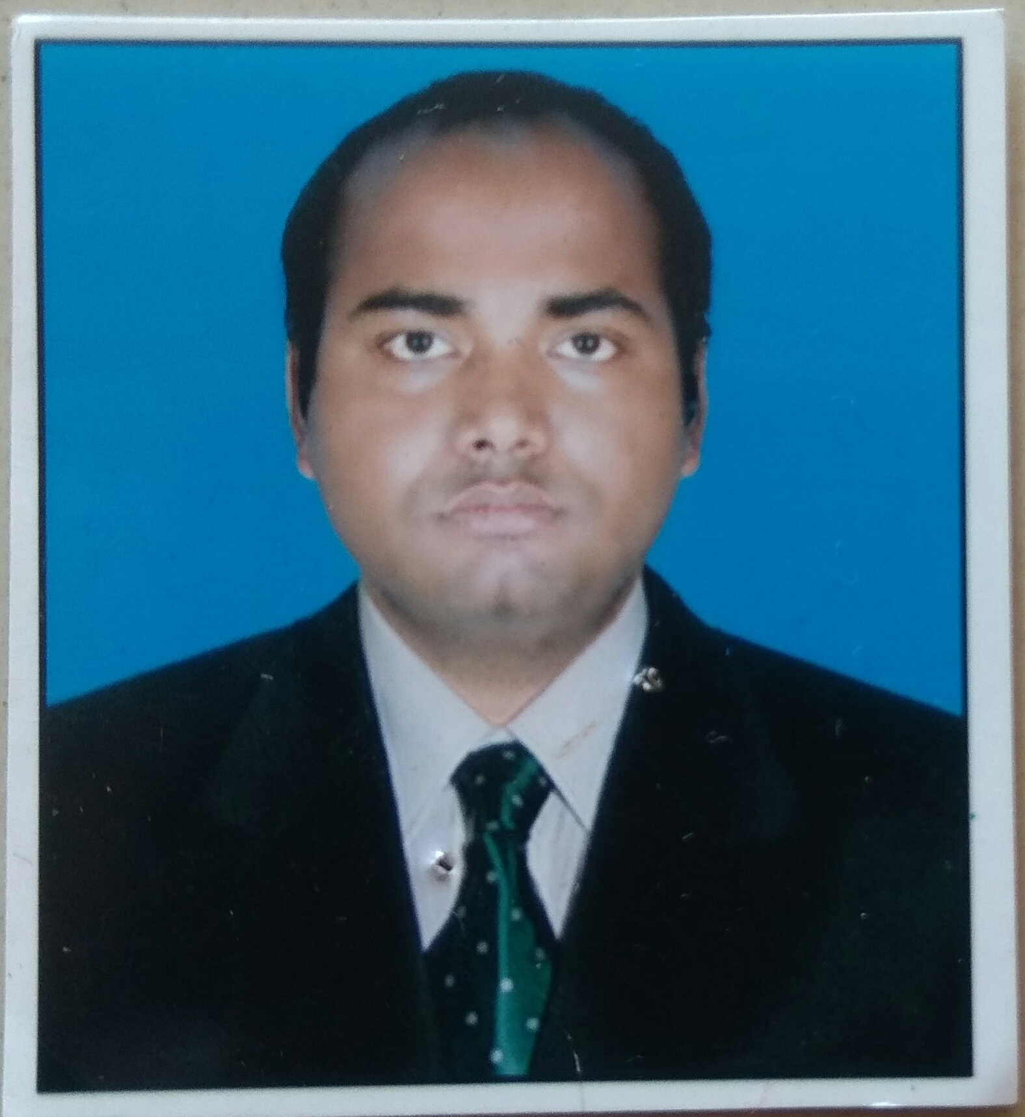 SARVESH KUMAR SINGH
PROFILE
B-Tech in Electronics and Telecommunication with 8 years of experience in Instrument field of Continuous polymer, Gypsum Based (Gypsum Plaster Board, Plaster ,Finishing Plaster, Bond-It)Building Material production .Covered erection and commissioning of CP. Attended 3 Month certification course of Yokogawa DCS and Foundation Fieldbus training at Bangalore. Well behaved and efficient to handle problems with best of my knowledge.

TECHNICAL EXPOSURE

- Project Exposure :

- Operations & Maintenance - Procurement - Sourcing /Pricing
- Erection & Commissioning - Cost Analysis - Team Management
- DCS Yokogawa Centum Vp / CS-3000 : Operation & Maintenance, Trouble shootout, Logic Programming of Engineering, Tag generate and modification in DCS as per requirement.
- Foundation fieldbus : Yokogawa Foundation fieldbus Erection and commissioning, Trouble shooting.
- PLC : Siemens S7 300,400,1200 Basic Programming , I/O list preparation, JOB scheduling for Commissioning and Erection ,Project Final Execution Scheduling.
- Project Bottleneck Identification, corrective action and Timely Execution .
- Actively involved in commissioning activities like Field instrument Loop checking ,Troubleshooting , Tuning.
- Preparation of instrument index & I/O list from P & ID drawing, Hook Up, JB schedule, Cable Schedule, Termination.
- Knowledge about Microprocessor based Electronics & Pneumatic transmitter, Flow, Level and Pressure Transmitters, different types of Control Valves, Solenoid Valves, Laboratory equipment and Load Cell etc.
- Calibration and maintenance of various types of Process Control Instruments.
- Various kinds of Utility System knowledge like HTM heater system of BAPC (Germany) & Soken (China), N2 plant.
- Also knowledge of Chips Cutter, Pneumatic Chips Conveying System, Pneumatic & Chain Conveying Systems for PTA, Automated Bagging System.
- Smart families Transmitters Rosemount make like Micromotion series Mass Flow meters, DP Transmitters, Diaphragm Seal type Level Transmitters. Also Yokogawa make Vortex type Flow Transmitters, Dynisco make Melt Pressure Transmitters, Annubar/Delta tube type Flow measurements, N2 Purge type Level measurement, Forbes Marshall make Variable Area Flow meters, E+H make Radio Active Level measurement etc.
- Calibration and maintenance of Weighbridge and Weigh-scale, pH meters.
- Knowledge of various types of calibrators like HART, Temperature Calibrator, mA Source.

- Maintenance Exposure :

- Handled project and prepared PM Schedule ,Checklist ,Monthly ,Weekly Schedule ,Calibration Schedule .
- Develop checklist and PM schedule in combustion system.
- Prepared Critical Spare list to reduce breakdown and maintain spare ..
- Communicate with other plant and manage costly spares centrally .
- Accountable for preparing maintenance plans/schedules for reducing machinery downtime to minimum for ensuring smooth production.
- Managing AMC of various machines like printer / weigh bridge / weigh machines/Fire alarm / dust Monitoring system.
- Provide training to team members regarding various problem solving tools Quick Kaizen, Enhanced Work Order(EWO), One Point lesson, Success Sheet and Root Cause Analysis.
- To maintain Reliability tracker for department and ensure at least 80% closer of monthly breakdown.
- Troubleshooting the totally integrated automation from Siemens (PLC Simatic S7 400 ,300+ SCADA WINCC) software and hardware.
- Monitoring workers and subcontractor’s adherence to safety regulations.
PROJECT EXPERIENCE
- Currently working for Saint-Gobain Gyproc India Ltd. In Autonomous plant with capacity of 15 Lacs Meter Square /Month of Gypsum plaster board and 16000 Ton/Month of Gypsum Plaster.
- Handled individual Exfoliation Burner Standard 23 project: All safety point gap completed as per standard 23 compliance, Checklist preparing, SOP & SMP preparing,OPL preparing for each equipment.
- Handled Individual JC Mixer Automation project :(Siemens S71200 programming ,I/O Assigning ,JB Scheduling ,Cable Schedule ,OLD System kept in Option .
- PG to NG transfer Project: handled Field Instrumentation (Instrument installation ,Cable Scheduling ,Loop Checking ,Cold & HOT Checking ,Calibration )
- Plaster Conveying System Automation :Cost estimation ,Instrument Procurement, Instrument installation ,Cable & JB Scheduling ,PLC S7 300 Programming ,Project Execution .
- Profibus Upgradation Project : Profibus Cable ,Connector Procurement ,Manpower handled ,Address assigning ,Healthiness checking before final execution, final execution ,Prepared Schedule for healthiness Checking.

- Completed project from Procurement to Startup and Operation of Continuous Polymerization Plant with capacity of 1400 Tone/Day (Chemtech technique Co. Ltd., China) with Yokogawa Centum Vp in Bhilosa Industries Pvt. Ltd .
- HTM Commissioning and Erection : Instrument installation ,Calibration ,JB & Cable Scheduling ,Loop Checking.
- Evaporator Commissioning Erection : Instrument installation ,Calibration ,JB & Cable Scheduling ,Loop Checking.
- PTA Conveying & Paste Preparation Area: Instrument installation ,Calibration ,JB & Cable Scheduling ,Loop Checking.

- Completed project from Procurement to Startup and Operation of Continuous Polymerization Plant with capacity of 300 Tone/Day (Huitong Chemical Engineering Technique Co. Ltd., China) with Yokogawa Centum Vp in DNH Spinners Pvt. Ltd., Surangi, Silvassa. Also completed Erection & Commissioning of POY Melt Transfer Line with capacity of 100 Tone/Day (Beijing Chonglee Machinery Engineering Co. Ltd., China).

- Completed Erection, Commissioning, Plant Startup and Operation of POY Plant with capacity of 140 Tone/Day (CHTC) with Allen Bradley SCADA in Raj Rayan Industries Ltd., Silvassa. Also completed Erection & Commissioning of POY Melt Transfer Line with Yokogawa DCS.
EMPLOYMENT HISTORY
Organization | : | Saint-Gobain Gyproc India Ltd ,WADA,THANE
Organization Profile | : | Saint-Gobain Gyproc India Ltd ,Producing Gypsum Based Building material Product Like Gypsum Plaster Board ,Plaster ,Bond-it, Ready-mix ,Jointing Compound Etc Gypsum based Autonomous Plant having production of Gypsum plaster Board 15 Lacs Square Meter/month and Having capacity producing 16000 of Tons/Month.
Designation | : | Instrumentation Engineer (Gyproc Division)
Duration | : | May,2019 to Till Date
Organization | : | Bhilosa Industries Pvt. Ltd.,Narouli, Silvassa
Organization Profile | : | Bhilosa Industries Pvt. Ltd. is a Petrochemical based Continuous Polymerization Plant having production of Polyester chips of 1400 Tons/Day. Also producing more than 300 colour based yarns and has market access across the globe which extends to Europe, America.
Designation | : | Instrumentation Engineer (Continuous Polymerization Division)
Duration | : | January,2017 to March,2019
Organization | : | DNH Spinners Pvt. Ltd.,Narouli,Silvassa
Organization Profile | : | DNH Spinners Pvt. Ltd. is a polyester textured yarn manufacturer and is producing more than 300 colour based yarns and has market access across the globe which extends to Europe, America and Africa. DNH completed the project of Continuous Polymerization plant of 300 TPD with POY spinning capacity of 100 TPD. This expansion shall increase the turnover of DNH spinners to 1000 Cr from the present turnover of close to 400 Cr.
Designation | : | Instrumentation Engineer (Continuous Polymerization Division)
Duration | : | September , 2015 to January,2017
Organization | : | RajRayasn Industries Limited, Surangi ,Silvassa
Organization Profile | : | A Petrochemical based Continuous Polymerization Plant having production of Polyester chips of 300 Tons/Day. Also it has production of POY, FDY .
Designation | : | Engineer Instrumentation (Continuous Polymerization Division)
Duration | : | December, 2012 to September, 2015
ACADEMIA
- B-Tech In ELECTRONICS & TELECOMMUNICATION with 69.68 % 2012 from
Vishveshwarya Institute of Engineering & Technology, G. B. Nagar, Greater NOIDA, UPTU.
- (H.S.C) Science Math Stream with 57.6 % June 07 from SSNIC, Mirzapur, UP. affiliated from UP Board .
- (S.S.C) Science Stream with 64.16 % June 05 from SSNIC, Mirzapur, UP. affiliated from UP Board.
- Yokogawa DCS and Foundation Fieldbus training from Sept 2012 to Nov 2012 at bangalore.

PERSONAL DOSSIERS |  |  | CORRESPONDENCE ADDRESS
Date of Birth | : | 17th August, 1990 | Flat No:301,
Marital Status | : | Single | Sai Kripa Building ,
Nationality | : | Indian | Ambadi ,Virar-421302
Languages Known | : | Hindi, English | Mumbai,Maharastra
Blood Group | : | B+ve | Contact No | : | +91 8141866969 (M)
E-mail | : | sarvesh091@gmail.com
Current ctc | : | 6.00 Lacs

DECLARATION
I hereby declare that all the information given above are true to the best of my knowledge.

PLACE : Mumbai _________________
DATE : [Sarvesh Kumar Singh]

