CURRICULUMVITAE Rabindra Ku. Choudhary 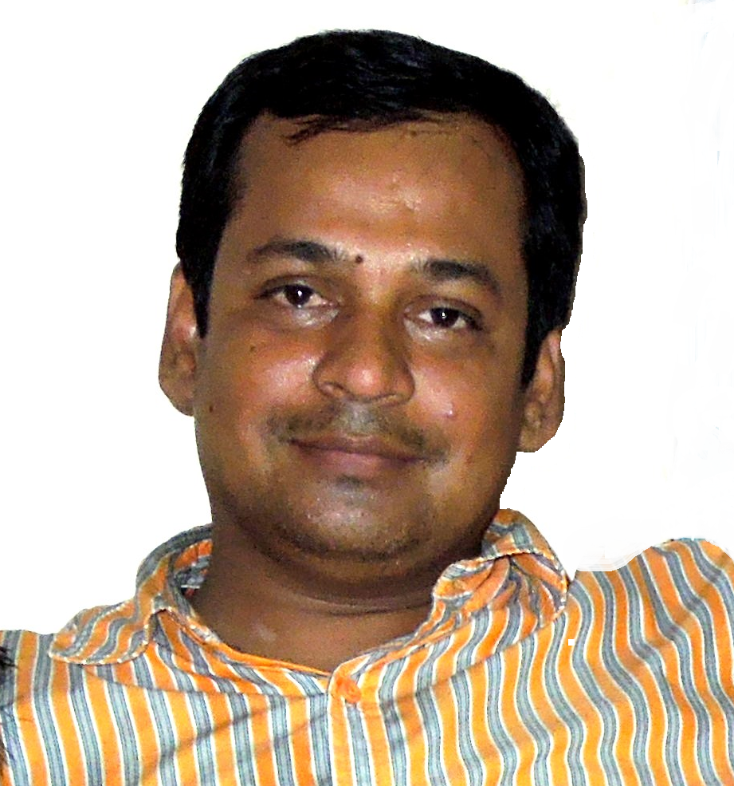
Project Division Electrical

Objective: To work in a growth oriented organization where I can utilize my
Technical and Personal skills and experience and grow technically.

Technical Qualification:
- Bachelor of Engineering in “Electrical and Electronics” Engineering with 67% marks & First Class from BIJAPUR, (BLDEA’S College),”Karnataka University Dharwad”, KARNATAKA,INDIA.
- P.G.D.E in Thermal Power Plant Engg. from “National Power Training Institute”, Durgapur,WestBengal, Recognized from ministry of power (It Authorizes 100 MW & above 100 MW with associated Switchyard).
Done my P.G.D.C. in Thermal Power Plant Engg. (2002 – 2003) with 64%.

Total experience: 12+ years

Details of working Profiles & Experience:
- Present Organization : JINDAL STEEL & POWER LIMITED,ANGUL,ORISSA
Working in project execution from 18th September
from beginning of project 2008 to till date.
Company Profile: It is a 6x135MW CPP Project CFBC, Project company in which my
involvement in All units’ of 135MW with BOP is Successfully Commissioned.

Reporting to : Sr.DGM Power plant (ELECTRICAL).
Job Profile /job Duration : Dy. Manager (Elect) Power Project ;5Years & 3months.

- Previous Organization : ADHUNIK METALIKS LTD. (Rourkela, Orissa)

Company Profile: Commissioned Successfully 2*17MW Captive Power Plant
Project, from WHRB 50 TPH & 130 TPH CFBC Boilers
It’s Rourkela Plant annual turnover is 1000 Cr.
Period : 14 April 2006 to 10 September 2008.
Reporting to : AGM Power plant (ELECTRICAL)

Job Profile /job Duration : My profile includes Project Engineer & in addition to that Done job as O&M shift in charge Electrical after project in- CPP-2*17MW; 2Years & 6Months.
Job carried out during Project:
Involved in Erection and commissioning Power Plant including of all HT panels, LV PCC & all MCC panel panels DC BATTERY CHARGER,UPS,SCVS,GCP ,GRP,EOP,JOP,DCDB,ACDB,etc & other BTG control &protection Panel Erection and commissioning of all Utilities have attended maintenance of DM water plant, cooling tower, pump house, air-conditioning system unit, Air Compressors Drier .Erection and commissioning of 90/20 TON EOT crane.

Responsibilities taken :
- PROJECT PERIOD---All project completion activities as per job schedule.
- Prepare the precommissioning and commissioning Check List.
- Check and Implement the work as per approved Drawings and Commissioning Check List.
- Test the LT & HT motors,Transformers their panels, wiring and do the relay settings.
- Do the commissioning trial run of HT & LT Motors.
- Check the precommissioning and commissioning activities of Power and Distribution Transformers.
- Check the interlocking in the HT and LT scheme for breaker operation.
- Check the earthing of the equipments.
- Check generator protection panel wiring of CT and PTs.
- Check the interlocking of Station Transformer breakers operation EHV and HT
- Check the interlocking between GT breakers and Generator Protection Systems.
- Check and test the relay of GRP,AVR and its setting.
- Commission the ECP, and HT Bus Transfer System .
- Prepare the checklist and implement the same for OCC & SCC of Generators.
- Done the Erection Testing and Commissioning of Battery, Battery Charger and perform the capacity test.
- Done the Erection testing and commissioning of Emergency DG Sets.

- MAINTENANCE PERIOD ---Responsible to take care of all primary and secondary power distribution for utilities department.
Job mainly involves operation, monitoring and supervision of power plant
Activities, coordinating with maintenance checking to carry out regular
Maintenance of the Lifeline of our various processes with preventive & periodic maintenance.
- To ensure smooth functioning of PCCs (Power Control Centre), MCCs (Motor Control Centre) & numerous power distribution systems through a sustained action plan.
- To maintain spare list for uninterrupted availability of Spares.
- Preparation of daily checklists, Preventive maintenance schedule. Maintain all records (Breakdown, shutdown, spares etc.). Troubleshooting, preparation of maintenance schedule (preventive breakdown) and manpower arrangement. To maintain all quality control records to monitoring all process parameters,. Upkeeps equipment history, breakdown analysis and troubleshooting. System up gradation for plant stability & enhance equipments reliability and safety to ensure smooth functioning & required troubleshooting for various equipments.
- Responsible for power generation and distribution .To maintain an activity report of Total production, Power consumption, Daily report, Gross generated & details of break down in the process.

- Previous Organization : BHUSHAN STEELS LTD. ( Srirampur, Kolkata)

Company Profile : It is the ISO 9002 & ISO 14000 certified company having
Most Efficient, effective, Quality & least breakdown
Achievements having Cold Rolling Mill (6-HI, 4-HI), GP-
Line, CTL, Annealing Plant, and also engaged in
Manufacturing of steel product appliances with its own
Backup DG Power.
Responsibilities taken : Carried our projects & subsequently was in maintenance field.
Designation : Assistant Electrical Engineer

Job Profile /job Duration : 17th October 2001 to 9th April 2006, 4Years & 7Months.
Reporting to : HOD & G.M. (ELECTRICAL)

PROJECT COMPLETED : Pipe Plant, Cable-Tape, Narrow Pickling, CBL with all project completion
as per schedule.
AFTER PROJECT COMPLITION =
- Responsibilities in area ERW Pipe Plant, Cable-Tape, Narrow Pickling, CBL.
- Overall Electrical Maintenance of electrical machines –AC Motors, DC Motors, HF Welder (250 KW, 120 KW), DC Drives –(DCS- 400, DCS- 500- ABB make), Allen Bradley type 1397, Reliance Electric, Gemco , AC Drives (make median), EOT Crane (20 tone), UPS supply, & all associated control and protection systems & Short out the problems related systems.
- To maintain all quality control records to monitoring all process parameters, cooperating with over all supervision & Maintenances of plant. Safety/security/upkeeps of machinery& Care of quality aspects/procedure/systems/processes.
To maintain an activity report of Total production, Power
Consumption, Daily report, Gross generated & details of break down in the process.
Training Undertaken: One week Training on “A.C. Drive Installation & Maintenance” from
ADVANCED TRAINING INSTITUTE, Kolkata, (Govt. of India)

Personal Traits: Strong analytical & Understanding skill, hard working, good
Communication & Managing skill and Self-starter.

Expected Salary: Negotiable.

Personal Details:
Date of Birth : 24/10/1976
Marital Status : Married
Contact number : 09777443445
Corresponding email : rabindra.choudhary@gmail.com
Indian Passport No : K5931679
Present Residence : E-5/1, JINDAL NAGAR, JSPLANGUL, ORISSA
Permanent address : Qr.No. – 12D, Street-8, Sector-10,
Bhilai, C.G. - 490006.
Languages Known : English, Hindi, Bengali, and Oriya.

Submitted in confidence

[R. K. Choudhary]

Date :

