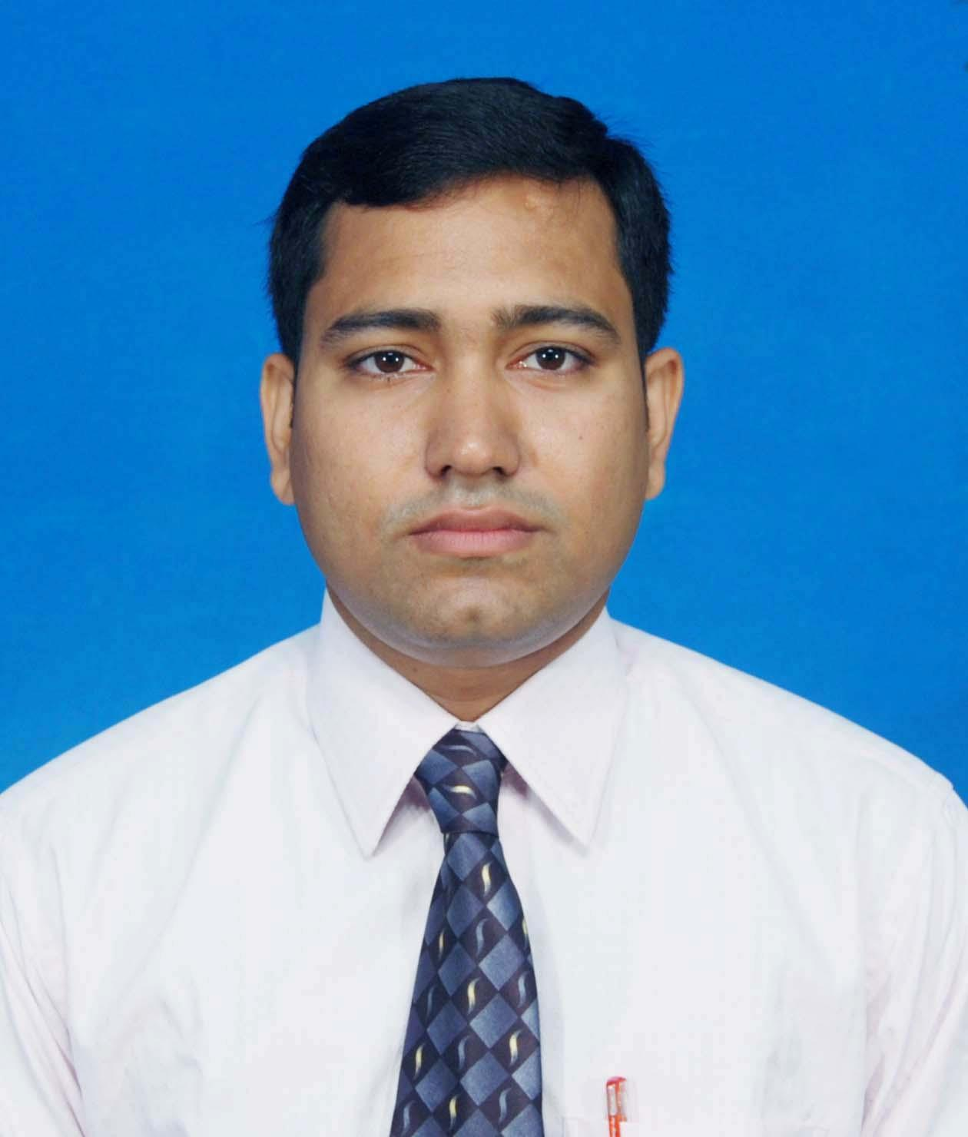
PRABIR KUMAR SAHA
Mobile: +91 9777451249, IMO NO - +91 9777451249, SKYPE ID - prabirsaha.npti@gmail.com
E-Mail: prabirsaha.npti@gmail.com

_____________________________________________________________________________________________

CAREER CONSPECTUS

B.Tech. (Power Engineering - Mechanical) professional with nearly 11.5 years of experience in Commissioning of Boilers, Power plant DCS & field Operation of Boiler & Turbine, Boiler & Turbine over hauling (125*2 MW).

- Ability to achieve and establish long-term partnership with an organization. Ability to lead the team for common objective of organization.
- Planning, directing and maintaining efficient production Target for ensuring smooth & efficient operation of 2*125 Power Plant.
- Expertise in managing Commissioning of Boilers enhancing Operational effectiveness of equipment.
- Hand on experience in:
- Working in Pulverized coal fired Boiler (125*2MW).
- Worked with the boiler commissioning teams of IJT for commissioning of 250 TPH *4 CFBC Boilers.
- Power plant operation from D.C.S (operating system of Siemens & maxDNA).
- Over hauling in (125*2 MW) Pulverized coal fired Boiler & Turbine.
- Result Oriented communicator with excellent relationship management skills and strong analytical, leadership, decision making, problem solving & organizational abilities.
- Provided strong leadership and technical expertise to maintain existing procedures and continuously improvement.
- Safety measures: Used different techniques and guidelines to ensure a safe environment around plant and premises. Ensured all maintenance workers are following prescribed safety policies and guidelines.

EMPLOYMENT SCAN

Presently working with Jindal Stainless Limited, KNIC, Danagadi, Jajpur, Odisha (125*2MW) as an asst.shift incharge.
Details of experience:

- Monitoring, controlling activities pertaining to BTG Package ( PF Boiler & Multistage (HP,IP & LP) Steam turbine ) & BOP package for 2x125 MW Thermal Power Plant supplied by M/s BHEL.
- Optimal plant start-up, shutdown of 2x125 MW Captive Power Plant that consists of
- Control System of Tandem Compounded two cylinders reheat Condensing Turbine of speed 3000 rpm from BHEL-
- Control System of 395 TPH Pulverized Boiler of working pressure 138 kg/cm2 and temperature of 540 deg C from BHEL.
- Cold,Warm and Hot Light up & Shutdown of 395 TPH, BHEL make Boiler.
- Rolling and synchronization of units. (2X125 MW, BHEL TG package)
- Sound Knowledge of Emergency handling like island, load throw off, blackout, pa fan stalling condition.
- Coordinating between maintenance dept. to carry out maint. Jobs & Assist in maintenance management system. Monitoring and reporting plant maintenance tool.
- Generation of weekly and monthly reports as per necessary to record plant history highlighting troublesome and repeated failures in any systems.
- Well versed on the limits of operation of the assets controls of the power plant, thermodynamics and its key drivers of thermal power plant efficiencies.
- Thorough Knowledge of plant safety, permits and isolations.

Maintenance Management

- Preventive & Breakdown Maintenance of Firing System like Coal firing, Oil firing.
- Preventive & Breakdown Maintenance of Balance of plant auxiliaries like feed water pumps, water system, dosing pumps.
- Preventive & Breakdown Maintenance of Soot blowing system supports inspection and set the spring hanger supports.
- Preventive & Breakdown Maintenance of Boiler fans like PA, ID, FD and its lube oil systems
- Mobilize resources for day-to-day mechanical maintenance activities. Ensure compliance to procedure and best practice. Assist respective discipline manager in spares identification for procurement.
- Analyses mechanical maintenance cost and budgeting.
- Collate discipline data for performance monitoring and reporting.
- Ensure compliance of mandatory training.

Previously working with Bhushan Steel Limited, Meramandali, Odisha (150*2MW) from July09 to feb11 as an assistant shift incharge Operation & commissioning.

Details of experience: .

Commissioning Management
- Hydro test of boiler
- Air leakage test of boiler and air duct.
- Load test and no load test of all drives.
- Refectory dries out of the boiler.
- Alkali boiled out of the boiler.
- Acid cleaning of the boiler.
- Steam blowing of the boiler.
- Safety valves floating of the boiler.
- Gas distribution test and modification of the gas distribution plate of E.S.P.

Operations Management
- DCS operation of CFBC boiler (250TPH)
- Cold start-up& hot start-up of C.F.B.C boiler with all the line-up activities during the process.
- Black-out operation of C.F.B.C boiler.
- Islanding operation of the unit and quick back synchronization of the unit.

Notable Highlights:

- Steady & safe operation of the plant with lesser no of tripping.
- Quick unit light up and synchronization after blackout.
- Cold start-up of the unit and synchronization within minimum possible time.
- Maintaining unit generation as per plant requirement.
- Controlling the emission of the boiler as per govt. norms.
- Effort to achieve the best possible boiler and turbine efficiency.
- Worked with the commissioning teams of IJT for commissioning of 250 TPH *4 CFBC Boilers.

TRAININGS & CERTIFICATION
- NDT LEVEL-2 RADIOGRAPHY TESTING
- NDT LEVEL-2 ULTRASONIC TESTING
- NDT LEVEL-2 MAGNETIC PRACTICAL TESTING
- NDT LEVEL-2 PENETRANT TESTING

ACADEMIC CREDENTIALS
- B.Tech. (Power Engineering - Mechanical) from National Power Training Institute (ER), Durgapur in 2009.
- Diploma in Mechanical Engineering from Jalpaiguri Polytechnics Institute, Jalpaiguri, W.B.S.C.T.E in 2006.
- SSC from Ghogomali high school(H.S),Siliguri, W.B.B.S.E in 2001.

IT Skills: MS Office.

PERSONAL DOSSIER
Date of Birth: 2nd August 1984
Passport No.: J6838421 (Issue date-01/06/2011, Expiry date-31/05/20021)
Languages: English, Hindi and Bengali
Address: Loknath Bazaar, Eastern By Pass, P.O- Ghogomali, Siliguri, Dist.-Jalpaiguri-734006, West Bengal, India.

