CURRICULUM VITAE 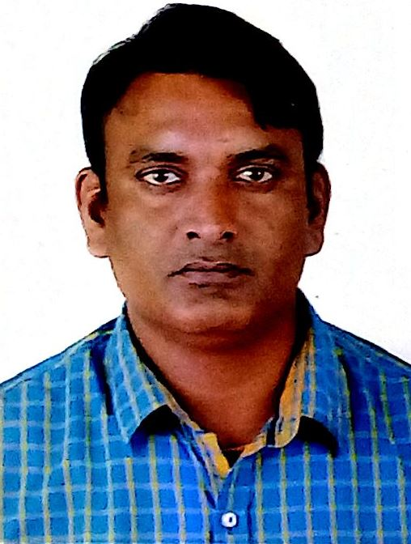

DHARMENDRA KUMAR
ADD.- Andal Mor, Mob:+917003000621 PO/PS- Andal, E-Mail: dhiru_ddd@yahoo.co.in
Dis- Burdwan, (W.B) dhirudd@gmail.com
Skype ID: dkumar666

SPECIALISATION : Senior Design & Project engineering of Plant Instrumentation & Control system.

EDUCATION : Bachelor of Electronics and Communication Engineering from Asansol Engineering Collage (the University of Burdwan), West Bengal with 1st class in 2004.

EXPERIENCE : 15+ Years

INDIAN : 1. With Development Consultants Pvt Ltd (DCPL)
ASSIGNMENT (July, 2008 - till date)

As Senior Project Engineer (C&I):-

OIL & GAS PROJECT:-

- LPG Bottling Plant at Jodhpur (IOCL)(April 2019– Sept 2019)
Preparation of technical specification for instrumentation items, Instruments list, IO list, Process Hook-up diagram and review of P&ID Diagram, Instrument List, DCS I/O List, Cable schedule, Instrument Hook-up diagram etc

POWER PROJECT:-

- 1X12.25 MW WHRSG CPP (Reliance Cement co. pvt ltd), Maihar, Madhaya Pradesh (May 2017- June 2018)
- 2X600 MW TPS Damodar Valley Corporation (DVC) Purulia,
West Bengal, India (Feb. 2009-Nov. 2011)
- 2x300 MW Rosa Thermal Power Project Uttar Pardesh, India
(July 2008 – Feb. 2009)

Experience in preparation of technical tender specification for instrumentation items, DCS System Architecture Drawing, CCR Lay out & Load Center, Technical Bid evaluation & finalization of bid and review of P&ID Diagram (BTG & BOP Area), Instrument List, DCS I/O List, Cable schedule, Instrument Hook-up diagram etc.

CEMENT PROJECT:-

• 3000 TPD Mombasa Cement ltd, ( 150 TPH Cement Grinding) Mombasa, Kenya ( July 2019- as on dated)
- 5000 TPD Mombasa Cement ltd, Mombasa, Kenya ( May 2017- as on dated)
- 1000 TPD Cement Grinding Project at Biratnagar, Nepal, (Sept. 2016 – March 2018)
- 650/1200 TPD Shayona Cement Project ltd, Malawi, Africa ( Aug. 2015 – Dec. 2017)
- 1 MTPA Tamilnad Cement Corporation LTD. Ariyalur, Tamilnadu (India), (Sept. 2014 – May 2018)
- 1X3000 TPD Dangote Cement Congo SA, Republic of Congo, (Dec. 2013 – Sept. 2014)
- 3.0 MTPA Orient Cement Project, Chittapur, Karnataka, (Dec. 2013. - Sept. 2014)
- 6000 TPD Sephaku Itsosen and Delmas Cement Project, SA, (Nov. 2011 – Sept. 2012)
Experience in preparation of technical tender specification for instrumentation items, DCS System Architecture Drawing, CCR Layout and Load Center, Technical Bid evaluation & finalization of bid, review of P&ID Diagram, Instrument List, DCS I/O List, Cable schedule, Instrument Hook-up diagram, inspection of DCS/PLC, Gas analyzer, MV & LV VFD Drive etc, and software FAT for cement project.

FOREIGN :
ASSIGNMENT
- 10000 TPD Al Ain Cement Factory, Abu Dhabi, UAE, (Sept. 2012 to Dec. 2013 – At AL AIN, U.A.E)
As Consultant Commissioning Engineer:- Responsible for Supervision of Erection and Commissioning of DCS (ABB based) system, I/O Panel, Sub control system and all field instruments. Also Responsible for Detail Engineering & Vendor Drawing Review as a Commissioning engineer. Making as build drawing according to the modification and rectification at site.

Previous Organization:-
- 20 MW Rathi Udyog Steel & Power ltd. Sambhalpur, Odisha ( Sept. 2007- July 2008 )
As Electronics & Instrumentation Engineer. Worked is related with erection, commissioning, testing & maintenance of DCS (ABB) operated 20 Mw (BHEL- Turbine) captive power plant.

- 2X12 MW MSP Steel & Power ltd. Jamgao, Raigarh, Chhattishgarh, (March 2007- Sept. 2007)
As Assistance Engineer (C&I) Worked is related with erection, commissioning, testing & maintenance of PLC (Schneider) operated 12 Mw captive power plant and 12x2 MW captive power plant operated by DCS (ABB).

- 32 MW Shyam Steel and Power ltd. Mangalpur, Raniganj (W.B), (March 2006- March 2007)
As Get (C&I)
Worked is related with erection, commissioning, testing & maintenance of DCS operated 32 MW captive power plant (CPP).

- Gopinath construction and co. ltd, at Reliance Hazira, Surat, (Augu.2004- Feb.2006)
As Site Engineer (C&I)
Organization:- Gopinath construction and co. ltd
Responsible for Optimum utilization of resources for better cost management. Man management- developing a orient culture for effective implementation.
Work is related with erection, commissioning of DCS, PLC, MCC, BMS-PLC, SB-PLC & Different type of transmitter & Gauge, cabling and its termination of 2 nos. HRSG (CPP).

TRAININ * Training from Bakeshwar Thermal Power Plant (210 mw) on Simulator for 7-Days .
* Attended training for workshop on Electronics manufacturing Technology conducted by center for Electronica test Engineering (CETE), Kolkata.

Software and Hardware : Siemens DCS, Sematic PCS-7, ABB DCS with PM 866 Controller

Office Tools : Microsoft Office, Auto-CAD 2007/2010.

PERSONAL DETAILS

Date of Birth : March’01, 1981

Sex : Male.
Marital Status : Married.
Passport Details : M1517872, Date of Expiry 26.08.2024
Languages Known : Hindi, English and Bengali.
Nationality : Indian.
Hobbies : listening music, playing badminton.
Address : Dharmendra kumar, Andal More (Near Grampanchayat), P.O & P.S -Andal, Dist. – Burdwan, West Bengal, PIN – 713321, India.

Certification:

I, the undersigned, certify that all the data furnished here, correctly describe by me, my qualifications and my experience.

Date:
[Signature ] Day/Month/Year

