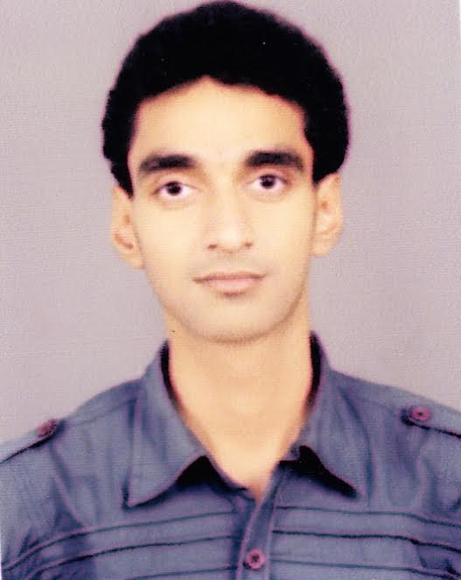

PARMENDRA KUMAR
Email id: parmendra362@gmail.com
Office Email-id: parmendra.kumar@becgroup.co.in
Mobile No: +91-7990219993
ADDRESS-H.no-B-404, near NMDC Steel plant Nagarnar, Chokhawada, jagdalpur-494001

A vibrant and enthusiastic graduate in Instrumentation & Control with 6 Years practical exposure in Instrumentation & Automation Packages erection, commissioning & maintenance.

EXPERTISE SYNOPSIS

- Project execution & commissioning, study of Process Flow drawings, P&ID’s, Hook-up Drawings, SLD’s.
- Preparation of Inquiry specifications of Field Instruments, Junction Boxes, BOM (Bill of Material) of Instrumentation erection hardware & accessories, Preparation and review of Instrument Data sheets, Hook-Up drawings.
- Issuing PR for Field Instrument/ Instrument accessories procurement,
- Inter-discipline interface engineering- Coordinating with Mechanical department for finalization of installation/erection BOQ and scope of supply for Instruments, I/O exchange between control system & package supply items like hydraulic/lubrication units, Coordinating with Civil & Structural department for cable routing/detailing.
- Preparation of cable schedule and interconnection drawing/termination details for various field instruments, Instrument mounting locations, cable routing, cable length/ cable quantity estimation,
- Working knowledge of ERP system for Engineering Documentation and Plant Maintenance,
- Installation, parameterization, calibration and commissioning of numerous instruments like Pressure transmitters, Temperature transmitters, Temperature elements like RTD’s, Thermocouples, Pyrometers, Level Transmitters, Flow meters, Level Switches, Pressure Switches, Temperature Switches, Flow Switches, PID Controllers, Hydraulic Actuators Control Valves, Dampers, PLC, DCS.
- Loop testing and I/O testing of field instruments via instruments like 475 Emerson Field Communicator (for FF Instruments), Beamax multitasking Field Communicator (FF, Profibus PA, HART) , Re-ranging and calibration of instruments via 375 HART Field Communicator of all analog transmitters, Adjustment and parameterization of positioners of Control Valves, smart positioners, Calibration and parameterization of varied field instruments ranging from Pressure, Level, Temperature, Flow to Control Valve positioners and Vibration Monitoring systems,
- On site supervision of Erection and Commissioning
- Site contractor management, resource planning, micro planning of Instrumentation jobs and time scheduling,

WORK EXPERIENCE

- Project: COKE OVEN BATTERY AND COKE DRY COOLING PLANT AT NMDC STEEL PLANT JAGDALPUR

BEC Bhilai Engineering Corp. Limited as SR. EXECUTIVE Engineer in Planning, Execution & Commissioning (Instrumentation & Automation)– Since Aug 2018 to till date.

Site:NMDC STEEL PLANT, NISP Jagdalpur.

COB – 7.0 M Tall Battery, 67 Nos of Ovens Each Battery Capacity – 30T/Oven Each oven

- Project: Rebuilding of Coke Oven Battery No. 03

BEC Bhilai Engineering Corp. Limited as EXECUTIVE in Planning & Execution (Instrumentation & Automation)– Since NOV 2016 to AUG-2018.

Site: RSP, SAIL, Rourkela
COB – 4.5M Tall Battery, 72 Ovens, Capacity – 19T/Oven
Responsibility-Erection and Commissioning of Field Instrumentation and Automation equipment as per the Engineering Drawing. Actively involved in completing Level-2 Automation Job for Coke Oven Battery.

- Project: 1X34MW STG erection and commissioning at Reliance industries limited Jamnagar.

Company- Swamina International Pvt.Ltd.
Site: Reliance Industries Limited Jamnagar Gujarat.
STG Turbine – 1X34MW Siemens STG Erection and Commissioning
Designation – Instrumentation In-Charge
Tenure-14th Oct 2015 to 22nd Oct 2016.

- O & M:1500 MW Gas power Plant at PPCL BAWANA New Delhi

Company-Swamina International Pvt.Ltd.
Site: Pragati Power Corporation Limited Bawana New Delhi
Maintenance – 1500 MW Gas power plant instrumentation maintenance
Designation – Site In-Charge
Tenure-21th August 2014 to 10th Oct 2015.

- Commissioning: 20MLD STP Plant at Hindustan Zinc limited Udaipur Site.

Company-Thermax Limited through Project Force.
Site: Hindustan Zinc Limited Udaipur Rajasthan
Maintenance – 20MLD STP Project.
Designation – Instrumentation Engineer.
Tenure-25th JAN 2014 to 20th Aug Oct 2014.

- O & M:250 MW DM Plant, PT Plant,Cl2 Plant at NLC Bikaner, Rajasthan

Company-Thermax Limited through Project Force.
Site: NLC Barsingsar Bikaner Rajasthan
Maintenance – 250 MW Thermal Power Plant.
Designation – Instrumentation Maintenance Engineer.
Tenure-2nd JAN 2013 to 15th Jan 2014.

Responsibilities:

- Detailed analysis of Project Contract Specifications & GTS (General Technical Specifications).
- Assisting Technical Project Manager and Commercial Project manager in preparation, finalization and amendment of drawing list/schedule, billing schedule.
- Indent raising and issuing PR’s (Purchase Requisitions) to Procurement & Logistics department, Evaluation of technical offers for Instrumentation package,
- Follow-up with vendors/sub-vendors/Projects/Logistics team members ensuring on time delivery,
- Cable routing, Cable schedule preparation, JB engineering,
- Active involvement in field Instrumentation erection & commissioning consists of Cable tray,Cable laying, Instrument installation, Hook-up,Glanding,Termination, Analyzers Erection and calibration, Automation packages consisting of Panel erection, FO CABLE, Ethernet cable laying, Profibus cable laying and connection, JB mounting, PLC/DCS (Siemens, Emerson DeltaV) system I/O testing, signal and loop checks, interlock testing.
- Loop testing and I/O testing of field instruments via Loop calibrator and Simulators, Re-ranging and calibration of instruments via 375 HART Field Communicator of all analog and field foundation transmitters, Parameterization, Emerson 475 Field Communicator, and Parameterization using Siemens Process Device Manager Software (PDM).
- Pre-commissioning startup trial running, assisting in trial runs,
- Erection & Commissioning of Fire Alarm Detection systems.
- Maintenance of commissioned COB troubleshooting of field instruments, training of client for maintenance of instruments and fault finding.
- Inspection and supervision of work done by contractors,
- Active Involvement in carrying out as-built documentation.

PROFESSIONAL QUALIFICATIONS

Course | Institution | Board/ University | Year | Marks/  CGPA
B.E. (Instrumentation & Control Engineering) | PDVVP College of Engineering, Ahmednagar  University of Pune  Maharashtra | AICTE | 2012 | 62%

SKILL SET

- Working knowledge of MS-Office.
- Working knowledge of PDM for Instrument Re-arranging & Parameterization.
- ERP system for engineering documentation and plant maintenance.

PERSONAL DETAILS

Date of Birth: 10th June 1990
Gender: Male
Father’s name: Mr. Vijay Kumar Gupta
Language: English, Hindi & Marathi
Marital Status: Single
Nationality/Passport No: Indian/K9294138
Hobbies: Reading NEWS Paper, Playing Cricket
Permanent Address: Indra Chowk Sikta, P.O-Sikta
Dist.-West Champaran, Bihar.PIN-845307

DECLARATION
I do hereby declare that the information furnished above is true to the best of my knowledge.

Date:
Place: Jagdalpur PARMENDRA KUMAR

