Ashwin us.

E Mail:ashwinus36@gmail.com Contact: 9778009005, 9447738823

Seeking an Assignments in Scientific and Systematic management
Post Applied Lead Mechanical
- A competent professional with 16 years industry experience in Machine maintenance, refurbishment, erection and commissioning, Production, Quality systems, Production Planning and control.
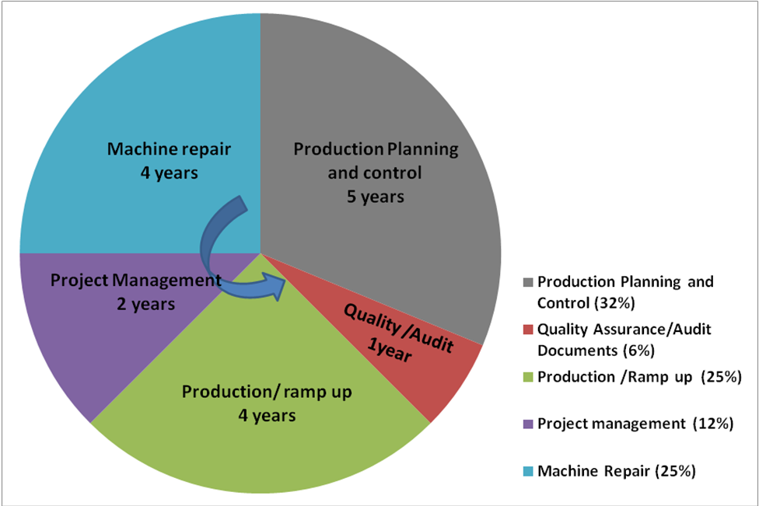

- Proficecncy in Daily Works Management,Six Sigma project,TS Document preparation,Facing audits.etc
- My Previous assignment was with Apollo tyres as Associate Manager Production Planning and Control
- Proficiency in maintenance of various rubber processing machineries, and equipments in reducing downtime, Improving OEE of various equipments after erection to reach the target.
- Managed a group of 10 mechanics, in one department. Acheived the required KPIs set by management.
- Managed a group of 85 team members and 3 engineers to achieve targeted production.
- Attended abrupt break downs, executed TPM activities, Planned maintenance, maintained minimum spares etc to contain MTTR and MTBF with in targets.

Organisational Experience

Since Aug’04 – Oct’08 with MRF tyres as Mechanical Maintenance Engineer

Role:

- To Attend Breakdowns in shifts, with the maintenance crew.
- To do TPM activities,execute PM activities,scheduled maintenance.

Notable Achievements:

- Reduced down time by arranging and keeping minimum spares for critical machines.
- Implementing kaizens to reduce down time and fatigue.

Since Oct’08 – With Apollo tyres Limited as Associate manager Production Planning and control

Role:
- Material planning for all machine centres so as to reach targeted production in all shifts.
- Ensuring Master plan is met at every month end.
- Preparing monthly reports and corrective actions for non conformance.
- Manage Manpower allocation to attain the production target in shift
- Erection and commissioning of tyre building machineries.
- Establish and follow maintenance procedures
- Plan and follow maintenance schedules
- Attend Breakdowns and implement corrective action.
- Maintaining necessary records for ISO TS ,facing audits and implement corrective action
- Improve quality and maintain capability of products.
- Implement corrective action for consistently attaining targets.
- Implement 5S for better shop floor management

Notable Achievements:
- Six sigma yellow belt Project implemented.
- Installed and commissioned 40 tonnes rubber processing machineries.
- Maintained and updated all ISO TS and quality documents to avoid NCs for Dept.

Trainings
- Undergone first aid training, six sigma yellow belt, internal auditor.
- Currently taking PMP course.

IT Knowledge
- MS Office - Auto CAD 2000 - SAP

Education
- SSLC from kerala board
- Pre Degree for Govt Art College Trivandrum kerala 1998
- B.Tech. (Mechanical) from College of Engineering Trivandrum from Kerala University in 2003.

Personal Details Age &Date of Birth : 39, 14-05-1981
Gender : Male
Hobbies : Reading,Yoga
Maritial status : Married
Address : Arunnivas,Chenkottukonam
Chempazanthi P.O
Trivandrum
Kerala state 695587

Locations
Preferred South India.

All the particulars given above are true to the best of my knowledge

Place: Trivandrum
Date: 01/03/2021 Ashwin us

