CURRICULUM VITAE
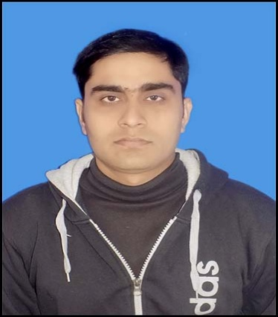

NISHANT KUMAR
Contacts: +91- 9647216806, 8763034241
Email id.: nishant3156@gmail.com

OBJECTIVE:
Seeking a position for a challenging role in Instrumentation, Control, Electronics & Electrical Project, Commissioning & Maintenance that will allow me to utilize my technical skills, experience and willingness to learn in making an organization successful.
WORK EXPERIENCE: 8+ Years
CORE SKILLS: Instrumentation, Control, Electrical, Electronics, Maintenance, Project, Commissioning, Preventive Maintenance, Field instruments, MCC & Panels, VFD, Calibration, Weigh Feeder, Problem Troubleshooting, MTBF, MTTR, HART, Hook-up diagrams, PLC, DCS, SCADA, P&ID, UPS, Hydraulic, Pneumatic, Technical Analysis of Equipment/Material before and after Purchase, 5S, TPM, Kaizen, ISO 9001, Manpower management, Breakdown Maintenance, Utility Maintenance, Steel Plant, Iron & Steel.
WORK DETAILS:
- Presently Working at SMS Envocare Ltd, (MEPL) Pune, as Manager in instrumentation & control dept. From Dec. 2017.
- Worked at 0.6MTPA Iron Ore Grinding, Beneficiation and Pellet Plant at Shri Mahavir Ferro Alloys Pvt. Ltd. Rourkela from June 2017 to Dec. 2017 as Assistant Manager in Maintenance in Instrumentation & Electrical dept.
- Worked at 0.6 MTPA Iron Ore Grinding, Beneficiation and Pellet Plant from Feb. 2016 to June 2017 as Senior Engineer in Project & Commissioning in Control & Instrumentation dept. (Green Field Project: Super Smelters Ltd, Asansol, West Bengal.)
- Worked at 1.2 MTPA Iron Ore Beneficiation & Pellet Plant in Project, Commissioning & Maintenance from Feb-2013 to Feb. 2016 as Executive Engineer in Instrumentation & Electrical dept. (Green Field Project: Pro-minerals Pvt. Ltd. Keonjhar, Odisha)
JOB RESPONSIBILITIES:

- Managing Project & Maintenance activities of dept. by leading, coordinating in order to meet the department goals and targets with full safety.
- Installation, Commissioning & Maintenance of PLC, DCS, SCADA, LT Motor, MCC & Panels, VFD, UPS.
- Having knowledge of equipment’s like Weigh Feeders, Belt Weigher, Load cell, Crushers, Chillers, Compressors, Scrubber, Ball Mill, Rod Mill, Jaw Crushers, All JIG, All FLUX, WHIMS etc.
- Commissioning & Troubleshooting of all kinds of field instruments such as Level Transmitter, Pressure Transmitter, Temperature Transmitter, Flow Transmitter, PH meter, Transmitters, Actuators, Control valves and various kinds/make of sensors, transducers and Safety Switches based on latest technologies.
- To ensure & maintain critical spares inventory are at optimum label and are of good quality & make.
- Daily Analysis of delays and take necessary action to up keep all dept. performances of KPI.
- Implement various maintenance system & set of procedures of all activities related to maintenance like TBM, Kaizen.
- Making & review of Instrument specification, IO list, termination details, cable laying schedule, Loop Diagrams, Instruments Location Layouts, Hook-up drawing, JB Schedule.
- Maintaining the calibration reports, history cards and other documents as per ISO.
- Plan the need and feasibility of additions, modifications and alteration to existing system.
- Planning & coordination of shutdown activities.
- Compliance to safety norms and improve safe working condition in the related area. Build and monitor systems to mitigate the hazards and risk involved in the process. Prepare SOPs for the related areas Ensure implementation of positive isolation.
- Having knowledge of SAP PM & conversant with general HSE guidelines of industry/fire & safety systems.
- Maintain quality systems like ISO 9001: 2015, ISO 14001: 2015.
Academic Records:
- B.Tech in Electronics Engineering from West Bengal University and Technology in 2012.
- 12th B.S.E.B, N.N. College. 2007.
- 10th C.B.S.E, Indian Public High School, 2005.
Soft. Skill:
Operating Systems : Windows, XP, 7.
Software package : Microsoft office (word, excel, power point).
Personal Details:
Name : Nishant Kumar
DOB : 26 Sept. 1990
Add. : Vaishali, Bihar
Pin : 844122
Marital Statuses : Single
Languages Known: Hindi, English & Bengali.
Declaration:
I hereby declare that the above written are true to the best of my knowledge and belief.
DATE: 01.03.2021 (Signature)
NISHANT KUMAR.

