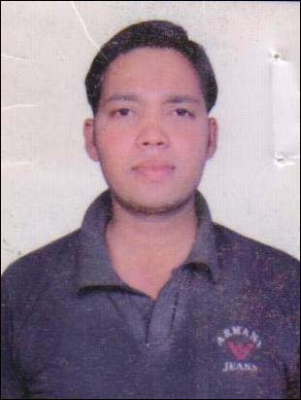
RESUME
MUKESH SOLANKI
Add- PURANI CHHAWANI
Gwalior (M.P.) – 474010
Mob.8109676157
E-mail:- solankimukesh81@gmail.com

Objectives :-
Seeking assignments in areas of Operation and Maintenance of Utilities, Plant Maintenance and Project Management.

Role:- Utility/Maintenance

Designation:- Shift Incharge Power Plant

Experience :- 3yrs.

Educational qualification:-B.E.(Mechanical) from S.R.C.E.M Banmore Morena affiliated to RGPV University Bhopal.

Experience of Industries:- G.A.P.L compny.

Areas of Exposure:-

- Boilers :- 52 kgs. to 30 ton per hr boiler AFBC ,CVL company
- D.I./D.M. water plants :- 2 kl/hr to 100 kl/hr with conductivity less than 1micro simens.
- R.O. Plants :- 2 kl/hr to 120 kl/hr of Ion Exchange & Thermax make E.T.P.:-
- Chemical E.T.P. (2880 m3/hr) & Bio E.T.P. (Mesofilic & Thermofilic)...m3/hr
for generating methane (CH4) gas for fuel.
- Coal Crushers:- Handled coal crushers having capacity up to 15 tons/hr with elevaters,belt conveyors, vibrating screen etc.
- Wet scrubbers:- Handled the scrubbers for controlling the fly ash of boilers, and chemical fumes of the processes.
- Air Compressors:- Generated and supply HPA(high pressure air) by reciprocating air compressors (Doublle stage water cooled) of Chicago pneumatics,and ingersolrand(I.R.)make centrifugal air compressors of 3000 cfm,refrigerated and regenerated (silica gel filled) type air dryers.
- Cooling Tower :- Handled cooling Towers up to3000 ton capacity induced forced draft cooling towers.
- Diesel Generator:- Handled diesel generators up 1250 KVA, Cummins make.
- Turbine:- 3MW back presure siemens turbine.

Companies Profiles:-

- Worked with Gwalior Alchobrew Pvt.Ltd.(Formerly known as Gwalior Distillers Ltd.GDL) from June’20016to Dec.2019 As a Senior Engineer Utilities & Maintanance.

Personal Profile

Name : Mukesh Solanki
Father’s Name : Shri Mangi Lal Solanki
Date of Birth : 03th Jun 1990
Sex : Male

Nationality : Indian

Language Known : Hindi & English
Marital Status : Married

Hobbies : Listening Music & reading Books

I hereby declare that the foregoing information is correct and complete to the best of my knowledge & belief and nothing has been concealed / distorted.

Date:
Place : (Mukesh Solanki)

