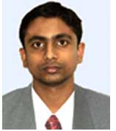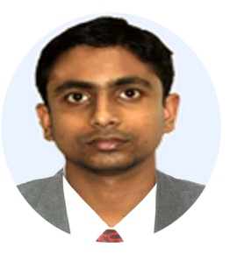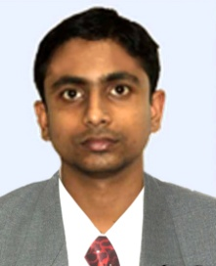

- Got selected as “Testimonial” by Symbiosys Center for Distance Education

in the Year 2020.

Achievement

Technical Education

- Pursued from institute of Computer Education with grade “EXCELLENT”.

- Pursued from Computer Training Institute State Youth Centre with Grade “B”.

Computer Application

Diploma in Financial Accounting

2006

2009

2010

* Passed Madhyamik from WBBSE in 2002 with 68.75 %
* Passed Higher Secondary from WBCHSE in 2004 with 53.50%
* Passed B.Com (Hons.) from Calcutta University in 2007 with 51.75%
* Passed PGDBA (Finance) from SCDL in the year 2019 with 69.88 % (First Class)

Secondery

Higher Secondery

Bachalore Degree

Post Graduation

Formal Education

* Late Amar Kumar Sanyal
* January 11th 1986
* Male
* Single
* Indian

Father’s Name:

Date of Birth:

Gender:

Marital Status:

Nationality:

Languages Known

Anal Kumar Sanyal

20, Beliaghata Main Road, Kolkata – 700 010

E-mail : [anal.sanyal@gmail.com](mailto:anal.sanyal@gmail.com)

Mob: +91 9830689205

- Bengali, English & Hindi.

Personal Details

Name :

Address :

Email :

Phone :

Curriculum Vitae



Apr’ 2006 to Nov’ 2010

Jan’ 2007 to Sep’ 2009

Oct’ 2009 to Feb’ 2011

Mar’ 2011 to May’ 2013

Jun’ 2013 to Apr’2018

Apr’2018 till date

- Worked as an Accountant-cum-Faculty (Part Timer) in M/s. ICE Infotech (Computer Centre)

* Worked as an Accountant in M/s. Electro Alloys Corp. (Manufacturing & Trading of Automobile Spare Parts)
* Worked as an Accountant in M/s. Watertech Engineers Pvt. Ltd.. (Manufacturing & Trading of Pumps, Motors and Accessories)
* Worked as Accounts Manager in M/s. Snowmasters Special Effects India Pvt. Ltd. (Deals with Special Effects Items/Events)
* Worked as Accounts Manager in M/s. Sanjeevani Health & Lifestyle Pvt. Ltd**. (Apollo Clinic, Saltlake)** (under same group as M/s. Snowmasters)
* Working as Accounts Manager in M/s. Institute of Advanced Management **(IAM)** **(Sister Concern of IIHM) under Indismart Group.**

Working Experience

* Photography, Trekking & Climbing….

1. Manage and oversee the daily operations of the Accounts Department.
2. Monitor and analyze department work to develop more efficient procedures and use of resources while maintaining a high level of accuracy.
3. Banking, Maintain Relationship with Banks as well as liaison with Govt. Dept.
4. Interface with other departments to verify transaction report data and issues.
5. Provide training to new and existing staff as needed.
6. Outstanding Maintain, Accounts Payable/Receivable, Party A/c. reconciliation. & dealing with them regarding the same.
7. Handle customers’ grievance, if any, and convert the same into satisfaction.
8. Ensure the timely reporting of all monthly financial information like MIS. Graphical representation of Misc. data.
9. Monitor all the assignments of TDS, Service Tax, ESI, PF. P.Tax & GST
10. Preparation of Finalization of Accounts.
11. Coordinate with CA in Internal Audit.
12. Budget Preparation with the help of the Dept. Head and Comparism with Actuals.

I hereby declare that all information furnished here are true to the best of my knowledge and belief.

Anal Kumar Sanyal

Date:

Kolkata

Hobbies:

Job profile