*Name: AMIT CHANDAN PRATAP*

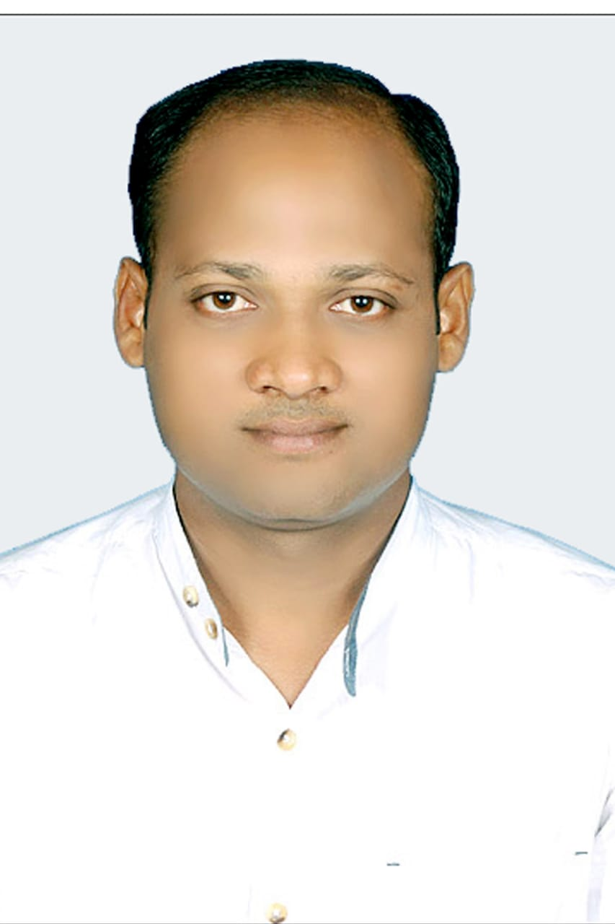

*C/O: Sri Dhirendra kumar Pratap, Plot No. 4D/1500,*

*Sector-9, C.D.A, Post:Markat Nagar, Dist:Cuttack,*

*State: Orissa, Pin: 753014, INDIA*

*Contact No.-🕽+91-9437649533* , 7008989044 **Passport No. - *L3600308***

*SKYPE ID-amitchandan2050@gmail.com,*

*E-Mail ID:-**🖂* [***amitchandan2050@gmail.com***](mailto:amitchandan2050@gmail.com)***.***

**LinkedIN-https://www.linkedin.com/in/er-amit-chandan-pratap-06976b1b/**

***SUMMARY-***

***B.Tech (2007-2010) Mechanical Branch from Dr. M.G.R. Educational & Research Institute, Chennai.***

***OBJECTIVE:***

I want to be a part of an organization, where I can use my technical skills and knowledge, what I have learnt from my academic career & project for the growth of the organization and myself, work in a challenging and dynamic environment to keep adding Value to myself and simultaneously contributes to growth and success of Organization. To secure an **Utility Engineer/ MECHANICAL ENGG** position within a fast growing industry in which my expertise can help the business meet its goals.

***PROFILE SUMMARY***

* **SR. Engineer** MECHANICAL with over **10.2 years** of rich experience in the field of various Electromechanical Maintenance, project including Fabrication & Erection in **power plant & chemical plant.**
* Outstan Deep knowledge of steam turbine generators, driven high pressure pumps, high purity water treatment procedures and heat transfer machines
* Amazing capability to formulate consensus and nurture positive relationships and communicate across functional lines
* ding knowledge of utilities and boiler maintenance
* Proficient with Boilers, Cooling towers, Compressors, Condensate systems
* Feed water systems, process steam systems and Waste water systems
* Remarkable ability to manage a manufacturing environment and coach members.
* Strong decision making, planning and time-management skills.
* Superior communication skills.
* Primary inspection responsibilities are monitoring, supervising and appraising the Contractor's/Sub-contractor's fabrication, construction, maintenance and repair performances in the area of quality control including evaluation of materials and procedures in accordance to applicable project specifications. Such inspection responsibilities includes monitoring and checking the quality works in the areas of mechanical, structural, piping, welding, pressure vessels, pipelines, tanks, insulation, non-destructive testing. Prepare inspection reports and issue non conformance reports as required. Other responsibilities are support to commissioning of plant and equipment utilities, preventive maintenance, condition monitoring, failure analysis, assist in the implementation of safety and environmental protection programs; and provides data required on project progress.
* Expertise in managing maintenance operations for reducing breakdown downtime & enhancing maintenance effectiveness of equipment.
* Skilled in organizing activities for continual improvement in Boiler maintenance & working towards cost reduction; gained expertise in maintenance work of WHRB’S, AFBC Boilers & Turbine.
* Track record of managing functions related to annual inspection, shut down of boilers, other emergency situations and effectively resolving the same.
* Contributed in preparation of Annual budget.

***EDUCATIONAL QUALIFICATION:***

*Completed my B.Tech. (Mechanical Branch) from Dr. M.G.R. Educational & Research Institute, Chennai*

|  |  |  |  |
| --- | --- | --- | --- |
| ***Course*** | ***Institute*** | ***Year of***  ***passing*** | ***%of marks or CGPA*** |
| *B.Tech(Mechanical)* | *Dr.M.G.R.Educational & Research Institute, Chennai, Tamilnadu* | *2010* | *7.53 CGPA* |
| *Diploma in*  *(Mechanical Engg.)* | *SCTE & VT.*  *(State board)* | *2006* | *63.17%* |
| *HSE* | *Lunia Sahayoga High School, Lunia, Bhadrak* | *2003* | *59.9%* |

***ACHIEVEMENTS:***

* *Participated in national level technical paper presentation in 2009*
* *I was selected as the president of student affair during my school life because of my impressive leadership quality and better managing capacity.*
* *Participated in Aero Modeling.*

***INDUSTRIAL TRAINING:***

* *I have completed my industrial tanning in* ***Captive power plant*** *in NALCO,ORISSA.*
* ***Training Title****: - Operation of CPP unit.* Thermal **Power Plant** has a **generation capacity of 1200 MW (10×120MW). *Duration****: - 30 days.*

***Description****: - Know about the different process of captive power plant including various inputs & outputs of the plant. The inputs (water, coal) are used by NALCO CPP for producing power & the outputs are used by Smelter plant for producing aluminum.*

***COMPETENCIES:***

* *Excellent communication & Interpersonal skills.*
* *Good hand on every field of engineering.*
* *Self motivated and willing to continue learning.*
* *Excellent statistical, technical and operational skills.*
* *Patient, hardworking & dedicative.*
* *Comprehensive problem solving abilities.*
* *Positive attitude.*
* *Self confidence & discipline.*
* *Enthusiastic & Motivated.*

***TECHNICAL PROFICIENCY***

* **Knowledge*****M.S. Office , ERP*** *(Word, Excel, Power Point).*
* *Basics of Windows XP, 2000, Vista.*
* *Programming languages:* ***C, C+ +***
* *Mechanical Software’s: Auto-Cad, CATIA R15*

***INDUSTRIAL VISIT***

* *Indian Coach Factory, Chennai.*
* *North Chennai Thermal power station, tamilnadu.*
* *Carburetor Manufacture ltd, Chennai*

***WORK EXPERIENCE 10 years exp***

**1.**Organization: (**ACB INDIA LTD**)GROUP OF ARYAN ISPAT & POWER PVT LTD, Sambalpur, as SR. Mechanical engg Maintenance dept. Joined as GET (Mechanical Maintenance) in Mechanical Dept Power Plant from DEC 2010 to FEB 2019 and now promoted to **Sr. Engineer (Mechanical In-charge). EXP-8.1 YEARS**

***Growth Path:***

GET Dec’2010 to Apr’2012.

MECHANICAL ENGG Apr’2012 to Apr’2016.

Sr. ENGG Apr’2016 to FEB 2019.

PLANT ENGG FEB 2019 TO CONTINUE.

***CARRIER PROFILE:***

|  |  |  |
| --- | --- | --- |
| ***Duration*** | ***Organization*** | ***Role*** |
| *DECMBER 2010 to FEB 2019* | ***ACB INDIA LTD GROUP OF***  ***ARYAN ISPAT & POWER PVT .LTD*** | *SR.ENGG (MAINTENANCE DEPT)POWER PLANT* |
| *FEB2019 TO SEPT 2019* | ***INDROX GLOBAL PVT.LTD*** | *MECHANICAL ENGG*  *(CHEMICAL PLANT)* |
| *OCT 2019 to till Today* | ***INTERNATIONAL STEEL SERVICES INC .BOKARO SAIL*** | *MECHANICAL ENGG*  *(CHEMICAL PLANT)* |

***Notice period: 30 DAYS***

***JOB RESPONSIBILITIES***

***Mechanical Maintenance:***

* Maintenance of Boiler and auxiliaries such as Pressure parts, Ducts, expansion joints, fans, Air preheated, wall soot blowers, long retractable soot blowers etc.
* Erection & Maintenance of RO plants.
* Erection & commissioning of ECONOMISER **COILS** **(1×27 TPH, 1×10 TPH 1×33TPH boiler ) with hydro test.**
* **All IBR & NON IBR PIPING OF BOILER.**
* Responsible for replacement of boiler pressure parts like, **BED coil, super heater coil etc.**
* Rotating equipments like centrifugal pumps, Gear pumps, screw pumps, Dosing pumps, Air blowers and various types of gear box. and alignment of CT Fan, Gear box & Pump Coupling.
* As per the requirements planning of day to day work schedule and distribution of jobs and inspection.
* Maintenance of screw compressors make – ELGI.
* **Maintenance of fire fighting equipments .**
* Maintenance of Turbine auxiliaries like condenser , hot well, AOP, Servomotors, control Valves, safety valves, gate valves, Globe valves.
* Maintenance of all rotating equipment rotary feeder, gear box, ID Fan , PA Fan , FD Fan, ACWP,CWP,CEP,BFP.
* Maintenance of CHP crusher ,Screen and all Belt Conveyor system,
* Maintenance of FLY AHP ash conveying line ,dome valve & seal and in silo ash conditioner, Screw Compressor.
* **Maintenance of Fly Ash silo system vent bag fitters, ash conditioner, Rotary Vane feeders.**
* Maintenance of Bottom ash handling system of coal handling plant.
* Maintenance of Impactor-crusher, vibrating screen, vibrating feeder motors, conveyers.
* Maintenance of Drag chain feeders and pocket feeders.
* Maintenance of centrifugal & reciprocating pump,
* **Fabrication, Erection, of a new coal shed 45& 50mtr span.**
* Maintenance of turbine gearbox.
* Managing maintenance schedules and budgets.
* Delivering planned and property maintenance.
* Managing a team of multi-disciplined maintenance technicians.
* Delegating work responsibilities.
* Recording daily maintenance activity.
* Running an efficient repairs reporting system.
* Responding quickly to any emergencies.
* Conducting employee performance reviews.
* Involved in the hiring on maintenance personnel.

***KEY SKILL:***

* Maintenance of thermal Power plants .
* Maintenance of utility equipments.
* Preventive Maintenance.
* Indent of Spare Parts.
* Planning & Organization of Man power, Materials and spares for routine maintenance activities and Annual Overhaul.
* Implementation of preventive maintenance to reduce breakdown times.
* Regenerative Job Operations & Maintenance Responsible for Overall production of AFBC Boiler. Planning and organizing preventive & predictive maintenance schedules of equipments to reduce the down time and increase operational reliability for 18MW & Identifying areas of obstruction/ breakdowns and taking steps to rectify the areas of concept through predictive maintenance practices.& Maintenance and troubleshooting of CHP, DM Plant, Compressor, , etc.
* Planning and organizing Preventive & Predictive maintenance for all boilers like WHRB boiler , AFBC boiler.

**2. Organization: (a)** **INTERNATIONAL STEEL SERVICES INC**

**(b)INDROX GLOBAL (P).LTD**

**Designation**- **PLANT ENGINEER(MECHANICAL)**

**Period-** April 2019 to till date

**PLACE-** BOKARO STEEL CITY (JHARKHAND)

**COMPANY PROFIL- (INTERNATIONAL STEEL SERVICES INC)**

Company EPC project taking of HCL Regeneration plant & execute with all respect. Right now company have 3 plants in bokaro steel city . Here company execute of **8500LPH** & **5500LPH HCL** Regeneration plant. Company deals with client of BSL & JINDAL.

**AREA OF RESPONSBILITY:-Acid regeneration plant (ARP)**

# *JOB RESPONSIBILITIES:-*

* I have knowledge of all process and operation of venture, separator, absorber, scrubber, pump, exhaust fan(I.D FAN).
* Inspection of plant & make record.
* Manage maintenance work.
* Looking plant safety works.
* Make the plant zero breakdown time.
* Responsible for operation of ARP(Acid regeneration plant).
* Decision making during emergencies.
* Plan work schedules and co-ordinate production.
* Support for engineering team leader with regards to day to day activities including reporting of performance and escalations of significant issues.
* Task management of shift engineering team, including direction and alignment of shift team to support production priorities.

# *MAINTENANCE:-*

* Maintenance of Acid pump (CPL, Venturi, Absorber, Scrubber etc).
* Maintenance of Equipments(IDFan, COG Booster,CA Blower).
* Maintenance of Vessels (Roaster, venturi, absorber, scrubber, separator.
* Maintenance of Piping (FRP, MS ,SS ,Gl ,PVDF).
* Maintenance of Compressor (Double acting reciprocating).
* Maintenance of Roaster Refractory.
* Maintenance of *val*ve.(B/F, Gate, Bal valve ,NRV).
* Coordination with clients.(BSL Operation & maintenance).

***Highlights:***

* Contributed in **maintenance activities** like inventory management & Modification as per requirements.
* Played a key role in planning the annual inspection & shutdown of boilers.
* Deftly coordinated for safety and housekeeping functions & with Technical Dept.
* Ensuring implementation of plans for tackling breakdowns & emergency situations and taking suitable action for resolving all major breakdowns in the plant.

***AREAS OF EXPERTISE***

***Man power management:***

* Leading a multi-skilled workforce, allocating task amongst them & providing guidance to them in O&M work; organizing trainings for the subordinate staff to increase their effectiveness at different stages of work.
* Creating and sustaining a dynamic environment that fosters development opportunities and motivates high performance amongst team members.

***Maintenance / Material Management***

* Planning & implementing the preventive & predictive maintenance schedules for improving the overall reliability & safety of plant equipment & machinery; involved in shut-down maintenance work & overhauling of equipment
* Ensuring formulation of plans for spare-parts/material availability, inventory control and following-up for procurement with Purchase Department.

***Quality Assurance / Cost Control***

* Identifying scope for modifications in equipments, process flow, working practices, consumables, etc. for controlling & reducing costs; organizing activities for continual improvement & working towards cost reduction.

***PROFILE***

* *Overall responsibility of maintaining work in power plant mechanical.*

***PERSONAL MEMORANDUM:***

*Date of Birth: 2nd Feb, 1988*

*Languages known (Both Oral & Written):English, Hindi, and Oriya.*

*Marital Status: Married*

*Nationality: Indian  
Sex: Male  
Presently Employed: YES*

*Hobbies: Playing Cricket, Watching Movies, Internet Surfing.*

Mobile No. : 9437649533, 7008989044

Email-ID:**amitchandan2050@gmail.com,**

**amitchandan2050@rediffmail.com**

***DECLARATION:***

*I certify that the information furnished above is factually correct and subject to verification. I also certify that I am at present in sound mental and physical condition to undertake employment with the organization. I accept that an appointment given to me on this basis can be revoked and or terminated at any time in future if any information has been misstated or unstated.*

*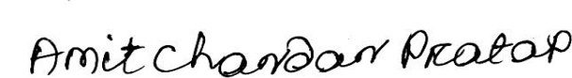****DT 20.01.20201 SIGNATURE***

***Place-Cuttack, Orissa. INDIA***