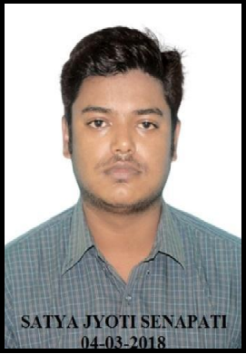 **Satya Jyoti Senapati**

Mob: +91-9439015517

Email: [satyajs.sjs@gmail.com](mailto:satyajs.sjs@gmail.com)

**INSTRUMENTATION ENGINEER**

**Work Experience:**

2014 –15.02.17 **VEDIK ISPAT Pvt. Ltd. (HRM), Hindupur Mandal, Ananthpur District, Andhra Pradesh.**

Instrumentation Engineering (G.E.T) 10th January 2014

**Responsibility:** Maintenance of the field instruments at Plate Mill (H.M.D, Leaser Gauge, Pressure and Flow Transmitters and G.E. Fanuc HMI & BIT Programming).

Maintenance and running of Diesel Generator (500KVA)

2017 – Today **BRG Iron & Steel Co. Pvt. Ltd. (Reheating Furnace), Dhenkanal, Odisha.**

Electronics & Instrumentation Engineering (Engineer). 16th Feb 2017 to till date

**Responsibility:** Maintenance in the field of 160TPH Reheat Walking Beam Furnace (Propane) (Level-1 Automation)

**HMI:** Allen Bradley

RSLogix5000 (Rockwell Automation)

**Commissioning:** Reheat Furnace(160Ton Per Hour Walking Beam Model) with Allen Bradley (Level-1)Field Instrument’s Calibration, Installation and Maintenance.

**Academic Qualification:**

2007 **Matriculation Examination.** First Division.

Central Board of Secondary Education.

2009 **Higher Secondary Examination**. Second Division

Odisha Council of Higher Secondary Education.

2013 **Degree in Applied Electronics & Instrumentation Engineering.** First Class.

Siksha ‘O’ Anushandhan University, Bhubaneswar.

**Additional Skills:**

Language: Odiya, English & Hindi.

IT: Microsoft Office, Certified of

Information Technology Application

**Strengths:**

Workaholic

Strong team orientation and manpower management

Learning Hunger for new technologies

Extreme value for time

**Miscellaneous:**

Nationality: Indian

Marital Status: Married

Date of Birth: 16.12.1991

Address: C/O Sushil Kumar Senapati

Vill: Kalianti P/O: Chayanpal Via: Kuanpal

P/S: MahangaDist: Cuttack Pin: 754202

.

Place: -Dhenkanal, Odisha ----------------------

Date: - 01.01.2021 Satya Jyoti Senapati