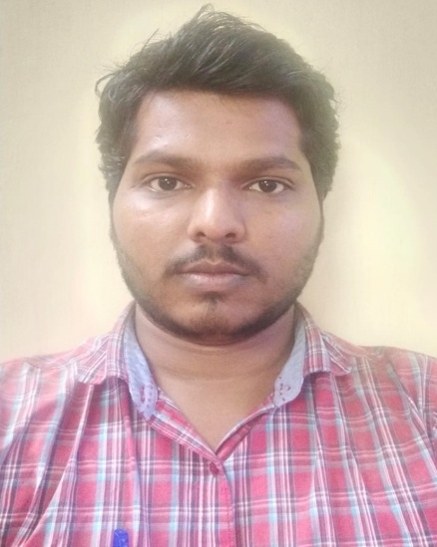

Krushna Kalbhor

Email ID :- [kkalbhor7@gmail.com](mailto:kkalbhor7@gmail.com)

Phone no. :- +919561714272 /+918369574344

# Core Competence:-

* Electrical & Instrumentation Automation Engineer
* PLC, SCADA troubleshooting
* VFD, Soft starter, Weigh Feeder
* Instrumentation PT, DPT, RTD’s, Thermocouple, Flowmeter, Level transmitter
* Commissioning
* Fault finding
* Sensors
* Motors, Control Panel
* Metrology
* Calibrating E&I equipment
* Material indent
* Shift Handling
* LT/HT Panel
* Customer support

# Technical Skills:-

* PLC(Schneider, Siemens) ,SCADA troubleshooting.
* Pneumatic, Hydraulic system
* Calibration, Installation, Commissioning
* Actuators.
* Fault finding
* MS office

# Professional Overview:-

Highly focused and self-motivated with active interest in taking initiatives to projects related automation, Machine learning, Deep learning in the area instrument. I aim to join an organization where I can prove my worth by contributing to the exponential growth of organization and thereby fuelling my growth with my team mates.

# Profile Summary:-

* Offering 4 years of experience, in which worked as Automation Service Engineer for 2 years 4 months and from last 2 years working as Electrical and Instrumentation Engineer.
* B.E. in Instrumentation from Mumbai University.

# Organization Experience:-

Current Company:- Uttam Galva Metallics Ltd.

From Dec-2018.

Key Responsibilities:-

* Shift handling, fault finding, electrical & Instrumentation Maintenance.
* Handling of projects such as mounting of sensor, water flow meter(Ultrasonic & Electromagnetic), PT, DPT, LT, Chlorine, PH, Turbidity, setting parameters(Calibration, Installation, Commissioning ),
* Troubleshooting of instruments in PLC(SchneiderTwido, SiemensS7-400), SCADA(Wonderware Intouch/Schneider Electric).
* Electrical equipments & instruments indent for field, throughout technical discussion with vendor.

And finalizing purchase with superiors.

* Maintaining SOP, SMP, HIRAC documents for IMS audits.
* Maintaining electrical spares in store. Getting list update every month.
* Attending safety related training, giving pep talk about work to workmen.
* Hands on experience of Actuators Installation, Calibration, Maintenance.

Previous Company:- Chetas Control Systems Pvt. Ltd. (Aug -16 to Nov-18) Key Responsibilities:-

* Installation, Calibration & Commissioning of Analytical Instruments like PT, LT, FT, Chlorine, PH, Turbidity.
* On site troubleshooting of Analytical Instruments.
* Planning required upgradation for instruments to achieve production quality.
* Present customer satisfaction index to the management on monthly basis.

# Academic Details:-

* B.E. in Instrumentation Engineering from RAIT, Navi Mumbai, Mumbai University (2011-2016).
* H.S.C from J.S.M. College, Alibag. with 60.83%.
* S.S.C from ArunKumar Vaidya Highschool, Alibag. 81.23%.

# Personal Details:-

* Permanent Address: Room no.-2, Shripad Society, Vidyanagar, Chendre, Alibag, Raigad, Maharashtra-402201.
* Present Address:

Room No. 20, BH1, Uttam Value main Colony, Bhugaon Link Road, Wardha, Maharashtra.

442001.

* Date of Birth :- 19th June 1993
* Marital Status:- Unmarried.
* Language Known:- English, Hindi, Marathi.
* Hobbies:- Cricket, Kho-Kho, Chess, Badminton, Facts reading, collecting info. Of latest technology.
* On site error detection & troubleshooting of PLC, RTU & Router for SCADA.
* Operation & Maintenance of automation system installed at Morbe Dam(Navi Mumbai Municipal Corporation.)
* Identifying & Rectifying the fault of SCADA system.
* Hands on experience of PLC(SchneiderTwido) Troubleshooting.
* Service related documentation, Maintaining service related documents, commissioning, service report in soft as well as hard copy.
* Provide operation and maintenance training to customers.
* Installation & On site troubleshooting of Actuators.
* Maintenance of machine panels. Panel, Field Wiring Inspection.
* Electrical BOM preparation. GRN of measuring electrical instrument. Trials of different electrical instruments. Preparing fault finding chart.

# Project Handled:-

* Installation of Energymeter system at 350 MLD Water Treatment Plant at Bhokarpada for Navi Mumbai Municipal Corporation.
* Installation & commissioning of Electromagnetic Flowmeters(Kronhe Marshall), LT/PT(E & H) at Thane Municipal Corporation Water Supply department.

# Internships:-

# Internship at Rashtriya Chemicals & Fertilizers Ltd.

# Effluent Treatment Plant, Urea plant, Ammonia Plant, Steam Generation Plant & Bagging Plant