***CURRICULUM VITAE***

|  |  |
| --- | --- |
| **ARINDAM SARKAR**    Duti Pata Appt, Flat-H, Block-A  Rammandir, Chinsurah, Hooghly  **E-mail:** arichem35@gmail.com  **Mob. No.:** **8910267715/9903398156** |  |

**Summary**

* Experienced plant Manager having rich experience in Manufacturing Industry, Fertilizer, Soap & Detergent ,Ink Industry, Concrete Industry.

**TRAININGS ACHIEVED**

* General Maintenance at state productivity council
* Safety management at state productivity council

**KEY SKILLS**

* Plant operation, Shop floor supervision & Man Management
* Maintenance supervision
* Purchase handling
* Stock taking & WIP
* Logistics & Freight rate negotiation with transporter

**Trans Concrete Pvt Ltd(Ready Mix Company) From Jan20 to Till now**

**Trans Concrete Pvt ltd is a significant division of integrated building material company.**

**Plant Manager**

Responsible for plant operation management

* Effective working the plant by ensuring safety of people & machinery.
* Production operation & supervision.
* Responsible for production output, product quality and on time shipping.
* Ensure the regular & preventive maintenance of the plant & equipment.
* Plant administration
* Ensure statutory compliance & maintain relationship with local stakeholders.
* Stock monitoring (i.e Cement status in silo,Stone,Sand,Fly Ash & Admixture) on daily basis
* Cement bulker,Fly ash bulker unloading supervision if needed
* Documentation of each & every job
* Cost Optimization through proper utilization of resources.

**SICPA India Pvt ltd. Sikkim (India). From July18 to Jan19(company close down)**

**Sicpa India Pvt Ltd (Security Printing ink Producer) is a well known MNC and market leader for security ink producer in the world**

**DY MANAGER PRODUCTION**

Responsible for plant operation management of manufacturing security ink of currency note for RBI.

* Production planning as per customer requirement in safe work practices, schedules, capacity & manpower planning.
* Production operation & supervision.
* Responsible for production output, product quality and on time shipping.
* Maintenance supervision
* Plant administration
* Commit to plant safety procedure.
* Stock taking & WIP
* Tanker loading & Unloading supervision
* Documentation of each & every job
* Sampling & tagging of Raw material ,
* Proper tagging of Packing material & Finished goods.

**Fena (P) Ltd. HOWRAH (India). Since December’12 to July18**

**Fena (P) Ltd.( FMCG company) is a well known name and market leader in**  **No-1 quality detergent powder, Toilet Soap, Laundry soap, Dish wash liquid manufacturer in India & also producing linear alkyl benzene Sulphonic acid (LABSA) for captive consumption.**

**DY MANAGER PRODUCTION**

Responsible for plant management of 24000 MTPA Detergent powder, 4500MTPA Detergent cake & 6000 MTPA LABSA,

* Support to production operation in safe work practices, schedules, capacity & manpower planning.
* Job setups & work instructions.
* To Prepare Monthly Production Plan as per Monthly Sales Plan and generate Material Requirement Plan for the month. Coordinate with Purchase department for material indents and procurement at right time.
* To prepare production plan-day wise based on available capacity. Coordinate with Purchase and stores to ensure availability of raw materials & packing materials
* Daily production report, Monthly Factory report , Monthly inventory planner preparation .
* Involvement with Pollution control board & Legal Metrology Department
* Involvement into safe operation of ETP.
* Identify the training needs of workers, & production staff to their development.

Fire & safety training to workers.

**Jayshree Chemical & Fertilizers (kharda, Kolkata ) From Mar ’2004 to Dec12**

**Jayshree Chemical & fertilizer a Fertilizer industry of well known B.K Birla Group , making,NPK Fertilizer,Sulphuri Acid,Single Super phosphate Fertilizer, “SAKTIMAN”**

**Shift Incharge**

Responsible for plant management of NPK 50MTPD,1000 MTPD Single super Phosphate,200 MTPD Sulphuric Acid,

* Conduct proper shift turn-over by determining plant status at the start & End of shift.
* Identifies abnormalities or any unresolved problem to be communicated to the next shift & situation where information should be passed on to higher levels.
* Determine material requirement based on production trend & other relevant factor.
* Complete all required documentation promptly & according to procedure.
* Identify situation where minor repairs can be carried out by production & coordinate with maintenance department.
* Production monitoring
* Supervises mill operator & other shifter including subcontractor reporting within the shift.
* Directs the conduct of activities relative to the inspection of various equipment ,flow of raw material ,other production related activities & minor corrective repairs of machineries.
* Responsible to carrying out the schedule of work on long & short period shutdown & responsible to carry out the annual overhauling job of both acid & fertilizer plant.

**COMPUTER SKILL:**

Operating Software: - SAP, Tally, MS word, MS Office

**ACADEMICS DETAILS**

|  |  |  |  |
| --- | --- | --- | --- |
| **Academic Qualification** | **Institute/College** | **Board/ University** | **Year of**  **Passing** |
| * Madhayamik(10TH) | S.T.P.P High School ,Santaldih | W.B.B.S.E | 1996 |
| * Higher Secondary (12TH) | S.T.P.P High School ,Santaldih | W.B.B.H.S.E | 1998 |

> B.E (CHEMICAL) Gandhi Institute of Engineering & Tech BERHAMPUR 2002

**ACHIEVEMENTS**

* Increased productivity & Develop systematic smooth operation

Structure of Department

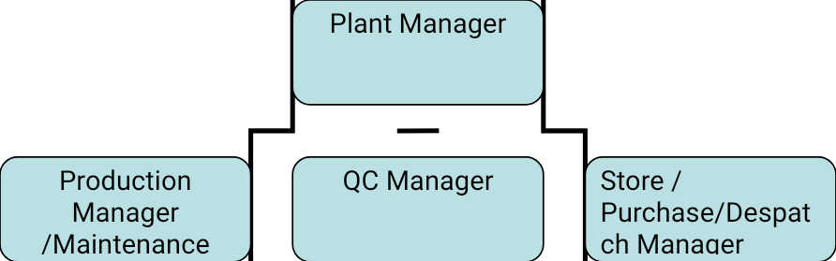

**PERSONAL DETAILS**

|  |  |  |  |
| --- | --- | --- | --- |
| * Date of Birth : 25 March 1979. * Address : Duti Pata Appt,Flat-H,Block-A,Rammandir,Chinsurah,hooghly West Benga West Bengal(India) * Marital Status : Married * Current location : Kolkata * Current CTC : 4.8 Lac P.A * Expected Salary : (Negotiable) * Reporting To : MD and V.P * Repotees : 7 people directly & 20 people Indirectly * Notice Period : 7 Days. |  |  | |
| **STRENGTHS**   * Ability to interest with people with ease. * Quick learner and friendly. * Ambitious and Highly motivated. * Managing time and work efficiently.   I hereby declare that all information’s given above are true and correct to best  of my knowledge and belief and I hold all the responsibilities of its authenticity |  |  | |
|  |  |  | |
|  |  |  | |
|  |  |  | |

**Date: 24.04.2020**

**Place: Chinsurah**

**(Arindam Sarkar*)***