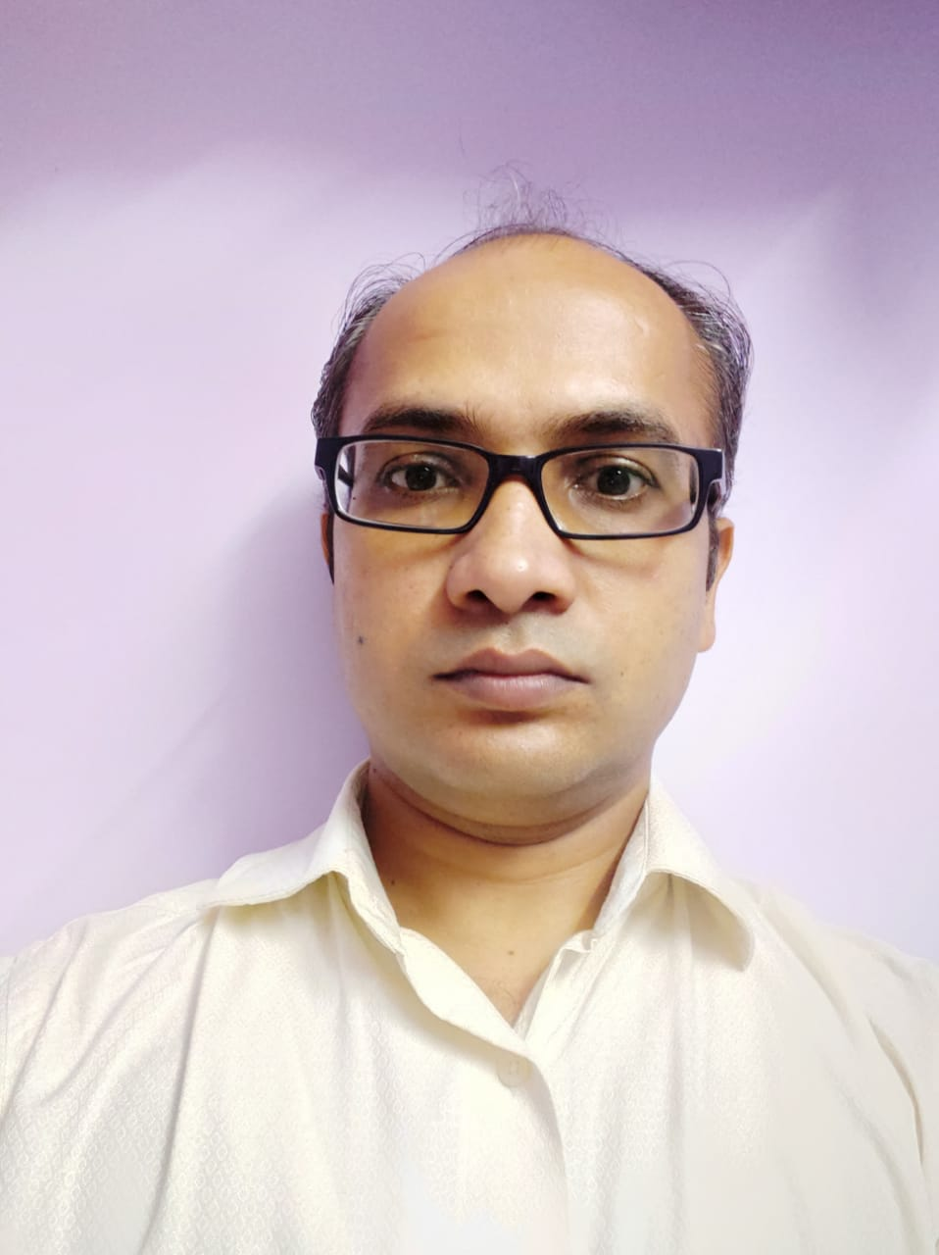**Lawlesh Kumar**

**Present Address**

Chiplun, Maharashtra

Ph: 09527547079, 9545437941, 09945915594, 8605526724

**Email**: [lawlesh_kumar@yahoo.co.in](mailto:lawlesh_kumar@yahoo.co.in),

[lawlesh20@gmail.com](mailto:lawlesh20@gmail.com)

|  |
| --- |
| PROFILE |

* **11 + years** of heavy industry experience as Electrical Maintenance.
* Thorough working knowledge/experience of electrical system of heavy industry operating throughout the clock.
* As an Electrical and Electronic engineer ready to perform and execute at the critical level of organization through my knowledge, skills and personal commitment.
* Strong and effective inter-personal and communication skills with the ability to interact professionally with a diverse group of clients and staff.

|  |
| --- |
| EDUCATIONAL QUALIFICATION |

|  |  |  |  |
| --- | --- | --- | --- |
| **DEGREE** | **INSTITUTION** | **YEAR OF PASSING** | **%** |
| B.E. (Hons. Degree**) -** Electrical & Electronics | RGPV | 2009 | 79.19% |
| HSC | BIEC | 2004 | 60.10% |
| SSC | ICSE | 2002 | 80.00% |

|  |
| --- |
| WORK EXPERIENCE |

**Present Company Name:** Gharda Chemicals Ltd, Maharashtra.

Gharda Chemicals is a leading developer of agrochemical products in India. To support its chemical industry, company has its own power generation plant. I am working as a Senior Executive – Electrical in electrical division of the company.

**Duration**: 25 June 2012 to till date

**Designation**: Senior Executive - Electrical

**Job Location**: Chiplun, Maharashtra

**Project Experience :**

* Commissioning and installation of 46 TPH FBC Boiler
* Commissioning and installation of 33 KV HT Yard / 4X 2 MVA Transformer
* Commissioning and installation of 3.3 KV/0.415 KV 2 MVA Transformer
* Commissioning and installation of 2.4 MW Turbo Steam Generator

**Job Responsibilities:**

* Monitoring smooth operation of Cogeneration plant of 7.5 MW
* Manpower handling and Total Preventive Maintenance(TPM)
* Analyzing Power generation & consumption of Day
* Maintenance of 33 KV Substation/ HT Yard/MV Room
* Maintenance of AC Drives Feeding parameters in Drives(ABB/Schneider/Delta/Yaskawa).
* Vendor Development/ Consulting External parties during annual maintenance of Power Plant
* Documentation-Capex, Reliability ,FAR/FIR,PM, CM
* Handling Audits-IMS/ENMS/Electrical Inspection
* PLC , SCADA and automatic system maintenanceElectrical
* Generator / Steam Turbine Maintenance
* 40 TPH , 46 TPH Boiler Electrical Equipment Maintenance
* ESP Maintenance
* DG sets Maintenance

**Reporting to Manager / AGM– Electrical**

**Persons Reporting to Me**

**Total number of Engineer – 2 nos**

**Total number of Electricians / Technicians – 10 nos.**

**Previous Company Name: Concord blue** India Limited, Mahad, Maharashtra.

The company has business in generating electrical energy from waste. At Mahad plant it produces "steam" and "sync gas".

**Duration**: 22 May 2011 to 22th June2012

**Designation**: Shift Manager

**Job Location**: Mahad, Maharashtra

**Job Responsibilities:**

* Monitoring smooth operation of plant
* Checking raw material consumption and production
* Manpower handling and TPM
* Energy generation & consumption of shift
* HAG , Boiler, Nitrogen plant maintenance
* Dryer operation and maintenance
* PLC , SCADA and automatic system maintenance
* Reporting to AGM of plant

**Previous Company** :Uttam Galva Steels Ltd.

**Duration** : 2 yrs 1 month

**Job Responsibility Features**

* Trouble Shooting skills of Compressor, Annealing(H2, N2), ARP, ETP, WTP & EOT cranes.
* Maintenance of 100 kv substation : SF6 breaker, ACB, CT/PT , 31.5 & 20 MVA T/F maintenance HT line.
* Checking AC, DC Drives, Feeding parameters in Drives (Siemens,Yaskawa, ABB Schneider, Delta). Installing drives.
* Solved Problems of Rolling Mills: 20 Hi, 6Hi, 4 Hi.
* PLC skills: Ladder logic L&T (MODSOFT), Siemens s5 fault navigation.
* TPM handling manpower management and supervising shutdowns.

|  |
| --- |
| ACHIEVEMENTS |

* **College topper** of all Semester in B.E in EEE.
* **All Branch College Toppers** in Second Semester of **B.E**.
* Got Prize as a Captain in Cricket Tournament at Randhir Verma Cricket Competition, Patna.
* Head organizer of cultural programs at college (Farewell party to our seniors in 2008, Fresher Party to juniors in 2007)
* Playing & Watching Cricket, Reading NewsPaper, Playing Chess

|  |
| --- |
| PERSONAL DETAILS |

**Father Name** : Late Mr. Shashi Bhushan Singh (Advocate)

**Email** : [lawlesh_kumar@yahoo.co.in](mailto:lawlesh_kumar@yahoo.co.in) , [lawlesh20@gmail.com](mailto:lawlesh20@gmail.com)

**D.O.B** : 14/10/1986

**Martial Status**  : Married

**Gender** : Male

**Permanent Address** : H/Name- Vasant Kunj, Road No. 3 , Mahavir Path, Defense Colony, MithilaColony Area, Bataganj, Digha, Patna-800018, Bihar

**Contact No** : +91-9945915594 ,9527547079 , 8605526724, 0-9545437941

|  |
| --- |
| PACKAGE |

Current CTC : 10.19 Lac per annum (Excluding Perks)

Expected CTC : 12-15 Lac per annum (Excluding Perks)(Negotiable)

Waiting for positive response.

**Thanking You.**

**Lawlesh Kumar**

Date : ______________ Place : ______________