**SUBHRA PRAKASH ROUT** 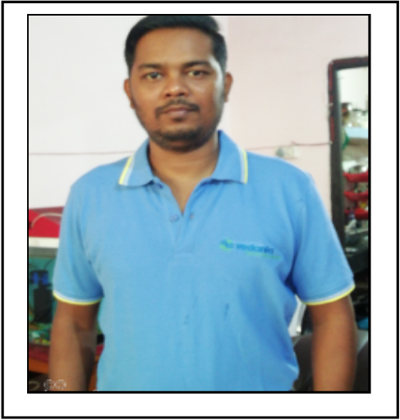

**Contact No.:** +91-8328921174, +91-8651036646

**E-Mail:** subhra1149@gmail.com

Performance-driven professional targeting assignments in **Maintenance/Operations** Location preference: **Anywhere in India**

|  |  |
| --- | --- |
| **PROFILE SUMMARY**   * Competent professional with over **13 years and 04 months** of rich experience in **Project Execution Maintenance Commissioning and Troubleshooting functions** * Specialization in operations & maintenance of Boilers and Turbine / Auxiliaries in Thermal Power Plant; skilled at Boiler Operations (CFBC,WHRB,AFBC) and Turbine operation * Successful at achieving minimal breakdowns, minimal accident & customer complaints; improving processes; compliance to safety rules & regulations * Excels at enhancing operational effectiveness by modifying existing machinery through diagnosis & rectification of faults and process automation thereby leading to better feasibility, reducing downtime, costs & labor requirements * Successfully convened an in-house training programme for complex repairs and knowledge-sharing for higher quality & safety standards * **Bagged Sabbash award and Safalta Award for Boiler feed pump tripping issue and Auxiliary saving** * Led operations for large teams (60-70 members) * Proficient in ramping up projects with competent cross-functional skills and on time execution * Believes in continuous learning and an innovative approach; possess excellent interpersonal, analytical and problem solving skills with a willingness to learn | **CORE COMPETENCIES**   * **Project Execution** * **Predictive, Preventive Maintenance** * **Shutdown Planning & Execution** * **Equipment Commissioning** * **Troubleshooting, Root Cause Analysis** * **Equipment Breakdown Analysis** * **Value Engineering** * **Vendor Coordination** * **Maintenance Expenditure Control** |

**ORGANIZATIONAL EXPERIENCE**

**Since May’14 with Electrosteel steels Vedanta Ltd.  Bokaro** as **Operation Manager (Power Plant)**

**Key Result Areas:**

* Managing **project execution** activities pertaining to utilities, machines and manpower; leading a team of **60-100 members**; supervising **site-installation, commissioning, handover** and **start-up** activities for the project
* Scheduling & planning **predictive / preventive / breakdown / corrective maintenance & overhaul** for reducing **equipment downtime to minimum;** performing **retrofitting** works and **overhauling of equipment**
* Monitoring implementation & documentation of quality systems and managing techno-commercial activities relating to O&M.
* Planning and controlling break down of machines; implementing the preventive & predictive maintenance schedules for improving the overall reliability and safety of plant equipment & machinery
* Conducting inspections in order to prevent accidents and adherence to safety norms
* Analyzing the nature of faults & initiating follow-up actions to provide quality feedback of the product; conducting analysis of existing processes, finding out shortcomings and suggesting improvements
* Advising subordinates on proper use, security and safe operation of all tools
* Examining site activities, availability of resources; evaluating site conditions / feasibility
* Supervising OEMs, vendors & contractors; assessing cost & expenses a; optimizing resources
* Training staff for maintenance activities, for O&M personnel for upkeep of machinery
* Monitoring costs to avoid wastages and keep expenses in control; maintaining and establishing maintenance procedures for production line to ensure production meets or performs better than budget
* Performing following technical functions:
* Lighting up Boiler
* Rolling the Turbine (Hot Rolling & Cold rolling)
* Minimizing heat loss
* Also looking after the CHP area operation.

**Highlights:**

* Implemented Kaizen, Five-S in the unit; conducting RCA for process improvement
* Delivered trainings for Process Optimization and better operational efficiency
* Successfully commissioned Turbo generator #02 in Electro steel plant in 2015
* Enhanced operational effectiveness by modifying existing machinery through diagnosis & rectification of faults and process automation thereby leading to better feasibility, reducing downtime, costs & labour requirements
* Exposure in managing operations for 2x60 MW Power Plant and 3x130T/hour, CFBC Boilers, 4x75T/hour, Waste Heat Boilers & Balance of Plant and 3×18.5 MW turbo blower operation

**Dec’09-May’14 with Nava Bharat ventures Ltd., Dhenkanal (Odisha) as Jr. Manager**

Executed operations for AFBC Boiler of 125 TPH each and Operation of 2×60 Mw turbine

**Sep’07-Nov’09 with Action Ispat and Power(P) Ltd., Jharsuguda as Sr. Engineer**

Performed operations and maintenance activities of Whrb Boilers and AFBC boiler

**Achievements:**

* Got Sabbash award and Safalta Award for Boiler feed pump tripping issue and Auxiliary saving in Colling water pump house area
* Save DM water by connecting Syphon in between GSC and Condenser as well as Increase Vacuum in Condenser
* Recognized for developing our own resources for take any such type of challenges
* Currently working on the project of Reduction in Station heat rate and reduction in Auxiliary power consumption.
* Got Employee of the Month and Team of the Month twice.

**EDUCATION**

* B.Tech. (Mechanical Engg.) from BPUT, 2007

**IT/OTHER SKILLS**

* SAP
* MS Office

**PERSONAL DETAILS**

**Date of Birth**: 1st March 1986

**Languages Known:** Hindi, English

**Permanent Address:** C/O-N.k.rout, At-Baniapat, D.D. College Road, Po-Keonjhar, Dist-Keonjhar Odisha758001