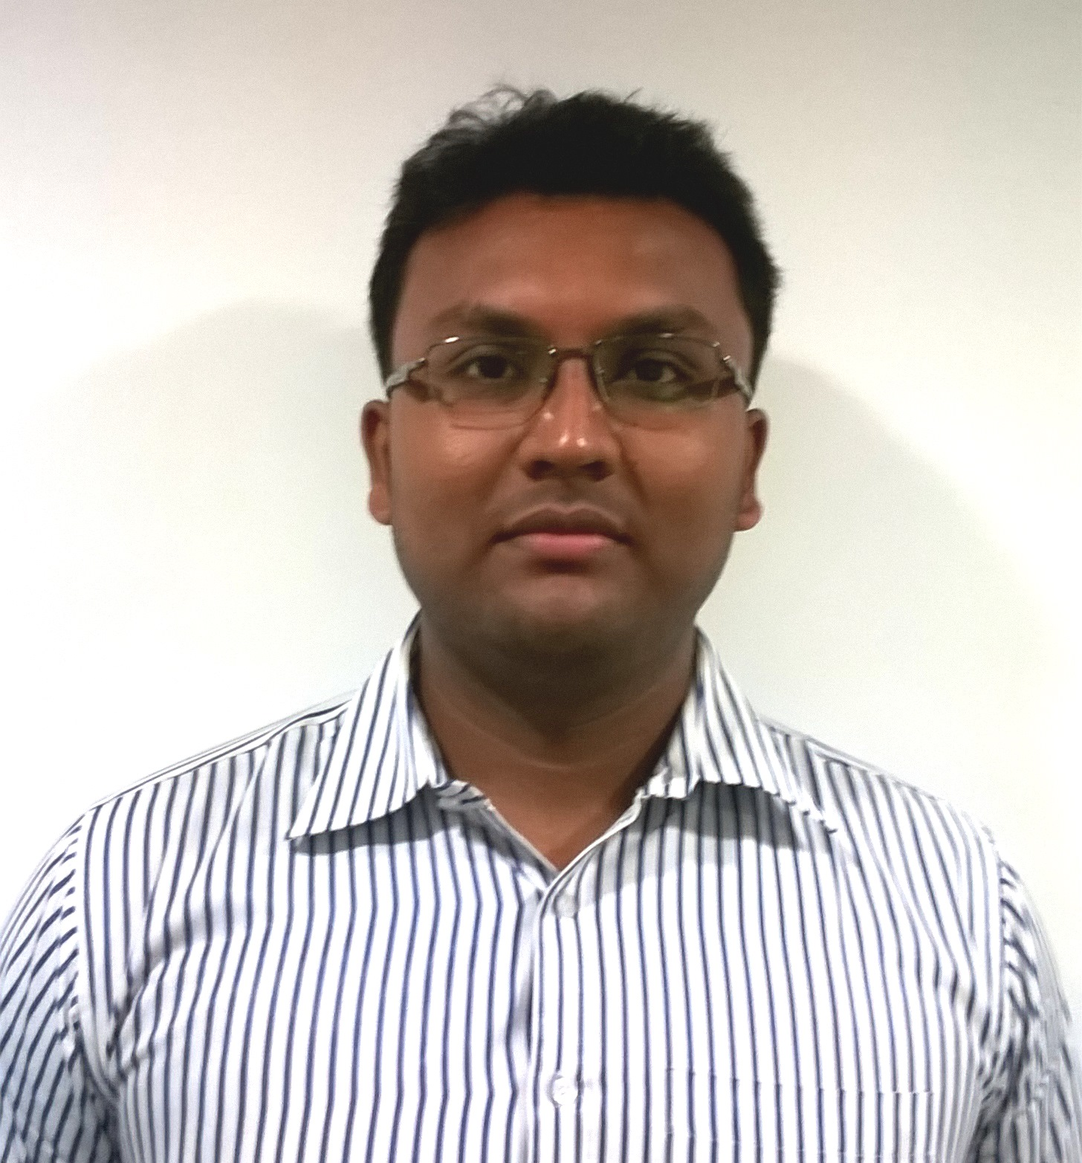**Mr. Snehashis Roy**

**Executive Commercial: Jyothy Labs Limited**

MBA (MIS), B.Sc. (Computer Science)

**E-mail:** snehashis160@gmail.com

**Mobile No.: +91 9831998181**

**Home:** +91 9681622998; +91 9232093999; +91 9681940953

***To work in a challenging and stimulating environment with opportunity to use my experience and to enrich my knowledge and enhance my experience, to contribute towards the achievement of organizational objective by applying my professional skills.***

**Professional Career Growth**

**Executive Commercial (East) – Jyothy Labs Limited** (May’2018 to till date)

* Internal Audit of Financial Control at Eastern Zone.
* Modification and new thought updated in System.
* Supervising of all Branch Operation i.e. Admin, Accounts, Payable, Receivable & Statutory Matter.

**Regional Accountant (East) – Unicharm India Pvt. Ltd.** (Dec’2015 to May’2018)

* Budgeting & Provisioning of Financial Activities.
* Kept a track of financial position of the debtors, follow up outstanding payments.
* Review of Statutory Compliance and Assessment.
* All Depot Compliance activity.

**Senior Regional Accounts Officer (East) – Marico Limited** (May’2014 to Dec’2015)

* Responsible for monitoring all credit limits of customers and including accounting receipt of debtors.
* Internal Stock Audit in Depots.
* Monitoring Leakage & Damage material.

**Accounts Assistant (East) – Colgate Palmolive (India) Limited** (Dec’2009 to Apr’2014)

* Kept a track of financial position of the debtors, follow up outstanding payments.
* Responsible for monitoring all receivables of the company including accounting of receipt from debtors.
* Prepared and shared MIS Report of all Branch Activities to HO.
* Internal Audit (Stock Count, Packing, Scrap Management etc.) in Warehouse.

**Work Experience**

Period: **From May’2018 to till date**

Organization: **Jyothy Labs Limited**

Location: 3rd Floor, Flat No. 3A & 3B, Poonam Building, 5/2 Russell Street, Kolkata - 700 071

Current Work Position: **Executive Commercial - East**

Department: **Commercial**

**Brief of Responsibilities:**

* Presently I am working at “Jyothy Labs Limited” at Kolkata as an “**Executive Commercial**”.
* Software Use: SAP for Primary and Aadhar & Lakshya for Secondary.
* Monitoring Distributors Claims (Primary & Secondary).
* Preparing Provision of all Branch Expenses i.e. Claims, Vendor Payment, Travel & Expense etc.
* Credit Limit Monitoring.
* AR Ageing Analysis and follow up with Sales Personnel for clearing dues.
* Analysis of all Sales Promotion Activities i.e. Schemes, QPS, Articles and Damage Stock etc.
* Monitoring Depot Compliance Activity.
* Monitoring Vendor Payment and Petty Cash.
* Update and Modification of software and all branch office working activities.

Period: **From Dec’2015 to May’2018**

Organization: **Unicharm India Pvt. Ltd.**

Location: 2nd Floor, J.K. Millennium Centre, 46D Jawaharlal Nehru Road, Kolkata - 700 071

Current Work Position: **Regional Accountant – East**

Department: **Accounts & Finance**

**Brief of Responsibilities:**

* I have worked at “Unicharm India Pvt. Ltd.” at Kolkata as a “**Regional Accountant**”.
* Software Use: GSS for Primary & Botree for Secondary.
* Daily Basis Collection Reconciliation & AR Management.
* Credit Limit Monitoring.
* Monitoring Distributors Claims & Travel Expense of Employees.
* Promotional Activity Processing.
* Maintain Petty Cash Voucher.
* Distributors Opening & Closing.
* Maintain C Form & F Form.
* Working VAT, CST & Entry Tax Payment & Return.
* Monitoring Sales Tax Assessment.
* Monitoring Vendor Payment and other Office expenses.
* Month End Provision Activity.
* Monitoring Damage Stock.

Period: **From May’2014 to Dec’2015**

Organization: **Marico Limited**

Location: 7th Floor PTI Building, DP-9, Sector V, Salt Lake, Kolkata- 700 091

Current Work Position: **Senior** **Regional Accounts Officer – East**

Department: **Commercial (Sales)**

**Brief of Responsibilities:**

* I have worked at “Marico Limited” at Kolkata as a “**Senior Regional Accounts Officer**”.
* Software Use: SAP for Primary and Botree (Minet & Midas) for Secondary.
* Distributors Opening & Closing.
* Employee Full & Final Settlement process..
* Collection Payment (RTGS/NEFT) and send it to Depot for billing.
* Credit monitoring and control.
* Employees Travel Expense Process.
* CFA & Transporter Expense Process.
* Vendor Payments Process.
* Maintain Petty Cash Voucher.
* Distributors’ Primary & Secondary Claims Process.
* Leakage & Damage Claims Process.
* VAT Claims process.
* Collection NOC from Customers on Quarterly basis and solve the Unconditional NOC.
* Monitoring and maintaining of agreements for renewal.
* Provision of all Branch Expense Activities.

Period: **From Dec’2009 to Apr’2014**

Organization: **Genius Consultants Ltd.** associate to **Colgate Palmolive (India) Limited**

Location: 2/7 Sarat Bose Road, 9th Floor, Vasundhara Building, Kolkata- 700 020

Previous Work Position: **Accounts Assistant – East**

Department: **Finance (Sales)**

**Brief of Responsibilities:**

* I have worked at “Colgate Palmolive (India) Limited” at Kolkata as an “**Accounts Assistant**”.
* Software use: SAP for Primary & DMS for Secondary.
* Employee Travel Expenses process.
* Distributor Claim Process i.e. Secondary Claims, Visibility, Freight, POC (Dental Section)
* Non Intel Billing Claim (DD Claims) processes.
* AR Reconciliation and share with Higher Management.
* Stockist Performance Incentive (Step Incentive) & Salesman Performance Incentive (Hero No.1) Process.
* Claims MIS Report making and share with Sales Team.
* Making IO as per budget.
* Prepare IO-GL Report (IO: Internal Order Code, GL: General Ledger Code) and share with HO for online claim process.
* Payment Collection (RTGS/NEFT) updates and share with Warehouse for billing.
* Reviewing NDC (No Due Certificate) and solve the pending issues.
* Prepare monthly SOX Key Control and sample (Claims & Vendor Payment) share with HO.
* GRN Entry for Vendor Payment, Payment process by HO.
* Full & Final Settlement of Customer.
* Credit Limit Monitoring & Control.
* Prepare Balance Confirmation (Account Statement) of the Customer.
* Petty Cash handling.
* Prepare BRS & Co-ordinate Legal Case.
* RTGS/DD Commission Reimbursement process.
* Prepare T&C Tracker for (Modern/Direct) Trade Customer.
* Prepare Budget for Visibility Payout & Activity Planner.
* IO Closing and Stockiest knock off at Month end Activity.

**Financial Skills**

Completed **“Certified Industrial Accountant +”** from **ICA**, in Dalhousie, Kolkata.

**Computer Skills**

Completed **“Advance Diploma in Information Technology”** (July 2004 - June 2005) with “A” Grade (76%) from DICM (Durgapur Institute of Career Management), Durgapur.

**Computer Proficiency**

* Operating Systems: Windows 7/XP/2010/2000/98.
* Application Software: MS-Office 2010/2007/2003/XP, SAP
* Very Good in (MS Excel, MS Word, MS PowerPoint) & Internet.

**Technical Skills**

Completed **“AutoCAD - Mechanical & Civil”** (Oct’2009 - Mar’2010) with **“A+”** Grade (94%) from “Durgapur Institute of Vocational Studies” City Centre, Durgapur – 713216.

**Other Skills**

Completed CONVERSATIONAL ENGLISH (Oct’2004 - Feb’2005) from B.B.C. (The British Institute Kolkata) in Durgapur.

**Projects on MBA**

* I had Project on “Billing System of Ganashakti” in DBMS, RDBMS, Visual Basic & Access at MBA Courses from Sikkim Manipal University, Ballygunge Phari, Kolkata.
* Do the Project from “GANASHAKTI” Newspaper office Kolkata. These projects completed by 3 months.

**Academic Background**

* Passed MBA, Specialization in “Management Information System” in 2009 in **63.5%** (Grade-B) from Sikkim Manipal University (SMU), Ballygunge Phari, Kolkata.
* Passed B.Sc. (Computer Science, Mathematics & Physics) in 2007 in **44.5%** from Michael Madhusudan Memorial College, Durgapur under Bardhhaman University.
* Passed Higher Secondary (H.S.-Science) in 2002 in **54.5%** from Durgapur AVB High School, Durgapur under West Bengal Council of Higher Secondary Education (W.B.C.H.S.E.)
* Passed Madhyamik in 2000 in **66.37%**  from Durgapur AVB High School, Durgapur under West Bengal Board of Secondary Education (W.B.B.S.E.)

**Personal Details**

* **Name:** Mr. Snehashis Roy
* **Father’s Name:** Mr. Dilip Kumar Roy
* **Mother’s Name:** Mrs. Rina Roy
* **Spouse Name:** Mrs. Karabi Roy
* **Date of Birth:** 28/09/1984
* **Present Address:** H-8, 3rd Floor, Adarsha Apartment, 10 No. Adarsha Pally, D.P. Nagar, Belgharia, Kolkata - 700056
* **Permanent Address:** LV(M)-19, ABL Township, Durgapur- 713206, District-Bardhhaman, West Bengal
* **My Mobile No.:** +91 9831998181
* **(Home) Ph. No.:** +91 9681622998; +91 9232093999; +91 9681940953
* **Email ID:** snehashis160@gmail.com
* **Marital Status:** Married
* **Nationality:** Indian
* **Passport No.:** H6702113

**Language Known**

* Bengali (Read, Write & Speak)
* Hindi (Read, Write & Speak)
* English (Read, Write & Speak)

**Remunerations Details**

* **Current CTC: 8.82 Lakh/Annum**
* **Not Included in CTC (Benefits):**
* I and my family will be covered as per the Medical Insurance Policy of the Company (2.50 Lakh/Annum).
* Cost of Transportation of all goods to be Bourne by company.
* Mobile Phone Reimbursement as per the Policy of the Company
* **Expected CTC:** Negotiable
* **Notice Period:** 1 month

**Hobbies**

* Physical Exercise (Workout at Gym)
* Listening Music
* Reading Mythological Story & Magazines

I hereby declare that the information furnished above is true to the best of my knowledge.

Place: Kolkata

Date: **Snehashis Roy**