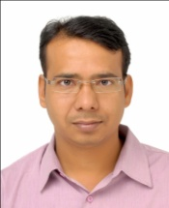**Md Kalim Ansari**

**Mobile**: 9431525506 / 8900060476

**E-mail**: **kalim.ansari@gmail.com**

**kalim.ansari@supershakti.in**

I have burning desire of being a professional in a firm where I can execute my skills, abilities and knowledge in a positive and beneficial manner for the industry having progressive vision.

**PROFILE SUMMARY**

A high performing Thermal Power Plant Operation & Maintenance professional with a superb record of outstanding performance in challenging situations. Currently working in **Super Smelters Limited**, as a **Sr. Manager Power Plant Operations**

With around 14 years of rich experience of Power Plant Operations, possess excellent exposure and knowledge of the Power industry and have effectively energized the organizations towards growth, strong transitioning and successful functional units. Seeking assignments across the Operation, Engineering & Supervision profiles in the areas of Manufacturing, Production, Operations and Projects

Competency areas are showcased below:

* Operation and Maintenance ♦ Commissioning ♦ Safety Measures & Environment♦ Condition Based Operation ♦Total Productive Maintenance (TPM) ♦ Integrated Management System (IMS)

A tour through my attached resume shall familiarize you with the details and surely enough, in my credentials; you would find a perfect fit for the said job. I shall be grateful if an occasion is set up for an interview when the possibility of our association could be explored further.

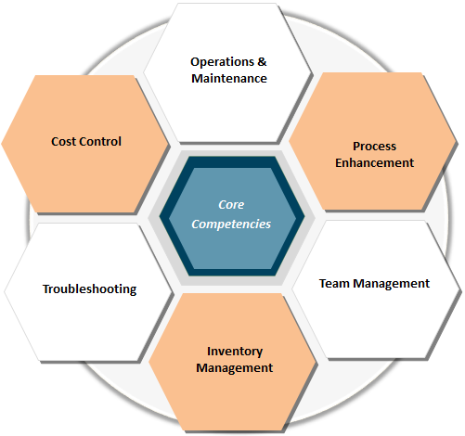

**Key Result Areas:**

* I have been Authorized by the Government of India and Ministry of Power to Operate or Undertake Maintenance of any part or whole of a Generating Station of Capacity of **100 MW** and above together with the associated sub-station.
* To plan, organize, coordinate, supervise and control the operation activities.
* Plant Performance Improvement
* Interaction with O&M Agency for Performance Improvement & Subordinates development
* Ensuring safety system, 5 S practice & IMS implementation at CPP
* Budget Preparation & Cost Control Management
* Man power Optimisation
* Inline with Management targets
* Full-filling the Statutory requirements
* Energy Conservation & Environment Protection
* Training in Operation & safety
* Preparation & revision of SOP & updating check list
* To manage the complete Power Plant Operation function correctly and effectively as per laid down procedure. These functions include upkeep of the boilers, turbines, balance of plants (BOP) and the facility available in the plant.
* To plan, allocate and monitor, Boiler operation, Turbine operation, BOP operation, condition monitoring, co-ordination with the maintenance department, external services.
* Prepare/present MIS reports/Operational budget within company guide lines
* Identification, Calculation and rectification of losses effecting plant and equipments performance and efficiency
* Deliverables: Availability of Units/station, PLF, Aux. Consumption, Shutdown as per budget and zero injury.
* Restoration of plant by emergency power under Black Out condition.
* Rich knowledge of AFBC,CFBC and HRSG, DCS (Yokogawa, Siemens and ABB) and PLC based Operation
* Isolation & Normalization of Equipment and Issue safe Permit to Work **(PTW)**.
* An active member of Housekeeping Team, Safety Steering Committee & Jishu Hozen Team of entire plant **(TPM**).
* Healthiness of fire fighting system and safety related activity in operation.
* Annual shut down of boiler & Turbine for overhauling and inspection
* Completed Boiler Commissioning and proceed as Trial of auxiliaries, Refractory dry out, Alkali boil out, Steam Blowing, Air nozzle pressure drop test etc.
* Completed **210 MW** Thermal units Operation on Simulator.

**ORGANISATIONAL EXPERIENCE**

**Jan’11 to till continues** Presently working as a Sr. Manager Operation & Maintenance of coal based thermal power plant.

Super Shakti Logo.jpgSuper smelters ltd is Flagship Company of SAI group of industries. The group has its five plants spread across rich mineral states of Bengal, Jharkhand & Bihar. Company is having Induction Furnace, Hot Strip Mill, TMT Mill, Structure Mill, Ferro Chrome, Pellet Plant and DRI divisions with Captive Power Plant of 88 MW total capacity which includes 1x18 MW Triveni make turbine, 1x35 MW Siemens make turbine & 1x35 MW BHEL make turbine with CFBC, AFBC and WHR Boilers.

**Aug’08 to Dec’10** Worked as an Assistant Manager Operation, was having the responsibilities of Shift Charge Engineer Operation and Maintenance of coal based thermal power plant, with total installed capacity of 118 MW

The group has set new standards in the manufacture of wire rods, bright bars, steel wires, wire ropes, strand, conveyor cord, wire drawing and cable machinery, with continuous growth in both the domestic and international markets, Usha Martin, the Group’s flagship company has emerged as India’s largest and the world’s second largest steel wire rope manufacturer

**Usha Martin Limited is** India's first to receive the TPM Excellence Award by JIPM, Japan**. At Jamshedpur having 1x25 MW BHEL make Turbine, 1x35MW & 1x30MW Siemens make turbine which runs on AFBC and WHRB Boilers.**

**May’07 to Jul’08** Worked as a Senior Engineer Power Plant Operation and Maintenance, was actively involved in Erection and Commissioning of 2x17 MW HTC (China) make Turbine with accessories and 1x130 T/Hr HTC China make CFBC & WHRB, after the successful completion of the project was responsible for the smooth operation of the plant.

AML is a flagship company of Adhunik Group; it has set up an integrated steel plant at Sundergarh, Orissa, with state-of-the-art technology.

**Sep’06 to Apr’07** Worked as a Junior Engineer in the Captive Power Plant of 2x25 MW ALSTOM make Turbine depends on 2x110 T/Hr AFBC boilers CVLmake, with total installed capacity of 90 MW.

C:\Users\KALIM ANSARI.KALIMANSARI-PC\Desktop\download.jpgPrakash Industries Ltd was started in the year 1980. With focused vision in the core competence areas of Mining, Steel and Power, Company is rapidly carving its niche in the Indian steel industry and has emerged as one of the key producers of value added steel products in the country.

**EDUCATION**

**Diploma in Electronics & Communication Engineering from Al-kabir Polytechnic, Jamshedpur in 2004**

**Post Diploma in Thermal Power Plant Engineering from National Power Training Institute (NPTI), Badarpur in 2006**

**BE in Electrical Engineering from JRN College of Engineering, Rajasthan in 2012**

**IT SKILLS**

* Proficient in Windows, MS Office, AutoCAD, ERP & Internet Applications



**PERSONAL DETAILS**

Date of Birth: 22nd Sept, 1980

Present Address: 726, Gamma-4, Sahara City, Mango, Jamshedpur, Jharkhand, 832110, India.

Languages Known: English, Hindi and Urdu

Passport Details: Passport No: M0121769

Date of Issue: 09/07/2014

Date of Expiry: 08/07/2024

Place of Issue: Ranchi.

Current salary: 96000/pm INR

Expected Basic salary: Negotiable

Notice period: Two Month