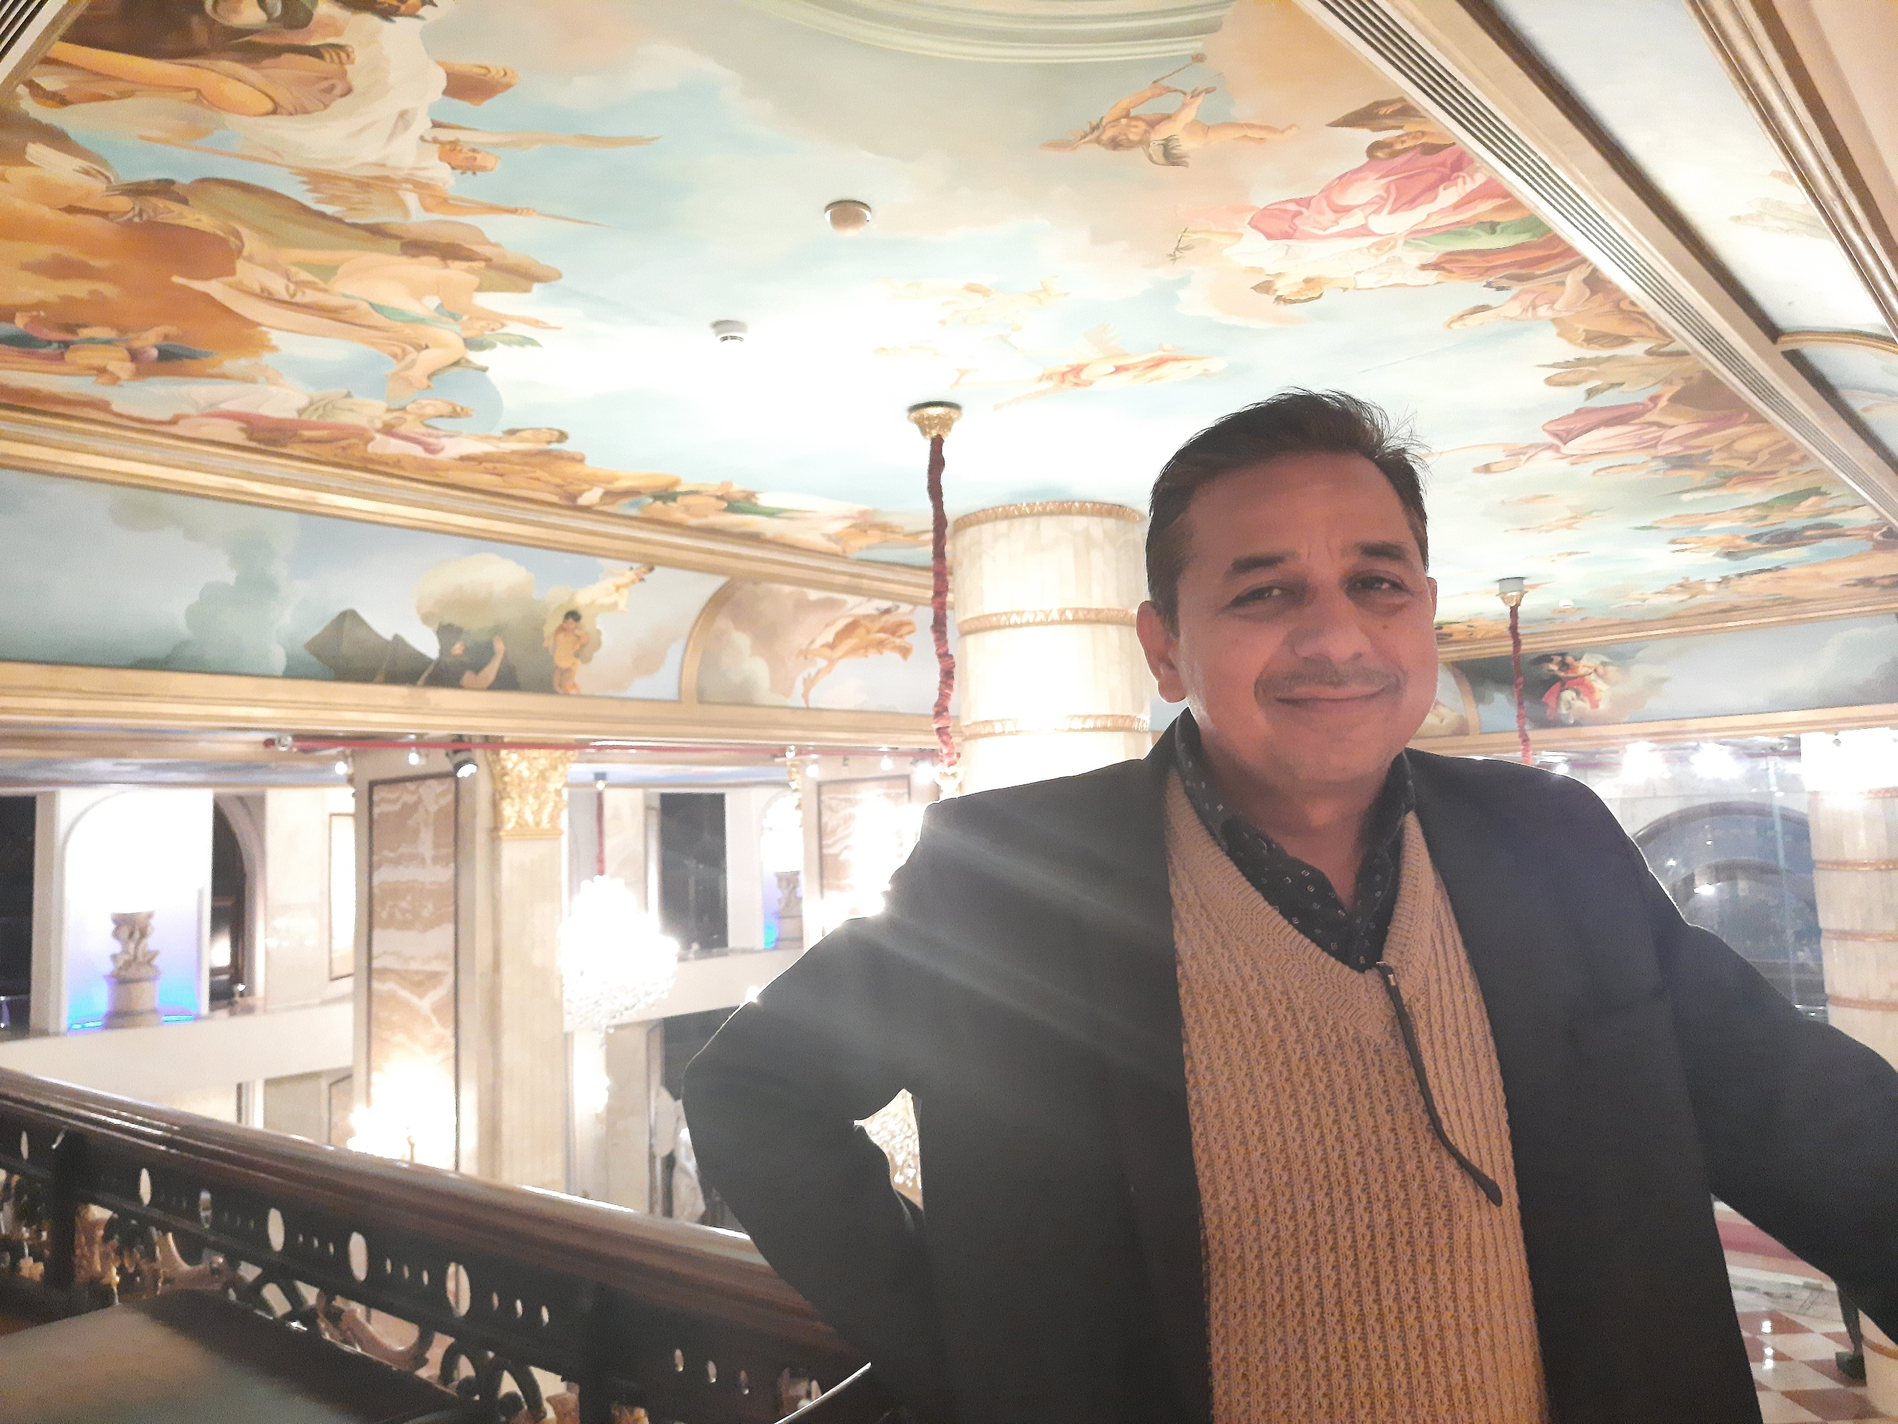

* +91-9099952721
* kishor.patil74@gmail.com
* linkedin.com/in/kishor-patil74
* A91, Omkar Shikhar, Tarsali bypass, Tarsali, Vadodara, Gujarat, India 390 009

▼ Objective

I am seeking for a Respectable Position in Management field where I can enhance my professional expertise.

▼Experience

* Seasoned and technically competent professional, extending career success in managing multiple technical functions.

I have total 26 years of experience in Various Fields like Power Plant, Continuous Process plant Automation, Proposal Engineering, Engineering Maintenance & expertise in Electrical trouble shooting, O & M of Power Plant, 66KV switchyard, 11KV double Bus Substation, HT/LT switchgear, Transformers. commissioning, Project & Technical expertise. Synchronization of Engine with Grid, turbine & Island Parallel. Well knowledge of SCADA, DIGSI, RSLOGIX5000, Ladder logic, Purchase, Stores. Expert in Manpower handling & multitask. ISO–9001-2015 Quality management systems, OHSAS, HIRA-C, DNV, CDM & 6S implementation & record maintaining.

|  |  |  |  |  |  |  |
| --- | --- | --- | --- | --- | --- | --- |
| SN | Name of The Organization | From | To | Total Year | Product Details for Experience/Exposure & Nature Of Industry | Designation/  Department |
| 1 | EPSL Trigeneration Pvt. Ltd. ( Energy Efficiency Services Ltd. Group ) | 4th Nov 2019 | Continue Till date |  | Provides Trigeneration Solution in all sectors. Gives full EPC solution. life time operation and service for trigeneration plant. > 600 MW installation u/operation in UK (Edina Power ltd ). Energy Efficient Organization. | Associate Manager – Engineering, Feasibility study, project support & commissioning |
| 2 | Quippo Energy Ltd-SREI Group | 16th July 2012 | 2nd Nov 2019 | 7.33 | Power Plants-Gas Engines, Turbines, DG, Boilers, Chillers, Provides EPC Solution Project Base Industry. provide full O & M of Power plant. | DGM – Services, Head O&M, Project, Tech., commissioning, Yard |
| 3 | Wartsila India Ltd. MNC | 12th April 2010 | 15th July2012 | 2.25 | HFO DG sets, Power generating Machinery, ranging from Ship Design to propulsion. EPC solutions. Project Base Industry | Sr. Executive- Services, O&M of Engine, HT/LT System, Plant In charge |
| 4 | Welspun India Ltd | 23rd Feb 2010 | 11th Apr2010 | 0.25 | 26.2MW CPP, HRSG & Chillers, World’s leading Home Textile Solution provider. Textile Industry | Sr. Manager Power Plant & subs station |
| 5 | Wartsila India Ltd. MNC | 15th Jan 2007 | 22ndFeb2010 | 3.1 | Ranging from Ship Design to propulsion, HFO, Gas Engines. Electrical Automation, EPC solutions Project Base Industry | Sr. Executive- Services, Engines, HT/LT system |
| 6 | Apollo Tyres Ltd. | 17th Aug 1999 | 11th Jan 2007 | 7.5 | Global Leader in Tyre Manufacturing, Product- Radial, Tractor tyres, CPP with Wartsila HFO, SKODA DG, Solar Gas Turbine, switchyard & Sub station. Engineering Industry | Executive (E-3) 18MW Power House, Utility, 66KV s/yard, HT/LT s/s |
| 7 | Jindal Saw Pipe Ltd. Seamless Tube Div. | 14th April 1996 | 16thAug1999 | 3.25 | Manuf. of SAW pipe, seamless tube Hot & Cold rolling , Furnace, automation by ABB PLC & A.C./D.C. drives & motors. Steel Industry | Asst. Engineer Elect. Maint. 132kV s/s & Automation. |
| 8 | Siemens Ltd | 05th Sept 1995 | 04thMar1996 | 0.5 | Leader in Manufacturing of Drives, SIPART, PLCs at Nashik Unit Engineering Industry | Inplant trainee – Logistics. entry in SAP |
| 9 | Maniyar Plast Ltd. | 01st April 1994 | 15thJun1995 | 1.1 | Manufacturing of Plastic Bags equipped with Looms & Tape Plant. | Maintenance Engineer Electrical Maint. |

▼Organization Chart & Career Achievements

**Organization Chart**

Executive Voice Chairperson EESL

Managing Director EESL

CEO EPSL & ED EESL

CEO Edina UK Ltd.

General Manager EPSL

Sr. Proposal Manager Edina UK Ltd.

**I AM HERE**

Asst. Manager

Mech. Tech.

Jr. Engineer Elect.

**Career Achievements**

* Multidepartment handling leadership quality
* Check feasibility of Trigeneration Plant, prepare comparison and provides committed savings to client. Technical & commercial benefits to client
* MWM Germany Authorized Engineer for Commissioning of MWM gas Gensets
* Energy conservation Projects carried out internally & studied by outside parties.
* Improved Power Factor up to unity & get Maximum rebate from Grid
* Erection Commissioning & Synchronization of Gas / HFO/ Diesel Engines/ Gas Turbine & Grid.
* Load analysis & Commissioning of Load shedding
* Duel Fuel Conversion done of Wartsila HFO DG set
* Exposure and Motivation to customers for green energy to save environment.

▼Job Description Summery

|  |  |  |  |  |  |  |  |  |  |  |  |  |  |  |  |  |  |  |  |  |  |  |  |  |  |  |  |  |  |  |  |  |  |  |  |  |  |  |  |  |  |  |  |  |  |  |  |  |  |  |  |  |  |  |  |  |
| --- | --- | --- | --- | --- | --- | --- | --- | --- | --- | --- | --- | --- | --- | --- | --- | --- | --- | --- | --- | --- | --- | --- | --- | --- | --- | --- | --- | --- | --- | --- | --- | --- | --- | --- | --- | --- | --- | --- | --- | --- | --- | --- | --- | --- | --- | --- | --- | --- | --- | --- | --- | --- | --- | --- | --- | --- |
| 1. **EPSL Trigeneration Pvt. Ltd. - New Delhi**  * Trigeneration Feasibility study at customer premises. * Align Company vision mission in different functions, making departments strategy for same * Technical support for Marketing. * Provides full analysis to customer about saving. Provides study report with guaranteed saving. * Responsible for commissioning of Gas Engine & CHP plant. * Preparation of Layout, SLDs, support to prepare P&ID. * Preparation of proposal suitable to customer and company with technical details. * Weekly meeting with Edina UK team on Project, Proposal. * Preparation of PMU, Project Handover documents, * Preparation of detail scope matrix. * Preparation of Project schedule. * BOQ & site Integration planning with required spares, technical details of Material and costing. * Project cost calculation and report preparation. * Power plant efficiency calculation. * Monthly Meeting with MD. * Site visit to check location and load pattern, to collect technical data. * Preparation of Audit documents. * Insurance of all equipment   **Purchase :-** Technical check of specifications, cost negotiation, vendor development, Inspection of capital equipment.  **Quality :-** check product quality for Human and machine safety. Prepare SOP of product in consult with OE. Equipment  inspection before dispatch from Vendor and after receiving at client location  **Higher Management :-**Planning as per senior management expectations. progress & future planning presentation in  meeting. Quality work on trigen solution. achieves company goals with team work. Documentation hard/ soft copy     1. **Quippo Energy Ltd. - Ahmedabad**  * Responsible for Company turnover goal growth, Operations improvement for QCDS (Quality, Cost, Delivery & Safety)   Monitor & improvement Performance by MIS (Management Information System) parameters. Cost saving in purchase  & from other operations. achieved high amount of saving.   * Functions -Project, Commissioning, O&M, Genset Assembly, Quality, Purchase/Store, Technical Support Marketing * Monthly MIS Report meeting with management, Self initiate in meeting for Parameter design & implementation. * Working on Lead By Example Leadership Style & Participative Leadership Style showing all managers/engineers real   improvement examples of company, Many Time done these best improvement examples by self involvement  and show them, then they start believing me and following best practices on daily basis. According to Manager skill  level. my leadership style change like coaching, teaching and delegation. I know how to get work done(effectiveness)  from low to high both skill level managers and engineers   * Value added Actions in all Functions as per Multidepartment Head Responsibilities * Some Examples are mentioned as per below   **Operations & Maintenance:**   * Responsible for collecting and analyzing the parameters, plant maintenance and technical data for tracking scheduled   and unscheduled maintenance   * Commissioning of Multiple MWM Gensets * Synchronization of Engines with Grid or Island parallel Engine Make- MWM, GE, Kawasaki Turbine, Cummins DG sets. * Operation & Maintenance of HT / LT switchgears i.e. VCBs, ACBs, HT/LT Alternators ( Marelli, Stamford, AVK) * Maintenance of Transformers & electrical system * Maintenance of MWM Gas Engine upto E-60, GE Engine upto 40K, ABB, KBB & MAN Turbocharger Major O/hauls. * Maintenance as per plan/OEM manual guidance, Condition monitoring for better life of equipment, better O.E.E. and   for cost reduction CBM & TPM maintenance started.   * Taking customer feedback quarterly & action plan for Improvement. Customer Satisfaction * Expertise in Trouble shooting & training to site team for Operation Excellence * To provide uninterrupted power by applying ZBD actions. * Annual Budget Preparation & Inventory control. Expenses control as per approved budget. * Yearly Maintenance Planning after discussion with Production Head * Promoting Kaizen Culture by checking Kaizen every week personally for all departments Developed team for same * Why Why analysis of failure, fishbone analysis & Horizontal deployment on other Machines * Woodward Controller & throttle Valve actuator servicing   **Project & Technical:**   * Technical Support for Power Plant Gas Turbine/engine Tender preparation & submission with all details. * New Engine assembly, packaging in yard with BOPs, Project, Technical Points & time schedule discussion. * Approvals from MD for job execution. Job execution as per approved plan. * Project preparation & execution at sites. * Load analysis at different companies & provides best option for reliable power plant. * Modifications, renovations in power pack to improve the reliability of engine at sites * Centralize controlling of Engines for Best O & M   **Purchase Support:**   * Cost Negotiation Process set and truly implemented like 3 Quotes comparison, Cost B/D analysis logic, different   logic as per product manufacturing process involved, Minimum 3 Vendor development strategy implementation for  best cost, quality and delivery for all products, SOP Made for same, Developed Managers and Engineers, Work with  design for BOM component selection best cost optimization alternative like radiator, Container, Breaker, Electrical  Panel components, Drives,….  **Store:**   * Inventory Reduction by weekly meeting & action plan, ABC Inventory system implemented Best 6S, Good Saving in   Inventory reduction, Target to reduce inventory by 40% of total value.  **Manpower Management & Documentation:**   * Excellent manpower Management & Handling skill, Handles 80 Peoples with proper job allotment. * Documentation maintaining as per ISO, EMS, 6S, Safety. * Working in AXAPTA & EPICORE system * Searching of Suitable Knowledgeable Employees & Selection on Merit  1. **Wartsila India Ltd.- Mumbai**   **Service Division - Operations**   * Accountable for the Operation and Maintenance of 5.6 MW Wartsila Make FO DG sets Power Plant, 11KV   Double Bus S/S, LT system & associated utilities like WHR Boiler-2TPH, Vapor absorption heat pump  (VAHP)- 360TR & 125 KVA Cummins DG set.   * Works as a Power Plant In charge * Plant inventory Management which includes vendor development & indigenization of spares * Synchronization of DGs, Operation of HT & LT switchgears. * Customer Satisfaction * Preparation of MIS & all reports send to Regional head. * Provides uninterrupted power to customer with Zero Breakdown. * Troubleshooting problems arising in total execution of job with minimum time lag. Taking stringent quality measures   including preparation / maintaining necessary documents and to ensure compliance with standards.  **Maintenance**   * Wartsila Engine & AVK Alternator servicing as per OEM guidelines & schedule. Engine overhaul done upto 60K &   Alternator Major servicing done.   * Calibration & testing of all field devices of engine. * Programming of AVR make Basler, ABB, Unitrol, Marelli &Stamford. Woodward 723 actuator controller Programming * Protection relay testing & calibrations. Relay settings & relay co ordination done. * Servicing of HT breakers VCB, SF-6 & ACB, LT breakers. * Sampling and analysis of fuels, lub oils and water * Planning of spares & scheduling of overhauls * Implementing preventive, planned and predictive maintenance to minimize downtime and prolong service life of   Power plant equipment. Ensuring availability of reasonable stocks of spares to address any maintenance calls.  **Environment safety/ Manpower Management**   * Hazardous Waste Management * Safety Management * environmental and other statutory & legal requirements * implementation & maintenance of Quality Management System ISO 9001-2008, ISO 14001-2004, OHSAS, 6S,HIRA-C * Manpower handling & training to Sub Ordinates. * Yearly, Monthly ,Daily planning and work allocation to team members, Daily morning start meeting for controlling   schedule and target achievements   1. **Welspun India Ltd, - Morai Vapi**  * Working as Sr. Manager Power Plant ( In charge) * Operation & Maintenance of 26.2 MW Power Plant with 7.0 MW Solar Taurus 70 Gas Turbine, 6.80MW Rolls Royce   Gas Engine, Wartsila HFO DG sets 18V32LN, 12V32LN & 6R32Ln, 16Ton 20Bar HRSG Boiler, WHRB   * Boilers, 14T, 10T X 02 Oil Fired Boilers, 1250 TR & 740 TR Chillers  1. **Apollo Tyres Ltd. - Vadodara**   **Operation & Maintenance**   * Accountable for Operation and Maintenance of 18 MW power plant having 2 X 4.2MW wartsila engine, 5.50MW Solor   Make Gas Turbine, 2X2.27MW SKODA Diesel Generators and associated utilities, 66KV switch yard, 11KV double Bus  Substation, L&T switchgear & Transformers up to 66KV, 11KV outdoor capacitor bank. 11Ton , 2Ton X 02 HRSG Boilers   * Hands on experience in O & M of Engines, Gas Turbine, 11KV double bus station, 66KV switchyard. 66KV Crompton   SF6 & Siemens HT switchgear servicing   * Planning of spares, scheduling of overhauls for all engines, Turbine, switchyard & Substation. * Responsible for all activities relating to the daily operation and maintenance of the power plant, WHRB Boiler & 66KV   switchyard & 11KV doubles bus substation.   * Synchronisation of HFO Wartsila Engine & Taurus 60 Gas Turbine * Maintenance of PLCS SCADA & RS view * Different types of alternators servicing up to 74000 running hrs. * Works on AVRs of BASLER, ABB * Programming of Woodward controller * Engine servicing up to 74000 running hrs. &Turbine up to 24000 r/hrs. * Duel Fuel Conversion of HFO DG * Collecting & analyzing plant maintenance & technical data for tracking scheduled & unscheduled maintenance. * O.E.E. ( Overall Equipment Effectiveness) * Health check-up of Machine & Maintenance made Condition base to reduce Operation cost.   **Planning & Documentation**   * Responsible for preparing daily, monthly, quarterly & annual plant maintenance. capital and operating budgets for   power plant operations   * Identify & actively seek to improve o & m, to provide operational reliability & availability to maximize equipment life. * Maintaining Documents as per CDM, ISO * Maintenance as per TPM & safety rules, work permits. * Working in SAP/R3 for spares, work order, P.R. etc. * Hazardous Waste Management & Safety Management * Audit data preparation & presentation.  1. **Jindal Saw Pipe Ltd. - Nashik**  * Accountable for the total electrical & Electronics maintenance of Hot Rolling mill plants. * Maintenance of A.C. drives up to 75HP , D.C. drives up to 2000HP, AC & DC motors up to 2000HP. * Maintenance of ABB PLCs, SCADA system * Maintenance of Hydraulic & Pneumatic system, compressors & EOT crane unto 25Ton. * 132KV Sub station Operation & Maintenance having Crompton make SF6 Breakers.   **Documentation & Planning**   * Exposure on permits to work and authorized person of department to issue hot work permit within plant. * Preparation of Budget for the financial year. Budget & Inventory Management. * ISO & QMS data maintaining.  1. **Siemens Ltd. - Nashik**  * Trainee Engineer in Logistics & Engineering department. * Preparation of Material Requisition, Purchase Requisition In SAP R/3 * Worked in Drives manufacturing department as production assistant. * Engineering Stores Inventory checking  1. **Maniyar Plast Ltd. - Jalgaon**  * Electrical Maintenance shift In charge for Total plant. * Maintenance of Drives , AC & DC motors. * Maintenance of panels & all Electrical system. * Spares management. * Records up keeping & Updating   ▼Training & Certification   |  |  |  |  | | --- | --- | --- | --- | | S.N. | Training details | From Organization | Year | | 1 | Unleash Your Leadership Potential | Step Consulting Culcatta | 2017 | | 2 | Internal Auditor-QMS-ISO-9001:2015 | SGS Ahmedabad | 2017 | | 3 | MWM TEM EVO Basic & Gas Engines Basics & Periphery Components in Germany got Dongale & Certificate as Authorized Commissioning Engineer | MWM Germany | 2012 | | 4 | Finance for non-finance Executives | SREI/Quippo Internal faculty | 2012 | | 5 | Towards Enabling Achievement | Chrysalis HRD | 2010 | | 6 | Speed Governor Speed Control System | Wartsila India ltd | 2009 | | 7 | PLC & SCADA Programming | Prolific System&Technologies Ltd Dehli | 2008 | | 8 | Customized Course on ControlLogix & ControlNet | Rockwell Automation Mumbai | 2006 | | 9 | Solar Gas Turbine Technical Training | Solar Turbines USA | 2005 | | 10 | Siemens Protection Relay Functions | Expel Prosys | 2005 | | 11 | L&T Automation | Larsen & Toubro Ltd. In Apollo tyres | 2002 | | 12 | HFO Engine, It’s Auxiliaries & Electrical System Technical & Operation training at Wartsila Mumbai for 10 Days | Wartsila NSD India Ltd. Mumbai | 2000 | | 13 | Leadership Changing Executive Role | Synergy Group | 2002 | |
| |  |  |  |  | | --- | --- | --- | --- | | ▼ Education   |  | | --- | | B.E. Electrical (Passed in 2008) , Distance Learning from National Engineering Institute Thane | | Diploma in Electronics Engineering in 1994 College of engineering & Technology Jalgaon Maharashtra | | Certificate Course in Autocad 2002 in 2002, Vadodara | | | ▼ Leadership   * Working as a Participative Quality leader in my organization for best contributing toward change management. Lead by example, being role model, High self-discipline, Believe in team work, changing of leadership style as per sub-ordinates competency (Situational leader). * Strong leadership traits and behavioral management skills along with excellent ability to coordinate with different people at one time under difficult situations and bring out the best in others while creating a healthy and friendly work environment, thus enhancing operational efficiency and optimizing resource utilization.   ▼Personal Details   * Date Of Birth :- 14th May 1974 * Passport Number :- T7524747 D.O. expiry 24th July 2029 * Notice Period :- 01 Month | | ▼ References  [Available upon request.] | |