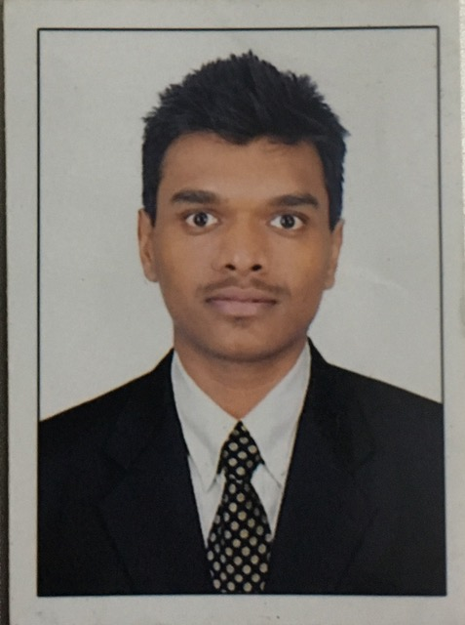

**Mr Rohan Kishorepuria || Vice President || Mechanical Engineer**

Mr. Rohan Kishorepuria is the youngest in the family business and is working in the organisation for almost 2 years,

He is a Mechanical engineering graduate and leads the plant operations in Galgalia, as a young generation he believes in technological advancement, Information technology and willing to take the organisation at new heights.