## MATHIVANAN SOMASUNDARAM **SENIOR ELECTRICAL ENGINEER**

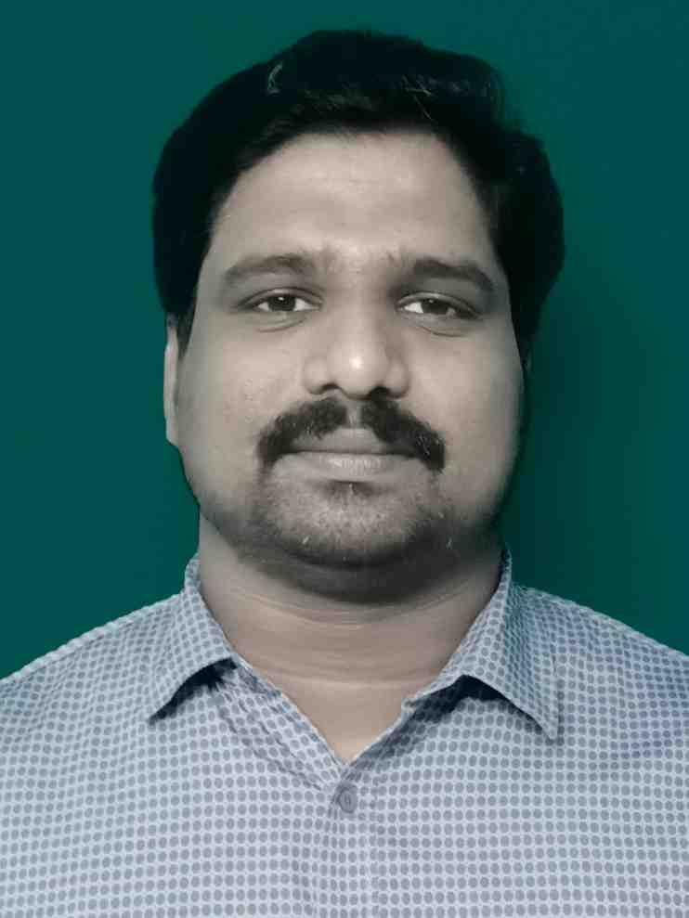

More than 10 years of experience in EHV, HV, MV & LV Electrical Substations, Utilities, Power, EPC, Oil & Gas both Offshore & Onshore (ADNOC, TAKREER, QATAR PETROLEUM, VHFL, ENOC) projects. Reviewing design drawings, QC, Contracts & Project Management, Testing & Commissioning, Operation & Maintenance

✆ +917358545220 (IND) 🖂 [mathi.prof@gmail.com](mailto:mathi.prof@gmail.com) Passport No: J8088303

Vellore, Tamil Nadu, India 632009

**EXPERTISE SKILLS**

Project Management Design-build process

Design Modification (AutoCAD) Troubleshooting and diagnostics

Site acceptance testing HV/LV Switchgear and Capacitor banks

Inspection procedures Electrical Inspection

Operations management Team Lead / Team Management

Technical documentation Scheduling / Planning

Pre-commissioning activities Electrical Schematics

Time management Client facing

Electrical Installation Power Distribution Systems

Power Transformers and AVR Protection Relays and Relay Interface

PLC / SCADA / Telecommunication Auto Changeover Operation and Scheme

Earthing & Lighting System UPS -Battery inspection and Charger testing

BOQ / BOM / QCP HVDC Transmission and Distribution System

IEC/ EN / NFPA Cost Analysis / FEED developing

**WORK HISTORY**

**Senior Electrical Engineer - Inel Power Electromechanical LLC, Dubai, UAE**  ( March 2016 to Present )

* Develop, maintain and update to implement an effective Quality Management System, QC quality plans, procedures and standards
* Preparing Method Statement (MS), Quality Control Procedure (QCP), Inspection, Testing and Commissioning Plan and make sure its conformity with contract and technical spec requirements
* Involving in engineering design, construction work and commissioning of the facilities within the project cycle all the electrical equipments AC/ DC Substations, including HVAC and HVDC (Invertors, Converters, Switching, rectifiers , Control, and filters)
* Preparing updates / upgrades design concepts and innovative solutions for achieving the Project’s strategic objectives, relying on basic theory, first principles and original ideas
* Involving in end-to-end work progress, review engineering design, project coordination, site monitoring, cost analysis, FEED developing and implementing
* Supervising and Inspecting installation of Electrical AIS & GIS Switchgear, HVAC & HVDC Transmission lines, Power Transformers, Solar panels, Battery Charger, Battery Banks, Control Relay panels, SCADA panels, Fire protection panels, VFD panels, AVR panels, Telecommunication Panels, LV panels and HVAC panels in Substations
* Reviewing and verifying BOM/BOQ, GTP, Approved Construction drawings, SLDs, O&M manuals and other technical documents with the installed equipments
* Planning of Work Schedules and job allocation to the team as per requirements
* Preparation of RFIs, PTWs, Daily / monthly work report and report the progress
* Ensure Site safety and taking measures to prevent electrical hazards
* Review RFP for electrical engineering drawings, SLD Drawings, as built drawings, contracts management, technical specifications, scope of work, RFI reports, review and make comments to concept design and phases for civil and electrical technical specification
* Facing the Client and ensuring the customer satisfaction through timely project completion, professionalism and efficiency

**Electrical Testing & Commissioning Engineer - Inel Power System Engineers (Pvt) Ltd, Chennai, India** (Jan 2012 to March 2016)

* Testing and Commissioning of Electrical AIS & GIS Switchgear, Power Transformers, Solar panels, Battery Charger, Battery Banks, Control Relay panels, SCADA panels, Cables, VFD panels, AVR panels, LV panels etc., in Substations and Switchyards
* Verifying Electrical Drawings / Schematics and modifying as per requirements using AutoCAD
* Leading the team and supervising all the Site Acceptance Testing of HV/MV/LV systems (AC/DC) and preparation of all the technical and operational reports
* Preparation of Daily / monthly work report and report the progress
* Performing High Voltage / Hi Pot tests for Switchgears, Cables, Bus bar etc. and SFRA / Tan Delta Tests for Power Transformers
* Protection relay configuration, testing and schematics modification using relay soft wares
* Auto Changeover Scheme testing and operation
* Interfacing PLC / SCADA / IO panels with CRP and ensure the operation up to remote station
* Protection relay configuration, testing and schematics modification using relay soft wares
* Facing the Client and ensuring the customer satisfaction through timely project completion, professionalism and efficiency
* Performing Pre-commissioning / Commissioning activities and handing over commissioned systems
* Clearance and rectification of Site notes, Snag points, Modifications, Checklist etc.
* Troubleshooting of any electrical faults occurred and investigating the cause

**Operation Engineer - Vinoth Electricals, Chennai, Tamilnadu, India** (June 2010 to Dec 2011)

* Operation / Maintenance / Service of Equipments in Industrial and Facilities Substations.
* Installation and Erection of Power Transformers, Switchgears, Electrical Equipments etc.
* Oil Filtration of Oil Insulated Switchgears and Transformers
* Troubleshooting and Breakdown maintenance of MV / LV systems

**EDUCATIONAL QUALIFICATION**

2006 – 2010 **Bachelor’s of Engineering** - Electrical & Electronics Engineering / 71%

Shri Andal Alagar college of Engg (Anna University) , Tamil Nadu, India

**ACCOMPLISHMENTS**

**Utilities/ Power Projects**

* Approved Switchgear Engineer at Dubai Electricity & Water Authority and worked in 400/132kV & 132/11kV DEWA stations (SHAMS, DXJANUB, COASTLIN, LBRCITY, LBRTOWN, CRKHRBR, FINCNTRD,MBRBLVRD, VILLANAS) - Dubai, UAE
* Approved Switchgear, Protection, Transformer Engineer & Lead Engineer at Fujairah Electricity & Water Authority and worked in 132/11kV FEWA stations (VHFL, Masfout, JP Cements) - Fujairah & Ras Al Khaimah, UAE
* Approved Switchgear, Protection & Transformer Engineer at Al Ain Distribution Company and worked in 132/11kV & 33/11kV AADC stations (Al Mohayer, Ghummad Farm) - Al Ain, UAE
* 400/220kV (Korattur SS, Tiruvalam SS, Sripermbudur SS), 230/110KV (Tiruvalam SS, Vinnamangalam SS) and 110/11KV (Velloretown SS, Devikapuram SS) - TNEB substations in India

**Oil & Gas / EPC Projects (Onshore/Offshore)**

* 33/11 kV Substation FEWA SS at Fujairah, UAE - M/s VHFL
* 11kV, 6.6kV, 3.3kV, 415V Substation at RRE-4 (Tanks) at Ruwais, UAE - M/s ADNOC (Daewoo E&C)
* 33/11kV & 11/0.415 kV Substation at RRE-2 (Processing) & RRE-7 (Offshore) at Ruwais, UAE - M/s Takreer (GS E&C)
* 33/11kV & 11/0.415 kV Substation at IRP-2 (Pipeline) at Al Ain, UAE - M/s ADNOC (GS E&C)
* 11/0.415 kV Substation at Offshore Plant at Tianjin, China - M/s Qatar Petroleum (Technip)
* 11/0.415 kV Substation in Processing Plant at Mesaieed, Qatar - M/s Qatar Petroleum

**ADDITIONAL SKILLS**

* Relay communication Software skills - (Enervista, PCM600, Easergy Studio& asSELerator Quickset)
* Protection Relays tested – ABB, ALSTOM , Schneider Electric, GE, L&T, SEL
* Schemes – Transformer Differential protection, Busbar Differential Protection, Feeder Differential Protection, Motor Protection, Backup Protection, TCS, TSS
* PLC, SCADA and IO panels testing and Scheme verification
* Voltage levels – 24 V to 220V (DC) and from 230 V upto 400 KV (AC)
* Testing Equipment Handled – 3ph Secondary injection kits (CMC 356/256, Freja 300), Primary injection kits (CPC100, ISA STS 5000), Hioki Power Analyzer, TWRM, Tan Delta Test set (Delta 4000/4010) & SFRA Test set (Doble M5400), Phenix 100 KV HV test set, VLF test set
* Good Knowledge of International Standards – IEC / EN / NFPA
* Language – Tamil (Native), English (Proficiency), Hindi (Advanced)

**REFERENCE**

1. Mr. Karthick – Manager at Inel Power Eletromechanical LLC, Dubai. Ph: +971552201928
2. Mr. Srinivasan – Director at Inel Power System Engineers P Ltd, Chennai, India. Ph: +919841424002

**DECLARATION**

I hereby declare that the particulars of information and facts stated above are true, correct and complete to the best of my knowledge and belief.

**PLACE: Authentically**

**DATE:** Mathivanan.S