|  |  |
| --- | --- |
| **Key Skills:** | **Profile Summery :**  16 Years of Financial controllership experiences in Multinational enterprise; Having experience in preparation and presentation of IFRS/US GAAP Consolidated financial statement, Corporate report for more than 13 entities ,Finance Planning and Analysis, Administration, Strategy, Planning and Execution, Resources management, Techno-commercial, Risk management, Change management, Treasury, Profit center management.    **Education:**  ICAI Chartered Accountant Qualified in 2004  Institute of Management and Commerce – BCOM Hons  ICWAI FINAL STAGE 3 (completed)  DipIFRS ACCA  Techincal Skill : SAP FICO Implementation experience, HFM ,  Office Skills: Excel , Word and office office application |

**Career Timeliness :**

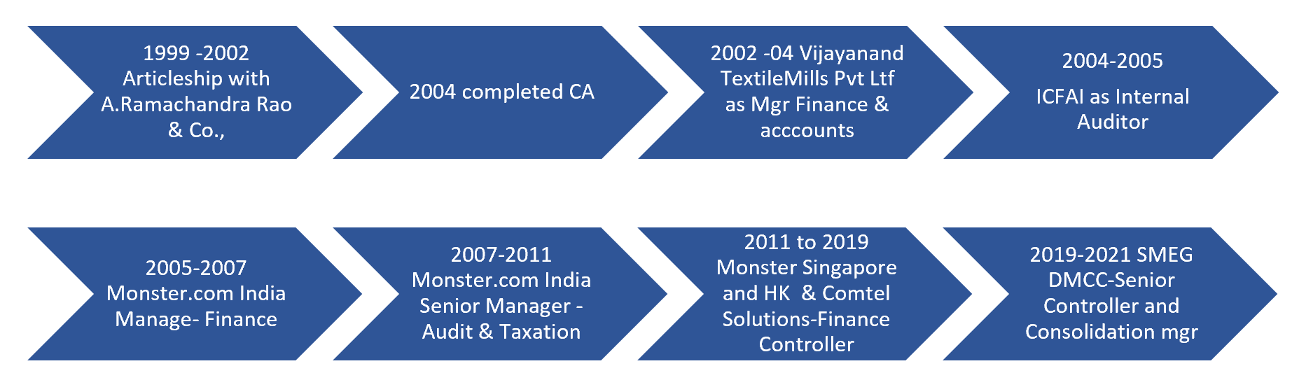

**Key Achievements**

* Managing over 13+ legal entity accounting, books closure & Group Consolidation for financial reporting - end to end Close to Disclose process.
* Experienced Financial Controller with more than 17 years of success in IT, Staffing & FMCG industry
* Skilled in uncovering opportunities to improve financial growth, risk management and internal controls
* Handling technical accounting Issues and Implementation of new IFRS/USGAAP standards- Solid understanding of IFRS and Strong accounting & Reporting knowledge with a thorough understanding of processes and reporting systems
* Successfully led and implemented of SAP erp system in group subsidiary
* Highly motivated and goal-driven Financial Controller skilled in collecting, monitoring and studying data to analyze financial status and recommend business strategy. Experienced in qualitative and quantitative analysis, contract management and forecasting. Tech-savvy in use of spreadsheets, accounting and financial management software. .
* Skilled Financial Controller bringing 15 years of experience working with Multi National organizations. Proven leadership and success in leading teams in achieving financial goals. Accomplished in working with executive leaders to develop business, financial and growth strategies

Jai hanuman

**WORK EXPERIENCE**

SMEG Distribution LLC DUBAI (PHOENIX COMMODITIES– Senior Controller and Consolidation

From DEC 2019 to April 2021

1. **Close, Consolidate and report** : Handling end to end Close to disclose process for all 13 entities , Preparation of consolidated financial statement for SMEG DMCC and Preparation of comprehensive Consolidation package for corporate reporting for purpose of ultimate consolidation into Phoenix Canso!. Prepare and post consolidation, Elimination and Top Side entries, such as eliminations, non-controlling interest, capitalized interest and purchase accounting, oversee all intercompany processes and reconciliations including resolution of intercompany balances
2. **Financial Analysis:** Reviewing the financial close package for all 13 entities, which include financial statements, budget vs. actual analysis, forecast, and reporting for the Board of Directors. Review and understand drivers of cost for key line items in the online P&L, including marketing, and promotional expenses. Provide recommendations and work with business partners for management of the expenses based on leadership direction
3. **Group Audit :** Responsibly for Statutory audit for group and all subsidiaries, provide interface for audit of all entities within group on timely basis. liaising with external auditors and managing the audit process for the group and all subsidiaries
4. **Financial Planning & Forcart:** Responsible for pulling together the Group plans and forecasts, Support the COO in the management of FP&A processes for long range multi-year planning, Responsible for rolling up the global forecast across all channels and geographies and analyzing results for senior leadership
5. Key Finance contact and direct liaison with international controllers for accounting and reporting issues
6. Collaborate with the Financial Technology team to support the maintenance and/or development of Finance-related systems and controls, particularly In house Sage & Consol tool
7. Formulated strategic plans and supported tactical initiatives to execute cost-savings deliverables, saving Aed 2 Million on automating ware house management.
8. Reviewed contracts financially impacting company and counseled executive leaders on impact contracts would have on company operations.

#### **Monster Singapore & Hk And Comtel Solutions- Financial Controller**

**From 06–2011 to 11-2019**

Monster.com is a leading online careers website and flagship brand of Monster Worldwide. From 1st Oct 2018 apart from the Controllership for Monster Singapore and Hong Kong, I was also entrusted with the controllership responsibilities for Comtel Solutions Singapore

1. **Month End /Quarterly Group Reporting**: Month End /Quarterly Group Reporting: As the Head office is Listed in Netherland 's, it places a high emphasis on precise and timely financial reporting, to comply with the requirements of the Group, Monitor and analyze monthly operating results against budget and submit a report to the global Finance controller and Finance Head.
2. **Supporting the organization as a business partner**: Support the management as a business partner in guiding the organization's long term financial strategy, providing financial insight, planning, analysis and reporting to enable management decision making and drive the business plans. implementing and enforcing group policies and setting local policies and controls.
3. **Administration of Finance Department:** Oversee daily operations of the finance department and the finance team, ensure that the cost is controlled and kept within budget, and Conduct a quarterly review of all cost, monitoring closely the achievement of the financial KPI set for the company Gross Margin, EBITA.
4. **Budgeting/Forecasts/ Planning:** Drive the budgeting and forecasting process for the company by following the Head office process and guidelines, consolidate and complete the preparation of the yearly budget and quarterly forecast, prepare a strategic planning for the company, work with Heads of Departments to develop five-year business plans for the company.
5. **Auditing and Taxation**: Responsible for completion of the statutory audit within the timelines set by holding company, review and Approve GST Returns and tax withholding returns, prepare tax and deferred tax calculations on monthly basis as per Head office requirement and ensure Corporate tax compliances.
6. **Internal Controls and Processes**: Establish and maintain an appropriate set of internal controls and guidelines in line with the Corporate policy and Auditing standards. Quarterly review of key controls and sox compliance.
7. **Accounts Payable:** Ensure proper administration of account payable team to see that the staff are carrying out Accounts Payable functions in a timely manner.
8. **Accounts Receivable:** Ensure the staff are carrying out the following Accounts Receivable functions timely and monitoring DSO
9. **Legal: Review** all contracts that need to be signed by the company with suppliers, airport authorities, and service providers and ensure the financial obligations of the company are within the budget, liaise with secretarial agents for company secretarial matters and filing of the Annual Returns.
10. **Treasury:** Establish and maintain a good banking relationship with bankers and financial institutions, Liase with Banks and Guarantee companies for Credit facilities, support corporate treasury in quarterly and year-end reports and financial requirements, ensure sufficient funding for local operations, manage company cash flow and implement good working capital management, prepare and Submit Monthly Cash Flow Projection for the next 3 months to Regional Finance Director.
11. **New Projects:** Involved in Due Diligence Work, prepare business plans for new projects/businesses, Involved in Tender submission and preparing tender documents.
12. **SAP Implementation**: Supporting Comte! with Sap Implementation along with KPMG- Business requirement gather, Mapping required in Sap , Helping with system configuration, User training , UAT Signing , PAT sign off from users , Cutting over activities , GoLive , Support training [Describe your responsibilities and achievements in terms of impact and results. Use examples but keep in short.]

#### **MONSETR.COM INDIA - Senior Manager – Audit and Taxation**

#### **From June 2005 to July 2011**

1. Finalization of Accounts- for both under Indian & US Gaap, and reconciliation of accounts maintained under Indian & US Gaap. Compliance with accounting standard, companies act, and other applicable laws. Responsible for completion of statutory audits, Limited reviews and Handling Business reporting to Head of finance
2. **SOX Compliances:**

* Establishing standardizing **and documenting** the Business process for sales order entry, billing, cash receipts and collections, accounts payable, cash disbursements, general ledger closure, and IT general controls. Including risk assessment in each process and establishing control activities to manage the risk
* Establishing Comprehensive risk control matrix for monster India so as to monitor the efficiency of key controls on regular basis and updating process documentation and RCM on any changes to process as a whole
* Actively engaged in SOX compliance audit conducted by third-party Consultant and following up on both findings and implementing Recommendations

1. **Internal audit:** Planning and conducting the internal audit of a different process of organization and preparing internal audit reports along with the recommendation.
2. **Taxation:** handling tax matters and responsible for tax compliance including filing for tax return for both corporate and Service tax and handling Income Tax assessment and service tax issues.
3. Other assignments include: Actively coordinating the Merger process and integration of Jobs Ahead with Monster.
4. **MIS reporting:** preparation of Budgets and Mis report for the head of finance on regular basis. Preparation of different budgets and quarterly report on budget utilization and achievement