**Udemy Kubernetes**

### Mumshad Mannambeth: [Kubernetes for the Absolute Beginners - Hands-on](https://capgemini.udemy.com/course-dashboard-redirect/?course_id=1602900)

**********************************************************************************

**K8s components:**

1. etcd
2. kubelet
3. Container Runtime
4. Controller
5. Scheduler
6. API Server etc.

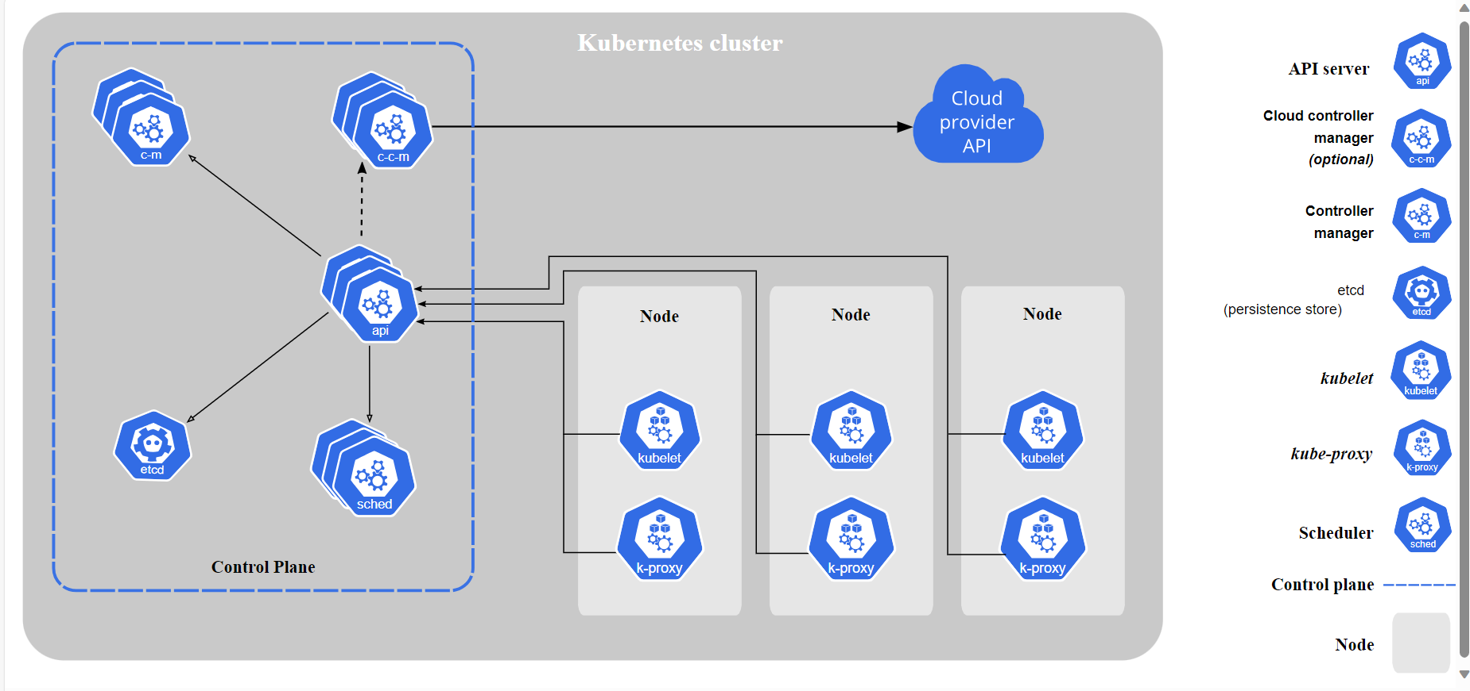

Master Nodes Worker nodes

[Kubernetes Components | Kubernetes](https://kubernetes.io/docs/concepts/overview/components/#:~:text=The%20API%20server%20is%20a%20component%20of%20the,horizontally%E2%80%94that%20is%2C%20it%20scales%20by%20deploying%20more%20instances.)

**API Server:** The API server is a component of the Kubernetes control plane that exposes the Kubernetes API. The API server is the front end for the Kubernetes control plane. The main implementation of a Kubernetes API server is **kube-apiserver**. kube-apiserver is designed to scale horizontally—that is, it scales by deploying more instances.

### kube-controller-manager

1. Node controller: Responsible for noticing and responding when nodes go down.
2. Job controller: Watches for Job objects that represent one-off tasks, then creates Pods to run those tasks to completion.
3. EndpointSlice controller: Populates EndpointSlice objects (to provide a link between Services and Pods).
4. ServiceAccount controller: Create default ServiceAccounts for new namespaces.

### cloud-controller-manager

The following controllers can have cloud provider dependencies:

* Node controller: For checking the cloud provider to determine if a node has been deleted in the cloud after it stops responding
* Route controller: For setting up routes in the underlying cloud infrastructure
* Service controller: For creating, updating and deleting cloud provider load balancers

What is worker machine in Kubernetes are known as?

Ans: Node or minion

A node in Kubernetes can onlyphysical machines and can never be a virtual machine?

Ans: False

Multiple nodes can together form a

Ans: Cluster

Question 4:

Which of the following processes runs on Kubernetes Master Node

Kube-api server

Question 5:

Which of the following is a distributed reliable key-value store used by kubernetes to store all data used to manage the cluster

Etcd

Question 6:

Which of the following services is responsible for distributing work or containers across multiple nodes.

Schedular

Question 7:

Which of the following is the underlying framework that is responsible for running application in containers like Docker?

Container runtime

Question 8:

Which is the command line utility used to manage a kubernetes cluster?

cubectl