*********************************************************************************
MongoDB-SpringBoot-RestAPI
**********************************************************************************
Sequence in MongoDB
Decision matrix
Criterion | Counters collection | Atlas Trigger | Snowflake ID
Synchronous, hot-path generation | ✅ Atomic per counter doc [mongodb.com] | ❌ Adds latency + at-least-once semantics [mongodb.com] | ✅ Local generation, no DB roundtrip [github.com]
Strictly contiguous integers | ✅ (with gaps possible on rollback) [dev.to] | ❌ | ❌
Throughput & horizontal scale | ◻️ Limited; hotspot | ❌ Not intended | ✅ Excellent; distributed [github.com]
Operational simplicity | ✅ Very simple | ◻️ Needs App Services setup & monitoring [mongodb.com] | ◻️ Needs worker ID assignment + clock discipline [github.com]
Time-ordering | ◻️ Only by value (integer) | ◻️ N/A | ✅ By design (timestamp-encoded) [en.wikipedia.org]

Production recommendations
- If your requirement = “printable, human-friendly, sequential numbers (e.g., invoices)”
- Go with Counters collection. Use:
  - findOneAndUpdate + $inc + returnDocument: "after" (to get the new value atomically). [mongodb.com]
  - Strong write concern and retryable writes.
  - Optional batch pre-allocation (allocate blocks per app instance) to reduce contention; accept gaps if a block isn’t fully used.
  - Be aware of gaps on rollback; if “no-gap” is mandatory, you’ll need a serialized insert pipeline or post-commit numbering strategy. [dev.to]
- If your requirement = “high-scale, distributed IDs”
- Implement Snowflake in your language/runtime; assign unique worker IDs per process/pod; ensure NTP and handle clock rollback/sequence rollover. (Multiple OSS implementations and the original spec exist.) [github.com], [en.wikipedia.org]
- Don’t put Atlas Triggers in the critical path of ID generation.
- Use them to augment (e.g., nightly reconciliation, alerts when counter nears a threshold, or backfill tasks). [mongodb.com]

✅ Counters Collection (App-managed $inc)
- MongoDB uses 64-bit signed integers for numeric fields by default.
- So the theoretical upper limit for value in your counters document is:
9,223,372,036,854,775,807 (≈ 9.22 quintillion)
- Practically:
  - You will never hit this in real-world scenarios.
  - If you need smaller ranges (e.g., daily reset), you can partition counters by date or scope.
- Performance limit:
  - The real bottleneck is write contention on the single document.
  - With block allocation (e.g., increment by 100), you can easily handle thousands of IDs/sec.
  - Without block allocation, expect contention at very high concurrency (>10k ops/sec).

✅ Atlas Trigger
- Atlas Trigger itself does not impose a numeric limit beyond MongoDB’s 64-bit integer.
- The same $inc logic applies inside the trigger function.
- Operational limits:
  - Atlas App Services has rate limits:
    - Free tier: ~500,000 function calls/month.
    - Paid tiers: higher, but still subject to per-second throttling (e.g., 1000 calls/sec).
  - Each trigger invocation adds network + function execution latency (usually 50–200 ms).
- So the practical upper limit for throughput is lower than counters in-app because:
  - Every request goes through App Services.
  - If you need millions of IDs/sec, triggers are not ideal.

✅ Summary Table
Feature | Counters Collection | Atlas Trigger
Numeric max | ~9.22 quintillion | Same (64-bit)
Throughput | Very high (with block allocation) | Lower (network + function overhead)
Rate limits | None (except DB capacity) | Atlas App Services limits
Latency | ~1–5 ms (direct DB) | ~50–200 ms (function + DB)

✅ Best Practice for Production
- Use Counters collection for high-volume, low-latency needs.
- Use Atlas Trigger for centralized logic, scheduled resets, or multi-service orchestration—but not for extreme throughput.

Side-by-Side Comparison
Aspect | Counters Collection (App) | Atlas Trigger (Server-side on Atlas)
Latency | Very low (single DB round-trip) | Slightly higher (network to App Services + function exec + DB call)
Portability | ✅ Works on any Mongo deployment | ❌ Atlas only
Throughput | High; can add block allocation (cache ranges) | High, but each call goes through App Services; add caching in function if needed
Complexity | Simple; logic in app code | Higher; deploy & secure App Services Functions/Triggers
Centralization | In each app (shared library recommended) | Central, server-managed “procedure”
Security | App auth to DB; control via roles/SC | App Services auth (API keys/Rules) + DB rules
Observability | App logs/metrics | App Services logs, invocation metrics
Scheduling/Events | App cron/Quartz | Built-in scheduled triggers & DB change triggers
Cost | Uses your app & DB resources | Includes App Services (billable in Atlas tiers)
Operations | Owned by app team | Owned via Atlas portal (deploy, version, permissions)
Failure Modes | App retry logic; DB write concerns matter | API unavailability, function timeouts, throttling limits

✅ Summary Table
Method | Sequential | Safe under concurrency | Recommended
ObjectId | No | Yes | If only uniqueness needed
UUID | No | Yes | If only uniqueness needed
Aggregation $max | Yes | No | ❌ Not safe
App memory counter | Yes | No | ❌ Not safe
Atlas Trigger | Yes | Yes | ✅ Good for managed
Counters collection | Yes | Yes | ✅ Best practice
Kaunsa choose karna chahiye?
- Sirf uniqueness chahiye → ObjectId (Option 1).
- Oracle-jaisi increasing numeric ID chahiye (contiguous nahi bhi chale) → counters ya Atlas Trigger (Option 2).
- Ultra-high throughput, distributed → Snowflake-like IDs (Option 3.A).
- Strict contiguous numeric & DB-side → counters-style atomic $inc hi best; Trigger se aap “single procedure” feel la sakte ho.

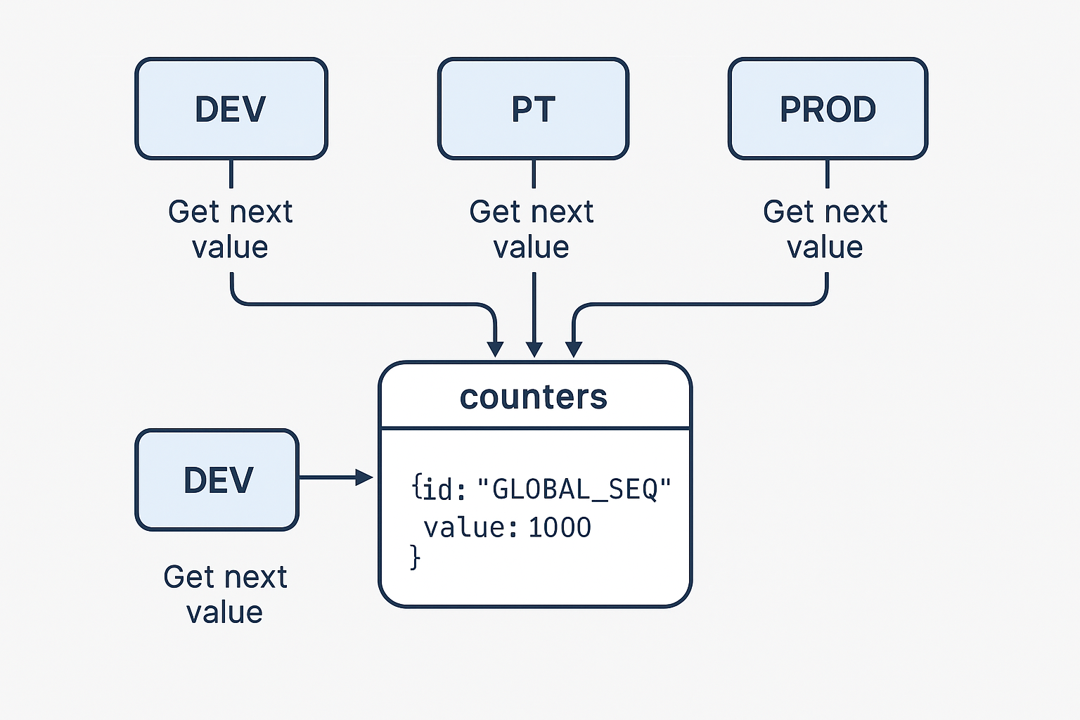

Here’s a diagram showing how a global sequence works in MongoDB across multiple environments (DEV, PT, PROD). It illustrates every environment calling the same centralized sequence source (counters collection) to fetch the next number—ensuring no overlap via atomic $inc.

How it works (step-by-step)
- Single source of truth
  - Create one document per sequence inside a counters collection:
JSON
{ "_id": "GLOBAL_SEQ", "value": 1000 }
Show more lines
  - Seed value to start - 1 (e.g., 999) so the first call returns 1000.
- Atomic increment for uniqueness
  - Every environment (DEV/PT/PROD) uses the same operation:
JavaScript
db.counters.findOneAndUpdate(
{ _id: "GLOBAL_SEQ" },
{ $inc: { value: 1 } },
{ returnDocument: "after", upsert: true, writeConcern: { w: "majority" } }
).value.value;
Show more lines
  - $inc on a single document is atomic, so the returned number is unique even under heavy concurrency.
- Optional per-environment isolation
  - If you prefer each environment to have its own sequence (to avoid cross-environment collisions), use separate IDs:
- DEV_SEQ, PT_SEQ, PROD_SEQ
  - Same logic, different _id values.
- Performance (block allocation)
  - Services can allocate ranges (like Oracle CACHE) to reduce round trips:
JavaScript
const size = 50;
const res = db.counters.findOneAndUpdate(
{ _id: "GLOBAL_SEQ" },
{ $inc: { value: size } },
{ returnDocument: "after", upsert: true }
);
const end = res.value.value;
const start = end - size + 1;
// Serve [start..end] in-memory
Show more lines
  - Multiple services can allocate blocks simultaneously without overlap; gaps are acceptable if a process dies before using its allocated numbers.
- Reliability & idempotency
  - Use writeConcern: "majority" for durability across failovers.
  - Enforce a unique index on the business ID field (e.g., orderId) to guard against retries:
JavaScript
db.orders.createIndex({ orderId: 1 }, { unique: true });

Show more lines

Quick checklist to adopt
- Create counters collection with one doc per sequence (_id = GLOBAL_SEQ)
- Use findOneAndUpdate(..., $inc) with upsert: true and writeConcern: majority
- Optionally split by environment (DEV_SEQ, PT_SEQ, PROD_SEQ)
- For throughput, implement block allocation
- Add unique index on downstream collections for idempotency

******************************************************************************

