ML framework & Terminology
********************************************************************************
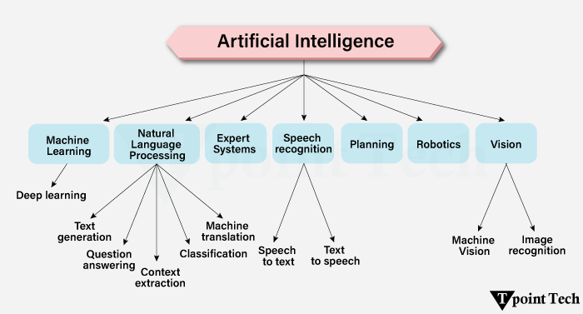
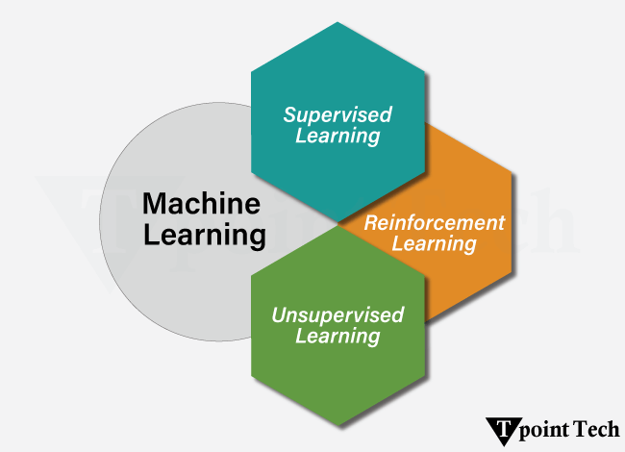
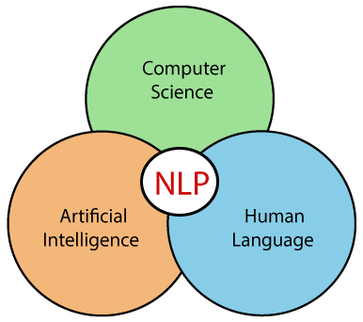

NLP
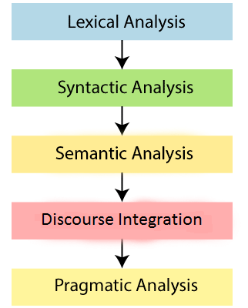
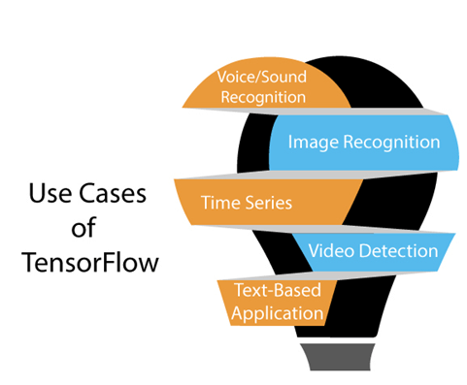
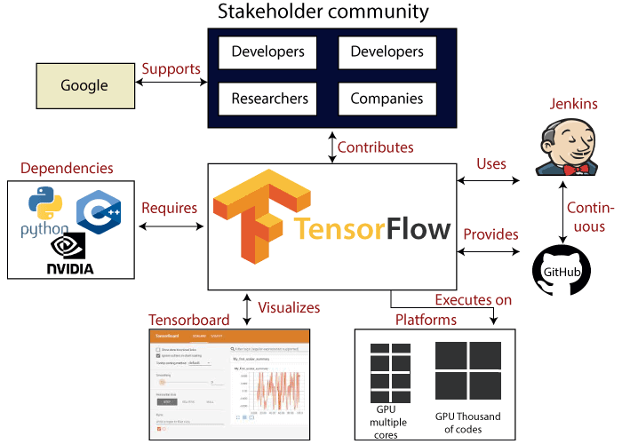
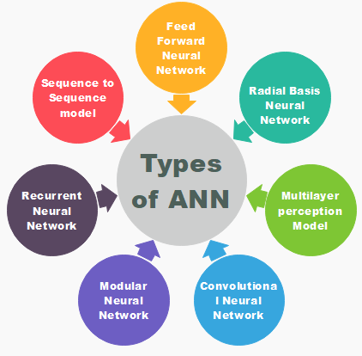
Subsets of Artificial Intelligence - Tpoint Tech
✅ If you're learning ML
Best path for you:
- Python basics
- NumPy + Pandas
- Machine Learning (scikit-learn)
- TensorFlow / Keras
DB->Observation, attributes
TensorFlow , PyTorch , Scikit-learn, Keras ,Datalab, matplotlib, Dataframes, one epoc, batchsize,neural networks, deep neural learning, gradient, overfitting,regularization,cross validation,bias variance tradeoff,feature engineering,steepness

- The boxes we type our code into are called cells.
- The import keyword means to bring in. We can bring in libraries or modules.
- The bluish green bar at the left side of each cell tells us that the code in the cell ran without error.

Python's meteoric rise can be partly attributed to TensorFlow.
👉 Cleansed = cleaned or purified
Meteoric=growing very fast
👉 Data Wrangling = Cleaning, organizing, and preparing raw data for analysis
Summary
- The majority of applied machine learning is supervised.
- Data cleansing accounts for a large part of machine learning.
- Pandas is a library in Python for data wrangling.
- Most models use CSVs or another tabular data structure like a SQL table as their data for modeling.
- Numpy is a numerical processing library in Python.
- A series is a one dimensional object similar to an array.
- NaN means not a number.
- A dataframe is a tabular data structure composed of rows and columns.
- read_csv reads a csv file into our dataframe.
- Placing a csv file in your root directory will allow you to call read_csv without specifying a path name.

Summary
- In regression the outcome to be predicted is a continuous number.
- Computers learn from past experience by using data sets.
- Naive Bayes is basically advanced counting.
- A Naive Bayes classifier assumes that the presence of a particular feature in a class is unrelated to the presence of any other feature.
- A decision tree is a decision support tool that uses a tree-like graph or model of decisions and their possible consequences, including chance event outcomes, resource costs, and utility. It is one way to display an algorithm.
- Logistic regression is used to predict the outcome variable which is categorical. A categorical variable is a variable that can take only specific and limited values.
- Linearly separable means the data can be separated by a line.
- Neural networks mimic the brains behavior.
- A vanilla Support Vector Machine is a type of linear separator.
- The SVM algorithm attempts to find an optimal vector (in this case, a line) that separates to groups of data points.

Summary
- The artificial neuron is the basis for all neural networks.
- The artificial neuron has input channels, a processing stage and an output.
- At the start of the model building phase all the inputs have random weights and biases.
- When a signal comes in it's multiplied by a weight value.
- The weights are adjusted based on the error of the last test result.
- After the weights are adjusted all those input signals are summed up to a single value.
- An offset is added to the sum. (the offset is called a bias)
- A neural network moves towards a state where the desired patterns are learned.
- If a group of random data points are linearly separable a single neuron can separate them out.
- In our algorithm we must have weights and a bias before we start.
- When we code our model the function responsible for carrying out the work did three things.
- Weighs input signals
- Sums then up
- Adds biases

Summary
- Supervised neural networks learn when we provide them a large set of question/answer pairs.
- To put in simple terms, backpropagation is like "learning from mistakes".
- By definition a deep neural network is one with more than one hidden layer.
- One epoch is one forward pass and one backward pass of all the training data.
- Batch size is the number of training examples in one forward/backward pass.

Summary
- Gradient Descent is a helper algorithm that aims to achieve the required optimal solution through trial and error method.
- The stopping point where we've reached the bottom of our bucket is called convergence.
- If an algorithm learns the training data too well it's called overfitting.
- Complex decision boundaries are a good sign your model suffers from overfitting.
- There are two core techniques used to handle overfitting.
- Regularization - altering how accurate our model will be.
- Cross Validation - use multiple subset of training data in the training process.
- The two approaches can be used in isolation or together.
- The trade off between accuracy with our training data and accuracy with our test data is the bias-variance tradeoff.
- Variables or columns in our data set used to build the best models are called features.
- All data fed into a machine learning model is numeric.
- Having enough data or enough examples is critical to your models success.

*********************************************************************************
🧠 TensorFlow – Simple Explanation
TensorFlow is an open-source machine learning (ML) and deep learning (DL) framework developed by Google.
👉 It helps you build, train, and deploy AI models.

✅ What TensorFlow is used for
You can use TensorFlow to build:
- 🤖 Machine learning models
- 🧠 Deep learning (neural networks)
- 📊 Data prediction systems
- 🗣️ Speech recognition
- 🖼️ Image classification
- 💬 Chatbots / NLP apps

✅ Why TensorFlow is popular
✔ Developed by Google
✔ Works on CPU, GPU, and cloud
✔ Supports large-scale production systems
✔ Huge community & documentation

✅ Basic Example (Python)
Here’s a very simple TensorFlow example 👇
Python
import tensorflow as tf

# Create some data
X = [1, 2, 3, 4]
Y = [2, 4, 6, 8] # Y = 2X

# Simple model
model = tf.keras.Sequential([
tf.keras.layers.Dense(1, input_shape=[1])
])

# Compile model
model.compile(optimizer='adam', loss='mean_squared_error')

# Train model
model.fit(X, Y, epochs=100, verbose=0)

# Predict
print(model.predict([5]))

👉 Output will be close to:
10

✅ Key Components
1. Tensor
- Multi-dimensional array (like NumPy)
- Example: [1, 2, 3] or matrix

2. Keras (Important ✅)
- High-level API inside TensorFlow
- Makes model building simple
Python
tf.keras.Sequential()
Show more lines

3. Model
- Defines how your ML system works
Types:
- Sequential (simple)
- Functional (advanced)

4. Training
- Model learns from data
model.fit(X, Y)
✅ TensorFlow vs Others
Feature | TensorFlow | PyTorch
Ease | Medium | Easy
Industry use | Very high | High
Research use | Medium | Very high
Production deployment | Strong | Good

✅ When to use TensorFlow
👉 Use TensorFlow if you want:
- Production-ready ML systems
- Android / mobile apps (TensorFlow Lite)
- Large-scale AI projects

✅ Alternatives
- PyTorch (more beginner-friendly)
- Scikit-learn (simple ML only)
- Keras (already inside TensorFlow)

🎯 Simple Summary
👉 TensorFlow = Tool to build AI models
- Input data → Train model → Predict output

✅ 1. Is TensorFlow built in Java?
❌ No
- TensorFlow is mainly written in:
  - C++ (core engine)
  - Python (main interface)
- That’s why most tutorials are in Python.
- But ✅ Yes, TensorFlow works with Java
NOTE: we can use tensorflow in java but it can not built in python(written in c++, and python is interface)
✅ 2. Can you use TensorFlow in Java?
✅ Yes (official support exists)
Google provides a TensorFlow Java API.
👉 This allows you to:
- Load trained models
- Run predictions
- Integrate ML into Java apps (Spring Boot, Android backend, etc.)
✅ 3. How Java works with TensorFlow
👉 Typical flow:
- Train model in Python
- Export model
- Use it in Java
Python → train model
↓
Save model (SavedModel)
↓
Java → load & predict

Example:
✅ 4. Simple Java Example (TensorFlow)

import org.tensorflow.SavedModelBundle;
import org.tensorflow.Tensor;

public class Example {
public static void main(String[] args) {
try (SavedModelBundle model = SavedModelBundle.load("model", "serve")) {

Tensor<?> input = Tensor.create(new float[][]{{5.0f}});
Tensor<?> output = model.session().runner()
.feed("input", input)
.fetch("output")
.run()
.get(0);

System.out.println(output);
}
}
}
🎯 Simple Understanding
👉 TensorFlow = Python-first
👉 Java = integration layer

*************************************************************************************
🧮 NumPy – Simple Explanation
NumPy (Numerical Python) is a Python library used for fast mathematical and array operations.
👉 It is the foundation of all machine learning & data science in Python.
✅ What NumPy is used for
NumPy helps you work with:
- 📊 Large datasets (arrays, matrices)
- ➕ Mathematical calculations
- 📈 Data processing for ML models
- ⚡ Fast computations (much faster than normal Python lists)
✅ Why NumPy is important
✔ Very fast (written in C under the hood)
✔ Easier math operations
✔ Used by libraries like:
- TensorFlow ✅
- Pandas ✅
- Scikit-learn ✅
👉 Without NumPy → ML is very difficult
✅ Basic Concept: Array
🔹 Python list:
Python
a = [1, 2, 3]
Show more lines
🔹 NumPy array:
Python
import numpy as np

a = np.array([1, 2, 3])
Show more lines
👉 NumPy array is faster and supports math directly
✅ Simple Operations
Python
import numpy as np

a = np.array([1, 2, 3])
b = np.array([4, 5, 6])

print(a + b) # [5 7 9]
print(a * b) # [4 10 18]
Show more lines
👉 Works element-wise (very powerful)
✅ Common Functions
🔹 Create arrays
Python
np.zeros(3) # [0. 0. 0.]
np.ones(3) # [1. 1. 1.]
np.arange(1, 5) # [1 2 3 4]
Show more lines

🔹 Math operations
Python
np.mean(a) # average
np.sum(a) # total
np.max(a) # max value
Show more lines

🔹 Reshape (important in ML)
Python
a.reshape(3, 1)
Show more lines

✅ Example (Real Use)
Python
import numpy as np

data = np.array([10, 20, 30, 40])
avg = np.mean(data)

print("Average:", avg)
Show more lines

✅ NumPy vs Python List
Feature | Python List | NumPy
Speed | Slow | Fast
Math operations | Manual loops | Direct
ML usage | ❌ | ✅

✅ When you use NumPy
👉 You’ll use it in:
- Machine Learning (TensorFlow, PyTorch)
- Data science
- Data analysis
- Scientific computing

✅ Relationship with TensorFlow
👉 Think like this:
NumPy → Data handling (arrays)
TensorFlow → Model building
👉 Example flow:
- Load data → NumPy
- Train model → TensorFlow

🎯 Simple Summary
👉 NumPy = fast math + arrays for Python
- Store data
- Perform calculations
- Prepare data for ML

✅ Best Learning Path
- Python basics
- ✅ NumPy (very important)
- Pandas
- Machine Learning
- TensorFlow
- ❌ Short Answer
👉 NumPy is NOT built in Java
👉 NumPy cannot be directly used in Java
👉 NumPy does NOT have official Java support

Option 3: Use Python + API (Best real-world approach)
👉 Industry approach:
NumPy (Python) → Process data
↓
Expose API (Flask/FastAPI)
↓
Call from Java (Spring Boot)
*************************************************************************************
🐼 Pandas – Simple Explanation
Pandas is a Python library used for data analysis and data handling.
👉 It works on top of NumPy and is used to store, clean, and analyze data easily.

✅ What Pandas is used for
Pandas helps you:
- 📊 Read data (CSV, Excel, JSON)
- 🧹 Clean messy data
- 🔍 Filter and search data
- 📈 Analyze and summarize data
- ✅ Prepare data for Machine Learning

✅ Key Concept: DataFrame
👉 Pandas uses DataFrame (table format)
Think like Excel sheet:
Name | Age | City
Rajesh | 30 | Pune
Amit | 25 | Mumbai

✅ Basic Example
Python
import pandas as pd

data = {
"Name": ["Rajesh", "Amit"],
"Age": [30, 25],
"City": ["Pune", "Mumbai"]
}

df = pd.DataFrame(data)

print(df)
Show more lines
👉 Output:
Name Age City
0 Rajesh 30 Pune
1 Amit 25 Mumbai

✅ Common Operations
🔹 Read file
Python
df = pd.read_csv("data.csv")
Show more lines

🔹 View data
Python
df.head() # first 5 rows
df.tail() # last rows
Show more lines

🔹 Select column
Python
df["Name"]
Show more lines

🔹 Filter data
Python
df[df["Age"] > 25]
Show more lines

🔹 Basic stats
Python
df.mean()
df.max()
df.describe()
Show more lines

✅ Pandas vs NumPy
Feature | Pandas | NumPy
Data type | Tables (rows/columns) | Arrays
Ease | Very easy | Medium
Use case | Data analysis | Math & ML base

✅ Relationship (Very Important)
👉 Think like this:
NumPy → fast calculations
Pandas → data handling (cleaning & analysis)
TensorFlow → ML models

✅ Is Pandas built in Java?
❌ No
- Pandas is a Python-only library
- Built using:
  - Python
  - NumPy

✅ Can Pandas be used in Java?
❌ No direct usage in Java
You cannot do:
Java
import pandas // ❌ not possible
Show more lines

✅ Alternatives in Java
If you want Pandas-like features in Java:
🟢 1. Tablesaw (Best alternative)
Java
import tech.tablesaw.api.Table;
Show more lines
✔ Similar to Pandas
✔ Supports CSV, filtering, analysis

🟢 2. Apache Spark (DataFrames in Java)
✔ Big data processing
✔ More powerful but complex

🟢 3. Use Python + API (Industry standard ✅)
Pandas (Python)
↓
Process data
↓
Expose API
↓
Java calls API
👉 Most common real-world approach

✅ When to use Pandas
👉 Use Pandas if:
- Working with Excel/CSV data
- Cleaning data before ML
- Data analysis/reporting

🎯 Simple Summary
👉 Pandas = Excel-like tool in Python
- Read data
- Clean data
- Analyze data

✅ Learning Path
- Python basics
- ✅ NumPy
- ✅ Pandas
- Machine Learning
- TensorFlow

************************************************************************************
🤖 Scikit-learn – Simple Explanation
Scikit-learn (sklearn) is a Python library used for Machine Learning (ML).
👉 It helps you build ML models easily without deep math or complex coding.

✅ What Scikit-learn is used for
You can use it to build:
- 📊 Prediction models (house price, salary, etc.)
- 🧠 Classification models (spam detection, fraud detection)
- 🔍 Clustering (group similar data)
- 📉 Data preprocessing (cleaning & scaling)

✅ Why Scikit-learn is popular
✔ Easy to learn (best for beginners)
✔ No deep math required
✔ Works with NumPy & Pandas
✔ Huge ML algorithm support

✅ Basic Example (Very Simple)
Python
from sklearn.linear_model import LinearRegression

# Data
X = [[1], [2], [3], [4]]
Y = [2, 4, 6, 8]

# Model
model = LinearRegression()

# Train
model.fit(X, Y)

# Predict
print(model.predict([[5]]))
Show less
👉 Output:
[10]

✅ Key Concepts
🔹 1. Model
- Algorithm used for prediction
Examples:
- Linear Regression
- Decision Tree
- Random Forest

🔹 2. Training
Python
model.fit(X, Y)
Show more lines
👉 Model learns from data

🔹 3. Prediction
Python
model.predict([[5]])
Show more lines
👉 Model gives output

🔹 4. Data Preprocessing
Python
from sklearn.preprocessing import StandardScaler
Show more lines
👉 Used to prepare data

✅ Common Algorithms in Scikit-learn
- Linear Regression
- Logistic Regression
- Decision Tree
- Random Forest
- K-Means (clustering)
- Support Vector Machine (SVM)

✅ Scikit-learn vs TensorFlow
Feature | Scikit-learn | TensorFlow
Type | ML (simple) | Deep learning
Easy to learn | ✅ Yes | ⚠️ Medium
Best for | Beginners | Advanced AI
Neural networks | Limited | Full support

✅ Relationship with NumPy & Pandas
👉 Flow:
Pandas → load & clean data
NumPy → handle arrays
Scikit-learn → build ML model
TensorFlow → deep learning

❌ Is Scikit-learn built in Java?
❌ No
- Built in Python
- Uses NumPy internally

❌ Can Scikit-learn be used in Java?
❌ No direct usage
You cannot do:
Java
import sklearn // ❌ not possible
Show more lines

✅ Alternatives in Java
If you want similar functionality:
🟢 1. Weka
- Popular ML library for Java
🟢 2. Deeplearning4j
- Uses ND4J
🟢 3. Best Real-world Approach ✅
Scikit-learn (Python)
↓
Create API (Flask/FastAPI)
↓
Call from Java (Spring Boot)

✅ When to use Scikit-learn
👉 Use it if:
- Beginner in ML ✅
- Working on structured data
- Want fast results
- Building prediction models

🎯 Simple Summary
👉 Scikit-learn = Easy machine learning library in Python
- Train model
- Predict output
- No heavy math needed

✅ Learning Order (Important)
- Python basics
- ✅ NumPy
- ✅ Pandas
- ✅ Scikit-learn
- TensorFlow

*************************************************************************************
🧠 Keras – Simple Explanation
Keras is a high-level deep learning library used to build neural networks easily.
👉 Today, Keras is part of TensorFlow
(You use it as tf.keras)

✅ What Keras is used for
Keras helps you build:
- 🧠 Neural networks (deep learning models)
- 🖼️ Image recognition models
- 🗣️ Speech / NLP models
- 🤖 AI applications

✅ Why Keras is popular
✔ Very easy to learn ✅
✔ Simple code (few lines)
✔ Built on top of TensorFlow
✔ Beginner-friendly
👉 Compared to TensorFlow core → Keras is much simpler

✅ Basic Example
Python
import tensorflow as tf

model = tf.keras.Sequential([
tf.keras.layers.Dense(10, activation='relu'),
tf.keras.layers.Dense(1)
])

model.compile(optimizer='adam', loss='mean_squared_error')

# training
model.fit([[1],[2],[3]], [2,4,6], epochs=10)

# prediction
print(model.predict([[5]]))
Show more lines
👉 Keras handles everything internally — very easy ✅

✅ Key Concepts
🔹 1. Model
- Structure of neural network
Python
tf.keras.Sequential()
Show more lines

🔹 2. Layers
- Building blocks of model
Examples:
Python
Dense = fully connected layer
Conv2D = image processing layer
Show more lines

🔹 3. Compile
- Set learning method
Python
model.compile(optimizer='adam', loss='mse')
Show more lines

🔹 4. Train
Python
model.fit(X, Y)
Show more lines

🔹 5. Predict
Python
model.predict(data)
Show more lines

✅ Keras vs TensorFlow
Feature | Keras | TensorFlow
Level | High-level | Low + high
Ease | ✅ Very easy | ⚠️ Medium
Control | Limited | Full control
Best for | Beginners | Advanced users
👉 Keras runs inside TensorFlow

✅ Keras vs Scikit-learn
Feature | Keras | Scikit-learn
Type | Deep learning | Machine learning
Neural networks | ✅ Yes | Limited
Use case | Images, NLP | Simple data

✅ Relationship (Important)
👉 Typical ML flow:
Pandas → Load data
NumPy → Process data
Scikit-learn → ML models
Keras → Deep learning models

❌ Is Keras built in Java?
❌ No
- Keras is a Python API
- Built on TensorFlow (C++ + Python)

❌ Can Keras be used in Java?
❌ No direct usage
You cannot do:
Java
import keras // ❌ not possible
Show more lines

✅ How Java uses Keras models
👉 Real-world approach:
Keras (Python) → Train model
↓
Export model (SavedModel / .h5)
↓
Java (TensorFlow API) → Load & predict

✅ When to use Keras
👉 Use Keras if:
- You want to learn AI quickly ✅
- Working on deep learning ✅
- Building neural networks ✅

🎯 Simple Summary
👉 Keras = Easy way to build deep learning models
- Built on TensorFlow
- Simple and beginner-friendly
- Mostly used with Python

✅ Learning Path (Recommended)
- Python basics
- NumPy
- Pandas
- Scikit-learn
- ✅ Keras (deep learning)

💡 Simple Analogy
- NumPy → calculator
- Pandas → Excel
- Scikit-learn → ML toolkit
- Keras → AI builder (neural networks)

********************************************************************************
🧪 DataLab – Simple Explanation
DataLab can refer to a few tools, but in most machine learning / data science context, it commonly means:
👉 Google Cloud Datalab (or similar “data lab” environments)

✅ What is DataLab?
👉 DataLab is an interactive workspace used to:
- Write code
- Analyze data
- Build machine learning models
👉 It is similar to: ✅ Jupyter Notebook
✅ Google Colab

✅ What you do in DataLab
Inside DataLab you can:
- 📊 Load datasets
- 🧹 Clean data (Pandas)
- 🧮 Use NumPy for calculations
- 🤖 Build models (scikit-learn / TensorFlow)
- 📈 Visualize data

✅ Example Workflow
Load data → Clean data → Analyze → Train model → Visualize
👉 All done in one place

✅ Technologies used inside DataLab
- Python ✅
- NumPy ✅
- Pandas ✅
- Scikit-learn ✅
- TensorFlow ✅

✅ Simple Example (like DataLab/Colab)
Python
import pandas as pd

# Load data
df = pd.read_csv("data.csv")

# Show first rows
print(df.head())
Show more lines

✅ DataLab vs Google Colab vs Jupyter
Feature | DataLab | Google Colab | Jupyter
Type | Cloud tool | Cloud tool | Local tool
Setup | Easy | Very easy | Manual
ML ready | ✅ | ✅ | ✅
👉 Today, Google Colab is used more than DataLab

✅ Current Reality (Important)
👉 Google Cloud Datalab (older) is mostly:
- Replaced by Vertex AI Workbench / Colab
👉 So when people say “DataLab” now:
- They often mean notebook-based data environment

❌ Is DataLab built in Java?
❌ No
- Works mainly with Python
- Not a Java-based tool

❌ Can you use it in Java?
❌ No direct use in Java
👉 BUT:
You can:
Python (DataLab)
↓
Create API
↓
Call from Java

✅ When to use DataLab (or similar tools)
👉 Use when:
- Learning ML ✅
- Doing data analysis ✅
- Building AI models ✅
- Running experiments ✅

🎯 Simple Summary
👉 DataLab = coding notebook for data science
- Write Python code
- Analyze data
- Train ML models

✅ Better Alternative (Recommended)
👉 Instead of DataLab, use:
✅ Google Colab (BEST)
👉 https://colab.research.google.com
✔ Free
✔ No setup
✔ Easy for beginners

✅ Final Understanding
- DataLab = environment, not a library
- Built for Python ML workflows
- Not used in Java directly

import matplotlib.pyplot as plt
✅ What does this line mean?
Python
import matplotlib.pyplot as plt
Show more lines

🔹 Simple Explanation
👉 This line imports a library in Python used for plotting graphs and charts.

✅ Break it down
🟢 matplotlib
- A Python library used for data visualization
- Helps create:
  - Graphs 📈
  - Charts 📊
  - Plots

🟢 pyplot
- A module inside matplotlib
- Works like MATLAB (easy plotting commands)

🟢 as plt
- Creates a shortcut name
- Instead of writing:
Python
matplotlib.pyplot.plot()
Show more lines
- You write:
Python
plt.plot()
Show more lines

✅ Simple Meaning
👉
“Import matplotlib plotting tools and call it ‘plt’ for easy use”

✅ Example (Basic Graph)
Python
import matplotlib.pyplot as plt

x = [1, 2, 3]
y = [2, 4, 6]

plt.plot(x, y)
plt.show()
Show more lines
👉 This will display a line graph

✅ What you can do with plt
- 📈 Line graph → plt.plot()
- 📊 Bar chart → plt.bar()
- 🌍 Pie chart → plt.pie()
- 📉 Scatter plot → plt.scatter()

✅ Real Use (Important for ML)
👉 You use it for:
- Data visualization
- Understanding patterns
- Showing ML results

🎯 Short Summary
👉 import matplotlib.pyplot as plt
= Load graph library and use it as "plt"

*************************************************************************************
✅ What is a DataFrame?
👉 A DataFrame is a table-like structure in Python (Pandas) used to store and work with data.
👉 It looks like an Excel sheet or database table

✅ Example of a DataFrame
Name | Age | City
Rajesh | 30 | Pune
Amit | 25 | Mumbai
👉 This table = DataFrame

✅ How to create a DataFrame
Python
import pandas as pd

data = {
"Name": ["Rajesh", "Amit"],
"Age": [30, 25],
"City": ["Pune", "Mumbai"]
}

df = pd.DataFrame(data)

print(df)
Show more lines

✅ Key Parts of DataFrame
- Rows → individual records
- Columns → features (Name, Age, City)
- Index → row numbers (0, 1, 2...)

✅ Common Operations
🔹 View data
Python
df.head() # first rows

Show more lines

🔹 Select column
Python
df["Name"]
Show more lines

🔹 Filter data
Python
df[df["Age"] > 25]
Show more lines

🔹 Add new column
Python
df["Salary"] = [50000, 60000]
Show more lines

🔹 Delete column
Python
df.drop("City", axis=1)
Show more lines

✅ Why DataFrames are important
👉 Used in:
- Data analysis ✅
- Machine learning ✅
- Data wrangling ✅
👉 They help:
- Organize data
- Clean data
- Analyze data

✅ DataFrame vs Array
Feature | DataFrame | NumPy Array
Format | Table | Matrix
Columns with names | ✅ Yes | ❌ No
Easy to use | ✅ Very easy | Medium

✅ Real Workflow (Important)
CSV/Excel → Pandas DataFrame → Clean data → ML model

🎯 Simple Summary
👉 DataFrame = table (like Excel) in Python
- Stores data in rows & columns
- Used for data analysis
- Core part of Pandas

💡 Easy Analogy
👉 DataFrame = Excel sheet inside Python

*************************************************************************************
🧠 Neural Network – Simple Explanation
✅ What is a Neural Network?
👉 A Neural Network is a machine learning model inspired by the human brain.
👉 It is used to:
- Learn patterns
- Make decisions
- Predict results

✅ Easy Meaning
Neural Network = Computer system that learns like a brain

✅ How it looks (Structure)
A neural network has 3 main parts:
Input Layer → Hidden Layer(s) → Output Layer
🔹 Example:
Input → [Hidden Layer] → Output
5 → [processing] → 10

✅ Example (Real Life)
👉 Suppose you want to predict salary:
Input: Experience (years)
Output: Salary
Neural network learns:
- More experience → higher salary

✅ Layers Explained
🔹 1. Input Layer
- Takes data (numbers, images, text)
Example:
Age, Salary, Experience

🔹 2. Hidden Layers (Important)
- Do calculations
- Learn patterns
👉 More hidden layers = deep learning

🔹 3. Output Layer
- Gives final result
Example:
Prediction: ₹50,000

✅ How Neural Network learns
👉 3 simple steps:
- Feed data
- Calculate output
- Compare & adjust (learning)
👉 This process is called:
- Training

✅ Simple Code Example (Keras)
Python
import tensorflow as tf

model = tf.keras.Sequential([
tf.keras.layers.Dense(10, activation='relu'),
tf.keras.layers.Dense(1)
])

model.compile(optimizer='adam', loss='mse')
Show more lines

✅ Where Neural Networks are used
- 🖼️ Image recognition (face detection)
- 🗣️ Speech recognition
- 💬 Chatbots (like AI assistants)
- 🚗 Self-driving cars
- 📊 Predictions (finance, business)

✅ Neural Network vs Traditional Programming
Traditional Code | Neural Network
You write logic | System learns logic
Rule-based | Data-based
Fixed output | Adaptive

✅ Types of Neural Networks
- ANN (Artificial Neural Network)
- CNN (for images)
- RNN (for sequences/text)
- Deep Neural Network (many layers)

🎯 Simple Summary
👉 Neural Network = brain-like model that learns from data and makes predictions

💡 Easy Analogy
- Brain neurons → Neural network nodes
- Learning → Training
- Memory → Weights

*************************************************************************************
📈 Gradient – Simple Explanation
✅ What is “Gradient”?
👉 Gradient = rate of change (how fast something is increasing or decreasing)

✅ Easy Meaning
👉 In simple words:
Gradient = slope (ढाल / परिवर्तन की गति)
👉 Hindi: Gradient = ढलान / परिवर्तन की दर

✅ Daily Life Example
Imagine a hill:
- Flat road → no slope → gradient = 0
- Steep hill → high slope → high gradient
👉 So:
- More steep → higher gradient
- Flat → zero gradient

✅ In Math (Simple)
If:
y = 2x
👉 Gradient = 2
(means for every +1 in x → y increases by 2)

✅ In Machine Learning (IMPORTANT ✅)
👉 Gradient tells:
How much output changes when input changes

✅ Why Gradient is important
In ML, gradient is used to:
- 📉 Minimize error
- 🤖 Train models
- 🧠 Improve predictions

✅ Gradient Descent (Important Concept)
👉 Most important usage:
🔹 Gradient Descent = learning algorithm
Steps:
- Start with wrong answer
- Check error
- Use gradient to adjust
- Repeat until correct

✅ Simple Idea
👉 Imagine going down a hill:
- Gradient shows direction
- You move downhill to reach lowest point
👉 Lowest point = minimum error

✅ Simple Example
You want:
Y = 2X
But model predicts:
Y = 3X (wrong)
👉 Gradient helps adjust:
3 → 2

✅ Types of Gradient
- Positive gradient → increasing
- Negative gradient → decreasing
- Zero gradient → no change

🎯 Simple Summary
👉 Gradient = how fast something changes
👉 In ML:
- Helps model learn
- Used in gradient descent
- Essential for neural networks

