REACT-LEARNING
************************************************************************************
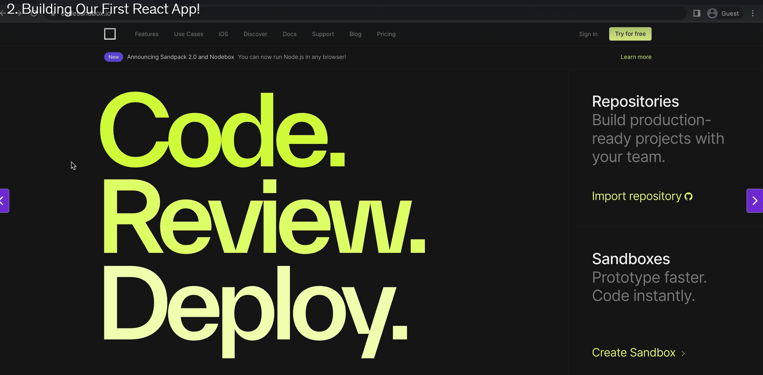
App.js - nodebox - CodeSandbox

For online coding practicde

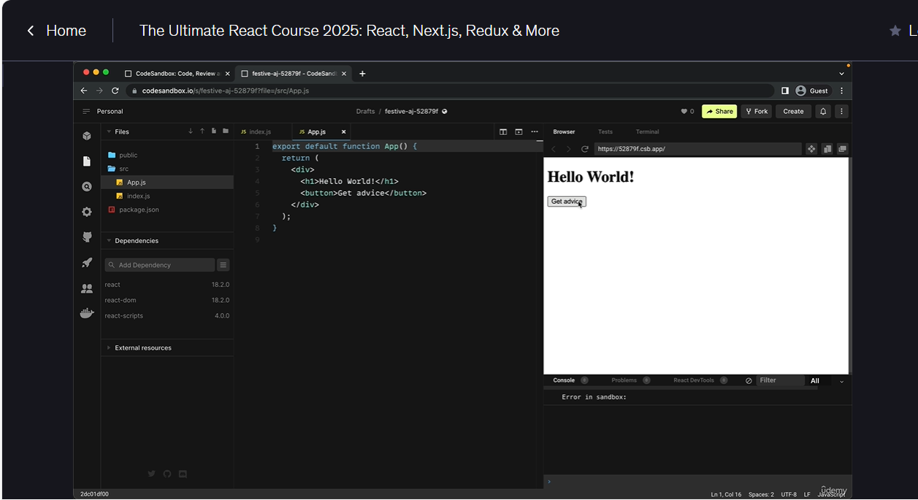
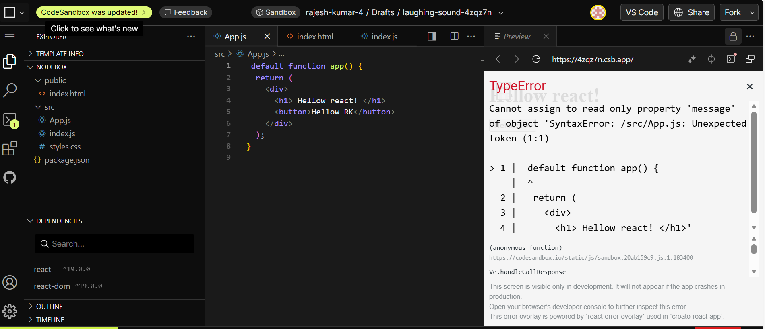
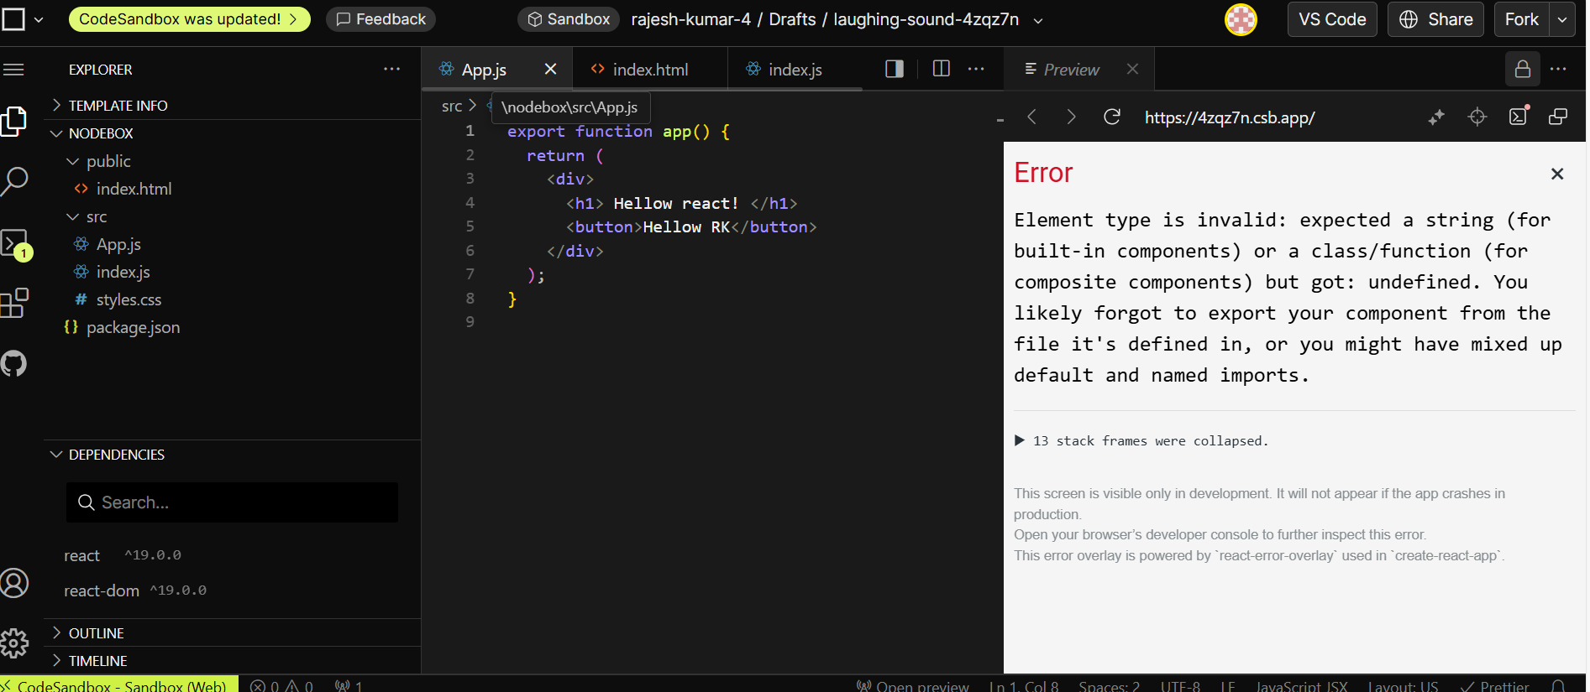
Code practice:

import { useEffect, useState } from "react";

export default function app() {
const [advice, setAdvice] = useState("");
const [count, setCount] = useState(0);
async function getAdvice() {
const res = await fetch("https://api.adviceslip.com/advice");
const data = await res.json();
setAdvice(data.slip.advice);
setCount((c) => c + 1);
//console.log(data);
}
useEffect(function () {
getAdvice();
}, []);
return (
<div>
<h1>{advice}</h1>
<button onClick={getAdvice}>get Advice</button>
<Message count={count} />
</div>
);
}
function Message(props) {
return (
<p>
you have read <strong> count is {props.count} </strong> piece of advice.
</p>
);
}

