FISER ACCOUNT
************************************************************************************
Core Java & OOPs Concepts:
- Explain the concept of Java class loading and how it works.

- What are the four main concepts of OOPs?

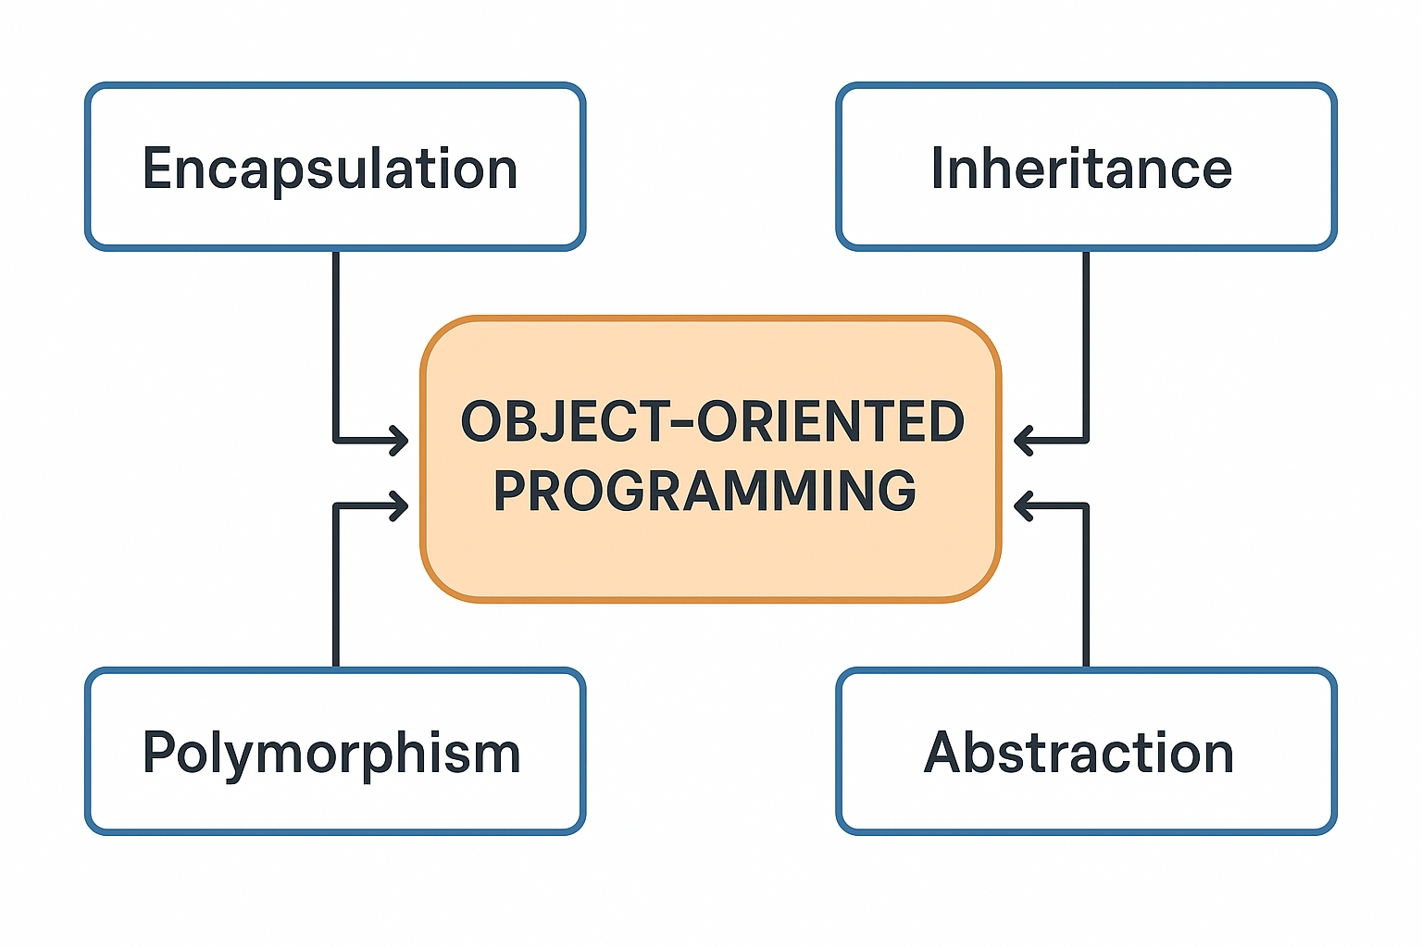
The four main concepts of Object-Oriented Programming (OOP) are:
- Encapsulation
  - This is the concept of wrapping data and methods that operate on the data into a single unit, i.e., a class.
  - It helps in hiding the internal state of the object from the outside world and only exposing a controlled interface.
  - Example: Using private variables and public getter/setter methods.
- Inheritance
  - This allows a class (child or subclass) to inherit properties and behaviors (methods) from another class (parent or superclass).
  - It promotes code reusability and establishes a natural hierarchy.
  - Example: A Car class inheriting from a Vehicle class.
- Polymorphism
  - This means many forms—the ability of different classes to be treated as instances of the same class through a common interface.
  - It allows methods to be overloaded (same method name, different parameters) or overridden (same method name and parameters, different implementation).
  - Example: A draw() method behaving differently for Circle, Rectangle, and Triangle classes.
- Abstraction
  - This is the concept of hiding complex implementation details and showing only the essential features of the object.
  - It helps in reducing programming complexity and increasing efficiency.
  - Example: An abstract class or interface that defines a blueprint without specifying the exact behavior.

- What is abstraction in OOPs?
- What is encapsulation? How is it achieved?
- What are the two types of polymorphism?
- What is run-time polymorphism, and how is it achieved?
- What is compile-time polymorphism, and how is it achieved?
- What is the difference between function overloading and function overriding?
- What are the main features of Java?
- What are the basic principles of OOPS programming?
- What is encapsulation in Java?
- How does encapsulation help in data hiding?
- How can private variables be accessed outside a class in Java?
- What is the role of getters and setters in encapsulation?
- difference between stack vs heap memory?
- What are access specifiers in java?
- Why java is platform independent ?
- Explain the features of java .
- What is JIT?
- Explain the elements in public static void main .
- What are the different datatype supported in java?
- What is the difference between instance and local variable?
- What is static variable?
- Difference between System.out, system.err, System.in?
- Explain about File input stream and File Output Stream.
- What is filtered streams
- What are operators in java and its types?
- Explain about String Buffer.
- Why are we using java?
- What type of inheritance not supported?
- What are the type of memory storages available in JVM?
- What is classloader?
- What is packages and when it is used & advantage of packages?
- Which variable has default value?
- What is buffered input stream and buffered output stream?
- what are the basic access specifies? sort in priority
- what is a constructor?
- what is abstract class and interface?
- what is a singleton class?
- differentiate between static and non-static methods?
- what is the keyword to use inheritance and interface ?
- difference between array list and vector ?
- how to connect to java application database ?
- what is the purpose of final keyword?
- What is JDBC?
- How will you compare two strings?
- What is this and super keyword?
- sealed class in java 21?
- pattern matching?
- records in java?
- String vs Stringbuffer vs stringbuilder
- final keyword
- final arraylist can be modified?
- What is mark and sweep?
- Explain Classloader in java and it's types?
- java garbage collector explain?
- Use of static method, variable in java? and it's advantages
- How will you implement a dispatcher servlet of springboot into core java(how spring works the mapping) -> java servlet and filters
- what are the OOPS concept you have used in your project?
- What are some of the features in java 8?
- Difference between overloading and overriding
- Two methods A, B in superclass , how will you access method A and not method B of superclass into subclass?
- What is the return type for split() functions?
- How will you design the classes and libraries for the project
- Why do we need serialization?
- Explain markable interface and provide some examples of markable interface.
Java exceptions:
- What is exception handling in Java?
- What are the two types of exceptions in Java?
- How do you handle checked exceptions in Java?
- What are some examples of runtime exceptions?
- What is a custom exception, and how do you create one?
- Show an example of using a try-catch block to read a file in Java.
- How do you properly close a file in Java?
- how to handle IO exceptions .
- throw vs throws
- try block without catch block?
- Exception vs error?

Java Collections:
- What is the difference between ConcurrentHashMap and HashMap?
- What is the difference between Hashtable and ConcurrentHashMap?
- what is hashtable ? what is the difference between hash table and hash map ?
- What is the Java Collection Framework?
- Why do we need to use the Java Collection Framework?
- What are the main interfaces in the Java Collection Framework?
- Does Map belong to the Collection interface?
- What are the classes that implement List, Queue, and Set?
- What is the difference between ArrayList and LinkedList?
- How does the HashMap work internally? How does it handle size, collisions, and hashing?

Java 8 features:
- Comparable comparator difference
- Provide a small example for Comparable and Comparator in Java.
- Features of Java 8
- Where are you using Functional Interfaces?
- Write code for a Functional Interface and demonstrate how to implement it
- What are Java 8 streams?
- What operations can be performed using Java 8 streams?

Java Multithreading:
- What issues will you face with multithreading, and how can we protect against them?
- Write a program to synchronize a block of code.
- Create a class implementing a thread-safe program.
- Synchronized in method level vs. block level. What are the differences and advantages of each?
- How do you stop a thread?
- How do you interrupt a thread?
- What is the lifecycle of a thread?
- What are deadlocks, and how do they impact systems?
- How does a deadlock impact a ConcurrentHashMap in Java?
- Provide an example of thread synchronization in Java.
- How do you create a synchronized list in Java?
- What is the difference between a concurrent list and a synchronized list in Java?
- What is ConcurrentModificationException, and how can it be avoided?
- What s deadlock? write a code snippet that displays the dead lock scenario , with multiple worker threads that creates dead lock .
- how to implement thread safe hashmap? and why is it preferable to use concurrent hashmap?
- What is concurrency in java?
- What is multithreading?
- What is synchronized multithreading?
- What are the states of a thread in Java?
- What is the New state in a thread lifecycle?
- What is the Runnable state in a thread lifecycle?
- What is the Blocked state in a thread lifecycle?
- What is the Waiting state in a thread lifecycle?
- What is the Timed Waiting state in a thread lifecycle?
- What is the Terminated state in a thread lifecycle?
- . what is deadlock?. how can we prevent deadlock?
- what is synchronisation?
- what is a thread?

REST APIs and HTTP methods
- What steps do you follow to write a REST API?
- What annotations do we use in REST API development?
- What is the difference between GET and POST mapping in REST?
- What is the difference between RequestParam and RequestBody?
- What is the purpose of the DELETE method in HTTP?
- Can you list a few HTTP status error codes and their meanings?
- Difference between put vs patch
- how will you handle authentication in rest templates?
- Difference REST API and SOAP
- how to achieve statefulness using rest api
- What are the different parts of a payload in an HTTP request?
- What are the types of HTTP methods?
  - Explain the usage of GET, POST, PUT, DELETE, and other HTTP methods.

SQL:
- How will you make data retrieval faster in SQL, especially for queries?
  - What strategies do you use to optimize query performance?
  - How do indexes improve query performance?
  - Can you explain how indexing works internally in a database?
- What types of joins have you used in your relational database?
- How do you write a SQL query to fetch data from multiple tables using joins?
- write a query to display employee name and employee primary address alone
  - two table -> table A & table B
  - table A has emp.name, emp.id
  - table B has emp.address (primary address, secondary address, emp id)
- What are the basic MySQL commands?
- What are the different types of SQL commands (DDL, DML, TCL)?
- What is Data Definition Language (DDL)? Give examples.
- What is Data Manipulation Language (DML)? Give examples.
- What is Transaction Control Language (TCL)? Give examples.
- What is the difference between ROLLBACK and SAVEPOINT?
- What is the variable used in SAVEPOINT?
- What happens when an error occurs during a transaction?
- What is the ACID property in databases?
- What is a primary key?
- What is a foreign key?
- What is the difference between a unique key and a primary key?
- When do you use the HAVING clause?
- What is the difference between WHERE and HAVING clauses?
- What is the GROUP BY function used for?
- What is the difference between DELETE ,DROP, TRUNCATE?
- What are different types of joins?
- What is the difference between inner join and outer join ?
- Can you write a JOIN query using two tables of your choice?
- Can you list and explain some aggregate functions in SQL?
- What is a savepoint in SQL?
- What is the purpose of a savepoint parameter?
- What is the difference between a foreign key and a primary key?
- What is stored procedure?
- What is VIEW?
- What is Subquery?
- Difference between sql and no sql database
- what does null value represent in database ?
- what is database?
- What is different between char and varchar?
- What is normalization?
- What is usage of denormalization?
- Different operators available in SQL?
- What is the purpose of orderby class?
- What is trigger?
- what are the constraints we have in sql .
- What is a recursive query ?
- what is UNION all and union? What is the important function in Union
- difference between having clause and GROUP by .
- write an SQL query : total salary paid for employees in each dept
- how many primary key can be there in a table ?. unique and foreign key
- which CRUD operation cant be rollbacked.
- write a SQL query to fetch only duplicate records .
- sql query to get the count of the employee who all have same name.
- sql query to sum of all the employees salary in a based on dept
- what is raw datatype in sql?
- Difference between varchar and varchar2?

- What is an inner join?
- Can you share an example of how you use an inner join with tables?
- How do left join and right join work?
- Can you provide a real-world example using an employee and department table?
- Have you worked with stored procedures?
  - How do stored procedures help in database operations?
  - What are some advanced SQL techniques you have used?
- What experience do you have with Oracle databases?
- When would you use the GROUP BY statement?
  - Can you provide an example of when it’s useful?
- Functions used with GROUP BY (MAX, MIN, AVG, etc.)
  - How do you use aggregation functions like MAX, MIN, AVG, etc., with GROUP BY?
- How would you call a stored procedure from Java?
- What are the key differences between Oracle and SQL databases in terms of functionality and features?
- Write SQL queries to create Employee and Developer tables.
- What is the difference between a foreign key and a primary key in a relational database?
- What is the relationship between indexing and primary keys in SQL?
- Write an SQL query to count the number of people in a department using GROUP BY on the Person table.
- Given failed transactions in the table will be stored in status column along with date how will you write a query to check the status as failed each day? Using groupBy
Eg: Select date, count(*) from transaction where status = "FAIL" group by date;
- modify the above query using both success count, fail count and date to be displayed?

- What are the different types of transactions (e.g., ACID, BASE)?
REDIS and MongoDB:
- What is your experience with Redis or MongoDB?
- What are MongoDB buckets, and how are they used?
- What is the difference between Redis and an in-memory cache?
- How do you implement Redis in your application?
- How can Redis be implemented for better performance in your application?
- How do you handle Redis read/write operations?
- Mongo db architecture explain
- Map, reduce in mongodb
- mongodb supports acid or not?
- what is replica set in mongodb?
- Master and slave in mongodb?
- redis advantage?

Microservices and Spring boot:
- Why do we need to use Spring Boot?
- Can we deploy Spring Boot in any enterprise application?
- How do you handle transaction rollback in Spring?
- What kind of transaction implementation does Spring provide?
  - What kind of interface and implementation (JTA, atomic, etc.) are you using in your project for managing transactions?
- Are you aware of any global transactions?
  - How do global transactions happen at the Java WSP level?
- Transaction Isolation Levels
  - How can you set transaction isolation levels?
  - What are different isolation levels, like serializable, read-committed, write-committed?
  - Why do you use serializable isolation in your project?
- Microservices Transaction Management
  - How do you handle transactions in a microservices architecture?
  - Can you explain a scenario where multiple actions (e.g., account creation, virtual debit card issuance, email trigger) need to be handled as a single transaction?
  - How do you ensure consistency in microservices?
  - What is the Saga pattern, and how do you implement it?
- Have you used AOP for logging?
- How do you segregate Microservices in Spring Boot projects?
- What different types of payload do you deal with in your microservices?
- You said you worked on EJBs earlier and moved to Spring Boot. How will you manage transactions?
- Can we have a stateless session in EJB?
- Write a simple Sign On api code snippet .(microservice program code snippet )
- where will you specify the specific packages to scan in the springboot application ?
- How to provide values to application.prop file? What are the ways?
- What is thymeleaf starter?
- Is AOP advisable for high-performance systems?
- What is the trade-off of using AOP in logging?
- How do you design the architecture of a microservice application using Spring Boot?
- How do you design and structure API payloads for various endpoints?
- How do you implement security within the payload design?
- how will u load a properties file into spring framework?
- How would you manage transactions in both environments?

Vulnerabilities & Security:
- How do you handle authentication and authorization?
- How do you handle dependency vulnerabilities in your project?
  - Have you used any tools like Snyk to scan dependencies?
- Have you worked on fixing security vulnerabilities?
  - Have you handled cross-site scripting (XSS) vulnerabilities?
  - How do you prevent malicious activities in your APIs?
  - What security filters do you implement in your application?
- What security principles from OWASP do you follow?
  - How do you validate incoming requests for unexpected parameters or headers?
  - How do you restrict request payload size to prevent attacks?
- Are you aware of the Log4j vulnerability from four years ago?
  - Since you log every request, is it safe to log whatever comes?
  - How do you ensure logging does not expose sensitive data?
- How do you handle encoding in Log4j?
  - How do you configure Log4j for secure logging?
- What is the difference between Authorization and Authentication?
- How do you implement and validate JWT tokens in your application?
- How do you prevent and fix SQL injection issues in your application?
- Do you have experience fixing XSS vulnerabilities? How do you prevent it?
- How does Log4j internally work with data structures?
- What is SQL injection, and how can it be prevented?
- What is the difference between one-way and two-way encryption?
- In your application, how did you manage authentication?
- What is a JWT token?
- Why do we need a JWT token?
- Current project- how do you implement and fixing security vulnerabilities?
  - OWASP - different grant types or authorization you have used
  - can you explain a scenario or flow how to implement a authorization grant types?
  - Real time example for OAUTH type?
  - how will you extend a OAUTH token time?

- have you worked on any vulnerabilities ?what is cross site request forgery?
Programming questions:
- Can you implement a simple integer sorting algorithm?
- Write a program to reverse a string in efficient way
- Write a program to create a file using try catch
- Write code in Java to process data using transactions and perform a rollback in case of an error.
- names="Albert,Ajay,Sanjay" write a program to sort this list names?
- write a simple try with resources code snippet for reading a file.
- java program : parent class and child class with same variable but different values. print only parent class value.
- Java program: write a method overriding program using super keyword
- Java Program: write an example program for abstract method?
- give an algorithm step by step to insert a node 3 in doubly linked list into 1 2 _ 4?
- write a java program for the string reverse operation without any predefined methods
- write a java program for the string reverse operation using streams
- Write a java program for the thread need to run for 1 hour and if I enable it then thread needs to run else thread needs to stop?
- Write a java program to print 1 to 10, skips only 7?

HTML
- What is the basic hierarchy in HTML?
- What is the purpose of DOCTYPE in HTML?
- What is the difference between id and class in HTML?
- What are some of basic HTML tags?
- What is the basic structure of HTML?
- What is a form tag in HTML?
- What are the two types of method used in form tag?
- What is the basic elements available in form tag ?
- Mention any navigational tags .
- What is attribute?
- How will create a hyperlink?
- What the purpose of image tag?
- What is the purpose of metatag?
- Difference between head and body tag?
- list out any attributes in DOC Type?
- purpose of form tag? input types in form tag.
- what are navigational tags ?what are the types and attributes we can use .

GIT:
- What is the difference between a local and a remote repository in Git?
- What is the Git command to create a new branch?
- What is the Git command to commit changes?
- What is the Git command to revert a commit?
- What are the main types of SQL commands?
- Difference between git pull vs git fetch?
- What will git merge , add, commit do?
- What is GIT?
- how will you save the file in GIT?
- What language we use in git ?
- what is git ?
- what is the extension of saving git file.
- How do you commit a branch file into git.
Javascript:
- Difference between Var and let keyword in javascript
- Write a javascript program for printing the number 1 to 100?
- Async operations in java script
- list out some of the inbuilt functions in java script.
- datatypes in java script
- purpose of BIG INT? range for integer and big int ?
- what is non primitive data type?
- Diff btw loose equality and strict equality.
- what is event elegation ?
- what are promises in js ?
Kafka:
- What are the components of kafka
- can we use kafka without zookeeper?
- Leader and follower in kafka
Spring:
- Singleton class
- @ComponentScan annotation use?
- @Configuration annotation?
- How spring application gets started?
- What is the purpose of spring boot application?
- How to implement spring security?
- What type of annotation we will be using for redis cache implementation?

Docker & CI/CD:
- what are all the docker commands used in your project?
- Explain CI/CD pipeline in your project
Generic Question:
- Have you faced any production issues during releases?
  - Can you explain some critical issues you’ve worked on in production?
  - Were these issues related to third-party services, logging jobs, or dependencies?
- Have you faced any performance issues due to high user load?
  - What kind of exceptions have you encountered in high-load scenarios?
  - Can you explain an issue where data type selection (e.g., using LinkedHashMap instead of HashMap) caused a performance problem?
  - How do you optimize database queries for large-scale data processing?
- Explain about your projects you have worked in college or organisation.
- Have you faced any issues with your project , have you implemented any algorithm to solve the issue
- Write a snippet for connecting redis from your springboot application?

