ARCHITECTURE · DESIGN · MVP SCOPE
Executive Time Management Copilot
An agentic prototype that turns fragmented meeting requests into qualified, context-rich, ranked and explainable recommendations — while the Executive Assistant retains authority over every consequential action.
The one-sentence design constraint
The agent may observe, research, qualify, recommend and draft. It may not accept, decline, cancel, move or send an executive meeting invitation. Every calendar write is preceded by a recorded EA approval event.
Agreed terminal action: an unsent draft event. That is the furthest the agent goes in the MVP — sending remains a separate, explicit EA step.

1. What the prototype proves
Three workflows, chosen because together they cover intake quality, decision complexity and governed learning.
# | MVP scenario | What it demonstrates
1 | Qualified single-executive scheduling | An incomplete request is qualified by the agent without EA involvement, enriched with authorised context, and returned as three ranked, explained options
2 | Multi-executive strategic scheduling | Conflict-aware coordination across several constrained calendars, with hard constraints eliminating options and trade-offs shown rather than actioned
3 | EA feedback-to-preference learning | Repeated EA corrections become a proposed preference rule that changes nothing until an authorised person approves it — then visibly changes the next recommendation

1.1 In scope
- Single request funnel through Teams and/or a web portal, with a standardised request schema and status tracking.
- Automated qualification and follow-up for missing information.
- Executive profile setup and governed preference management.
- Authorised calendar availability analysis and context retrieval from approved Microsoft 365 sources.
- Priority recommendation from explicit rules, hierarchy and request context.
- Ranked single- and multi-executive options with travel and location constraints.
- EA review workbench: approve, edit, reject, return for information, regenerate.
- Draft calendar event creation only after recorded EA approval.
- Structured EA feedback, candidate preference proposals, and end-to-end audit.

1.2 Explicitly out of scope
- Autonomous acceptance, decline, cancellation, rescheduling or invitation sending.
- Silent or automatic changes to executive preferences or organisational policy.
- Enterprise rollout beyond a controlled pilot cohort; full travel booking; CRM/HR/ERP integration.
- Cross-company assistant-to-assistant negotiation; fine-tuning a model on executive data.

2. Design principles
# | Principle | Consequence in the build
1 | EA copilot, not replacement | The agent reduces toil; the EA keeps judgement, relationships and final authority
2 | Human approval before writes | No calendar or communication write occurs without a recorded EA approval event
3 | Least privilege by design | Operates only within the assigned EA’s delegated Microsoft 365 permissions
4 | Explainable recommendations | Every option shows constraints, policies, evidence and trade-offs
5 | LLM for language, deterministic services for decisions | Models extract, summarise and explain; rules and optimisation decide permissions, policy and feasibility
6 | Governed learning | Feedback is evidence; a pattern is a candidate; only an approved rule influences output
7 | Privacy and data minimisation | Retrieve only authorised data; prefer source references over persistent copies
8 | Auditable and reversible | Recommendations, approvals, feedback and policy changes are versioned and recoverable

3. Functional architecture
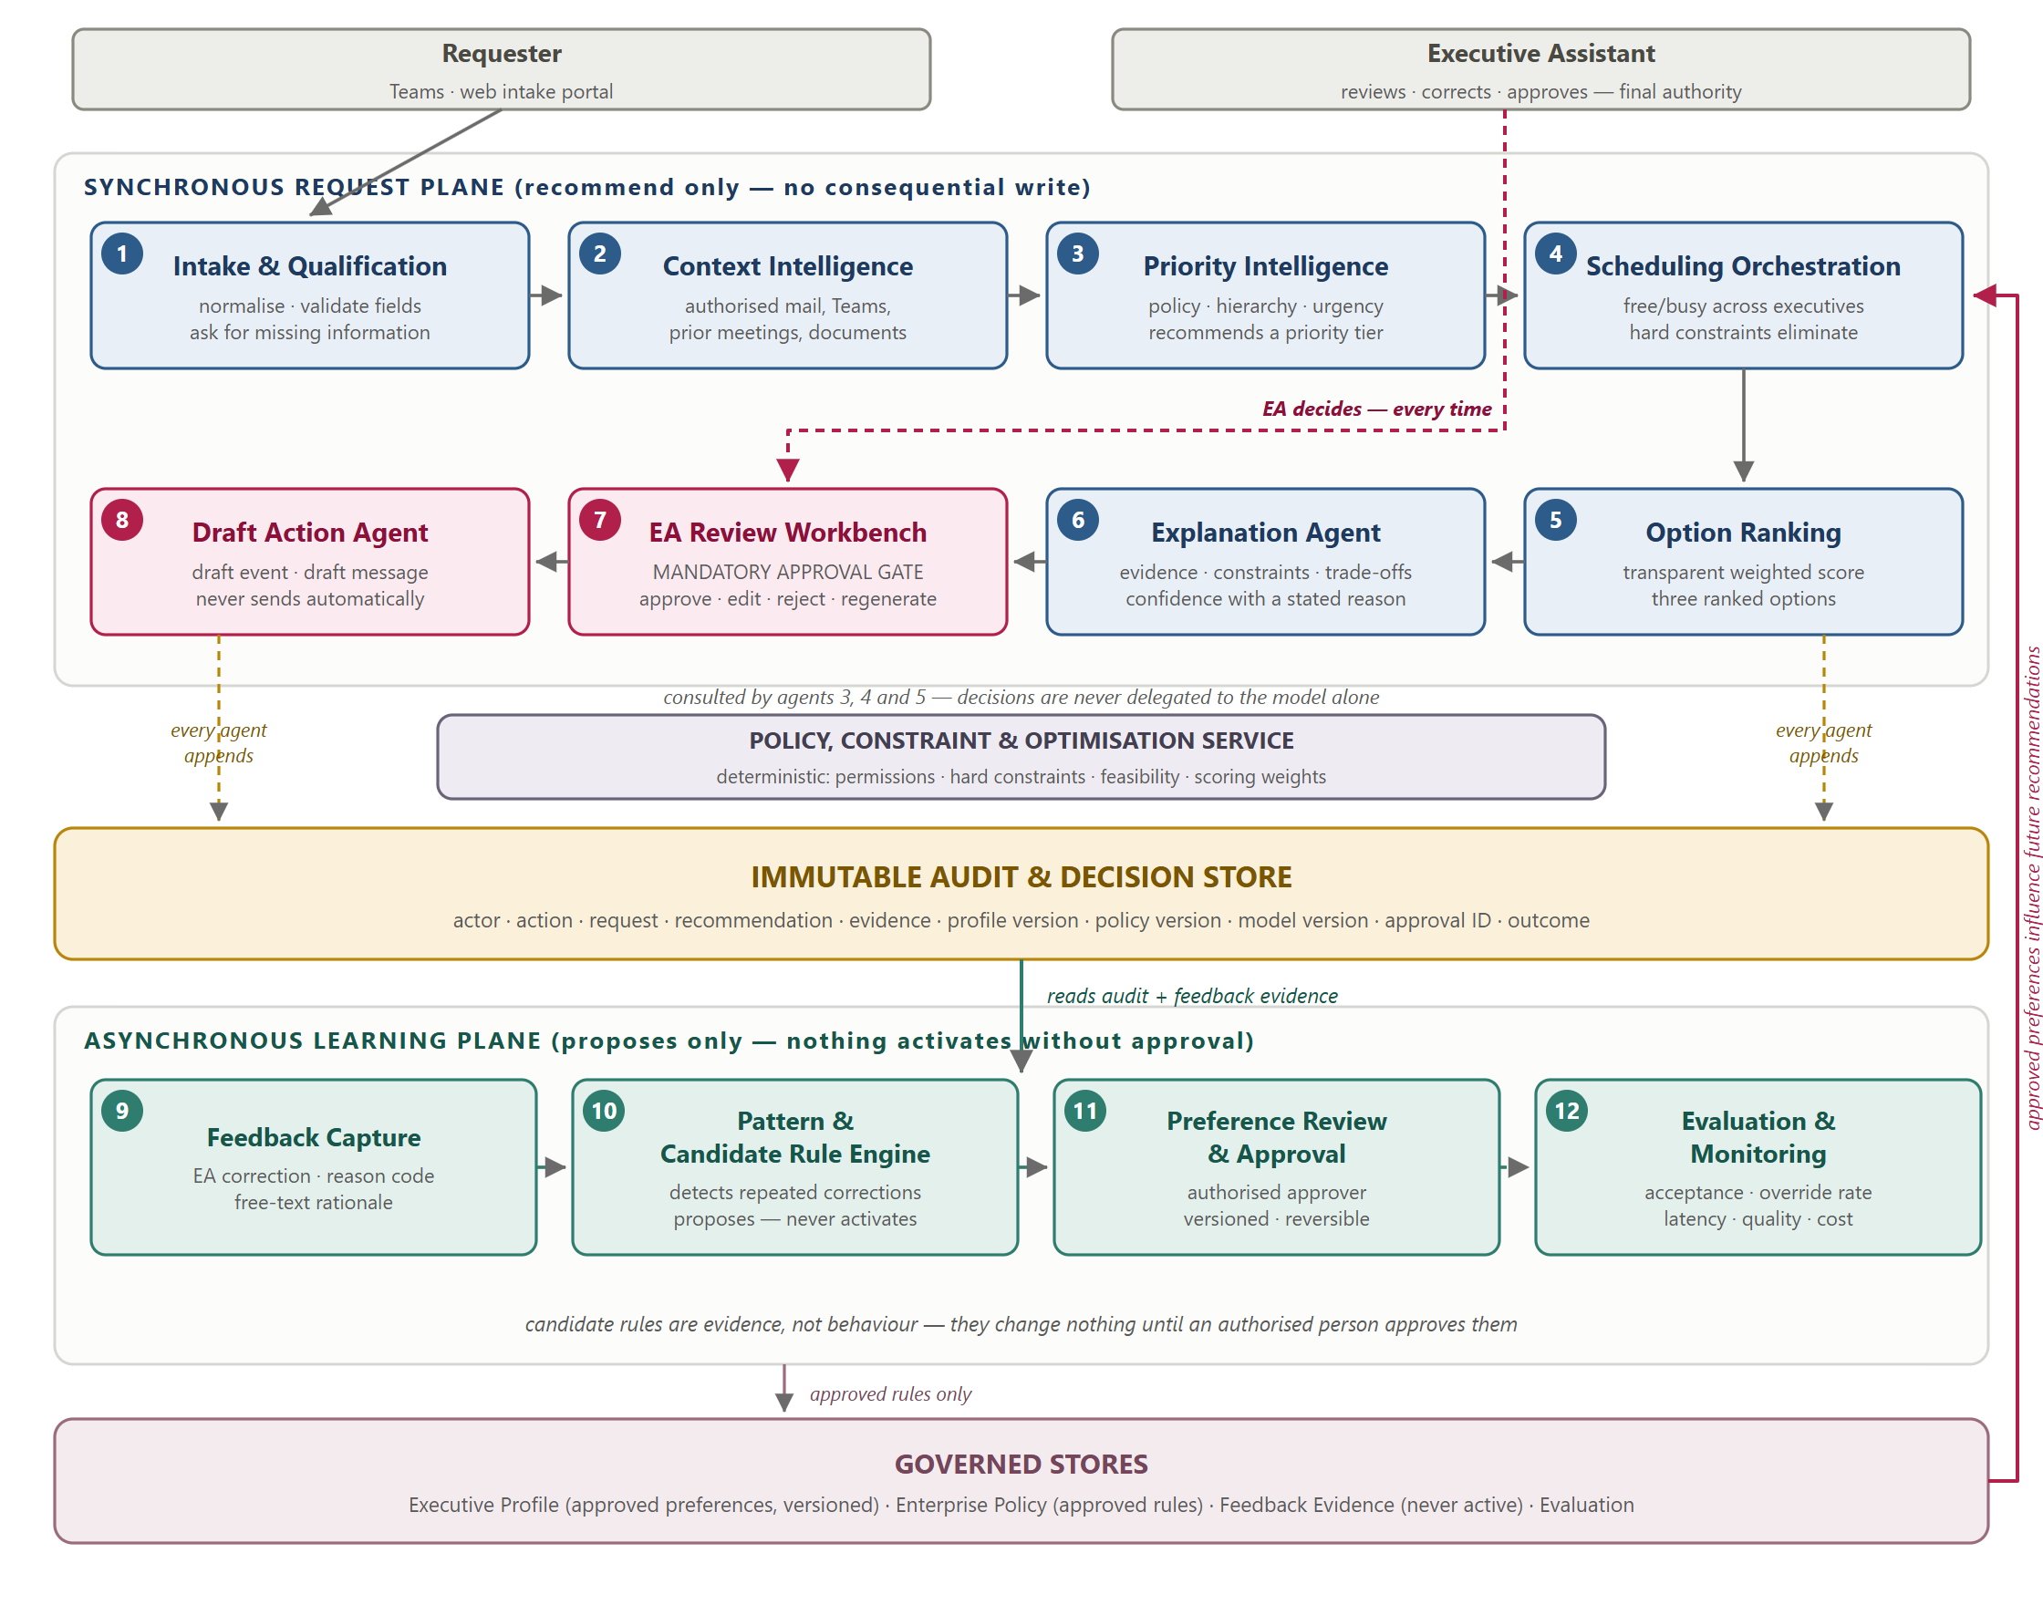
Figure 1 — Functional architecture. Twelve components in two planes. The synchronous plane recommends but never writes; the EA Review Workbench (7) is a mandatory gate; the asynchronous plane proposes rules but cannot activate them. Only approved, versioned rules in the governed stores influence future recommendations.

4. Agent and service responsibilities
The "must not" column is the enforceable part of the design. Each restriction is implemented as a tool allow-list and a deterministic policy check, not as prompt instruction.
# | Agent / service | Responsibility | Must not
1 | Intake & qualification | Normalise requests, validate fields, collect missing information | Escalate an incomplete request as decision-ready
2 | Context intelligence | Build a grounded decision package from authorised M365 content | Present unsupported claims or unauthorised content
3 | Priority intelligence | Recommend a business priority tier from policy, hierarchy and urgency | Change enterprise policy or produce an opaque ranking
4 | Scheduling orchestration | Evaluate availability and eliminate infeasible options | Book, move, cancel, accept or decline any meeting
5 | Option ranking | Score feasible options against governed weights | Hide the scoring basis or invent an option
6 | Explanation | Produce a reviewable decision packet with evidence and confidence | Expose data beyond the EA’s authorisation
7 | EA review workbench | Present options and capture the approval decision | Proceed without an explicit, recorded EA decision
8 | Draft action agent | Create draft events and draft messages after approval | Act before approval or send anything automatically
9 | Feedback capture | Record the correction, reason code and rationale | Alter a recommendation retrospectively
10 | Pattern & candidate-rule engine | Detect repeated corrections and propose a rule | Activate an inferred rule
11 | Preference review & approval | Route candidates to an authorised approver | Approve on the user’s behalf or skip versioning
12 | Evaluation & monitoring | Track acceptance, override rate, latency, quality and cost | Feed measurements back into recommendations automatically
— | Policy, constraint & optimisation service | Enforce permissions, hard constraints, feasibility and scoring weights | Delegate a policy decision to a language model alone

4.1 Transparent scoring
Hard constraints eliminate invalid options. Soft constraints rank what survives. Weights are governed configuration, not hidden prompt behaviour.
Score = wp·P + wu·U + wf·F + wl·L + wc·C − wd·D
P business-priority alignment · U urgency and deadline fit · F executive preference fit · L location and travel suitability · C calendar quality · D disruption cost

5. Reference architecture
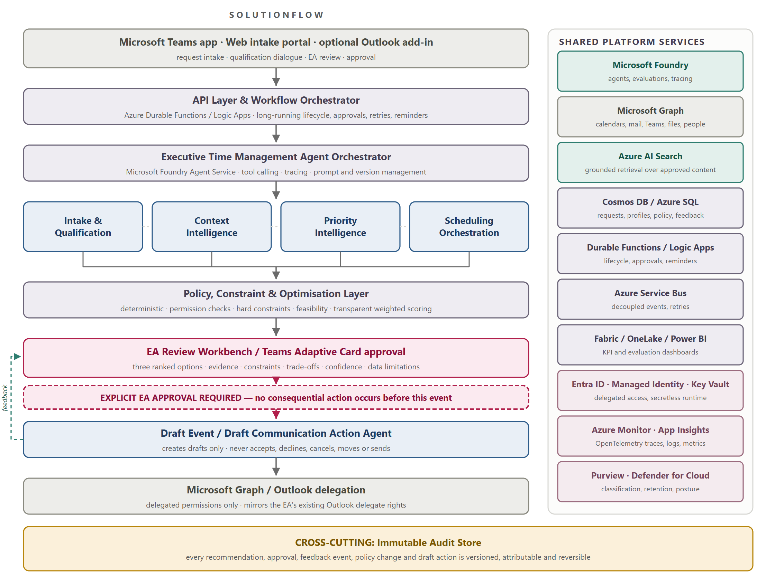
Figure 2 — Reference architecture. The approval gate sits between recommendation and action; nothing below it executes without a recorded EA approval. Shared platform services are listed at right; the immutable audit store spans the whole flow.

5.1 Microsoft technology mapping
Capability | Service | Prototype role
Agent engineering | Microsoft Foundry, Azure OpenAI | Agent development, tool calling, tracing, prompt and version management, evaluations
User experience | Teams app, Adaptive Cards, React or Power Apps | Intake, qualification dialogue, EA review, approval, explanations
Microsoft 365 integration | Microsoft Graph | Calendars, free/busy, events, mail, Teams messages, files, people
Workflow | Azure Durable Functions or Logic Apps | Long-running request lifecycle, approvals, retries, reminders
State and profile store | Azure Cosmos DB or Azure SQL | Requests, executive profiles, policy records, feedback, versioning
Search and grounding | Azure AI Search + embeddings | Grounded retrieval across approved content
Constraint optimisation | Azure Functions or Container Apps (Python) | Deterministic rules, multi-calendar feasibility, scoring
Messaging | Azure Service Bus | Decoupled events, retries, durable processing
Data and metrics | Microsoft Fabric, OneLake, Power BI | KPI dashboards, feedback analytics, evaluation reporting
Identity and secrets | Entra ID, Managed Identity, Key Vault | Delegated access, least privilege, secretless runtime
Governance and audit | Microsoft Purview, Azure Monitor, Log Analytics | Classification, retention, audit, operational evidence

5.2 Security and privacy essentials
- Delegated access only. The prototype mirrors the EA’s existing Outlook delegate rights and honours view-only and private-appointment restrictions. Authorisation is enforced at each tool call, not only at login.
- Prompt-injection boundary. Retrieved mail, Teams messages and documents are attacker-influenced text. They are wrapped as data; instructions found inside them are never executed. The component that reads untrusted content has no write capability.
- Kill switch. Calendar-write operations can be disabled while read-only recommendations continue to function.
- Audit record. Actor, action, time, request ID, recommendation ID, evidence references, profile version, policy version, model version, approval ID and outcome — append-only and searchable.
- Data minimisation. Prefer source links and short-lived derived summaries over persistent copies of raw mail or documents. Personal constraints are treated as sensitive profile data.

6. Request lifecycle
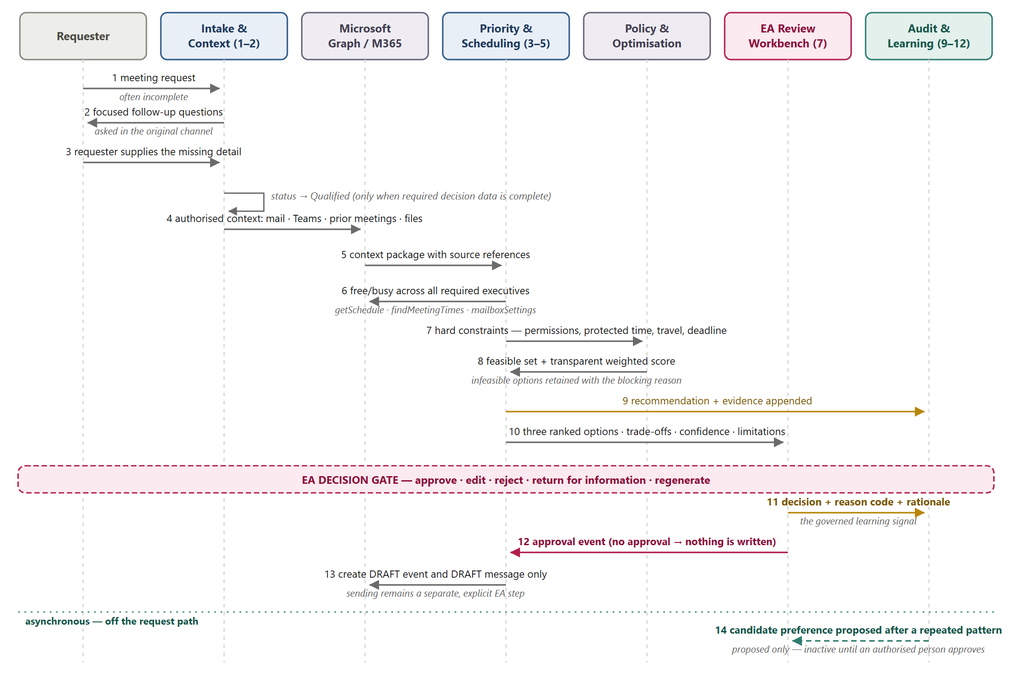
Figure 3 — Request lifecycle for a single meeting request. Steps 1–10 produce a recommendation; nothing is written. Step 11 is the governed learning signal. Step 12 is the approval event without which step 13 cannot occur. Step 14 is asynchronous and proposes only.

7. MVP scenarios and acceptance criteria

7.1 Scenario 1 — Qualified single-executive scheduling
Problem. Requests arrive through informal channels with insufficient detail. EAs spend time chasing requesters, gathering context and renegotiating times.
Flow. A requester submits through Teams or the portal. The intake agent detects a missing objective, justification, attendee or deadline and asks focused follow-up questions in the original channel. The request becomes Qualified only when required decision data is complete. The context agent retrieves permitted mail, Teams conversations, prior meetings and documents. The priority agent applies policy and profile rules to recommend a tier. The scheduling agent evaluates availability, protected blocks, preferred hours, preparation time, travel buffers and duration norms. The EA receives three ranked options with explanations and evidence, then approves, edits, rejects, returns for information, or regenerates. Only after approval does the action agent create a draft event.
Acceptance criteria
- An incomplete request is identified and qualified without EA intervention.
- The EA receives a concise context package with source references.
- At least three feasible options are produced where feasible options exist.
- Each option shows constraints considered, conflicts avoided and priority rationale.
- No event is created before a recorded EA approval.

7.2 Scenario 2 — Multi-executive strategic scheduling
Problem. The highest-value case involves several senior leaders whose calendars are constrained, whose priorities differ, and where a proposed meeting competes with protected commitments or travel.
Flow. The request is qualified and required executives identified. Context and priority agents surface strategic signals — CEO sponsorship, board preparation, customer escalation, deadline sensitivity. The scheduling agent evaluates authorised free/busy across all required executives, then applies hard constraints: permission boundaries, non-movable events, protected time, deadline, travel feasibility and minimum preparation buffers. Feasible options are ranked by the transparent score in §4.1. Where an option would require moving an existing commitment, it is displayed as a proposed trade-off only. No action is taken until the EA approves.
Acceptance criteria
- At least three executive calendars are evaluated using authorised access.
- Infeasible options are identified with the blocking constraint stated.
- At least three ranked alternatives are offered where possible.
- Affected commitments and disruption trade-offs are shown explicitly.
- No existing meeting is ever automatically rescheduled.

7.3 Scenario 3 — EA feedback-to-preference learning
Problem. EAs hold critical tacit knowledge — working style, acceptable trade-offs, stakeholder sensitivity, travel expectations. The system should capture it safely over time without removing human control.
Flow. The EA selects an alternate time, changes priority, modifies duration, corrects context or rejects a proposal, optionally with a reason code and free-text rationale. The feedback service stores the decision, the original recommendation, the chosen outcome, the reason, supporting references, and the effective profile and policy versions. A pattern detector identifies repeated, consistent corrections and creates a candidate preference — it does not activate it. An authorised approver reviews the evidence and can approve, edit, reject, pause or defer. If approved, the preference is stored as a versioned profile rule with an effective date, and future recommendations state which approved preference influenced the result. The EA can disable or roll it back at any time.
Worked example. In five of seven applicable requests, the EA moves proposed Tuesday-morning appointments for Executive A to later in the day. Proposed rule: "Prefer meetings after 10:00 on Tuesdays for Executive A unless priority is Tier 1 or the requester specifies a non-negotiable deadline." The EA approves, edits the threshold, rejects, or marks it temporary.
Acceptance criteria
- Structured and free-text feedback can be supplied for every recommendation.
- Every feedback event is auditable and linked to its recommendation, policy version and profile version.
- A repeated pattern generates a candidate preference update.
- Candidate updates never affect recommendations until an authorised person approves them.
- Approved rules are versioned, explainable and reversible.
- The demo shows a before-and-after recommendation changed by an approved preference.

8. Governed feedback and learning
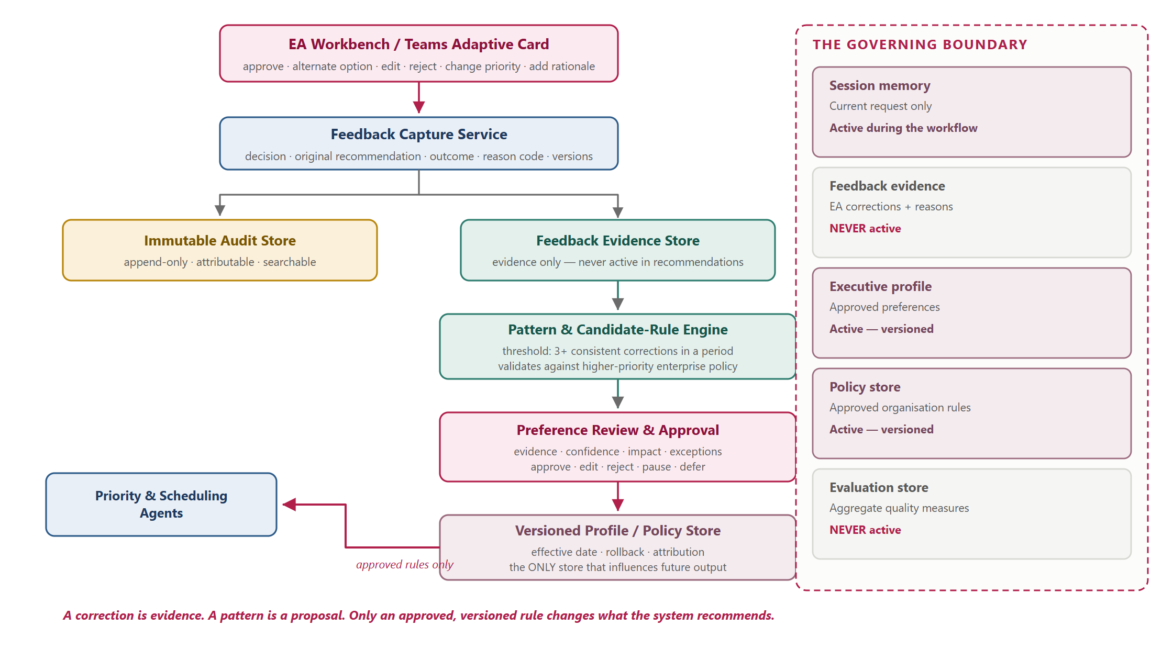
Figure 4 — Governed learning. Feedback splits into an immutable audit record and an evidence store that is never active in recommendations. A pattern becomes a candidate, a candidate requires an authorised approval, and only the versioned profile and policy store influences future output.

8.1 Learning boundaries
Learning type | Example | Applied when | Approval required
Per-request feedback | "This request is more urgent than rated." | Current request only | EA correction is immediate for that request
Executive preference candidate | "Avoid meetings before 09:30." | Future requests, after approval | EA or profile owner
Scheduling rule candidate | "Add a 30-minute buffer after external meetings." | Future requests, after approval | EA
Organisation policy candidate | "Board-related requests outrank ordinary operating meetings." | Cross-executive, after approval | Business / policy owner
Product-quality feedback | "The agent missed a relevant Teams discussion." | Evaluation backlog only | Product and engineering governance

Promotion controls. A repeat-pattern threshold (three or more consistent corrections in a defined period); validation against higher-priority enterprise policy; an approver determined by rule scope; and a review card showing evidence, confidence, potential impact, exceptions, effective date and rollback. Cross-executive generalisation requires an enterprise policy owner.

9. Demo storyline
One connected scenario carries the full value chain. A senior leader requests a 45-minute decision meeting with the CEO, CFO and operations leader ahead of a planning deadline. The submitted request lacks business justification and supporting artefacts.
- The intake agent asks the requester for the missing objective, the decision required, and the supporting planning document.
- The context agent surfaces permitted supporting communications, related prior meetings and stakeholder context.
- The priority agent identifies CEO sponsorship and deadline sensitivity, recommending a strategic tier with visible evidence.
- The scheduling agent evaluates authorised availability, protected blocks, travel buffers and executive preferences.
- The EA receives three ranked options: the first meets the deadline without disruption; the second compresses CFO preparation time; the third misses the decision deadline.
- The EA selects the first option, edits the attendee list, and explicitly authorises a draft invitation.
- The action agent creates the draft event. It does not send.
- After similar corrections across several requests, the agent proposes a Tuesday-morning preference rule for one executive. The EA reviews the evidence and approves the versioned preference.
- A subsequent recommendation visibly applies the approved preference and explains its effect.

Why beat 9 is the one that matters
Any prototype can show a system that produces an answer. The persuasive moment is the before-and-after: the same request, answered differently, because a human approved a rule the system proposed from its own observed evidence — and can revoke it just as easily.

10. Evaluation measures
Measure | MVP target
Intake completeness before EA review | At least 80% of requests decision-ready after agent qualification
EA effort per qualified request | 25–40% reduction in coordination and context-gathering time
Clarification and scheduling exchanges | 30% or greater reduction in back-and-forth messages
Recommendation usefulness | EA accepts or lightly edits a recommended option in 60–70% of eligible cases
Context-package usefulness | At least 80% positive EA rating
Explainability coverage | 100% of recommendations show evidence, constraints, policy factors and confidence
Approval compliance | 100% of calendar writes have a recorded EA approval
Unauthorised actions | Zero
Feedback learning governance | 100% of persistent preference changes have an authorised approval and version record

Evaluation set. Realistic anonymised or synthetic examples covering: incomplete requests, high-priority versus routine, conflicting preferences, multi-executive conflicts, board-preparation protections, travel constraints, restricted calendar visibility, misleading context, EA overrides, and prompt-injection-like text inside retrieved content.

11. Build sequence
Phase | Focus | Demo checkpoint
0 · 1–2 wks | Discovery: cohort, schema, consent model, preference workshops, priority taxonomy, threat model | Agreed MVP scope and the no-autonomous-scheduling policy
1 · 2 wks | Teams intake, request lifecycle, qualification agent, Entra auth, audit foundation | A poorly formed request is automatically qualified before EA review
2 · 2–3 wks | Executive profiles, Graph calendar reads, scoped context retrieval, single-executive recommendations, explanation cards | An EA receives a qualified request, evidence-backed context and explained options for one executive
3 · 2–3 wks | Cross-calendar optimisation, trade-off display, approval workflow, draft-event creation, feedback capture, candidate rules | A strategic multi-executive request produces explained trade-offs; the EA approves a draft and a proposed learning rule
4 · 1–2 wks | Scenario, security and failure-mode testing; prompt-injection tests; KPI dashboard; showcase | Leadership walkthrough of the full storyline in §9

Estimated duration: 8–12 weeks, dependent on tenant readiness, Graph consent, availability of representative data, and security review timing.

12. Open questions for this review
# | Question | Owner
Q1 | Should preference scope be per executive, per executive-pair, or per meeting type? This determines how quickly the system can learn anything useful. | Product / ML
Q2 | Is a three-correction threshold the right bar for proposing a candidate rule, and who is the authorised approver for each rule scope? | EA / Policy owner
Q3 | Are the scoring weights in §4.1 governed configuration owned by the business, or engineering defaults for the prototype? | Business / Architecture
Q4 | Which pilot tenant will host the prototype, and does it contain representative executive calendars or synthetic ones? | Platform / Security
Q5 | Is "refuse and log" the correct response to a detected prompt-injection attempt, or should it escalate to the EA as a visible security event? | Security
Q6 | What is the retention policy for the audit and feedback evidence stores, and who approves it before pilot data is used? | Compliance

Resolved. The terminal action for the MVP is a draft calendar event created after recorded EA approval, with sending left as a separate explicit EA step. Scenarios 1 and 2 and Figures 1–3 reflect this.

Appendix A — Prototype integration path
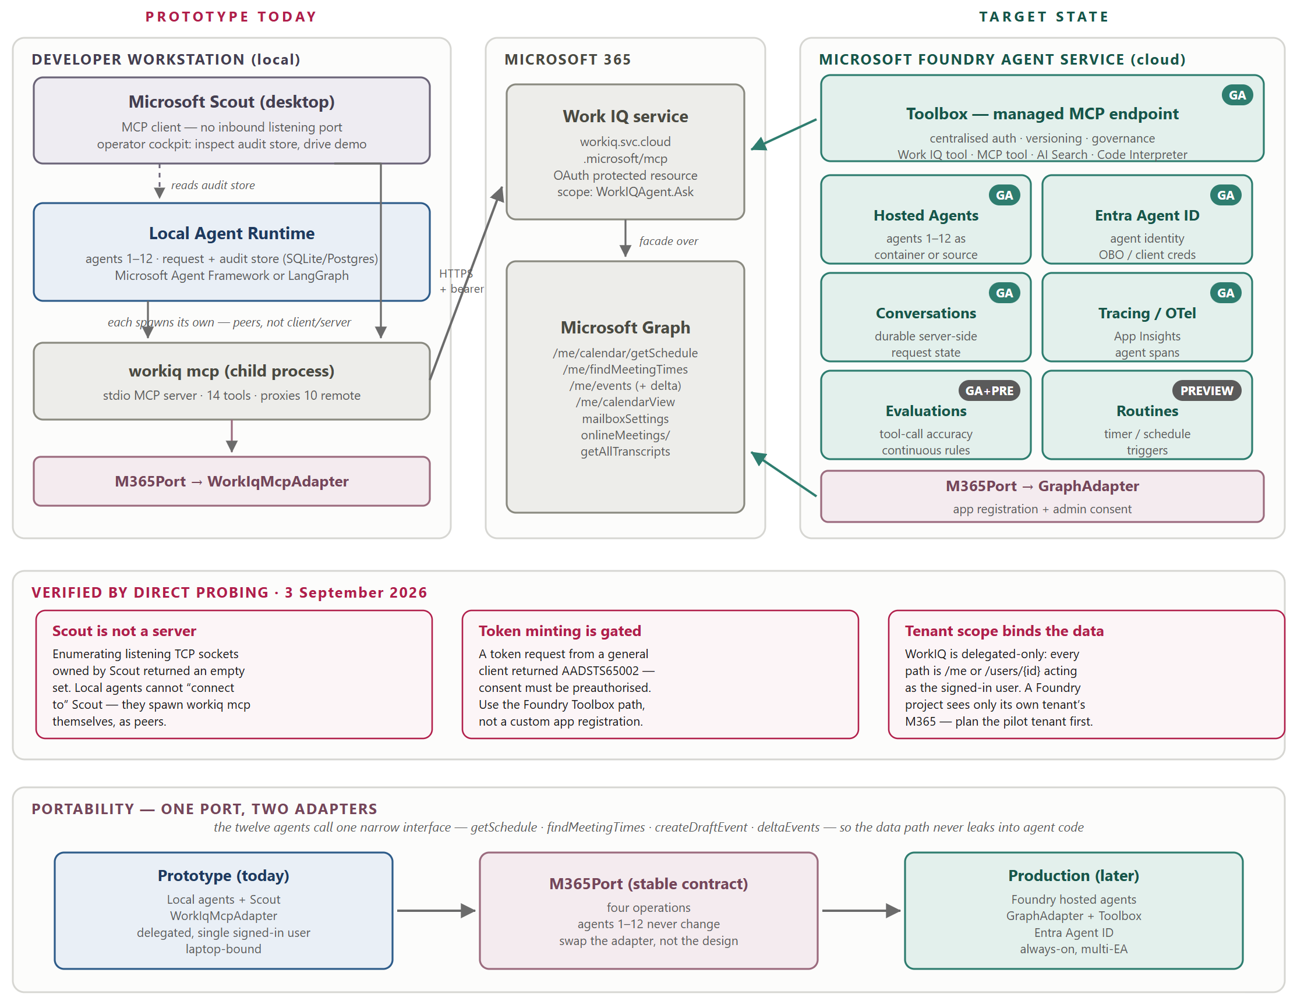
Figure 5 — How the prototype reaches Microsoft 365 today, and the target state. Left: agents 1–12 run locally alongside Scout, each spawning its own Work IQ MCP process. Centre: the Microsoft 365 data surface. Right: the Foundry deployment the design migrates to. The M365Port abstraction is what makes that migration a change of adapter rather than a rewrite.

A.1 How local agents obtain Microsoft 365 access
The prototype runs on a workstation before it runs in the cloud. The integration below was established by direct probing rather than assumption, because the obvious mental model turns out to be wrong in a way that affects the build.
- Scout is a peer, not a gateway. Microsoft Scout exposes no inbound listening ports — it is an MCP client, not a server, so local agents cannot "connect to" it. What Scout does is spawn the Work IQ CLI as a stdio child process, and the agent runtime does exactly the same thing independently. Concurrent instances coexist without contention.
- Scout’s role in the demo is the operator cockpit. It inspects the audit store, replays a decision, and drives the walkthrough. That is a genuine role — it is simply not the data path.
- The Work IQ CLI is a proxy over a remote service. It presents fourteen tools, ten proxied from an OAuth-protected MCP endpoint. Beyond the semantic "ask" interface it exposes a structured entity surface over Microsoft Graph — including getSchedule, findMeetingTimes, events with delta, calendarView, mailboxSettings and meeting transcripts.
- Two findings shape the target state. A token request from a general-purpose client returns AADSTS65002 — Work IQ is a first-party API that only preauthorised clients may request, so the supported cloud route is the Foundry Toolbox where Work IQ is a GA tool with managed credential injection. And access is delegated-only: every path acts as the signed-in user, so a Foundry project sees only its own tenant’s Microsoft 365.
- Everything routes through one narrow port. Agents 1–12 call four operations — getSchedule, findMeetingTimes, createDraftEvent and deltaEvents. The prototype binds them to a Work IQ adapter; production binds them to a Graph adapter with an app registration and admin consent. The agents are unaware of the difference.

Why this matters for Q4
Because Work IQ access is delegated and tenant-bound, the choice of pilot tenant decides what the prototype can actually see. A tenant without representative executive calendars will need seeded or synthetic profiles, and that decision should be made before Phase 2 rather than discovered during it.

